Lesson 5 Demo 4: Resolving Merge Conflicts on Modifications

This section will guide you to:

* Resolve merge conflicts on modifications

This lab has seven subsections, namely:

1. Creating a file with some content in it
2. Adding the file to the repository and committing it
3. Creating a new branch
4. Overwriting the content in the previously created file
5. Committing the new content
6. Checking the Git status to identify the merge conflicts
7. Using **git add** to stage the newly merged content

**Note**: The following commands can be executed in any sample repository that we created in the earlier demos.

**Step 1:** Create a sample directory and initialize it as a git repository

* Execute the following command to create a new directory

**mkdir resolve-merge-conflict**

* Navigate to the directory and Initialize it as a git repository

**cd resolve-merge-conflict**

**git init .**

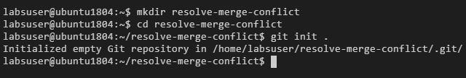

**Step 2:** Creating a file with some content in it

* In the master branch, create a new file using the following command:

**vi index.html**



* Add the following lines in the file:

**This is the first line of my home page**

**This is the line added in master branch**

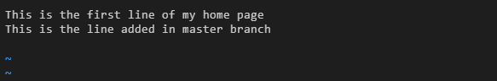

**Note:** Press **Esc** key and enter **:wq** to save the file.

**Step 3:** Adding the file to the repository and committing it

* Use the following command to add the file to the repository:

**git add .**

* Use the following command to commit the changes:

**git commit -m "Master : Added Second line"**

**git status**

**git log --oneline**

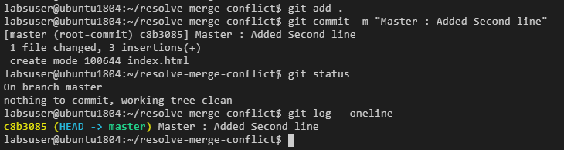

**Step 4:** Creating a new branch

* Use the following command to create a new branch:

**git branch feature-one**

* Use the following command to switch to the newly created branch:

**git checkout feature-one**

**git log --oneline**

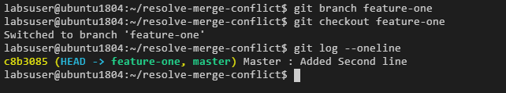

**Step 5:** Overwriting the content in the previously created file

* Use the following command to edit the index.html file:

**vi index.html**



* Add the following line in the file:

**this line has been added in the feature-one branch**

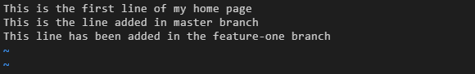

**Note:** Press **Esc** key and enter **:wq** to save the file.

**Step 6:** Committing the new content

* Execute the following command

**git add .**

* Use the following command to commit the changes:

**git commit -m "Feature-one Branch: Added Third line"**

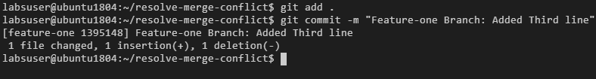

**Step 7:** Checking the Git status to identify the merge conflicts

* Run the following command in the terminal:

**git status**

* Switch back to the master branch

**git checkout -**

* Use the following command to merge the file changes made in both the branches:

**git merge feature-one**

* Open the index.html file using the following command:

**vi index.html**

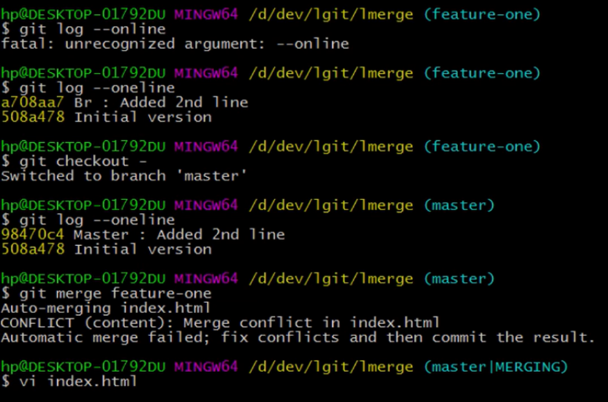

* Remove the second, fourth, and sixth lines from the content as shown in the following screenshot:

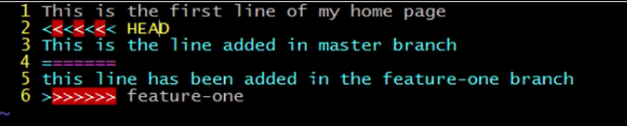

* Run the following command to merge without conflict:

**git merge feature-one**

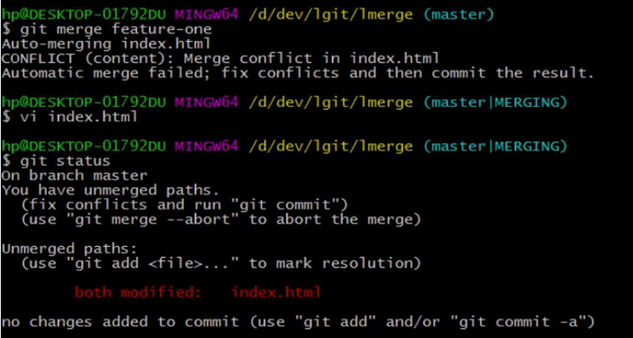

**Step 7:** Using **git add** to stage the newly merged content

**git add .**

* Use the following command to create a new commit to finalize the merge

**git commit -m “retained the master changes while doing a merge”**

