5.5 Stashing in Git

This section will guide you to:

* Stash in Git

This lab has four subsections, namely:

5.5.1 Working on a file and stage one of the changes

5.5.2 Checking the git status

5.5.3 Using **git stash** to stash the changes

5.5.4 Using git stash list to see which stashes you’ve stored

**Please note**: Use the sample repository created in the previous demos for this demo.

**Step 5.5.1:** Working on a file and stage one of the changes

* Create **file1.txt** in your home directory, add the following text in it, and save the file.  
  **M: this is prod ready code**

**B: Fixed INC001**

**B: Fixed INC002**

* Commit all the changes using the command below.  
  **git commit -a**
* Now, add the following text in the file.

**B: Assigned INC003 … WIP**

* Run the following commands in the terminal.

**$ cat file1**

**$ git stash** (Please note: This is the basic stash command. However you can add a message as shown in the screenshot)

**$ git log --oneline**

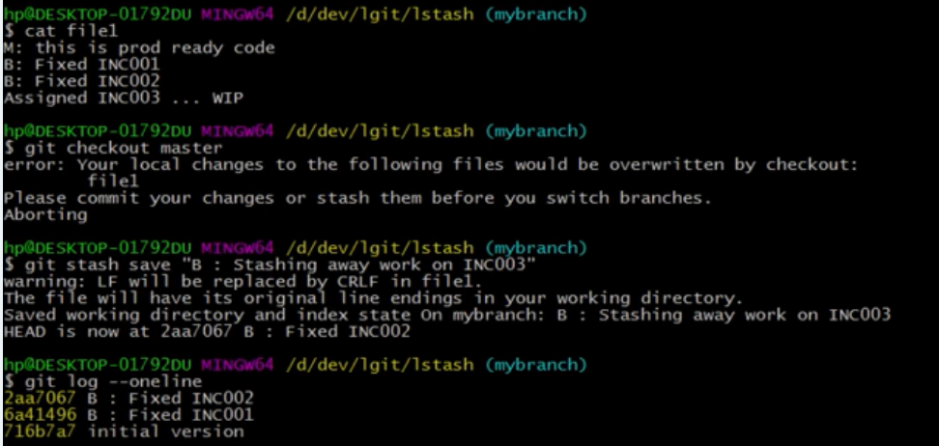

**Step 5.5.2:** Checking the git status

* Run the following command in the terminal:

**$ git status**

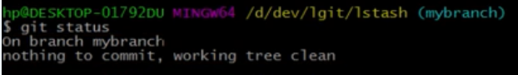

**Step 5.5.3:** Using **git stash** to stash the changes

* Run the following command in the terminal:

**$ git stash list**

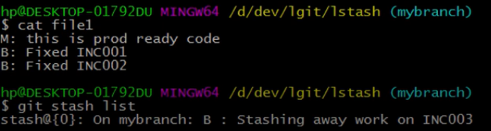

**Step 5.5.4:** Using git stash list to see which stashes you’ve stored

* Run the following command in the terminal:

**$****git stash pop stash@{0}**

