5.6 Rebasing in Git

This section will guide you to:

* Rebase in Git

This lab has three subsections, namely:

5.6.1 Creating a feature branch

5.6.2 Editing files in the master branch

5.6.3 Executing git rebase

**Please note**: Execute the below commands in a **sample repository** created in the previous demos.

**Step 5.6.1:** Creating a feature branch

* Use the following command to create a feature branch:

**$ git branch feature-one**

* Run the following command to verify the creation of the feature-one branch:

**$ git branch -a**

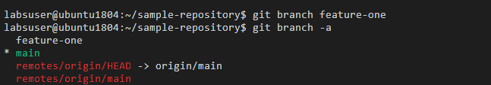

* Switch to the feature-one branch

**$ git checkout feature-one**

* Verify you are in the feature-one branch

**$ git status**

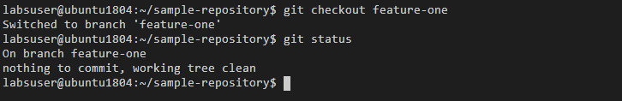

**Step 5.6.2:** Editing files in the master branch

* Switch to the master branch

**$ git checkout main**

* Run the following command to create a file

**$ vi file.html**

* Add the below code in the file.html file   
  **<html>**

**<body>**

**<p> This is a Test html file </p>**

**</body>**

**</html>**

* Type the following command to exit the editor:

**ctrl+Shift+:** and type **wq**

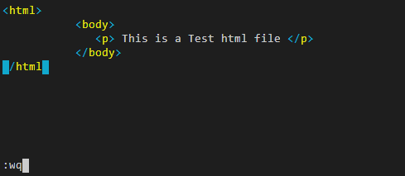

* Use the following commands to commit the changes:

**$ git add file.html**

**$****git commit -m “file modified”**

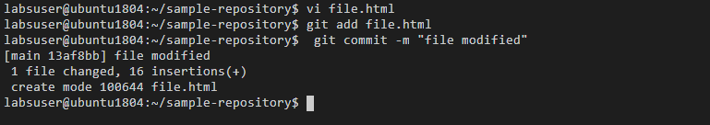

**Step 5.6.3:** Executing git rebase

* Switch to the feature-one branch

**$ git checkout feature-one**

* Use the following command to execute git rebasing:

**$ git rebase --autostash main**

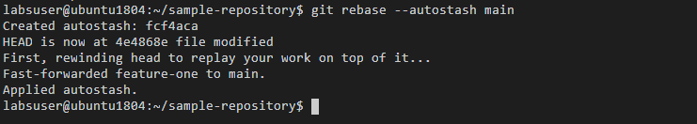

* Run the following command in the terminal

**$ git log --oneline**

