Lesson 7 Demo 1: Installation of EGit Support into Eclipse IDE

This section will guide you to:

* Install EGit support into Eclipse IDE

**Note:** Egit is already installed in the Eclipse IDE in your Practice Lab.

This lab has four subsections, namely:

1   Visiting  <http://download.eclipse.org/egit/updates>to get the plugin repository location

2 Navigating to Help and installing new software

3 Adding repository location

4 Verifying the installation in Eclipse Marketplace

**Step 1:**  Visiting<http://download.eclipse.org/egit/updates>[to get the plugin repository location](http://download.eclipse.org/egit/updates)

* Navigate to **/opt/eclipse** directory and click on the executable eclipse file to open the Eclipse IDE
* Open  <http://download.eclipse.org/egit/updates> in your browser.

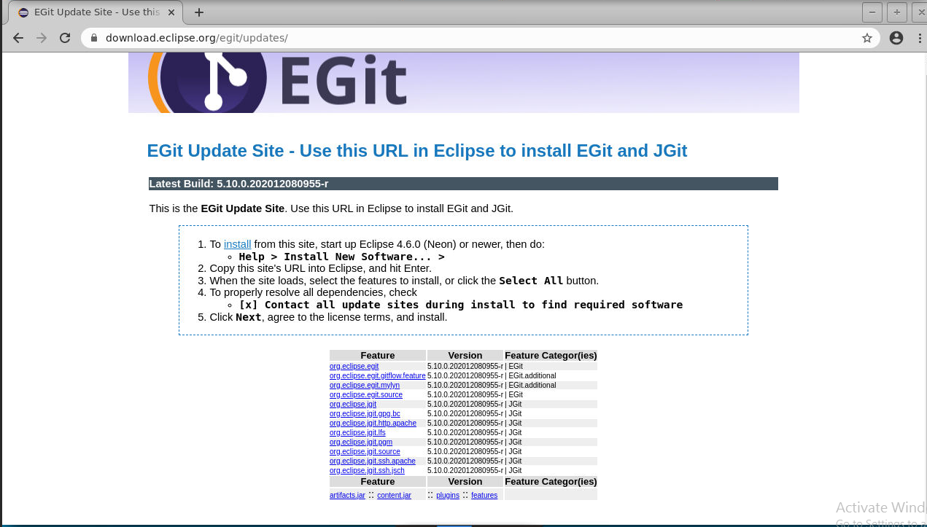

* Follow the instructions given in the above site to complete the installation process. The steps are given below.

**Step 2:** Click on **Help** in your Eclipse IDE ‘s menu bar and select **installing new software**

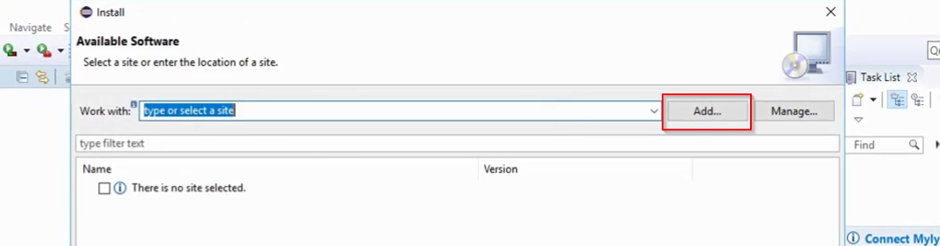

**Step 3:** Adding repository location

* Enter the Name as **Egit**
* In the location textbox paste the url of the link that we had copied ([**http://download.eclipse.org/egit/updates/**](http://download.eclipse.org/egit/updates/))

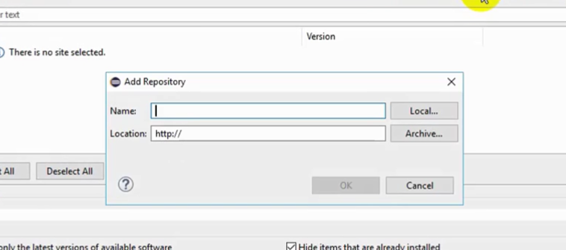

* Click on the **Select All** button
* Click **Next**
* Select the option *I agree to terms and license option*

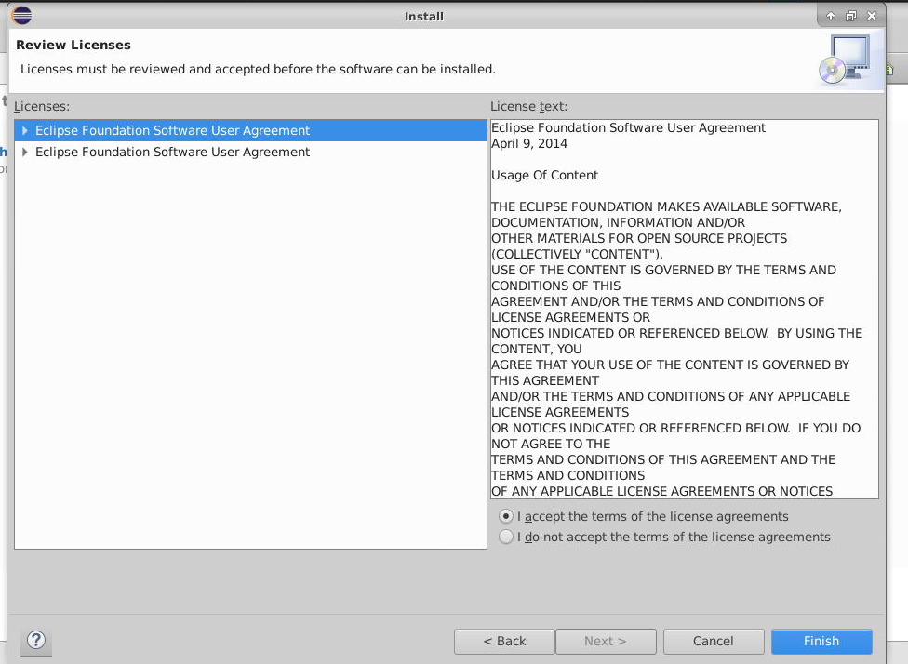

* After it is successfully installed, you might have to restart the Eclipse IDE.

**Step 4:** Verifying the installation in Eclipse Marketplace

* Navigate to **help -> Eclipse Marketplace**
* When you search for EGit, You find that it is already installed.

