Lesson 7 Demo 2: Merging Files Using EGit

This section will guide you to:

* Merge files using EGit

This lab has four subsections, namely:

1. Cloning a repository in your Eclipse Project
2. Creating and committing a file in the Eclipse Project
3. Making Changes in the file from remote repository
4. Pulling and merging from the remote repository

**Note**: Please complete Lesson 7 Demo 1 before you begin this demo.

**Step 1:** Cloning a repository in your Eclipse Project

* Navigate to **/opt/eclipse** directory and click on the executable eclipse file to open the Eclipse IDE

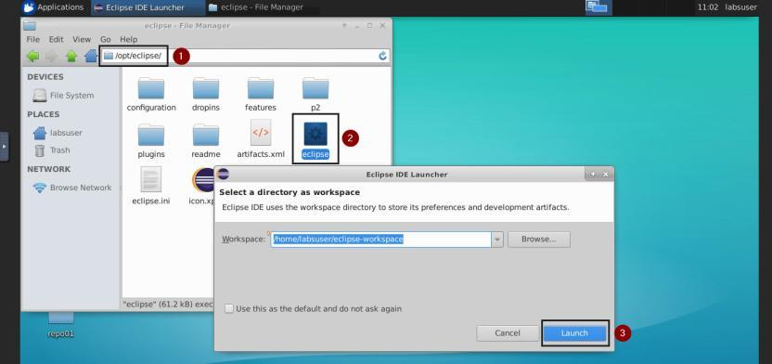

* Create a new Java project with a name of your choice. We have created a project called **Merging**.

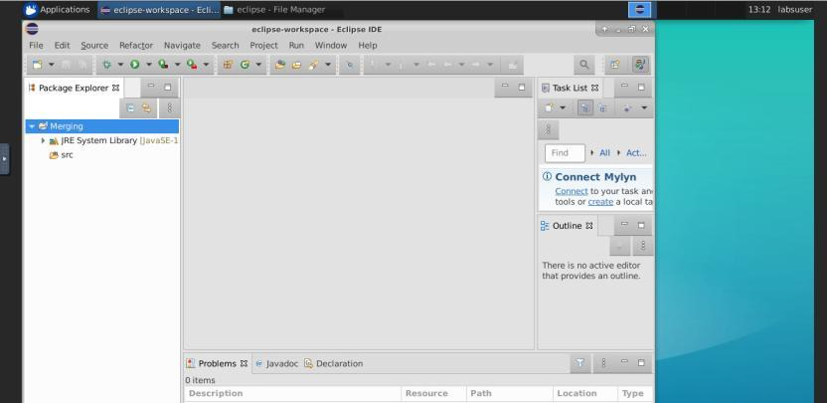

* Right click on the project name, click on team, choose share project

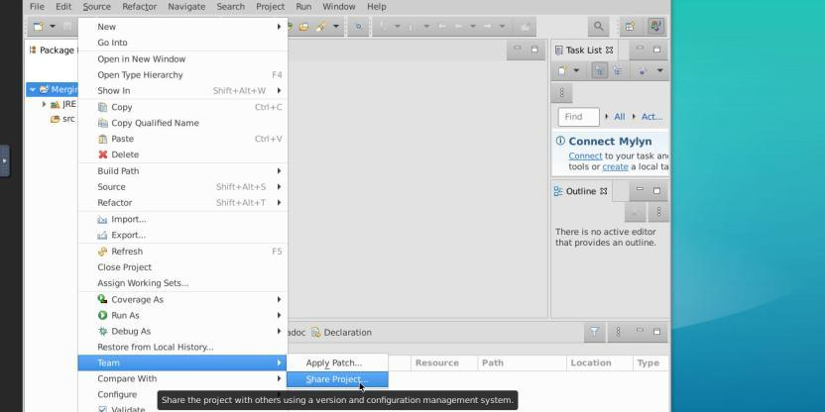

* Click on the create button and select a local repository from home. Paste the path after hitting the create button.

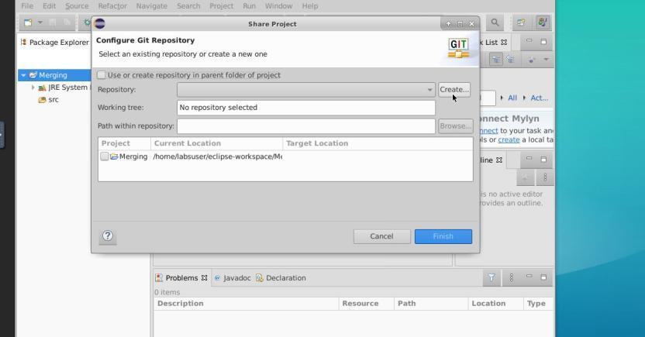

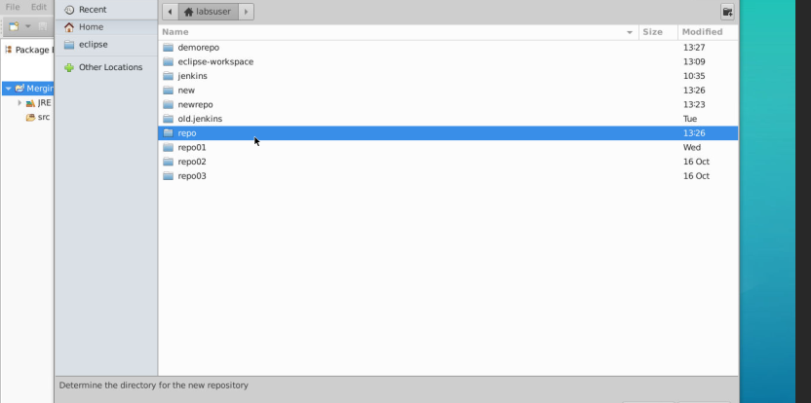

**Step 2:** Creating and committing a file in the Eclipse Project

* Right click on the project name and click on new, select class, provide a valid name, and click on the **Finish** button

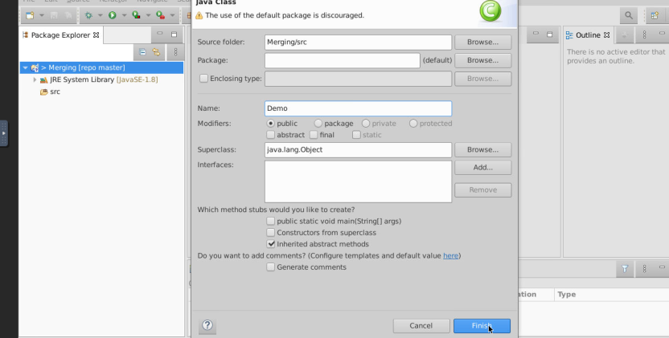

* Right click on the on the class name on the left navigation menu and click on **commit**

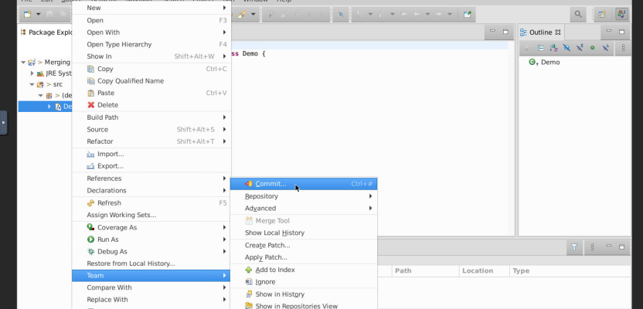

* Click on **Add all files**, provide a commit message and then click on **Commit and Push** button

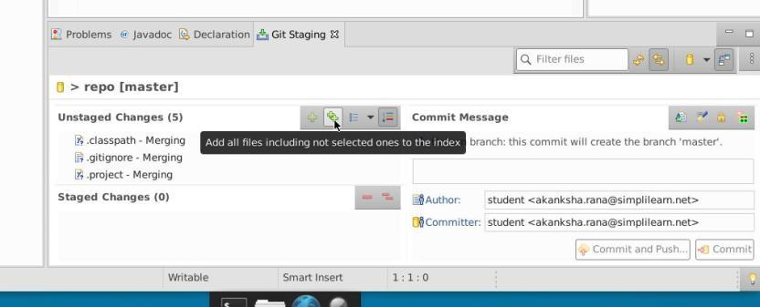

* Click on the **Push** button on the Push confirmation window

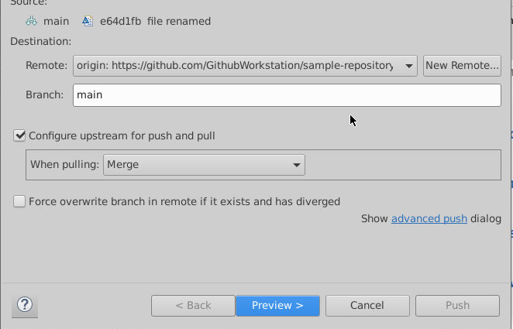

* Please provide your username and password. Do not copy from the below snapshot

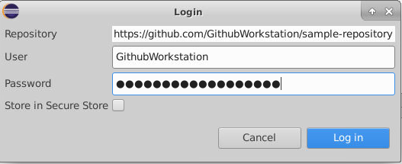

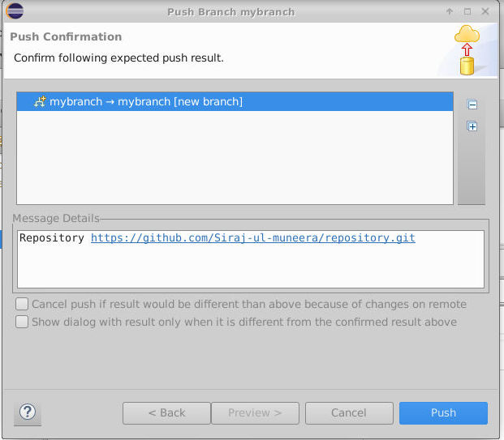

**Step 3:** Making changes in the file from remote repository

* Open and edit the file in the remote repository

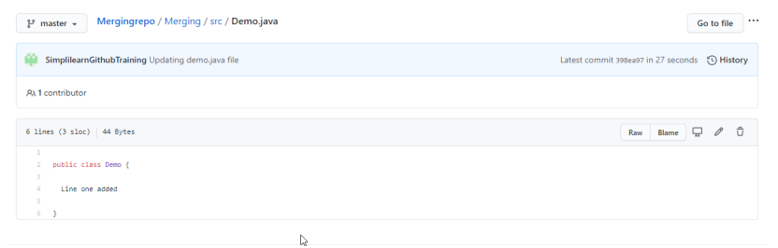

**Step 4:** Pulling and merging from the remote repository

* Right click on the project name in the left navigation menu, click on **Team** and choose **Pull**

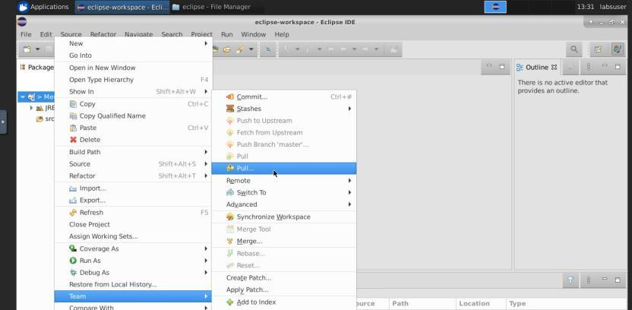

* For the **When** pulling dropdown, choose **Merge** and then click on **Finish**

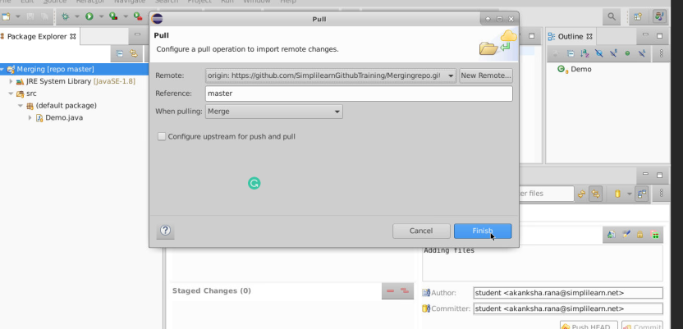

* The changes made in the file in the remote repository will be merged in the file in the project