Big Mountain Resort is a premium ski resort that has around 350,000 visitors each year. Their recent chair list addition increased operating costs by $1,540,000 this season. The resort’s pricing strategy has been to charge above the average price of resorts in its market segment, and stakeholders want to make a change that will cut costs without undermining the ticket price. Big Mountain Resort wants to remain at a premium price point and must continue to justify this cost with premium offerings.

I began my data wrangling process by creating a table of ticket prices that allowed me to compare the difference in prices between states. While observing the data, I was able to find a few features that have outliers, for which I either dropped irrelevant rows, or found the correct information and replaced the data. I also dropped rows with no pricing data, as pricing is our key variable. I then found information on state populations and areas to merge with my state summary statistics. I was able to determine that in Montana, there is no pricing difference between weekends and weekdays, so I decided to move forward with the variable that has less missing values: AdultWeekend. Additionally, as shown in the **scatterplot**, price discrepancies between weekend and weekday are restricted to sub $100 resorts. My final data has some missing data, but all of the rows have some useful information.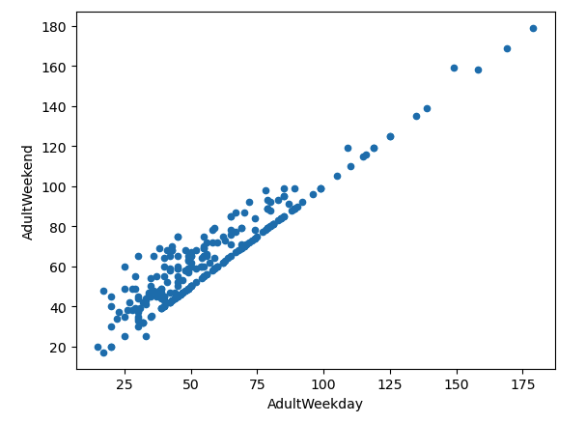

To start my exploratory data analysis, I used summary statistics to calculate Resort Density in order to visualize the relationship between the total resorts per state to their total population & area. I went on to use a **heatmap** to gain a high level view of relationships amongst the features. In order to confirm these correlations, I created scatter plots for each feature against ticket price. I was able to confirm a strong positive correlation with the Vertical Drop, Fast Quads, Runs, and Total Chairs.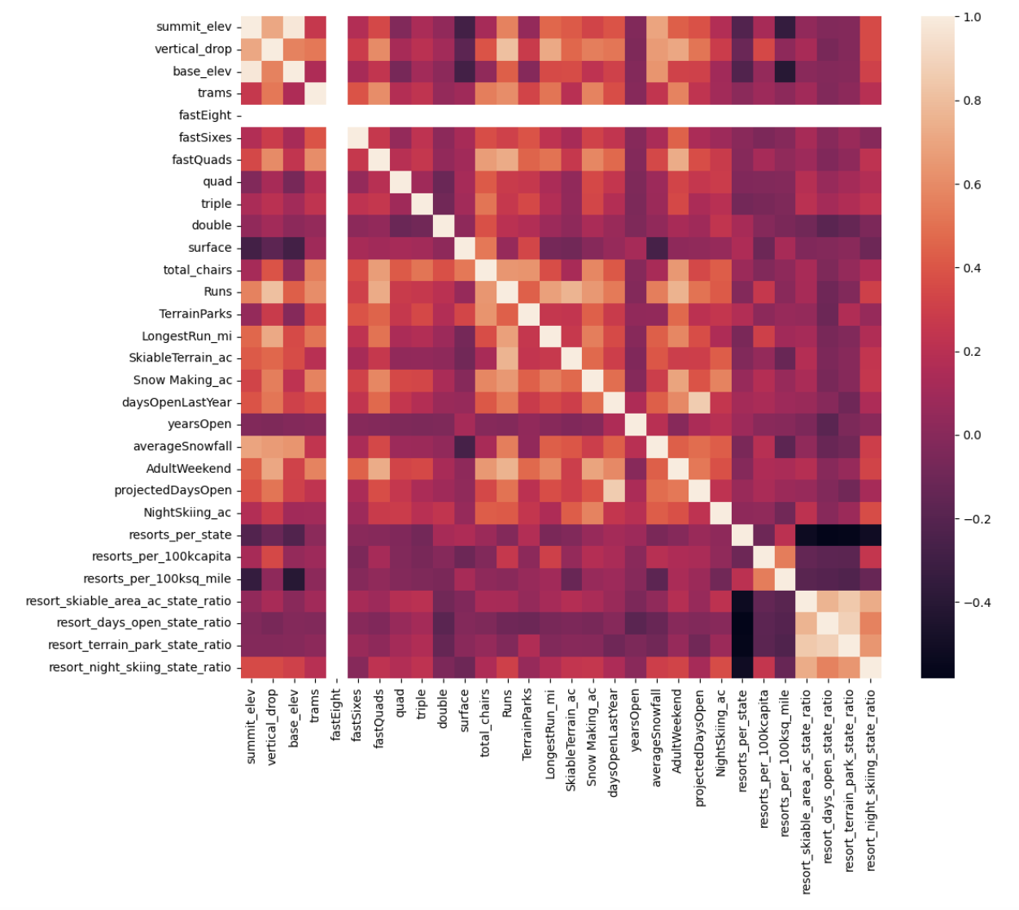

In order to have an independent assessment of how my model would perform, I partitioned the data into training and testing splits. Using various models, I was able to confirm that Vertical Drop is the biggest positive feature, which aligns with my exploratory data analysis. Finally, I decided to move forward with a linear model that has the lowest mean absolute error by ~$1.00 and was able to find the dominant top four features: fastQuads, Runs, Snow Making_ac, vertical_drop.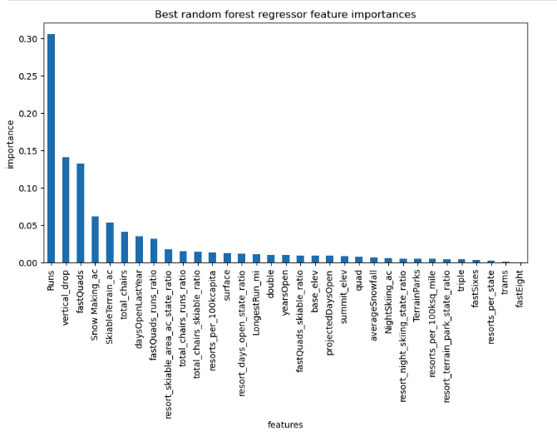

Then, I took my model for ski resort ticket price and leveraged it to gain insights into what price Big Mountain's facilities might actually support as well as explore the impacts of changes to various resort parameters. My modeled price is $92.19, which suggests that there is room for an increase in price. I ran multiple scenarios, but two stood out as profitable options. Scenario 1 suggests that Big Mountain Resort could close down up to 5 runs with negligible losses. Scenario 2 suggests that adding a run, increasing the vertical drop by 150 feet, and installing an additional chair lift would increase support for ticket price by $1.24.

Through this process, I have been able to come up with two viable options for Big Mountain Resort to better capitalize on their facilities and remain at a premium price point. One option involves downsizing on runs with no change in ticket price, and the other involves adding features and increasing ticket price.