To register a device
Click on register under devices in the navbar, enter the required details and click submit
To update a device
Option 1
Click on update under devices in the navbar, enter the required details and click submit
Option 2
Navigate to the show all devices page by clicking on show all under devices in the navbar, search for your device by entering the device id in the search box and use the update button on the device card, change only the details which have to be updated and submit
To see all devices
Click on show all under devices in the navbar and use the toggle buttons like Active, Inactive, Retired
To search for a device
Navigate to the show all devices page by clicking on show all under devices in the navbar, then enter your device id in the search box, in the device exists then the details will be printed else u can register a new device
Filter devices
Navigate to the show all devices page by clicking on show all under devices in the navbar, click on the filter icon and select your desired filters
To delete a device
Navigate to the show all devices page by clicking on show all under devices in the navbar, then enter your device id in the search box and use the delete button to delete your device, this makes the device “Inactive”, to Retire your device update its status to “Retired”

To assign owner to a device
Navigate to the show all devices page by clicking on show all under devices in the navbar, search for your device by entering the device id in the search box and use the assign owner button on the device card
To see all owners
Click on show all under owners in the navbar

To Register an owner
Click on register under devices in the navbar, enter the required details and click submit

To update owner details
Option 1
Click on update under owners in the navbar, enter the required details and click submit
Option 2
Navigate to the show all owners page by clicking on show all under owners in the navbar, search for your owner by entering the owner id in the search box and use the update button on the owner card, change only the details which have to be updated and submit

To change status of a device
Navigate to show all devices under devices in the navbar, search for your device by entering the device id in the search box and use the update button to change the status, to confirm a notification will be triggered to your mail and a notification will pop up on the screen which can be acknowledged by the user

How to view device statistics and ask questions about the database
Navigate to the dashboard page by clicking on dashboard on the navbar and click on analyze which creates charts and displays them on the screen, for further questions not being shown by the charts, BOB the chatbot can be used
How can I change my password
While signing in use the forgot password feature

What is the meaning of a device being active?
The device is currently in good working condition and can be assigned to an owner
What is the meaning of a device being inactive?
The device has been soft deleted, that is, the data on the device still exists but it has been removed from use for further inspection, it can be made active again by restoring it
What is the meaning of a device being Retired?
The device has been completely deleted, it cannot be restored back to active, the data also has been removed from the device

How do I view the operations performed relating to a device?
Navigate to the show all devices page by clicking on show all under devices in the navbar, then enter your device id in the search box, if the device exists then click on the audit log button on the device card to view the operations on the device
How can I bring an incactive device back to active state?
Navigate to the show all devices page by clicking on show all under devices in the navbar, click on the inactive toggle button to view the inactive devices, then enter your device id which has to be restored in the search box, if the device exists then click on the restore button

What are the actions that can be performed on active devices?
update, delete, assign owner, check audit logs

What are the actions that can be performed on inactive devices?
restore, check audit logss
What are the actions that can be performed on retired devices?
check audit logs

Device Management Portal

Overview
The Device Management Portal is a full-stack web application designed to streamline the management of devices and their ownership lifecycle. It enables organizations to register, assign, update, and track devices efficiently, while maintaining a secure and auditable system.

This project demonstrates the use of microservices architecture, secure authentication, and modular design using modern technologies like Spring Boot, React, and MySQL.

Frontend Features
The frontend is built using React.js and communicates with backend services via Axios. It provides a clean and responsive UI with the following features:

Login/Register: Secure user authentication with the option to sign in using Google.
Dashboard: Overview of devices and owners including the number of devices and owners and their details.
Device Management: Register, update, assign, and soft-delete devices.
Owner Management: Add and assign owners to devices.
Audit Trail Viewer: View historical changes to devices
Chatbot: To answer queries related to the functionality of the page
Charts: Real-time charts for to track various trends with AI-powered descriptions

  - Types of Devices

Status | Description
Active | Device is operational and assignable
Inactive | Soft-deleted; data retained but removed from use
Restored | Reactivated after being soft-deleted
Retired | Permanently deleted; data removed

Tech Stack

Layer | Technology
Frontend | React.js
Backend | Spring Boot (Java)
Integration | Axios
Database | MySQL
Service Discovery | Eureka Server
Configuration | Spring Cloud Config Server
API Gateway | Spring Cloud Gateway
Authentication | JWT (JSON Web Token)

- Microservices Architecture

API & Authentication Service

Port: 8083

Responsibilities:
Acts as the API Gateway
Handles user registration and login
Issues JWT tokens for authenticated access
Database: usersdb

User Table Columns:
ID
user_name email
password role

Device Service
Port: 8082

Responsibilities:
Register new devices
Assign devices to owners Update device details
Soft-delete devices Register owners
Maintain audit trail of device changes
Database: device_details
Tables:
devices owners
audit_trail
status_tracker

System Architecture

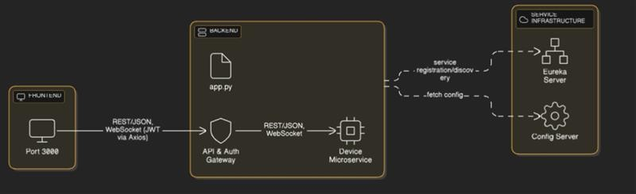
image name: system architecture image

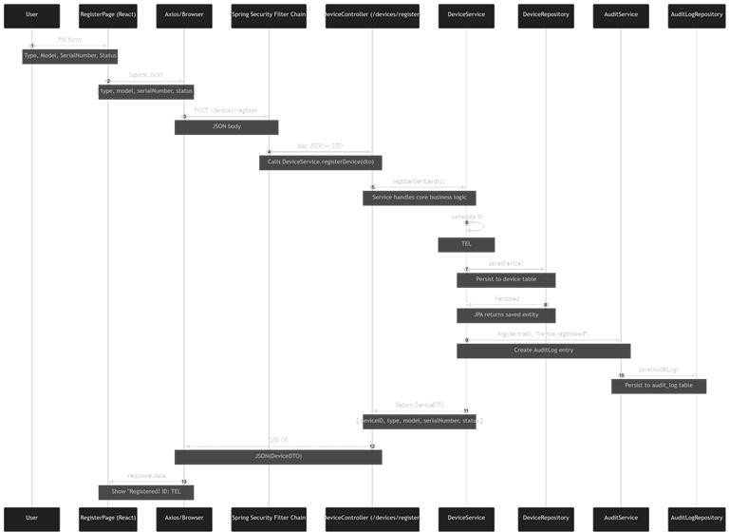
image name: system architecture image

- Authentication Flow

- User submits login credentials.

- API & Auth Service validates credentials against usersdb.

- On success, a JWT token is issued.

- The token is attached to subsequent requests to access protected endpoints.

Service Discovery & Configuration

Eureka Server (Port 8761) registers all microservices and enables dynamic discovery.
Spring Cloud Config Server provides centralized configuration, allowing services to fetch their settings at runtime.

This setup ensures scalability, resilience, and ease of maintenance.

Sequence Diagram

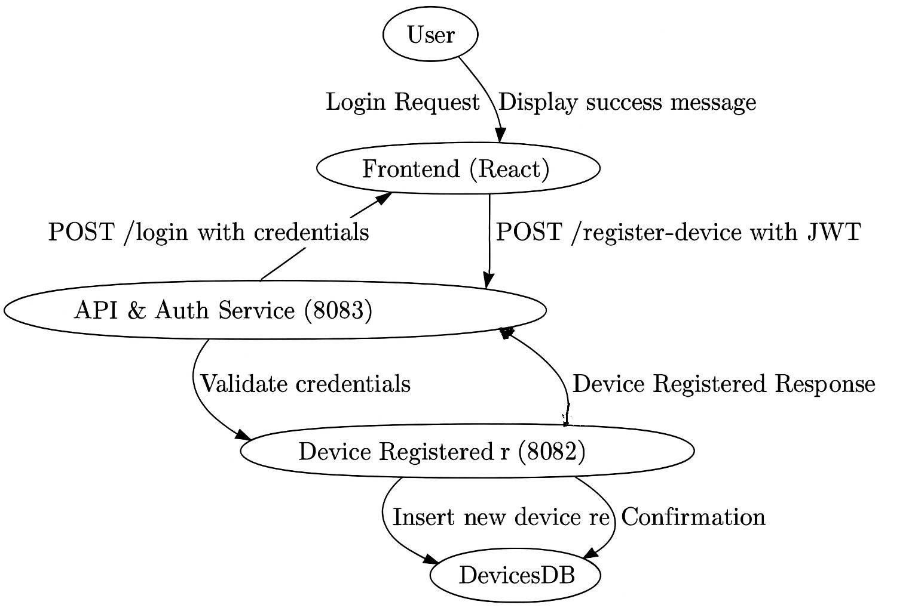
image name: sequence diagram

- Device Status Trends Dashboard

The Device Status Trends Dashboard provides administrators with insights into the lifecycle of devices, enabling better monitoring of system health, usage patterns, and maintenance planning.

Scope
Analyze device lifecycle events

Visualize device status changes

Store & retrieve charts via S3 for dashboard display

Ensure no user-specific/ownership data is exposed

  - Device Statuses Tracked

Status | Description
Active | Device is in use and operational
Soft-deleted | Device is temporarily removed but retained for audit
Restored | Device reactivated after being soft-deleted

