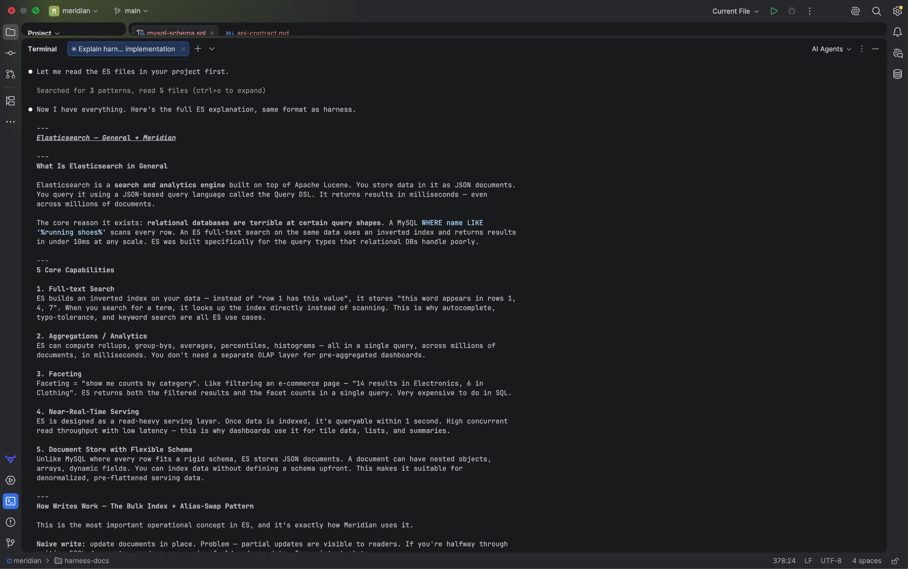
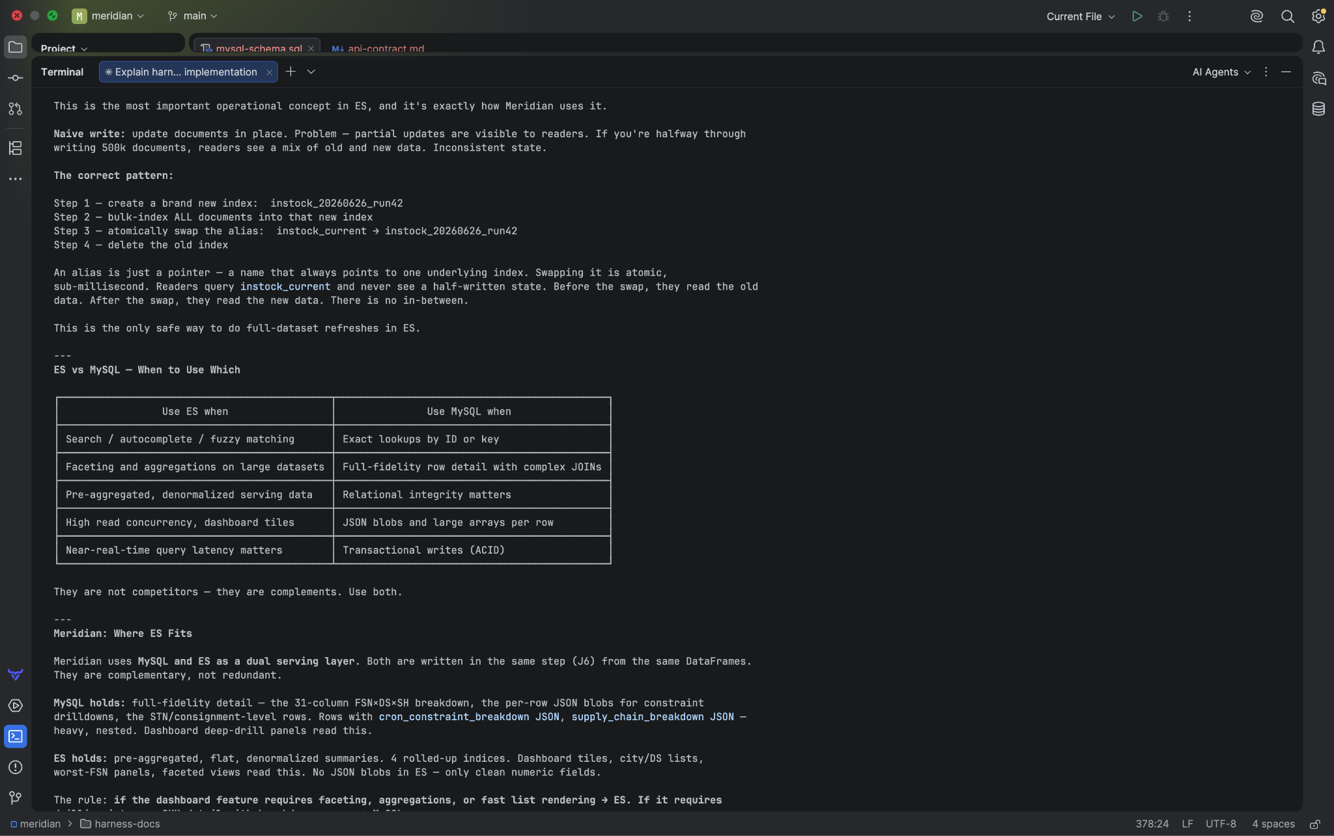
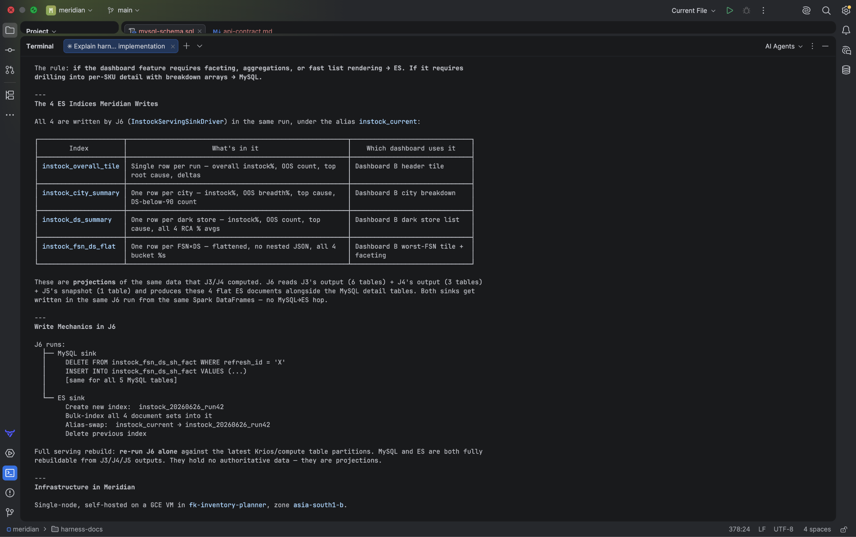
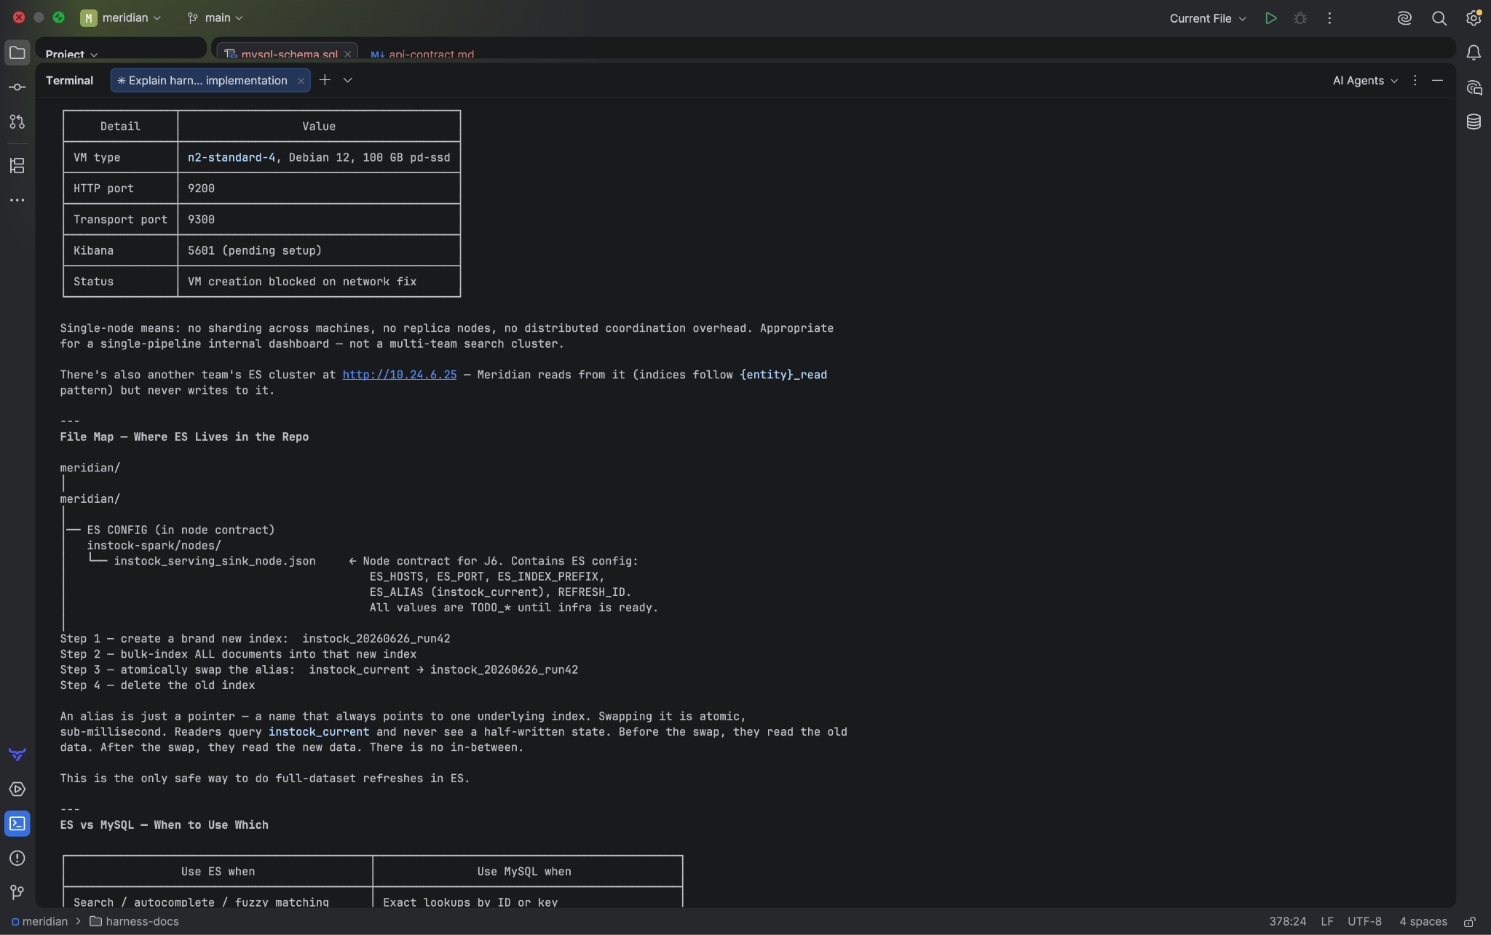

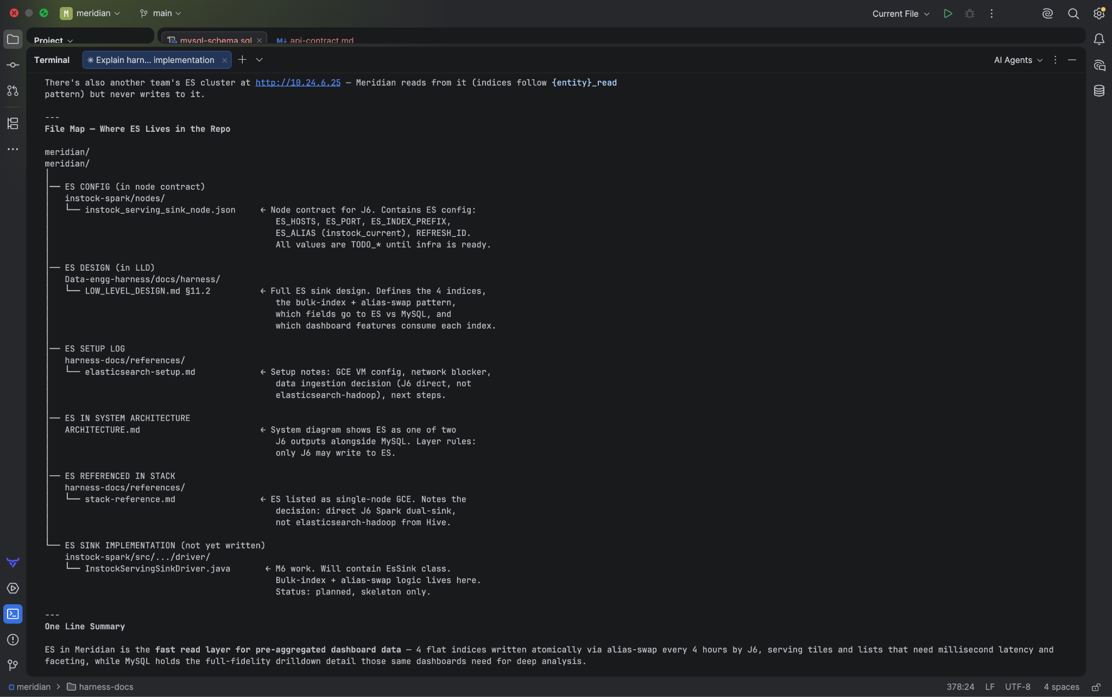

MySQL — full detail, for drilldowns

Every table stores full-fidelity raw data. When a user clicks into a specific OOS product to see why it went OOS —
constraint breakdown, STN details, consignment history — that query hits MySQL. It needs all the columns, all the
JSON blobs, all the nested breakdown rows.

ES — pre-aggregated summaries, for fast rendering

ES only stores what the dashboard needs to render the main screen fast — tiles, city list, dark store list, worst-FSN
panel. Flat, rolled-up, no JSON blobs.

