Homework 3: AI Report Validation System
Anjali Katta
FDA Device Recall Report Validator — Prompt A vs B vs C Experiment

1. Writing Component
For Homework 3 I built a validation system that scores AI-generated FDA Device Recall executive reports on a domain-specific rubric and then runs a controlled experiment comparing three competing report-writing prompts. The validation target is the same kind of report I produced in Homework 2, that being a short executive brief about device recalls, but here, instead of producing one report, I generate sixty under three different system prompts and judge all of them with a separate validator agent.
I deliberately customized the validator away from the LAB's generic Likert scales (accuracy, formality, faithfulness, clarity, succinctness, relevance). Those dimensions do not really capture what makes a regulatory recall brief useful, so my rubric uses five domain-specific Likert dimensions instead: regulatory_grounding, data_specificity, patient_safety_framing, actionability, and structural_fidelity, as well as a hard boolean called hallucination_free. In regulated text, fabricating a firm name or a recall number is disqualifying regardless of how polished the rest of the report sounds, so I treat it as a pass/fail gate rather than another Likert dimension. A report only passes the benchmark if its mean Likert score is ≥ 4.0 AND hallucination_free is true.
The experiment held the openFDA recall sample constant across all 60 reports, so prompt was the only manipulated variable. Prompt A was a stiff Regulatory Analyst persona that demanded the four-section structure and FDA classification language; Prompt B was a terse Executive Brief persona that prioritized recommendations; Prompt C was a Narrative Story persona with no headings. Twenty reports per prompt gave me 60 data points for analysis. I generated reports at temperature 0.7 (so they vary realistically) and judged them at temperature 0.3 (so judging is consistent), with gpt-4o-mini on both ends.
The statistical results were very clear. Bartlett's test rejected equal variances (p = 0.0001), so I used Welch's ANOVA on overall_score, which gave F(2.00, 34.93) = 178.06, p = 4.79e-19, which is overwhelmingly significant. Tukey HSD showed that Prompt A (mean 4.58) and Prompt B (mean 4.26) both crushed Prompt C (mean 2.90) at p ≈ 0, while A vs B was borderline (mean diff = -0.32, p_adj = 0.0517). The OLS regression overall_score ~ C(prompt_id) gave R² = 0.757, with prompt explaining about 75.7% of the variance. The pass rate was 85% for Prompt A, 80% for Prompt B, and 0% for Prompt C: the narrative prompt produced zero usable executive briefs.
Two things surprised me. First, A vs B was statistically a tie even though their per-dimension profiles diverged sharply: A dominated structural_fidelity (F ≈ 96.9) while B dominated actionability (F ≈ 921.9, because it scored 5 on every report). The composite mean averaged out their tradeoffs. Second, no reports failed the hallucination_free check, which suggests gpt-4o-mini follows 'do not invent recall numbers' instructions reliably even at temperature 0.7, which is a useful baseline finding for any future work that depends on grounded outputs.

2. Git Repository Links
All HW3 code lives in 11_decision_support/ in the dsai repository:
- Validation system (FDA-specific rubric): https://github.com/anjalikatta/dsai/blob/main/11_decision_support/homework3_validator.py
- Report generator (3 prompts × 20 reports): https://github.com/anjalikatta/dsai/blob/main/11_decision_support/homework3_generate_reports.py
- Statistical analysis (Bartlett / Welch ANOVA / Tukey / OLS): https://github.com/anjalikatta/dsai/blob/main/11_decision_support/homework3_stats.py
- Held-constant FDA recall source data: https://github.com/anjalikatta/dsai/blob/main/11_decision_support/data/source_data.txt
- 60 generated reports being validated: https://github.com/anjalikatta/dsai/blob/main/11_decision_support/data/fda_reports.csv
- Validator output (60 rows × 7 dimensions + benchmark pass): https://github.com/anjalikatta/dsai/blob/main/11_decision_support/data/validation_scores.csv
- Raw validator JSON audit trail: https://github.com/anjalikatta/dsai/blob/main/11_decision_support/data/validation_raw.jsonl
- Stats run log + headline numbers (JSON): https://github.com/anjalikatta/dsai/blob/main/11_decision_support/data/stats_summary.json
- HW2 system that produced the same kind of executive report: https://github.com/anjalikatta/dsai/blob/main/08_function_calling/homework2_fda_agent.py

3. Screenshots / Outputs
Screenshots and the two figures produced by homework3_stats.py are embedded below. Run the three scripts in order to reproduce them.

3.1 Validator running (live, per-report scores)
Run: python homework3_validator.py — produces a per-report Likert average and pass/fail for each of the 60 reports.
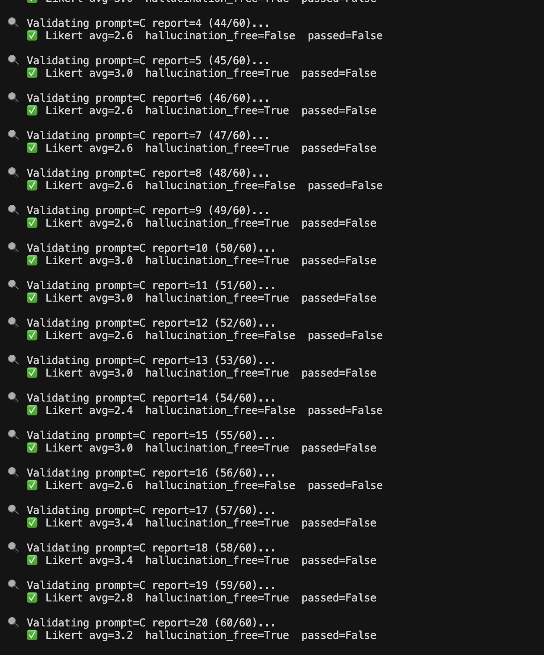
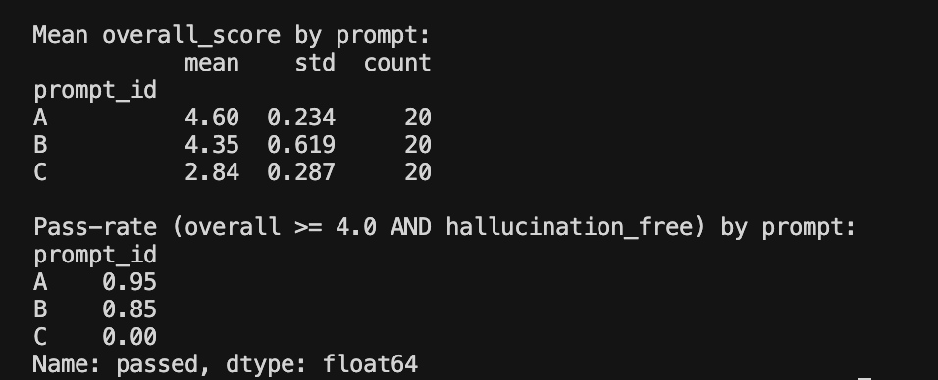

3.2 Sample validation JSON for one report
One row from data/validation_scores.csv, expanded:
Field | Value
prompt_id | A
report_id | 1
regulatory_grounding | 4
data_specificity | 5
patient_safety_framing | 5
actionability | 4
structural_fidelity | 5
hallucination_free | True
overall_score | 4.6
passed | True
details | The report accurately references specific recalls, firms, and product codes. It effectively frames the regulatory context and addresses patient safety. Recommendations are actionable, though slightly general. Structure is clear and follows the required format.

3.3 Tukey HSD post-hoc table
From homework3_stats.py — pairwise comparison of the three prompts:
Group 1 | Group 2 | Mean diff | p-adj | Reject H0?
A | B | -0.32 | 0.0517 | ❌ no
A | C | -1.68 | 0.0000 | ✅ yes
B | C | -1.36 | 0.0000 | ✅ yes

3.4 Overall score by prompt (boxplot)
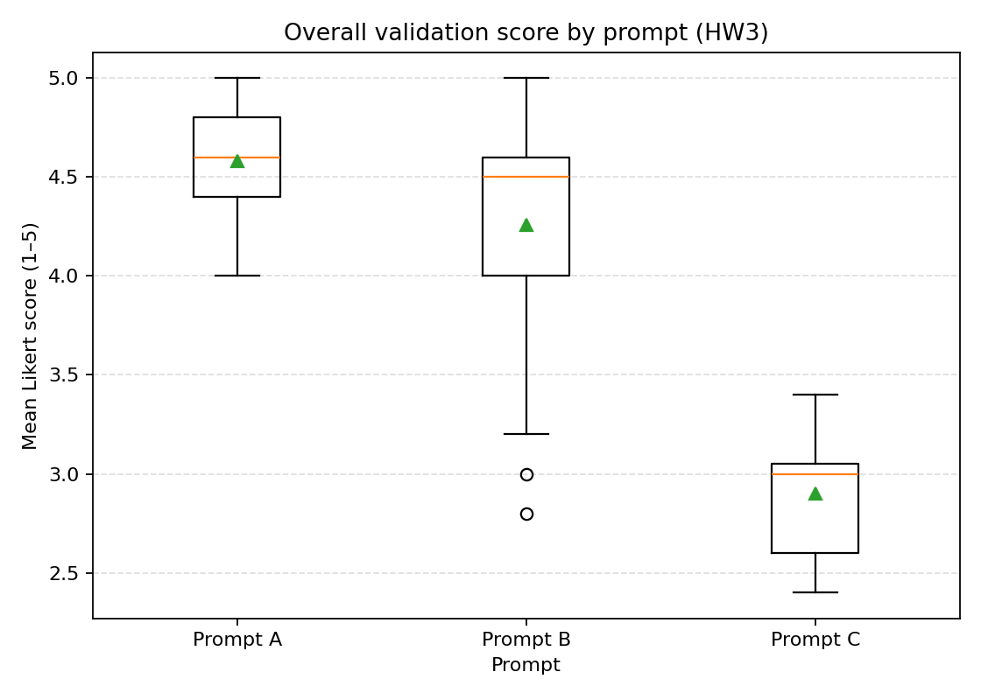
Boxplot of overall_score (mean of 5 Likert dims) by prompt. Welch F(2.00, 34.93) = 178.06, p = 4.79e-19.

3.5 Per-dimension means by prompt (bar chart)
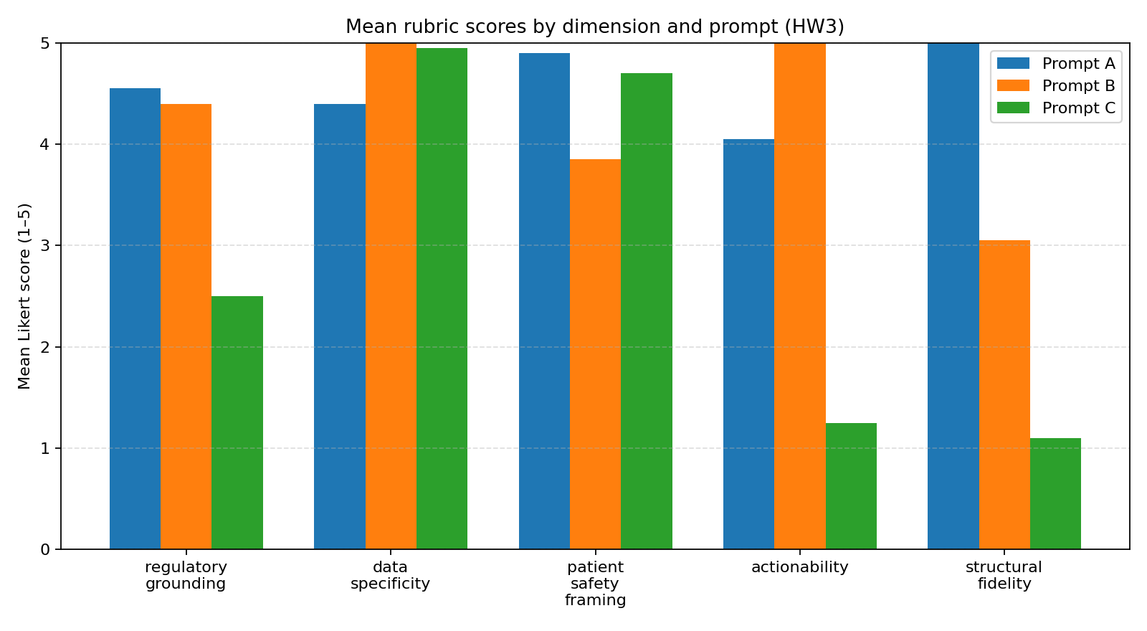
Mean Likert score for each rubric dimension by prompt. Prompt A wins structural_fidelity; Prompt B wins actionability; Prompt C trails on every dimension except data_specificity.

4. Documentation

4.1 Validation Criteria Table
How the rubric differs from the LAB's Likert scales:
Dimension | Description | Scale | Benchmark | Differs from LAB?
regulatory_grounding | Correct FDA classification language (Class I/II/III), 21 CFR Part 7 framing. | 1–5 Likert | Mean ≥ 4 to pass | New — domain-specific. LAB had no regulatory dimension.
data_specificity | Cites concrete recall numbers, dates, firms, product codes from source. | 1–5 Likert | Mean ≥ 4 to pass | Replaces LAB 'accuracy' with a stricter, source-grounded test.
patient_safety_framing | Explicitly addresses patient/clinical impact, not just business impact. | 1–5 Likert | Mean ≥ 4 to pass | New — LAB has no patient/safety dimension.
actionability | Recommendations are concrete, distinct, implementable; not generic platitudes. | 1–5 Likert | Mean ≥ 4 to pass | New — LAB has no actionability dimension.
structural_fidelity | Follows four-section executive brief structure with clear headings. | 1–5 Likert | Mean ≥ 4 to pass | New — LAB had no structural-form dimension.
hallucination_free | Every firm, recall number, date, and product code appears in source data. | Boolean (true/false) | MUST be true (hard fail) | Hard pass/fail gate, not Likert. LAB had no benchmark/hard fail.

4.2 Experimental Design
Item | Value
Reports per prompt | 20
Number of prompts | 3 (A, B, C)
Total reports validated | 60
Source data | openFDA Device Recall API, year 2024, n=12 records, held constant across all reports
Generator model / temperature | gpt-4o-mini, temperature=0.7
Validator model / temperature | gpt-4o-mini, temperature=0.3, response_format=json_object
Manipulated variable | system prompt persona only
Pass benchmark | overall_score ≥ 4.0 AND hallucination_free = true

4.3 Statistical Analysis
Hypothesis: at least one of the three prompts produces FDA recall executive reports that score significantly differently from the others on the custom rubric.
Test | Result | Interpretation
Bartlett's test (homogeneity of variance) | χ² = 17.799, p = 0.0001 | Variances unequal → use Welch's ANOVA
Welch's ANOVA (unequal variance) | F(2.00, 34.93) = 178.06, p = 4.79e-19 | At least one prompt differs significantly
Tukey HSD: A vs B | meandiff = -0.32, p_adj = 0.0517 | Borderline — A and B are statistically a tie at α=0.05
Tukey HSD: A vs C | meandiff = -1.68, p_adj = 0.0000 | Prompt A is significantly better than Prompt C
Tukey HSD: B vs C | meandiff = -1.36, p_adj = 0.0000 | Prompt B is significantly better than Prompt C
OLS regression (overall_score ~ C(prompt_id)) | R² = 0.757 | Prompt explains 75.7% of variance

Per-dimension Welch / Standard ANOVAs (where prompts diverge):
Dimension | F | p-value | Mean A | Mean B | Mean C
regulatory_grounding | 17.12 | 8.78e-06 | 4.55 | 4.4 | 2.5
data_specificity | 9.19 | 3.47e-04 | 4.4 | 5.0 | 4.95
patient_safety_framing | 24.65 | 1.99e-07 | 4.9 | 3.85 | 4.7
actionability | 921.90 | 3.91e-44 | 4.05 | 5.0 | 1.25
structural_fidelity | 96.87 | 4.62e-19 | 5.0 | 3.05 | 1.1

4.4 System Design
Three-step pipeline; the AI reviewer is its own LLM call kept separate from the report writer:
Step | Script | What it does | AI role
1. Generate reports | homework3_generate_reports.py | Pulls openFDA recall sample once, writes 20 reports per prompt at temperature=0.7. | Report writer (gpt-4o-mini)
2. Validate reports | homework3_validator.py | Scores each report on the FDA-specific rubric and the hard hallucination_free gate. | AI reviewer / judge (gpt-4o-mini, response_format=json_object, temperature=0.3)
3. Statistical analysis | homework3_stats.py | Bartlett → Welch ANOVA → Tukey HSD → per-dimension ANOVAs → OLS regression. Saves figures. | No AI; pure statsmodels / scipy.

4.5 Technical Details
Stack:
- Python 3.13 in a project-local virtualenv (.venv-hw3)
- OpenAI SDK (gpt-4o-mini) with response_format=json_object for the validator
- scipy + statsmodels for Bartlett, Welch ANOVA, Tukey HSD, and OLS
- matplotlib for the boxplot and bar chart
- python-docx for this submission file
Configuration:
- OPENAI_API_KEY loaded from 11_decision_support/.env (gitignored)
- openFDA Device Recall API — public, no key required (rate limits apply)
Files produced by a clean run:
- data/source_data.txt — held-constant ground truth
- data/fda_reports.csv — 60 generated reports (3 × 20)
- data/validation_scores.csv — 60 rows × 5 Likert + boolean + overall + passed + details
- data/validation_raw.jsonl — auditable raw JSON for every validator call
- data/stats_report.txt and data/stats_summary.json
- figures/boxplot_overall.png and figures/dimensions_bar.png

4.6 Usage Instructions
1. Create a project-local virtualenv and install dependencies:
python3 -m venv .venv-hw3
.venv-hw3/bin/pip install scipy statsmodels matplotlib openai pandas python-docx python-dotenv requests

2. Add your OpenAI key:
echo 'OPENAI_API_KEY=sk-...' > 11_decision_support/.env

3. Run the pipeline in order (generator → validator → stats):
.venv-hw3/bin/python 11_decision_support/homework3_generate_reports.py
.venv-hw3/bin/python 11_decision_support/homework3_validator.py
.venv-hw3/bin/python 11_decision_support/homework3_stats.py

4. Rebuild this docx (after a fresh run):
.venv-hw3/bin/python 11_decision_support/build_homework3_docx.py

