Homework 1: AI-Powered Reporter Software
SYSEN 5381 — Data Science and AI for Systems Engineering
Anjali Katta
FDA Medical Device Recall Reporter

1. System Overview
My AI-powered reporter software integrates three components I built over the past three weeks into a single pipeline that retrieves FDA medical device recall data, displays it through an interactive web interface, and generates analytical reports using AI. The project centers on the FDA's open Device Recall API, which provides information about medical devices that have been recalled due to safety or quality concerns. I chose this API because medical device safety is directly relevant to systems engineering, since understanding failure modes, root causes, and trends helps engineers design better products and quality systems.
The system works as a three-stage pipeline. First, an R script (my_good_query.R) handles the raw API query. It loads an API key from a .env file, sends a GET request to the FDA endpoint with date-range and limit parameters, parses the JSON response, and prints a sample of the results. Second, a Shiny web application (app.R and utils.R) wraps that same API logic in a browser-based interface where users can pick start and end dates, choose how many records to retrieve, and explore the results in a sortable, filterable data table. The app uses the bslib package for a modern UI theme and includes status messages and error handling so users know exactly what's happening. Third, a Python script (ai_reporter.py) queries the same FDA endpoint, aggregates the data into summary statistics, including top root causes, monthly recall counts, and sends that summary to GPT-4o-mini with a prompt to produce a Markdown report.
The biggest design choice was how to format data for the AI prompt. In early iterations, I sent raw JSON to the model and the output was vague and generic. By pre-aggregating the data into root-cause counts and monthly totals, then embedding those summaries directly in the prompt, the AI could reference specific numbers and produce a much more useful report. I also iterated on the prompt itself three times. I started broad, then added explicit section headers, and finally specified exact sentence and bullet counts to get consistent, professional output. One challenge was handling the FDA's date format (YYYYMMDD strings) across both R and Python; I wrote formatting helpers in both languages to convert them to readable YYYY-MM-DD dates. Overall, combining these three components showed me how API queries, interactive applications, and AI generation can work together in a real data pipeline.

2. Git Repository Links
All source code is hosted on GitHub. Links below point to the specific files on the main branch.

API Query Script
- my_good_query.R: https://github.com/anjalikatta/dsai/blob/main/01_query_api/my_good_query.R
- README (query documentation): https://github.com/anjalikatta/dsai/blob/main/01_query_api/README_my_good_query.md

Shiny Application
- app.R (main Shiny app): https://github.com/anjalikatta/dsai/blob/main/02_productivity/shiny_app/app.R
- utils.R (helper functions): https://github.com/anjalikatta/dsai/blob/main/02_productivity/shiny_app/utils.R
- DESCRIPTION (R dependencies): https://github.com/anjalikatta/dsai/blob/main/02_productivity/shiny_app/DESCRIPTION
- README (Shiny app documentation): https://github.com/anjalikatta/dsai/blob/main/02_productivity/shiny_app/README.md

AI Reporter Script
- ai_reporter.py (AI-powered reporter): https://github.com/anjalikatta/dsai/blob/main/03_query_ai/ai_reporter.py
- lab_ai_reporter_output.md (generated report): https://github.com/anjalikatta/dsai/blob/main/03_query_ai/lab_ai_reporter_output.md

3. Screenshots and Outputs

3.1 Shiny App — Interface
The Shiny app displays query parameter controls (date range, max records) and a Query button:
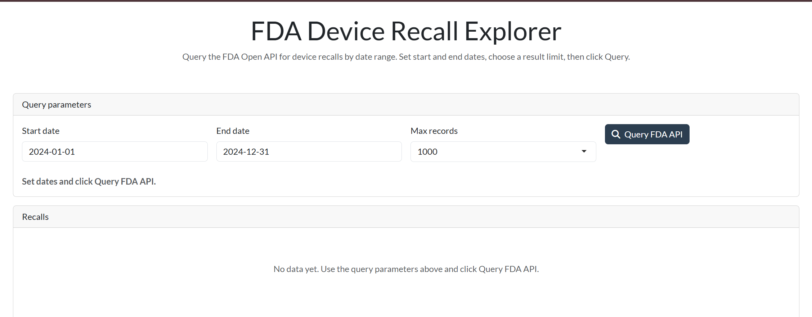

3.2 Shiny App — Query Results
After clicking Query FDA API, the app displays results in a sortable, filterable DataTable:
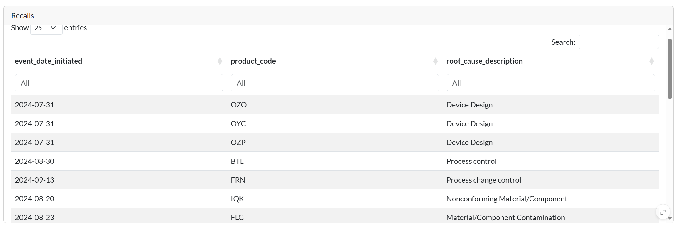

3.3 Shiny App — Error Handling
When the start date is after the end date, the app shows an error message:
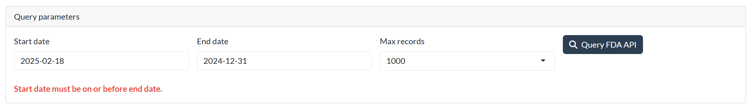

3.4 AI-Generated Report (Sample Output)
Below is a screenshot of the AI-generated report produced by ai_reporter.py using OpenAI GPT-4o-mini. This report was saved to lab_ai_reporter_output.md (https://github.com/anjalikatta/dsai/blob/main/03_query_ai/lab_ai_reporter_output.md).
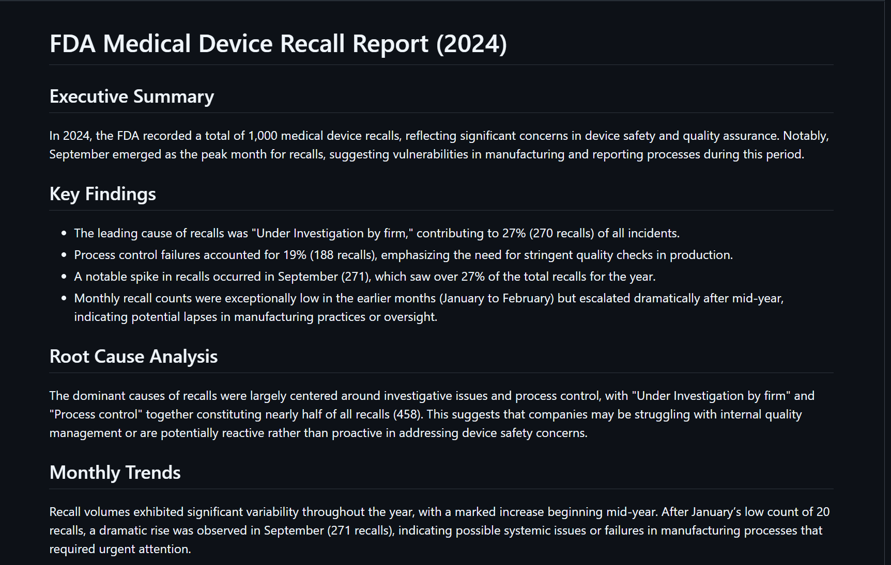

FDA Medical Device Recall Report (2024)

Executive Summary
In 2024, the FDA recorded a total of 1,000 medical device recalls, reflecting significant concerns in device safety and quality assurance. Notably, September emerged as the peak month for recalls, suggesting vulnerabilities in manufacturing and reporting processes during this period.

Key Findings
- The leading cause of recalls was "Under Investigation by firm," contributing to 27% (270 recalls) of all incidents.
- Process control failures accounted for 19% (188 recalls), emphasizing the need for stringent quality checks in production.
- A notable spike in recalls occurred in September (271), which saw over 27% of the total recalls for the year.
- Monthly recall counts were exceptionally low in the earlier months (January to February) but escalated dramatically after mid-year, indicating potential lapses in manufacturing practices or oversight.

Root Cause Analysis
The dominant causes of recalls were largely centered around investigative issues and process control, with "Under Investigation by firm" and "Process control" together constituting nearly half of all recalls (458). This suggests that companies may be struggling with internal quality management or are potentially reactive rather than proactive in addressing device safety concerns.

Monthly Trends
Recall volumes exhibited significant variability throughout the year, with a marked increase beginning mid-year. After January's low count of 20 recalls, a dramatic rise was observed in September (271 recalls), indicating possible systemic issues or failures in manufacturing processes that required urgent attention.

Recommendations
- Enhance Quality Assurance Protocols: Manufacturers should invest in robust process controls and regular audits to proactively identify potential risks before they result in recalls.
- Increase Transparency: Firms should foster greater transparency with the FDA regarding their quality assurance practices and recall responses to facilitate more effective oversight.
- Focus on Design and Component Selection: Particular attention should be given to the design phases and selection of components to mitigate the risk of recalls due to design flaws or nonconformance.

4. Documentation

4.1 Data Summary
The FDA Device Recall API returns JSON objects with many fields. The table below summarizes the key columns used in this project.
Column Name | Data Type | Description
recall_number | character (string) | Unique FDA recall identifier (e.g., Z-1234-2024)
event_date_initiated | character / date | Date the recall was initiated; raw format YYYYMMDD, converted to YYYY-MM-DD in the app
product_code | character (string) | FDA product classification code for the recalled device
root_cause_description | character (string) | Text description of the root cause of the recall (e.g., Process Control, Software Design)

Additional fields available from the API (not displayed by default): recalling_firm, product_description, code_info, cfres_id, res_event_number, k_numbers, openfda.device_name, openfda.medical_specialty_description.

4.2 Technical Details
API Endpoint: https://api.fda.gov/device/recall.json (GET)
API Authentication: API key passed as query parameter. Free key from https://open.fda.gov/apis/authentication/
AI Model: OpenAI GPT-4o-mini via https://api.openai.com/v1/chat/completions

Required API Keys
Variable | Location | Purpose
API_KEY | 01_query_api/.env | FDA Open API key (for higher rate limits)
OPENAI_API_KEY | .env (project root) | OpenAI API key (required for AI report generation)

Project File Structure
File | Description
01_query_api/my_good_query.R | R script — queries FDA API, prints 15 sample rows
01_query_api/README_my_good_query.md | Documentation for the API query script
02_productivity/shiny_app/app.R | R Shiny app — interactive web UI for FDA recalls
02_productivity/shiny_app/utils.R | Helper functions (API client, date formatting)
02_productivity/shiny_app/DESCRIPTION | R package dependencies for the Shiny app
02_productivity/shiny_app/README.md | Documentation for the Shiny app
03_query_ai/ai_reporter.py | Python script — queries API, sends to OpenAI, saves report
03_query_ai/lab_ai_reporter_output.md | Sample AI-generated report output

R Packages (Shiny App)
Package | Purpose
shiny | Web application framework
bslib | Bootstrap theme and layout
httr | HTTP requests to FDA API
jsonlite | JSON parsing
dplyr | Data manipulation
DT | Interactive DataTable widget

Python Packages (AI Reporter)
Package | Purpose
requests | HTTP requests to FDA and OpenAI APIs
pandas | Data manipulation and aggregation
python-dotenv | Load .env files for API keys

4.3 Usage Instructions

Prerequisites
- R (>= 4.0) with packages: shiny, bslib, httr, jsonlite, dplyr, DT
- Python 3.11+ with packages: requests, pandas, python-dotenv
- FDA API key (free from https://open.fda.gov/apis/authentication/)
- OpenAI API key (from https://platform.openai.com/api-keys)

Step 1: Clone the Repository
git clone https://github.com/anjalikatta/dsai.git && cd dsai

Step 2: Set Up API Keys
Create two .env files:
- 01_query_api/.env — add the line: API_KEY=your_fda_api_key_here
- .env (project root) — add the line: OPENAI_API_KEY=your_openai_key_here

Step 3: Install R Dependencies
install.packages(c("shiny", "bslib", "httr", "jsonlite", "dplyr", "DT"))

Step 4: Install Python Dependencies
pip install requests pandas python-dotenv

Step 5: Run the API Query Script
Rscript 01_query_api/my_good_query.R
This prints the first 15 FDA device recall records for 2024 to the console.

Step 6: Run the Shiny App
R -e 'shiny::runApp("02_productivity/shiny_app")'
Open the URL printed in the console (typically http://127.0.0.1:xxxx). Set date range, choose max records, and click Query FDA API.

Step 7: Run the AI Reporter
python 03_query_ai/ai_reporter.py
The script queries the FDA API, processes the data, sends it to OpenAI, and saves the report to 03_query_ai/lab_ai_reporter_output.md.

