Internship Task 3: Web Application Security Report
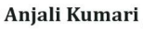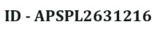
1. Objective
The objective of this task is to identify, exploit, and provide mitigation strategies for OWASP Top 10 vulnerabilities. This was performed in a controlled lab environment using Kali Linux, DVWA (Damn Vulnerable Web Application), and Burp Suite.

2. Vulnerability 1: SQL Injection (SQLi)
- Description: SQL Injection occurs when an attacker can interfere with the queries that an application makes to its database.
- Exploitation: By entering the payload ' OR '1'='1 into the User ID field, the application was tricked into returning all user records from the database instead of just one.
- Advanced Exploitation: Using the payload ' UNION SELECT 1, version() #, I successfully extracted the backend database version (MariaDB 11.8.6).
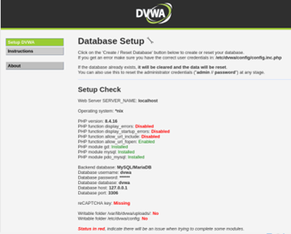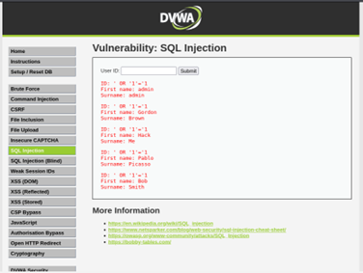
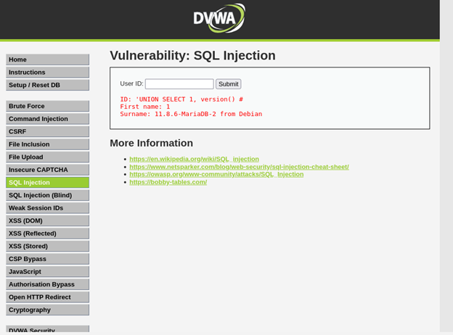

- Mitigation:
  - Use Prepared Statements (Parameterized Queries).
  - Implement strict input validation and the "Principle of Least Privilege" for database accounts.

3. Vulnerability 2: Stored Cross-Site Scripting (XSS)
- Description: Stored XSS occurs when an application receives data from a user and includes that data within its later HTTP responses in an unsafe way.
- Exploitation: I injected the following JavaScript into the Guestbook message field: <script>alert('Vulnerable')</script>. This script is now stored on the server and executes a popup alert every time the page is loaded.
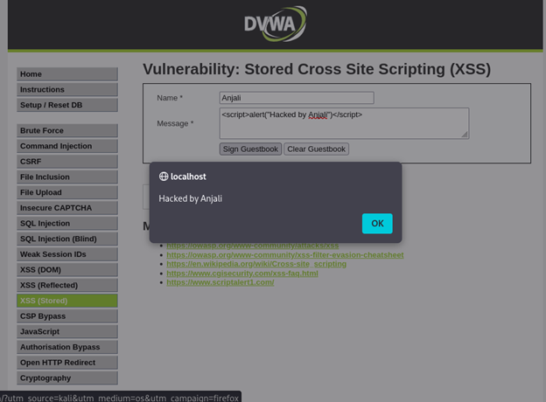
- Mitigation:
  - Output Encoding: Convert special characters (like < and >) into HTML entities.
  - Content Security Policy (CSP): Use modern browser security headers to restrict where scripts can run.

4. Advanced Tooling: Burp Suite Community Edition
- Usage: Burp Suite was used as a local proxy to intercept and analyze HTTP requests between the browser and the DVWA server.
- Demonstration: I utilized the Proxy Intercept feature to capture raw HTTP GET/POST requests, allowing for manual manipulation of parameters before they reached the server.
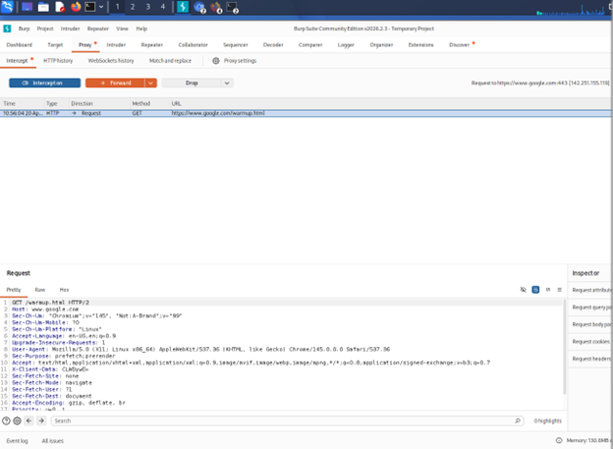
5. Conclusion
Through this task, I have demonstrated how unvalidated user input can lead to critical data leaks (SQLi) and client-side execution (XSS). Understanding these flaws is essential for implementing secure coding practices and robust web application firewalls (WAF).

