# **FIRST FOUNDATION MACHINE TEST - SET 1**

--1.1

CREATE TABLE ITEMS

(

itemId INT PRIMARY KEY,

itemName VARCHAR(20)

)

INSERT INTO ITEMS VALUES(1,'Bar-one')

INSERT INTO ITEMS VALUES(2,'Kitkat')

INSERT INTO ITEMS VALUES(3,'Milky bar')

INSERT INTO ITEMS VALUES(4,'Munch')

SELECT * FROM ITEMS

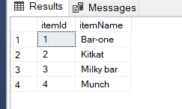

CREATE TABLE SHOP

(

shopId INT PRIMARY KEY,

shopName VARCHAR(30)

)

INSERT INTO SHOP VALUES

(1, 'Amal Stores'),

(2, 'Jyothi Stores'),

(3, 'Indira Stores');

SELECT * FROM SHOP

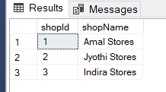

CREATE TABLE unit

(

unitId INT PRIMARY KEY,

unitName VARCHAR(25)

)

INSERT INTO unit VALUES

(1, 'Piece'),

(2, 'Box')

SELECT * FROM UNIT

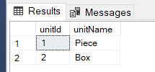

CREATE TABLE Sales (

SaleID INT PRIMARY KEY,

ShopID INT,

ItemID INT,

Quantity INT,

unitId INT,

UnitPrice DECIMAL(10, 2),

SaleDate DATE,

FOREIGN KEY (unitId) REFERENCES unit (unitId),

FOREIGN KEY (ShopID) REFERENCES Shop (ShopID),

FOREIGN KEY (ItemID) REFERENCES Items (ItemID)

);

INSERT INTO Sales (SaleID, ShopID, ItemID, Quantity,Unitid, UnitPrice,SaleDate)

VALUES

(1, 1, 1, 100,1, 10.00,'2018-10-05'),

(2, 1, 2, 200,1, 15.00,'2018-10-05'),

(3, 1, 3, 50,1, 5.00,'2018-10-05'),

(4, 1, 4, 150,1, 10.00,'2018-10-05'),

(5, 2, 1, 10 ,2, 280.00,'2018-10-10'),

(6, 2, 2, 30 , 2,420.00,'2018-10-10'),

(7, 2, 3, 40 ,2, 140.00,'2018-10-10'),

(8, 2, 4, 20 ,2, 280.00,'2018-10-10'),

(9, 3, 1, 50,2, 280.00,'2018-09-15'),

(10,3, 2, 70,2, 420.00,'2018-09-15'),

(11,3, 3, 30,2, 140.00,'2018-10-10'),

(12, 1, 1, 150,1, 10.00,'2018-09-15'),

(13, 1, 2, 250,1, 15.00,'2018-09-15'),

(14, 1, 4, 200,1, 10.00,'2018-10-10');

SELECT * FROM SALES

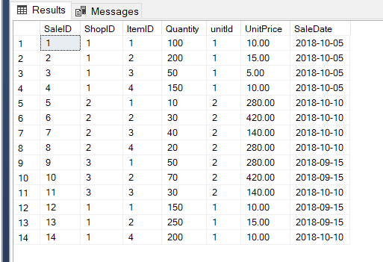

--1.2

SELECT TOP 1 itemname,sum(s.quantity*s.unitprice) AS revenue FROM Sales s

INNER JOIN ITEMS i

ON i.itemId=s.ItemID

WHERE MONTH(saledate)=10

GROUP BY itemname

ORDER BY revenue DESC

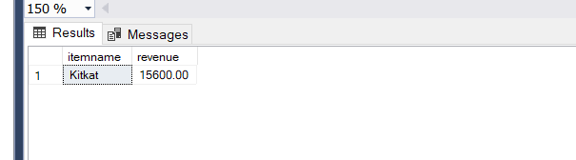

--1.3

SELECT TOP 1 i.itemname,sum(s.quantity) as total_quantity FROM Sales s

INNER JOIN ITEMS i

ON i.itemId=s.ItemID

INNER JOIN SHOP sh

ON s.ShopID=sh.shopId

WHERE MONTH(saledate)=10 and sh.shopName='Amal Stores'

GROUP BY itemname

ORDER BY total_quantity DESC

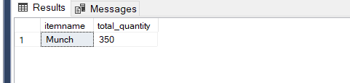

--1.4

SELECT i.itemName, sum(s.quantity*s.unitprice) AS revenue

FROM Sales s

INNER JOIN ITEMS i

ON i.itemId=s.ItemID

WHERE MONTH(saledate)=10

GROUP BY itemName

HAVING sum(s.quantity*s.unitprice) >10000

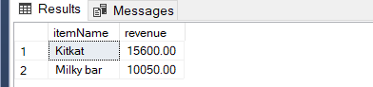

--1.5

SELECT TOP 1 sh.shopName, sum(s.quantity*s.unitprice) AS revenue

FROM Sales s

INNER JOIN SHOP sh

ON s.ShopID=sh.shopId

WHERE MONTH(saledate)=10

GROUP BY shopName

ORDER BY revenue DESC

