

Project Report
TITLE: ANJALI ONLINE WARDROBE
“anjstyle.com”
Mini Project of Web Programming
Subject Code: 25CAP-605

Submitted By: Submitted To:
Name: Anjali kumari Prof. Mansirat Kaur
UID: 25MCA20023 Assistant Professor
Class:MCA
Section: 1/A

Masters in Computer Applications (MCA)
University Institute of Computing
Chandigarh University,
Gharuan, Mohali, Punjab, India-140413



TABLE OF CONTENTS

- Declaration
- Acknowledgement
- Abstract
- Introduction
- Hardware and Software Requirements
- Methodology
- Implementation (Code and Output)
- References.



DECLARATION

This is to certify that, with the guidance and support of my teachers, I have successfully created the original project titled “Anjali online wardrobe.”
This project is a genuine piece of work and has not been submitted to any other university or institution for the award of any degree or diploma.

Date: 16-10-2025
Student’s Signature: Anjali singh.

ACKNOWLEDGEMENT

I would like to express my deepest gratitude to all those who have supported and guided me throughout the completion of this work, “anjali online wardrobe”.
First and foremost, I extend my sincere thanks to my mentor Mansirat Kaur for their invaluable guidance, insightful feedback, and constant encouragement, which shaped this research in meaningful ways.
I am also grateful to Chandigarh University for providing me with the resources and environment that enabled me to explore the intersection of Natural Language Processing and healthcare.
My heartfelt appreciation goes to my peers and colleagues who contributed their time, shared knowledge, and offered constructive suggestions that enriched this work.
Lastly, I am deeply thankful to my family and friends for their unwavering support, patience, and motivation, without which this endeavor would not have been possible.

Thank you all for being part of this journey.

ANJALI KUMARI(25MCA20023).

ABSTRACT

This project presents a fully responsive and visually sophisticated website designed for Anjali Wardrobe Collections, showcasing a diverse range of clothing, jewelry, and fashion accessories. Developed using HTML5 and CSS3, the platform combines elegance with functionality to deliver an intuitive online shopping experience. Key features include an interactive user interface, dynamic product search, shopping cart integration, and a contact form for seamless communication. The website emphasizes aesthetic appeal and user-friendly navigation, offering a structured and immersive display of premium collections such as concert outfits, perfumes, heels, and curated fashion items. By integrating fundamental e-commerce functionalities with responsive design principles, the platform aims to provide a refined, engaging, and accessible digital space for fashion enthusiasts to explore, select, and purchase products with ease.

Features: -
Fully Responsive Design: Optimized for desktops, tablets, and mobile devices, ensuring a seamless browsing experience across all screen sizes.

Elegant User Interface: Visually appealing layout with consistent color schemes,
typography, and interactive elements for an enhanced user experience.
Product Showcase: Displays a wide range of clothing, jewelry, heels, perfumes, and premium fashion items with high-quality images.
Interactive Product Search: Allows users to quickly find desired products with real-time filtering options.
Shopping Cart Functionality: Users can add, remove, and review selected products before checkout.

INTRODUCTION
In the digital age, an appealing and user-friendly online presence is essential for fashion and lifestyle brands to showcase their products effectively. Anjali Wardrobe Collections is a responsive website designed to present a curated selection of clothing, heels, perfumes, and other premium fashion items. The platform aims to combine aesthetics with functionality, offering users an engaging and interactive browsing experience.

The project not only highlights visually appealing product presentation but also incorporates fundamental e-commerce features, providing a foundation for a professional online retail experience. By integrating modern web design principles, this website serves as both a showcase for fashion collections and a practical digital platform for online shopping.

Objectives: -

- To use HTML to build an organized website.
- To use CSS to create a contemporary user interface.
- To offer a layout that is responsive and compatible with many devices.

HARDWARE AND SOFTWARE

Tools and Technologies: -
- Frontend Languages: HTML5, CSS3
- Editor Used: Visual Studio Code
- Testing Browser: Google Chrome, Mozilla Firefox

METHODOLOGY

Requirement Analysis:

Defined the project scope: a responsive e-commerce website for AnjStyle Wardrobe Collections.

Identified key features: product gallery, interactive accordion, search and cart functionality, contact options, and social media links.

Considered target users and devices (desktop, tablet, mobile) for responsive design.

Planning & Design:

Created wireframes and layout sketches for the navbar, gallery, footer, and accordion sections.

Selected color schemes, typography, and gradients to align with brand aesthetics.

Decided on semantic HTML5 structure with <header>, <main>, <section>, and <footer> tags.

Development:

Implemented HTML5 for structured content: navbar, product gallery, accordion, and footer.

Used CSS3 for styling: gradients, hover effects, responsive grids, flexbox layouts, and accordion animations.

Integrated icons via Google Material Icons and social media icons.

Added interactive elements:

Accordion for product details.

Search bar for products.

Language selector dropdown.

Shopping cart and “Buy Now” buttons.

Testing & Validation:

Tested website on Google Chrome and Mozilla Firefox for cross-browser compatibility.

Verified responsiveness on multiple devices (desktop, tablet, mobile).

Validated HTML and CSS code to ensure proper rendering and adherence to web standards.

Checked interactive elements (accordion, buttons, dropdowns) for functionality and usability.

Deployment & Review:

Organized project files: HTML pages, CSS stylesheets, and image assets.

Deployed website locally and reviewed UI/UX for user engagement.

Collected feedback for enhancements such as improved navigation, responsive adjustments, and accessibility flexibility

IMPLEMENTATION
- HTML – Used for structuring pages (header, nav, products,).
- CSS – Used for styling: background images, sticky navbar, grid system, animations, and hover effects.
CODE(HTML):1st page

<!DOCTYPE html>
<html lang="en">
<head>
<meta charset="UTF-8">
<meta name="viewport" content="width=device-width, initial-scale=1.0">
<meta http-equiv="refresh" content="2; url=mypage2.html">
<link rel="stylesheet" href="stylemydev.css">
<title>MY Web Content</title>
</head>
<body class="bodytype">
<h1 class="heading">welcome to anjstyle.com</h1>
<div class="mydiv">
<div class="my_small_div"></div>
</div>
</body>
</html>

CODE(HTML):2st page
<!DOCTYPE html>
<html lang="en">
<head>
<meta charset="UTF-8">
<meta name="viewport" content="width=device-width, initial-scale=1.0">
<title>Main page</title>
<link rel="stylesheet" href="stylemydev.css">
<style>
body{
margin: 0;
background: linear-gradient(135deg, #86837c, #ff84c5);}
li{
cursor: pointer;
border: 1px solid rgb(7, 219, 243);
border-radius: 10px;
padding: 4px 4px;
color: black;
background-color: #8bd3fd;
transition: background-color 0.3s ease-in-out;
}
li:hover{
background-color: #d9107b;
}
</style>
<link href="https://fonts.googleapis.com/icon?family=Material+Icons" rel="stylesheet">
</head>
<body class="image_back">
<div class="submain">
exclusive orders only for you ....!
If you want something right, then do it with AS.
</div>
<div class="main-text"> Hey girlies
</div>
<div class="gallery">
<a href="pageimg.html" target="_blank">
<img src="https://fotos.perfil.com/2025/10/16/900/0/madison-beer-en-el-victorias-secret-fashion-show-2025-2119694.jpg" alt="madison-beer-en-el-victorias-secret-fashion-show-2025-2119694">
</a>
<img src=" + /G9VMewc05vCofAAn2K5X8krNxFUkObr0HVP8pCsZ01tjuhgne6fEfyWoaq5vD4rIGg6WIPVBVypjxFlmuWfFbdrmIxUAngCVU/ " alt="madison-beer-en-el-victorias-secret-fashion-show-2025-2119694">
<img src="https://tse4.mm.bing.net/th/id/OIP.WYYHNNqLUm3XtTCengk8KAAAAA?pid=Api&P=0&h=180" alt="pink pajama">
<img src="https://tse2.mm.bing.net/th/id/OIP.PXWZhnNr7_s9vXEaaeyMkwHaHa?pid=Api&P=0&h=180" alt="madison-beer-en-el-victorias-secret-fashion-show-2025-2119694">

</div>
<div class="navbar">
<div class="icons">
<span class="material-icons">search</span>
<span class="material-icons">shopping_cart</span>
</div>

<div class="nav">
<select id="language">
<option value="ENGLISH">EN</option>
<option value="Korean">KO</option>
<option value="Hindi">HN</option>
<option value="SPANISH">SP</option>
</select>
</div>
</nav>
<ul class="nav_heading">

<li> <span>Home</span>
</li>
<li>
<span>Information</span>
</li>
<li>
<span>Purchase</span>
</li>
<li>
<span>Reach us</span>
</li>
</ul>
</nav>
</div>
<!-- Footer -->
<footer class="footer">
<div class="footer-container">
<div class="footer-section about">
<h3>AnjStyle</h3>
<p>Discover the latest trends in fashion and make a statement with every outfit.</p>
</div>
<div class="footer-section links">
<h3>Quick Links</h3>
</div>
<div class="footer-section social">
<h3>Follow Us</h3>
<div class="social-icons">
<a href="#"><img src="https://img.icons8.com/ios-glyphs/30/000000/facebook-new.png"/></a>
<a href="#"><img src="https://img.icons8.com/ios-glyphs/30/000000/instagram-new.png"/></a>
<a href="#"><img src="https://img.icons8.com/ios-glyphs/30/000000/twitter.png"/></a>
</div>
</div>
</div>
<div class="footer-bottom">
&copy; 2025 AnjStyle. All Rights Reserved.
</div>
</footer>
</body>
</html>
CODE (HTML) 3RD page:
<!DOCTYPE html>
<html lang="en">
<head>
<meta charset="UTF-8">
<meta name="viewport" content="width=device-width, initial-scale=1.0">
<title>Document</title>
<link rel="stylesheet" href="imagestyle.css">
</head>
<body>

<!-- Navbar -->
<div class="navbar">
<div class="logo">ANJSTYLE</div>
<div class="search-cart">
<input type="text" placeholder="Search products...">
<div class="cart">🛒</div>
</div>
</div>

<!-- Left Accordion -->
<div class="accordion">
<div class="accordion-item">
<input type="checkbox" id="section1">
<label for="section1">description</label>
<div class="accordion-content">
<p>This fabric is made from like ,cotton,wool,syntetic blends,or leather and loose fitting, acolorful and bright clothes</p>
</div>
</div>
<div class="accordion-item">
<inpUt type="checkbox" id="section2">
<label for="section2">Style</label>
<div class="accordion-content">
<p>"This give you a very aesthetics and designer looks on you."</p>
</div>
</div>
<div class="accordion-item">
<input type="checkbox" id="section3">
<label for="section3">delivery</label>
<div class="accordion-content">
<p>free delivery on every 5k purchases </p>
</div>
</div>
</div>
<!-- Product Section -->
<div class="product-card">
<img class="product-image" src="https://i.pinimg.com/736x/f9/36/c1/f936c1ac2275f13d8dc375bb83bbaf2e.jpg" alt="Olivia Rodrigo">
<p class="product-title"><b>OLIVIA RODRIGO CONCERT OUTFIT - GUTS WORLD TOUR</b></p>
<p class="product-price"><b>Rs.76,000.00</b></p>
<div class="button-group">
<button class="btn add-cart">Add to Cart</button>
<button class="btn buy-now">Buy Now</button>
</div>
<img src="https://tse2.mm.bing.net/th/id/OIP.AJ5jtUjeJwYemmdkVVKBogHaFM?pid=Api&P=0&h=180" alt="taylor swift">
<p class="product-title"><b>TAYLOR SWIFT CONCERT OUTFIT - GUTS WORLD TOUR</b></p>
<p class="product-price"><b>Rs64,000.00</b></p>
<div class="button-group">
<button class="btn add-cart">Add to Cart</button>
<button class="btn buy-now">Buy Now</button>
</div>
<img src="https://tse3.mm.bing.net/th/id/OIP.oCz_Fsgf73b-jQePGyGt9QHaLH?pid=Api&P=0&h=180" alt="selena gomez">
<p class="product-title"><b>SELENA GOMEZ CONCERT OUTFIT - GUTS WORLD TOUR</b></p>
<p class="product-price"><b>Rs66,600.00</b></p>
<div class="button-group">
<button class="btn add-cart">Add to Cart</button>
<button class="btn buy-now">Buy Now</button>
</div>
</div>
<!-- Footer -->
<footer class="footer">
<div class="footer-container">
<div class="footer-section about">
<h3>AnjStyle</h3>
<p>Discover the latest trends in fashion and make a statement with every outfit.</p>
</div>
<div class="footer-section links">
<h3>Quick Links</h3>
</div>
<div class="footer-section social">
<h3>Follow Us</h3>
<div class="social-icons">
<a href="#"><img src="https://img.icons8.com/ios-glyphs/30/000000/facebook-new.png"/></a>
<a href="#"><img src="https://img.icons8.com/ios-glyphs/30/000000/instagram-new.png"/></a>
<a href="#"><img src="https://img.icons8.com/ios-glyphs/30/000000/twitter.png"/></a>
</div>
</div>
</div>
<div class="footer-bottom">
&copy; 2025 AnjStyle. All Rights Reserved.
</div>
</footer>
</body>
</html>
</html>

CSS CODE:
* {
box-sizing: border-box;
margin: 0;
padding: 0;
font-family: Arial, sans-serif;
}

body {
/* background: linear-gradient(135deg, #f3c6f0, #8787ef); */
background-attachment: fixed;
display: flex;
flex-direction: column;
align-items: center;
min-height: 100vh;
padding-top: 80px; /* space for fixed navbar */
}

/* Navbar */
.navbar {
position: fixed;
top: 0;
left: 0;
width: 100%;
background: rgba(255, 255, 255, 0.95);
box-shadow: 0 2px 10px rgba(0,0,0,0.1);
display: flex;
justify-content: space-between;
align-items: center;
padding: 10px 50px;
z-index: 1000;
}

.navbar .logo {
font-size: 24px;
font-weight: bold;
color: #333;
}

.navbar .search-cart {
display: flex;
align-items: center;
gap: 15px;
}

.navbar input[type="text"] {
padding: 7px 12px;
border-radius: 20px;
border: 1px solid #ccc;
outline: none;
}

.navbar .cart {
font-size: 22px;
color: #e60073;
cursor: pointer;
}

/* Container for products */
.product-container {
display: grid;
grid-template-columns: repeat(auto-fit, minmax(250px, 1fr));
gap: 25px;
width: 100%;
max-width: 1200px;
margin-bottom: 50px;
}

/* Product card */
.product-card {
background: #fff;
border-radius: 20px;
box-shadow: 0 5px 15px rgba(0,0,0,0.2);
text-align: center;
padding: 20px;
transition: transform 0.3s ease, box-shadow 0.3s ease;
}

.product-card:hover {
transform: translateY(-10px);
box-shadow: 0 10px 20px rgba(0,0,0,0.3);
}

.product-image {
width: 100%;
border: 1px solid #ccc;
border-radius: 15px;
margin-bottom: 15px;
}

.product-title {
font-size: 16px;
color: #333;
margin-bottom: 10px;
}

.product-price {
font-size: 18px;
color: #e60073;
margin-bottom: 20px;
}

.button-group {
display: flex;
justify-content: space-around;
}

.btn {
padding: 10px 18px;
border: none;
border-radius: 10px;
cursor: pointer;
transition: 0.3s;
font-weight: bold;
}

.add-cart {
background: #8b8bff;
color: white;
}

.add-cart:hover {
background: #6666ff;
}

.buy-now {
background: #e60073;
color: white;
}

.buy-now:hover {
background: #cc0066;
}
.footer {
background: #fff;
color: #333;
padding: 40px 20px 20px 20px;
text-align: left;
width: 100%;
box-shadow: 0 -2px 10px rgba(0,0,0,0.1);
}
.footer-container {
display: flex;
justify-content: space-between;
flex-wrap: wrap;
max-width: 1200px;
margin: auto;
}
.footer-section {
flex: 1;
margin: 20px;
min-width: 200px;
}

.footer-section h3 {
margin-bottom: 15px;
color: #555;
}

.footer-section ul {
list-style: none;
padding: 0;
}
.footer-section ul li {
margin-bottom: 10px;
}
.footer-section ul li a {
text-decoration: none;
color: #333;
transition: color 0.3s;
}
.footer-section ul li a:hover {
color: #8787ef;}
.social-icons a {
margin-right: 10px;
display: inline-block;
}
.footer-bottom {
text-align: center;
margin-top: 30px;
font-size: 14px;
color: #777;
}
.footer {
background: #fff;
color: #333;
padding: 40px 20px 20px 20px;
text-align: left;
width: 100%;
box-shadow: 0 -2px 10px rgba(0,0,0,0.1);
}
.footer-container {
display: flex;
justify-content: space-between;
flex-wrap: wrap;
max-width: 1200px;
margin: auto;
}
.footer-section {
flex: 1;
margin: 20px;
min-width: 200px;
}
.footer-section h3 {
margin-bottom: 15px;
color: #555;
}

.footer-section ul {
list-style: none;
padding: 0;
}
.footer-section ul li {
margin-bottom: 10px;
}
.footer-section ul li a {
text-decoration: none;
color: #333;
transition: color 0.3s;
}
.footer-section ul li a:hover {
color: #8787ef;
}
.social-icons a {
margin-right: 10px;
display: inline-block;
}
.footer-bottom {
text-align: center;
margin-top: 30px;
font-size: 14px;
color: #777;
body {
font-family: Arial, sans-serif;
background: linear-gradient(135deg, #a8edea, #fed6e3);
display: flex;
justify-content: center;
align-items: center;
height: 100vh;
}

/* Left-side accordion */
.accordion {
position: fixed;
top: 80px; /* below navbar */
left: 20px;
width: 220px;
background: rgba(252, 140, 232, 0.9);
border-radius: 15px;
box-shadow: 0 4px 10px rgba(125, 123, 123, 0.2);
padding: 10px;
z-index: 1000;
}

.accordion-item {
margin-bottom: 10px;}
.accordion label {
display: block;
background: #adcfff;
color: #fff;
padding: 10px;
cursor: pointer;
border-radius: 6px;
font-weight: bold;
transition: background 0.3s;
}

.accordion label:hover {
background: #fc98f0;
}

.accordion input[type="checkbox"] {
display: none;
}
.accordion-content {
max-height: 0;
overflow: hidden;
background: #f9f9f9;
padding: 0 10px;
border-radius: 5px;
transition: max-height 0.3s ease;
}

.accordion input[type="checkbox"]:checked ~ .accordion-content {
max-height: 100px;
padding: 10px;
}
/* Adjust product section to leave space for accordion */
.product-card {
margin-left: 260px; /* Prevent overlap with accordion */
padding: 20px;
}
* {
box-sizing: border-box;
margin: 0;
padding: 0;
}

body, html {
font-family: 'Segoe UI', Tahoma, Geneva, Verdana, sans-serif;
}

.bodytype {
/* height: 100vh; */
width: 500px;
background: linear-gradient(135deg, #52514f, #d86ea7);
display: flex;
flex-direction: column;
justify-content: center;
align-items: center;
position: relative;
top: 0;
left: 0;
}

/* Loader circle */
.mydiv {
border: 5px solid rgba(72, 71, 67, 0.5);
border-top: 5px solid rgba(241, 230, 204, 0.7);
border-radius: 50%;
width: 60px;
height: 60px;
animation: spin 1s linear infinite;
opacity: 0.9;
margin: 20px;
}

@keyframes spin {
0% { transform: rotate(0deg); }
100% { transform: rotate(360deg); }
}

.heading {
margin-top: 20px;
font-size: 2rem;
font-weight: 500;
text-align: center;
letter-spacing: 2px;
color: rgba(14, 14, 13, 0.7);
text-shadow: 2px 2px 4px rgba(0, 0, 0, 0.3);
animation: pulse 1.5s ease-in-out infinite;
opacity: 0.9;
}
@keyframes pulse{
0% ,100% { opacity: 1; transform: scale(1);}
50%{opacity: 0.5; transform: scale(1.1);}
}

.navbar {
position: fixed;
top: 0;
left: 0;
width: 100%;
height: 75px;
background-color: #141313;
opacity: 0.9;
border-bottom: 2px solid #8e858a;
display: flex;
justify-content: flex-end;
align-items: center;
z-index: 1000;
padding-right: 2%;
}

.navbar:hover {
color: #de4194;
text-shadow: 0 0 10px #cf5697;
transform: scale(1);
}

.nav_heading{
width: 100%;
font-size: large;
display: flex;
justify-content: flex-end;
list-style: none;
gap: 20px;
font-family: 'Franklin Gothic Medium', 'Arial Narrow', Arial, sans-serif;
}

.main-text {
margin-top: 30px;
text-decoration: underline;
text-transform: uppercase;
color: rgb(7, 12, 12);
text-shadow: 4px 4px 5px rgb(75, 72, 72);
font-style: italic;
text-align: center;
font-size: 30px;
font-weight: bold;
}

.gallery {
display: flex;
flex-direction: column;
align-items: center;
gap: 20px;
padding: 20px;
}

.gallery img {
max-width: 500px;
height: auto;
object-fit: contain;
object-position: center;
border-radius: 10px;
border: 1px solid #ccc;
transition: transform 0.4s ease, box-shadow 0.4s ease;
box-shadow: 0 4px 10px rgba(0, 0, 0, 0.2);
}

.gallery img:hover {
transform: scale(1.05);
box-shadow: 0 8px 20px rgba(102, 109, 116, 0.4);
}

#language {
border: 1px solid rgb(7, 219, 243);
border-radius: 10px;
margin-left: 20px;
padding: 4px 8px;
color: black;
background-color: #8bd3fd;
transition: background-color 0.3s ease-in-out;
font-weight: bold;
}

#language:hover {
background-color: #ce3c8a;
color: rgb(239, 199, 224);
cursor: pointer;
}

.submain{
border: 2px solid #333;
background-color: rgb(247, 246, 245);
margin-top: 75px;
color: rgb(7, 12, 12);
text-shadow: 4px 4px 5px rgb(75, 72, 72);
font-style: italic;
text-align: center;
font-size: 30px;
font-weight: bold;
padding: 20px;
}

.icons {
display: flex;
align-items: center;
gap: 30px;
margin-left: 4%;
}

.material-icons {
font-size: 26px;
color: rgb(236, 235, 235);
transition: color 0.3s, transform 0.3s;
cursor: pointer;
}

.material-icons:hover {
color: #d9107b;
transform: scale(1.1);
}

.footer {
background: #fff;
color: #333;
padding: 40px 20px 20px 20px;
text-align: left;
width: 100%;
box-shadow: 0 -2px 10px rgba(0,0,0,0.1);
}

.footer-container {
display: flex;
justify-content: space-between;
flex-wrap: wrap;
max-width: 1200px;
margin: auto;
}

.footer-section {
flex: 1;
margin: 20px;
min-width: 200px;
}

.footer-section h3 {
margin-bottom: 15px;
color: #555;
}

.footer-section ul {
list-style: none;
padding: 0;
}

.footer-section ul li {
margin-bottom: 10px;
}

.footer-section ul li a {
text-decoration: none;
color: #333;
transition: color 0.3s;
}

.footer-section ul li a:hover {
color: #8787ef;
}

.social-icons a {
margin-right: 10px;
display: inline-block;
}

.footer-bottom {
text-align: center;
margin-top: 30px;
font-size: 14px;
color: #777;
}
.footer {
background: #fff;
color: #333;
padding: 40px 20px 20px 20px;
text-align: left;
width: 100%;
box-shadow: 0 -2px 10px rgba(0,0,0,0.1);
}

.footer-container {
display: flex;
justify-content: space-between;
flex-wrap: wrap;
max-width: 1200px;
margin: auto;
}

.footer-section {
flex: 1;
margin: 20px;
min-width: 200px;
}

.footer-section h3 {
margin-bottom: 15px;
color: #555;
}

.footer-section ul {
list-style: none;
padding: 0;
}

.footer-section ul li {
margin-bottom: 10px;
}

.footer-section ul li a {
text-decoration: none;
color: #333;
transition: color 0.3s;
}

.footer-section ul li a:hover {
color: #8787ef;
}

.social-icons a {
margin-right: 10px;
display: inline-block;
}

.footer-bottom {
text-align: center;
margin-top: 30px;
font-size: 14px;
color: #777;
}

@media (max-width: 900px) {
.nav_heading {
flex-wrap: wrap;
justify-content: center;
}

.nav_heading li {
margin: 5px;
padding: 5px 10px;
}

.navbar {
flex-direction: column;
gap: 10px;
}

.gallery img {
height: 250px;
}
}

@media (max-width: 600px) {
.main-text {
font-size: 24px;
}

.submain {
font-size: 16px;
padding: 0 15px;
}
.gallery {
grid-template-columns: 1fr;
padding: 10px;
}
.footer-container {
flex-direction: column;
text-align: center;
}
.footer-section {
margin: 11px 0;
}

.icons {
gap: 7.5px;
}

.footer-section h3 {
font-size: 18px;
}
}

OUTPUT:

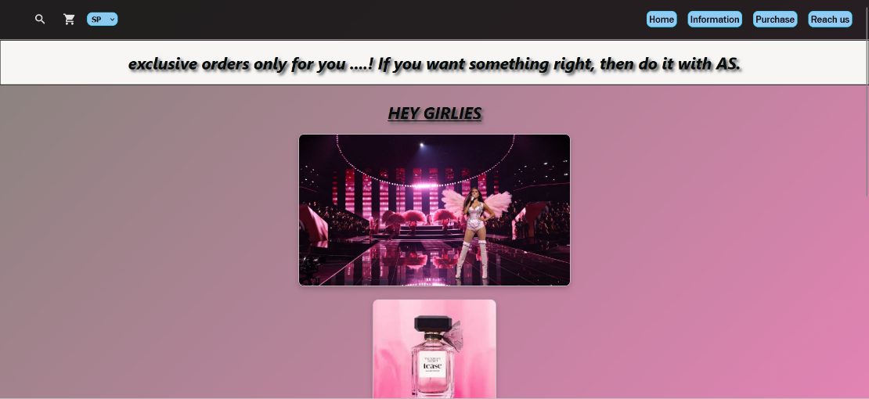

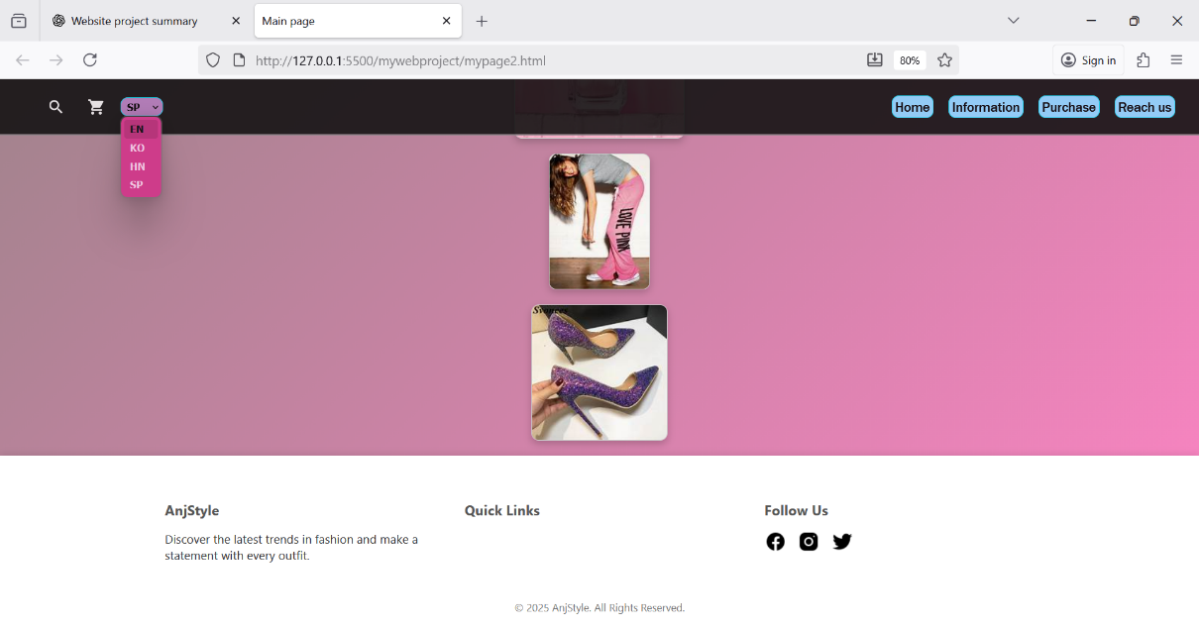
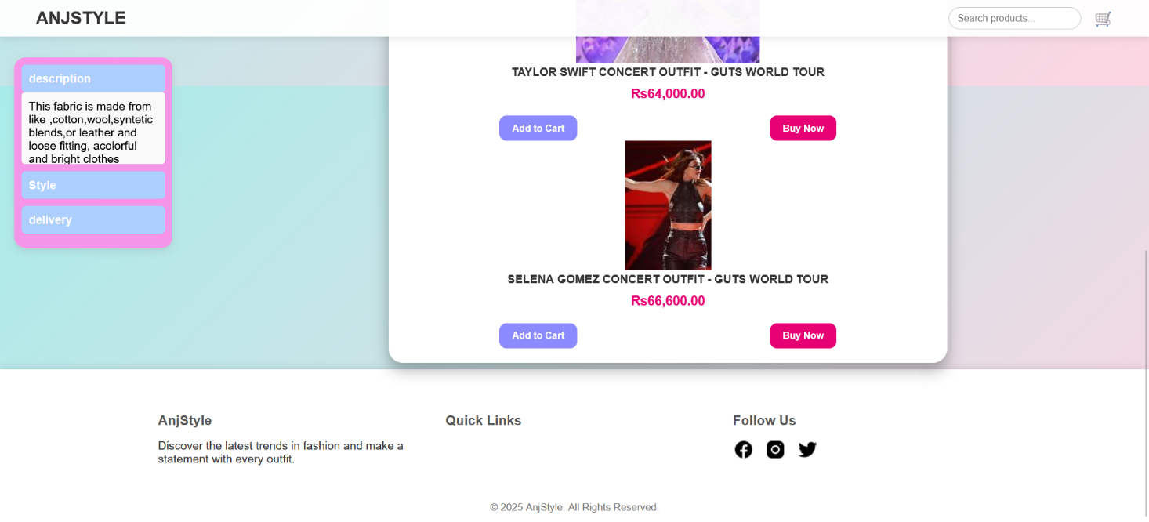

REFERENCES
- W3Schools – https://www.w3schools.com/
- Chatgpt.com/
- Pwskills.com/
- MDN Web Docs – https://developer.mozilla.org/
- CSS Tricks – https://css-tricks.com/

