Worksheet 2
Student Name: Daljeet Singh UID: 25MCA20090
Branch: MCA Section/Group: 25MCA-1-A
Semester: 3rd Date of Performance: 16-08-2026
Subject Name: Business Analytics Subject Code: 25CAH-703

Aim/Overview of the practical:
To understand and implement Pivot Tables and Pivot Charts in Microsoft Excel for summarizing, analyzing, and visually representing large sets of data.

Objective:
  - To learn how to create a Pivot Table from raw data.
  - To summarize data using Rows, Columns, Values, and Filters in a Pivot Table.
  - To calculate useful summaries such as Sum, Count, Average, and Total.

To create Pivot Charts for graphical representation of summarized data.
  - To understand how Pivot Tables and Charts help in data analysis and decision-making.

Apparatus / Requirements:

Microsoft Excel

Procedure/Code
  - Open the excel workbook.
  - Select any cell inside the Sales Data worksheet.
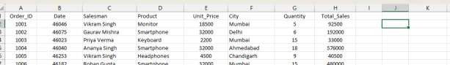

  - Go to the Insert tab.
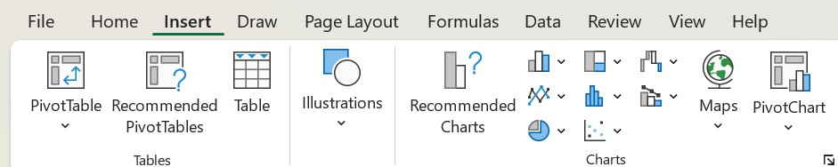

  - Click PivotTable.
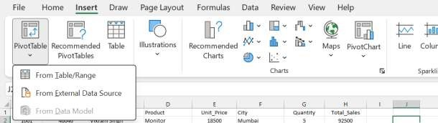

  - Click on Table/Range.
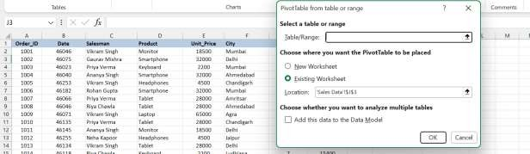
  - Select Table/Range.
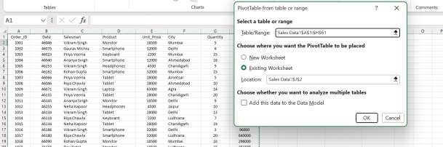

  - Click Ok and The PivotTable Fields panel will appear on the right side.
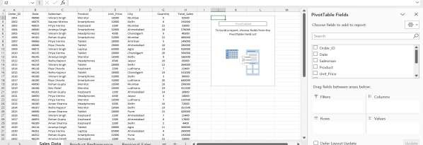

  - Drag City into the Rows area,Total_Sales into the Values area, Product into the Columns area to compare sales of different products.
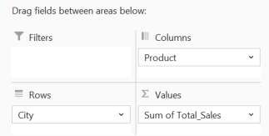

  - Drag Salesman into the Filters area if you want to analyze the data for a particular salesperson.
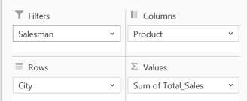
  - The Pivot Table will now summarize the sales data.
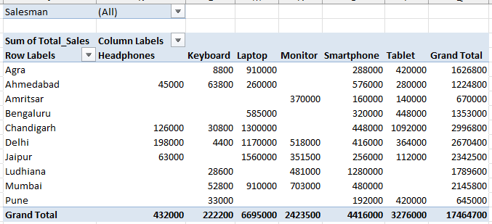
  - Click anywhere inside the Pivot Table.
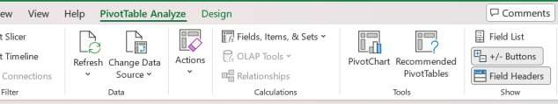
  - Go to the Insert tab.

  - Select PivotChart.
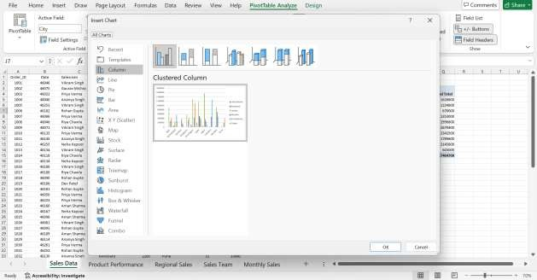

  - Choose a suitable chart type, such as Column Chart or Bar Chart.
  - Click OK and Excel will create a chart based on the Pivot Table.
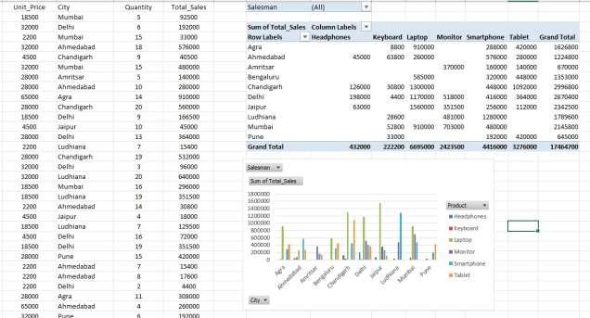

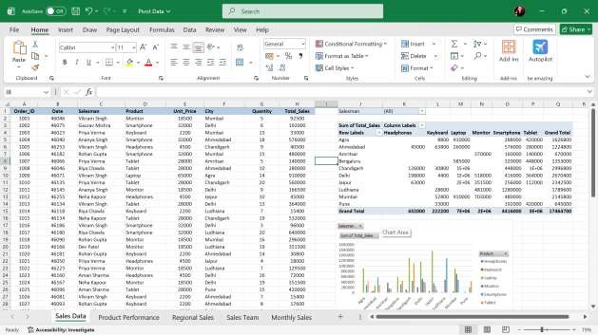

Pivot table and Chart 2
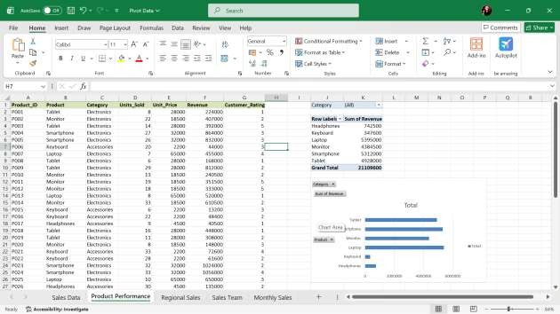

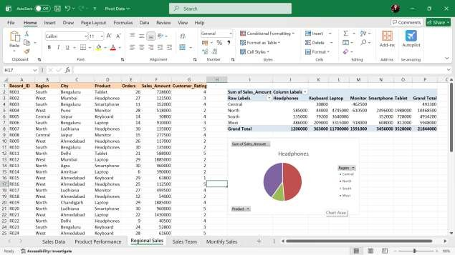

Pivot table and Chart 4
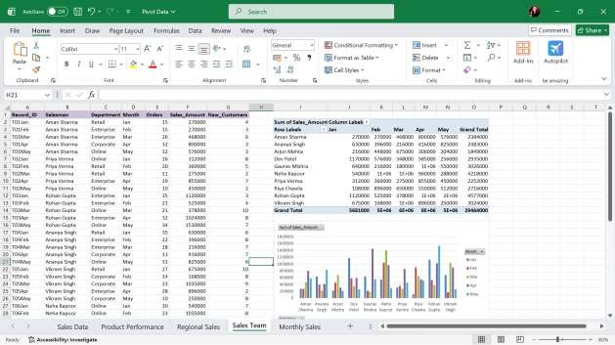

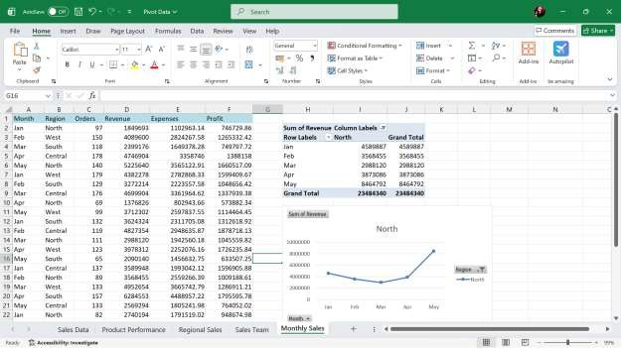

Learning outcomes (What I have learnt):

Create and manage Pivot Tables using raw data in Microsoft Excel.
  - Summarize and analyze large datasets using Rows, Columns, Values, and Filters.
  - Perform calculations such as Sum, Count, and Average using Pivot Tables.

Create and customize Pivot Charts for visual data representation.
  - Analyze data based on different categories such as products, regions, salespersons, and months.
  - Interpret summarized data to identify trends, comparisons, and useful insights.
  - Use Pivot Tables and Charts to support data analysis and decision-making.

