Student Name: Ashi Gupta Branch: MCA (General) Semester: 3rd
Subject Name: IOT Lab

Worksheet 5

UID: 25MCA20160
Section/Group: 25MCA-1A
Date of Performance: 18/09/2026 Subject Code: 25CAH-708

-------------------------------------------------------------------------------------------------------------------

Aim/Overview of the practical: (EVEN UIDS)
Interface an Arduino Uno with Temp Sensor to calculate the temperature in Fahrenheit and print on a Serial monitor and on LCD. Follow the mentioned cases after the calculation of distance.
  - If the temp is > 70-degree F green light is in ON condition.
  - If the temp is<70-degree F and temp is> 30-degree F yellow light is in ON condition and the green light remains Off
  - If the temp is < 30 degree F turn on the buzzer and the lights will remain OFF.

Apparatus:
- Hardware Requirements:
  - Arduino Uno R3 – 1,
  - Breadboard -1,
  - LED – 2 (Yellow, green),
  - Resistor (220Ω) 2,
  - Buzzer – 1,
  - TMP36,I2c
  - Jumper Wires,
  - USB Cable/Power Supply

Software requirements:
  - Arduino IDE,
  - CH340,

Code & Circuit Diagram(TinkerCad):
#include <Wire.h>
#include <LiquidCrystal_I2C.h> LiquidCrystal_I2C lcd(0x27, 16, 2); int tempPin = A0;
int greenLED = 4; int yellowLED = 6; int buzzer = 8; void setup() {
Serial.begin(9600); lcd.init(); lcd.backlight();
pinMode(greenLED, OUTPUT);

pinMode(yellowLED, OUTPUT); pinMode(buzzer, OUTPUT); lcd.setCursor(0, 0); lcd.print("Temperature:");
}
void loop() {
// Read TMP36
int value = analogRead(tempPin);
// Convert analog value to voltage float voltage = value * 5.0 / 1023.0;
// TMP36 -> Celsius
float temperatureC = (voltage - 0.5) * 100.0;
// Celsius -> Fahrenheit
float temperatureF = (temperatureC * 9.0 / 5.0) + 32.0;
// Serial Monitor Serial.print("Temperature: "); Serial.print(temperatureF); Serial.println(" F"); lcd.setCursor(0, 1); lcd.print("Temp: "); lcd.print(temperatureF, 1); lcd.print(" F ");
// First turn everything OFF digitalWrite(greenLED, LOW); digitalWrite(yellowLED, LOW); noTone(buzzer);
// Condition 1: Temperature > 70 F if (temperatureF > 70) { digitalWrite(greenLED, HIGH);
}
// Condition 2: 30 F < Temperature < 70 F
else if (temperatureF > 30 && temperatureF < 70) { digitalWrite(yellowLED, HIGH);
}
// Condition 3: Temperature < 30 F else if (temperatureF < 30) { tone(buzzer, 1000);
}
delay(1000);
}

Output:

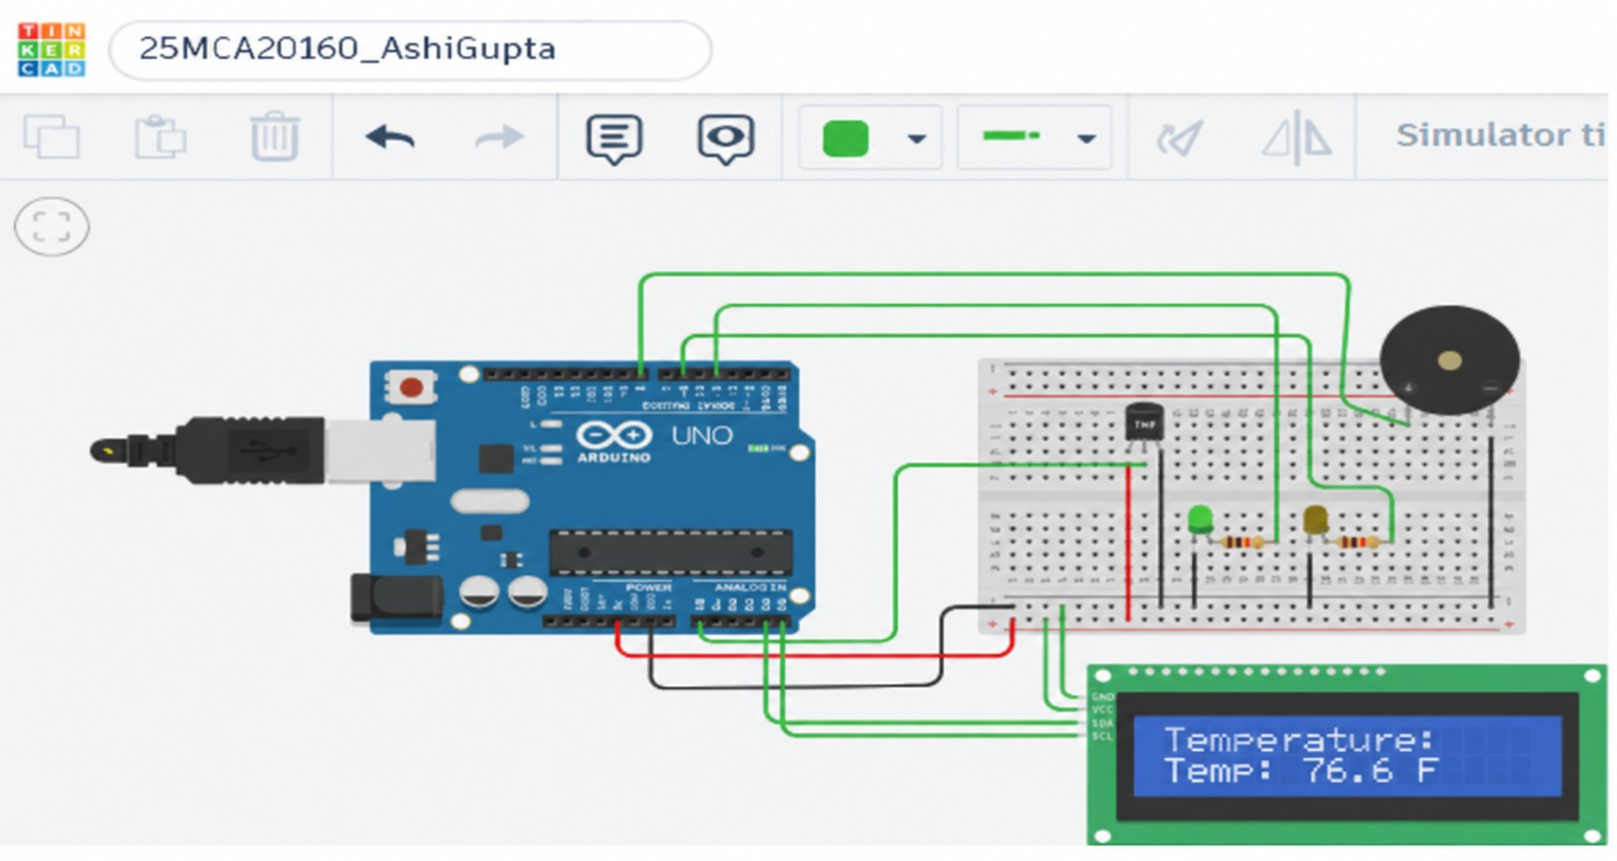
Condition 1: temp is > 70-degree F green light is in ON

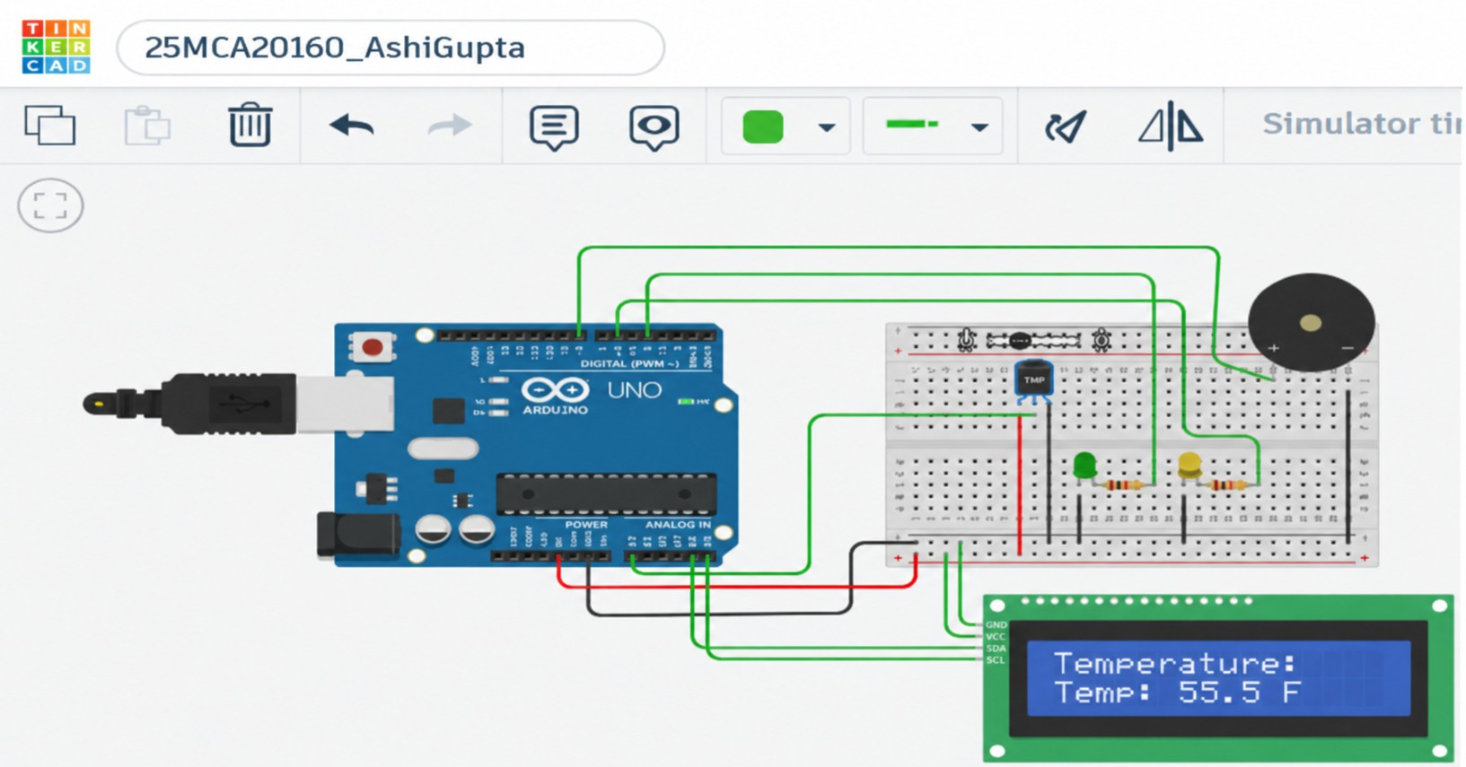
Condition 2: temp is<70-degree F and temp is> 30-degree F yellow light is in ON

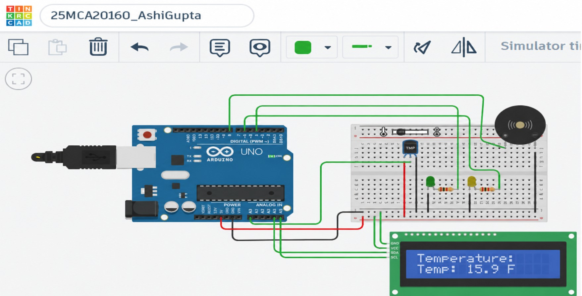

Condition 3: temp is < 30 degree F turn on the buzzer and the lights will remain OFF

Learning Outcomes :

- Interface a TMP36 temperature sensor with an Arduino Uno.
- Read the analog output of the TMP36 and calculate the temperature in Fahrenheit.
- Display the calculated temperature on the Serial Monitor and I2C LCD.
- Control green and yellow LEDs and a buzzer based on predefined temperature conditions.
- Implement a basic temperature monitoring and alert system using Arduino Uno.

