Introduction to JavaScript
JavaScript is an object-based scripting language which is lightweight and cross-platform.
JavaScript is not a compiled language, but it is a translated language. The JavaScript Translator (embedded in the browser) is responsible for translating the JavaScript code for the web browser.
JavaScript (js) is a light-weight object-oriented programming language which is used by several websites for scripting the webpages. It is an interpreted, full-fledged programming language that enables dynamic interactivity on websites when applied to an HTML document. It was introduced in the year 1995 for adding programs to the webpages in the Netscape Navigator browser. Since then, it has been adopted by all other graphical web browsers. With JavaScript, users can build modern web applications to interact directly without reloading the page every time. The traditional website uses js to provide several forms of interactivity and simplicity.
Java Script Libraries
- JQuery
- React

Application of JavaScript
JavaScript is used to create interactive websites. It is mainly used for:
- Client-side validation,
- Dynamic drop-down menus,
- Displaying date and time,
- Displaying pop-up windows and dialog boxes (like an alert dialog box, confirm dialog box and prompt dialog box),

JavaScript Example
- <script>
- document.write("Hello JavaScript by JavaScript");
- </script>

Functions
A function is a block of code which will be executed only if it is called. If you have a few lines of code that needs to be used several times, you can create a function including the repeating lines of code and then call the function wherever you want.

Types of Functions
There are two types of functions in JavaScript like other programming languages such c, c++, and java etc.
- Pre-defined Functions
- User-defined Functions

Create a Function in JavaScript
- Use the keyword function followed by the name of the function.
- After the function name, open and close parentheses.
- After parenthesis, open and close curly braces.
- Within curly braces, write your lines of code.
Syntax:
function functionname()

{

lines of code to be executed

}

<html>
<head>
<title>Functions!!!</title>
<script type="text/javascript">
function myFunction()
{
document.write("This is a simple function.<br />");
}
myFunction();
</script>
</head>
<body>
</body>
</html

Function with Arguments
You can create functions with arguments as well. Arguments should be specified within parenthesis
Syntax:
function functionname(arg1, arg2)

{

lines of code to be executed
}

Function Return
When JavaScript reaches a return statement, the function will stop executing.
If the function was invoked from a statement, JavaScript will "return" to execute the code after the invoking statement.
Functions often compute a return value. The return value is "returned" back to the "caller":

Example
Calculate the product of two numbers, and return the result:
let x = myFunction(4, 3); // Function is called, return value will end up in x
function myFunction(a, b) {
return a * b; // Function returns the product of a and b
}

Introduction to NodeJs
Node.js is a cross-platform runtime environment and library for running JavaScript applications outside the browser. It is used for creating server-side and networking web applications. It is open source and free to use.
Node.js is a platform built on Chrome's JavaScript runtime for easily building fast and scalable network applications. Node.js uses an event-driven, non-blocking I/O model that makes it lightweight and efficient, perfect for data-intensive real-time applications that run across distributed devices

Features of Node.js
Following is a list of some important features of Node.js that makes it the first choice of software architects.
- Extremely fast: Node.js is built on Google Chrome's V8 JavaScript Engine, so its library is very fast in code execution.
- I/O is Asynchronous and Event Driven: All APIs of Node.js library are asynchronous i.e. non-blocking. So, a Node.js based server never waits for an API to return data. The server moves to the next API after calling it and a notification mechanism of Events of Node.js helps the server to get a response from the previous API call. It is also a reason that it is very fast.
- Single threaded: Node.js follows a single threaded model with event looping.
- Highly Scalable: Node.js is highly scalable because event mechanism helps the server to respond in a non-blocking way.
- No buffering: Node.js cuts down the overall processing time while uploading audio and video files. Node.js applications never buffer any data. These applications simply output the data in chunks.
- Open source: Node.js has an open-source community which has produced many excellent modules to add additional capabilities to Node.js applications.
Application of NodeJS: NodeJS should be preferred to build:
- Real-Time Chats,
- Complex Single-Page applications,
- Real-time collaboration tools,
- Streaming apps
- JSON APIs based application

NPM - Node Package Manager
Node Package Manager (NPM) is a command line tool that installs, updates or uninstalls Node.js packages in your application. It is also an online repository for open-source Node.js packages. The node community around the world creates useful modules and publishes them as packages in this repository.
A package contains all the files needed for a module and modules are the JavaScript libraries that can be included in Node project according to the requirement of the project. NPM can install all the dependencies of a project through the package. json file. It can also update and uninstall package
V8
V8 is a C++-based open-source JavaScript engine developed by Google. It was originally designed for Google Chrome and Chromium-based browsers (such as Brave) in 2008, but it was later utilized to create Node.js for server-side coding.
V8 is known to be a JavaScript engine because it takes JavaScript code and executes it while browsing in Chrome. It provides a runtime environment for the execution of JavaScript code. The best part is that the JavaScript engine is completely independent of the browser in which it runs. This is the feature that led Node.js designers to choose the V8 engine to power the framework,

Asynchronous vs Synchronous request
  - Synchronous methods: Synchronous functions block the execution of the program until the file operation is performed. These functions are also called blocking functions.
All asynchronous methods can perform synchronously just by appending “Sync” to the function name. Some of the synchronous methods of fs module in NodeJS are:
- fs.readFileSync()
- fs.renameSync()
- fs.writeSync()
- fs.writeFileSync()
- fs.fsyncSync()
- fs.appendFileSync()
- fs.statSync()
- fs.readdirSync()
- fs.existsSync()
Example 1: Synchronous read method
Step 1: Let’s create a JavaScript file named main.js and a text file with the name sample.txt having the following statement:
GeeksForGeeks is a Computer Science portal.
Step 2: Add the following code inside main.js file and execute it:
- main.js
var fs = require("fs");

// Synchronous read
console.log("Synchronous read method:");
var data = fs.readFileSync('sample.txt');
console.log("Data in the file is - " + data.toString());
Output:
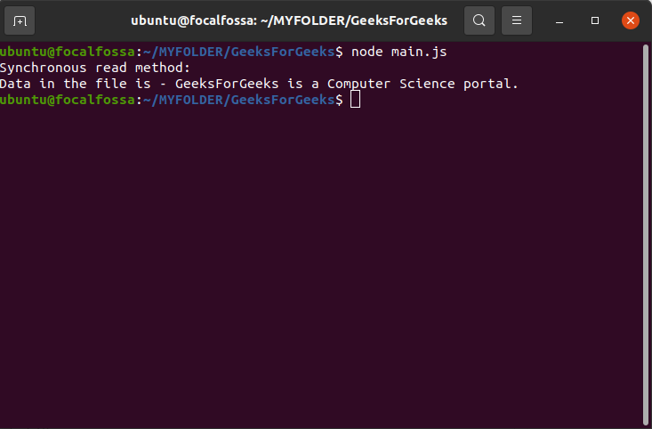

Asynchronous functions do not block the execution of the program and each command is executed after the previous command even if the previous command has not computed the result. The previous command runs in the background and loads the result once it has finished processing. Thus, these functions are called non-blocking functions. They take a callback function as the last parameter

Some of the asynchronous methods of fs module in NodeJS are:
- fs.readFile()
- fs.rename()
- fs.write()
- fs.writeFile()
- fs.fsync()
- fs.appendFile()
- fs.stat()
- fs.readdir()
- fs.exists()
Heavy operations which consume time for processing such as querying huge data from a database should be done asynchronously as other operations can still be executed and thus, reducing the time of execution of the program.
Example 1: Asynchronous read method
Step 1: Let’s create a JavaScript file named main.js and a text file with the name sample.txt having the following statement:
GeeksForGeeks is a Computer Science portal.
Step 2: Add the following code inside main.js file and execute it:
- main.js
var fs = require("fs");

// Asynchronous read
console.log("Asynchronous read method:");
fs.readFile('sample.txt', function (err, data) {
if (err) {
return console.error(err);
}
console.log("Data in the file is - " + data.toString());
});
Output:
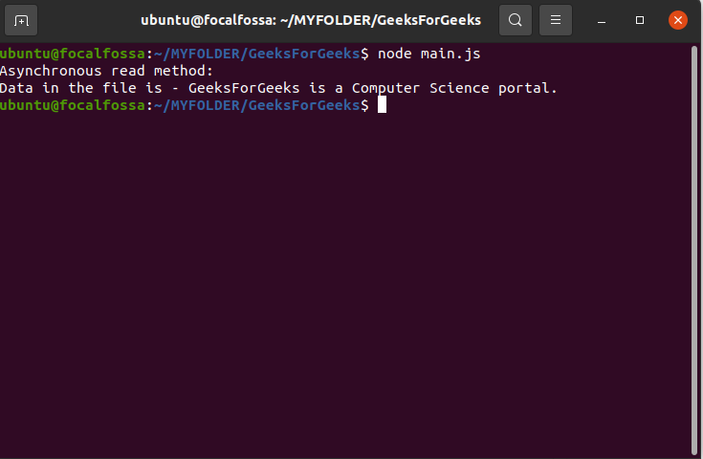

Difference between Asynchronous and Synchronous methods:
Sr.no | Synchronous methods | Asynchronous methods
1. | Synchronous functions are called blocking functions | Asynchronous functions are called non-blocking functions.
2. | It blocks the execution of the program until the file operation has finished processing. | It does not block the execution of the program.
3. | These functions take File Descriptor as the last argument. | These functions take a callback function as the last argument.
4. | Examples: fs.readFileSync(), fs.appendFileSync(), fs.writeFileSync() etc. | Examples: fs.readFile(), fs.appendFile(), fs.writeFile(), fs.stat() etc.

REPL (READ, EVAL, PRINT, LOOP)

REPL (READ, EVAL, PRINT, LOOP) is a computer environment similar to Shell (Unix/Linux) and command prompt. Node comes with the REPL environment when it is installed. System interacts with the user through outputs of commands/expressions used. It is useful in writing and debugging the codes. The work of REPL can be understood from its full form:
Read : It reads the inputs from users and parses it into JavaScript data structure. It is then stored to memory.
Eval : The parsed JavaScript data structure is evaluated for the results.
Print : The result is printed after the evaluation.
Loop : Loops the input command. To come out of NODE REPL, press ctrl+c twice
Getting Started with REPL:
To start working with REPL environment of NODE; open up the terminal (in case of UNIX/LINUX) or the Command prompt (in case of Windows) and write node and press ‘enter’ to start the REPL.
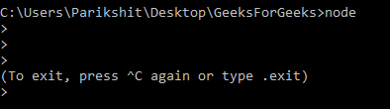
open node repl
The REPL has started and is demarcated by the ‘>’ symbol. Various operations can be performed on the REPL. Below are some of the examples to get familiar with the REPL environment.
Example: Performing Arithmetical operations in REPL
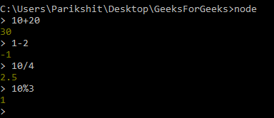
Arithmetical operations in REPL
Example: Performing operations using libraries of NODE. MATH library is being used in below example.
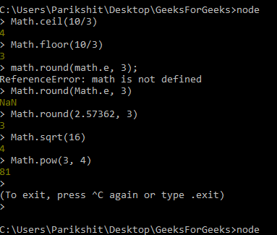
Math library methods gfg
Note: using ‘math’ shows error as the library is referenced as ‘Math’ in NODE and not ‘math’.
Example: Using variables in REPL. The keyword var is used to assign values to variables.
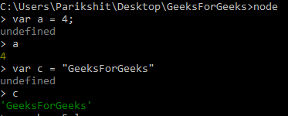
Using Variables in REPL
Example: Using loops in REPL. Loops can be used in REPL as in other editors.
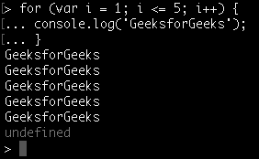
Note: Use ctrl – c to terminate the command and ctrl – c twice to terminate the NODE REPL.
.help is used to list out all the commands.
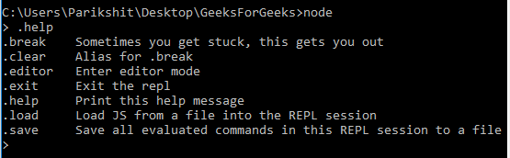

Using .help in REPL
Working with Buffers and Streams
Streams
Streams are a fundamental concept in Node.js that provide a way to process large amounts of data efficiently. Streams in Node.js are a type of data handler that enable reading and writing data in chunks instead of loading entire files into memory. This allows applications to process data in a more efficient and scalable way.
In Node.js, there are four types of streams: Readable, Writable, Duplex, and Transform. A Readable stream represents a source of data that can be read from, while a Writable stream represents a destination for data that can be written to. A Duplex stream represents both a Readable and Writable stream, and a Transform stream represents a Duplex stream that modifies or transforms the data as it passes through.
To use streams in Node.js, we can create a stream object using the appropriate class from the ‘stream’ module, and then pipe the stream to another stream or data source. For example, to read data from a file using a Readable stream, we can use the ‘fs’ module to create a Readable stream object, and then pipe it to a Writable stream that writes the data to the console or another file.
Here’s an example of using streams in Node.js:
const fs = require('fs');

const readableStream = fs.createReadStream('input.txt');
const writableStream = fs.createWriteStream('output.txt');

readableStream.pipe(writableStream);
In this example, we create a Readable stream using the ‘fs’ module’s ‘createReadStream’ method, and a Writable stream using the ‘createWriteStream’ method. We then pipe the Readable stream to the Writable stream using the ‘pipe’ method.
Buffer
Buffers are another important concept in Node.js that provide a way to handle binary data in memory. Buffers are essentially arrays of integers that represent raw binary data. They can be used to store data in memory, read data from files or network sockets, and manipulate data in various ways.
In Node.js, Buffers are a built-in data type that are part of the ‘Buffer’ module. Buffers can be created in several ways, such as from a string, an array, or a buffer from another source.
To create a Buffer in Node.js, we can use the ‘Buffer.from()’ method, which takes a source data and an optional encoding parameter. For example, to create a Buffer from a string, we can use the following code:
const buffer = Buffer.from('Hello, World!', 'utf-8');
Once we have a Buffer object, we can manipulate the data in various ways, such as reading or writing individual bytes, copying data to another buffer, or converting the buffer to a string.
Here’s an example of working with Buffers in Node.js:
const buffer1 = Buffer.from('Hello');
const buffer2 = Buffer.from('World');
const buffer3 = Buffer.concat([buffer1, buffer2]);

console.log(buffer3.toString());
In this example, we create two Buffer objects using the ‘Buffer.from()’ method, and then concatenate them into a third Buffer using the ‘Buffer.concat()’ method. We then convert the resulting buffer to a string using the ‘toString()’ method and log it to the console.
Creating Server with Http request
To access web pages of any web application, you need a web server. The web server will handle all the http requests for the web application e.g IIS is a web server for ASP.NET web applications and Apache is a web server for PHP or Java web applications.
Node.js provides capabilities to create your own web server which will handle HTTP requests asynchronously. You can use IIS or Apache to run Node.js web application but it is recommended to use Node.js web server.

Create Node.js Web Server
Node.js makes it easy to create a simple web server that processes incoming requests asynchronously.
The following example is a simple Node.js web server contained in server.js file.
var http = require('http'); // 1 - Import Node.js core module

var server = http.createServer(function (req, res) { // 2 - creating server

//handle incomming requests here..

});

server.listen(5000); //3 - listen for any incoming requests

console.log('Node.js web server at port 5000 is running..')
In the above example, we import the http module using require() function. The http module is a core module of Node.js, so no need to install it using NPM. The next step is to call createServer() method of http and specify callback function with request and response parameter. Finally, call listen() method of server object which was returned from createServer() method with port number, to start listening to incoming requests on port 5000. You can specify any unused port here.
Run the above web server by writing node server.js command in command prompt or terminal window and it will display message as shown below.
C:\> node server.js
Node.js web server at port 5000 is running..
This is how you create a Node.js web server using simple steps. Now, let's see how to handle HTTP request and send response in Node.js web server.
442.5K
Streaming service limits videos to just 10 minutes

Handle HTTP Request
The http.createServer() method includes request and response parameters which is supplied by Node.js. The request object can be used to get information about the current HTTP request e.g., url, request header, and data. The response object can be used to send a response for a current HTTP request.
The following example demonstrates handling HTTP request and response in Node.js.
var http = require('http'); // Import Node.js core module

var server = http.createServer(function (req, res) { //create web server
if (req.url == '/') { //check the URL of the current request

// set response header
res.writeHead(200, { 'Content-Type': 'text/html' });

// set response content
res.write('<html><body><p>This is home Page.</p></body></html>');
res.end();

}
else if (req.url == "/student") {

res.writeHead(200, { 'Content-Type': 'text/html' });
res.write('<html><body><p>This is student Page.</p></body></html>');
res.end();

}
else if (req.url == "/admin") {

res.writeHead(200, { 'Content-Type': 'text/html' });
res.write('<html><body><p>This is admin Page.</p></body></html>');
res.end();

}
else
res.end('Invalid Request!');

});

server.listen(5000); //6 - listen for any incoming requests

console.log('Node.js web server at port 5000 is running..')
In the above example, req.url is used to check the url of the current request and based on that it sends the response. To send a response, first it sets the response header using writeHead() method and then writes a string as a response body using write() method. Finally, Node.js web server sends the response using end() method.
Now, run the above web server as shown below.
C:\> node server.js
Node.js web server at port 5000 is running..
To test it, you can use the command-line program curl, which most Mac and Linux machines have pre-installed.
curl -i http://localhost:5000
You should see the following response.
HTTP/1.1 200 OK
Content-Type: text/plain
Date: Tue, 8 Sep 2015 03:05:08 GMT
Connection: keep-alive
This is home page.
For Windows users, point your browser to http://localhost:5000 and see the following result.
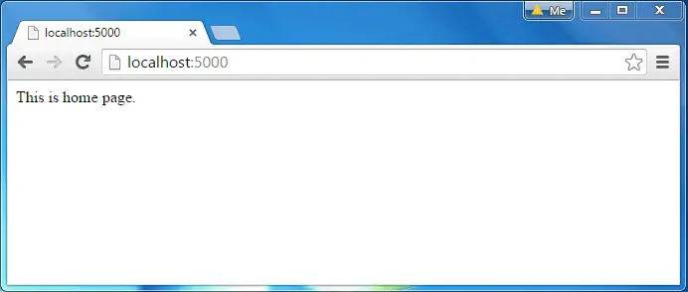
Events
Every action on a computer is an event. Like when a connection is made or a file is opened.

Node.js EventEmitter
Node.js allows us to create and handle custom events easily by using events module. Event module includes EventEmitter class which can be used to raise and handle custom events.
The following example demonstrates EventEmitter class for raising and handling a custom event.
Example: Raise and Handle Node.js events
Copy
// get the reference of EventEmitter class of events module
var events = require('events');

//create an object of EventEmitter class by using above reference
var em = new events.EventEmitter();

//Subscribe for FirstEvent
em.on('FirstEvent', function (data) {
console.log('First subscriber: ' + data);
});

// Raising FirstEvent
em.emit('FirstEvent', 'This is my first Node.js event emitter example.');

In the above example, we first import the 'events' module and then create an object of EventEmitter class. We then specify event handler function using on() function. The on() method requires name of the event to handle and callback function which is called when an event is raised.
Process
The process module in Node.js allows us to get information related to the node and control its behavior. This module is, and we can use it to get information such as process ID, version, release, CPU usage, and uptime globally available or perform actions such as killing processes, setting uid, setting groups, unmasking, etc.

example 1

// Including the module into out project
var process = require('process');

// Viewing the current working directory
console.log('Working directory --> ' + process.cwd());

// Viewing the version of process we are using
console.log('Process version --> ' + process.version);

// Viewing the type of OS we are using
console.log('Current OS --> ' + process.platform);
// Viewing the arguments passed
console.log('Arguments --> ', process.argv);
// Viewing the Feature Object
console.log('Feature Property: \n', process.features);
- Line 2: We include the process module in our code.
- Line 5: We print the current working directory using process.
- Line 8: We print the version of process that we are using.
- Line 11: We print the type of OS we are working on.
- Line 14: We print the arguments passed when the current application was run.
- Line 17: We view the Feature Object in process.

Web Modules
Web servers are programs that deal with http requests. The http requests sent by the client are handled by the web server and it then gives a response to the clients. A web server generally provides the html, stylesheets, and images.

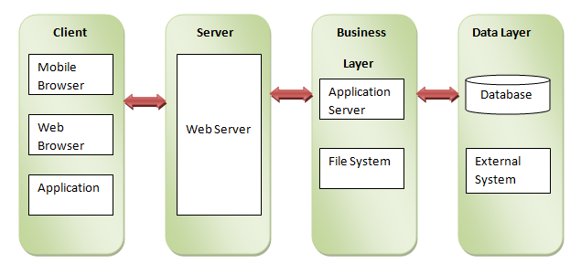

Web Server Architecture:

1. Client:
Browsers and other applications that make http requests to the server are known as clients.

2. Server:
This layer takes the requests made by the client and sends them a response.

3. Business:
This layer contains all the logics and functions required in the application, it also interacts with the data layer using databases.

4. Data:
This layer contains the data required by the application. The data is generally stored in the databases.

Create a Web server:
We will be creating a nodejs server using http which is a builtin module of node js.
Code for creating a web server:
const http = require('http');
http.createServer(function (request, response) {
response.write("Welcome to DataFlair");
response.end();
}).listen(3000);
console.log('Server is running on port 3000');
Output:
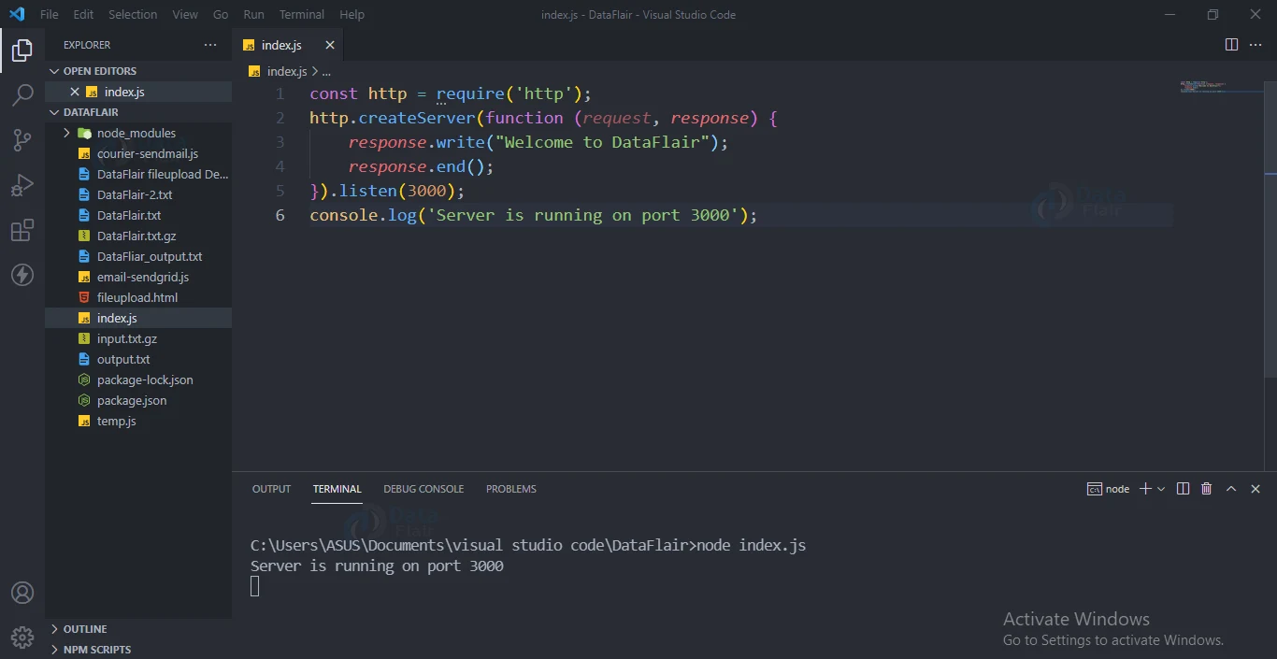

Making a request to node server:
Open your browser and go to localhost:3000 you will see like the below image:
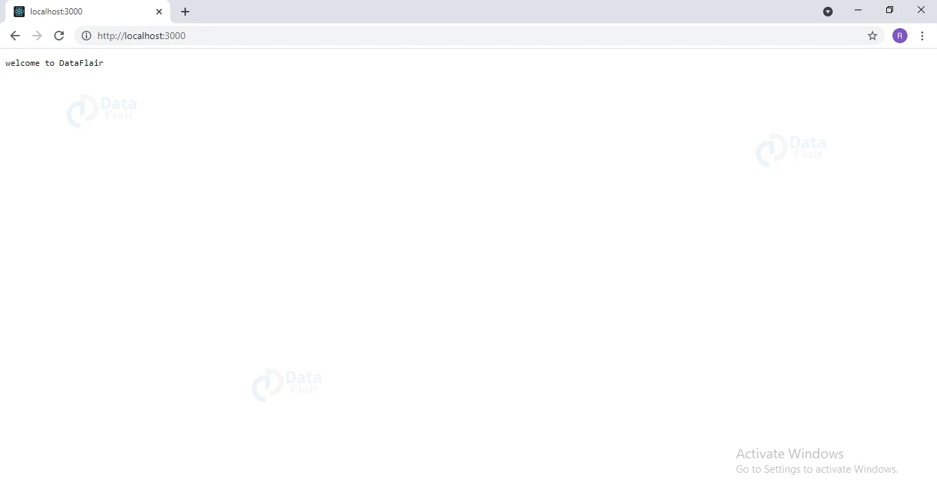

Output at terminal:
Server is running on port 3000

Cryptography in NodeJs

Crypto in Node.js
Crypto is a module in Node.js which deals with an algorithm that performs data encryption and decryption. This is used for security purpose like user authentication where storing the password in Database in the encrypted form.
Crypto module provides set of classes like hash, HMAC, cipher, decipher, sign, and verify. The instance of that class is used to create Encryption and Decryption. Node.js cannot create a class object using the new keyword.
The Node.js Crypto module supports cryptography. It provides cryptographic functionality that includes a set of wrappers for open SSL's hash HMAC, cipher, decipher, sign and verify functions.

What is Hash
A hash is a fixed-length string of bits i.e. procedurally and deterministically generated from some arbitrary block of source data.

What is HMAC
HMAC stands for Hash-based Message Authentication Code. It is a process for applying a hash algorithm to both data and a secret key that results in a single final hash.
// Importing module
const SHA256 = require("crypto-js/sha256");
const plaindata = "GeeksForGeeks"
const hasheddata = SHA256(plainText).toString()
console.log(hasheddata)

Run the index.js file using the below command:

node index.js
Output:
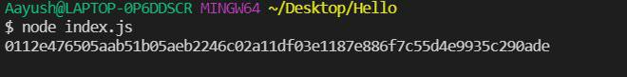

Reading and writing into file
