

Worksheet No. - 2

Student Name: Anjali kumari UID: 25MCA20023
Branch: MCA general Section:Group:1/A
Semester:3rd Date of Performance:8 Aug.
Subject Name:Backend Technology.

Subject Code: CONT_25CAH-706
Experiment 1: Create a Signup page and store the inputted data by user in file

Aim:

To develop a web-based Employee Salary Management System using Node.js that allows users to register and log in securely and provides an employee dashboard for viewing employee details, salary information, and graphical salary analysis.

Objective:
- Develop a web-based Employee Salary Management System using Node.js.
- Implement user registration and login authentication.
- Store and manage user credentials using users.txt.
- Display employee personal, contact, and job information dynamically.
- Display salary details including Basic Salary, HRA, Medical Allowance, Bonus, and Annual Salary.
- Provide salary visualization using charts and a live current-time display.
- Create a responsive and user-friendly dashboard using HTML, CSS, Bootstrap, and JavaScript.

Task to be done :

- Create the Node.js server and project folder structure.
- Design the Login and Registration pages.
- Implement registration and login routes with credential validation.
- Create and read employee data from employee.txt.
- Develop the dynamic Employee Dashboard.
- Add salary charts, profile image, logo, and live time functionality.
- Test the complete system and fix routing, file-loading, and authentication errors.



- Online Resources:
- Node.js Official Documentation

- EJS Official Documentation

- MDN Web Docs (HTML, CSS, JavaScript)

- W3Schools – HTML, CSS, JavaScript
- GeeksforGeeks – Node.js and Express.js Tutorials

Software Requirements
- Node.js (Latest LTS Version)
- Visual Studio Code
- Google Chrome / Microsoft Edge / Mozilla Firefox
- Command Prompt / Windows PowerShell / Terminal
- npm (Node Package Manager

Standard Tools Used
- Node.js
- HTML5
- CSS3
- JavaScript
- File System (fs) Module
- Browser (Chrome/Edge/Firefox) for user input and displaying the output

- Procedure/ Algorithm:
<section class="hero">

<div class="container">

<!-- LOGO -->
<img
src="/logo.png"
alt="ABC Technologies Logo"
class="logo"
onerror="this.style.display='none';"
>

<!-- ANIMATED TITLE -->
<h1 class="welcome-title">
Employee Salary Management System
</h1>



<!-- ANIMATED SUBTITLE -->
<p class="welcome-subtitle">
Secure Employee Management & Salary Dashboard
</p>

</div>

</section

66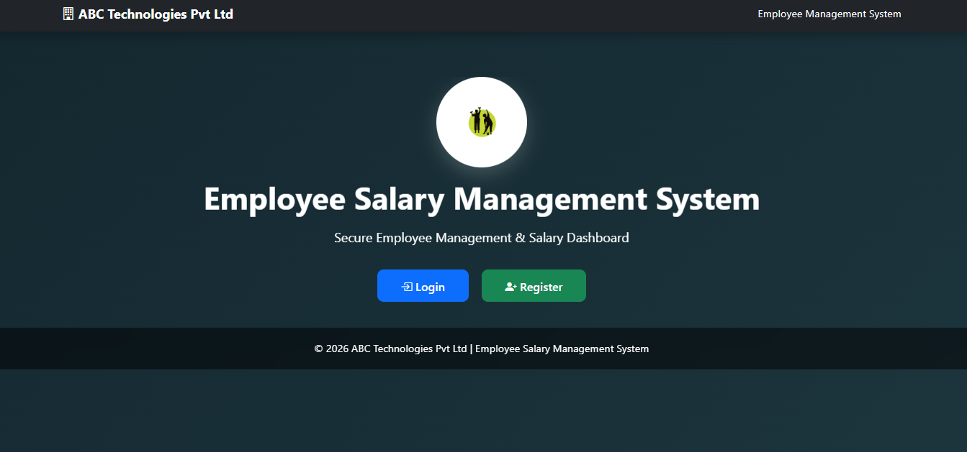


\\\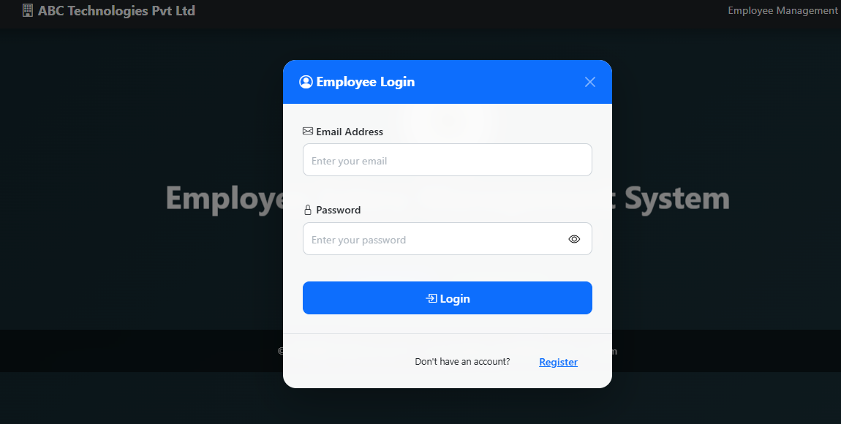

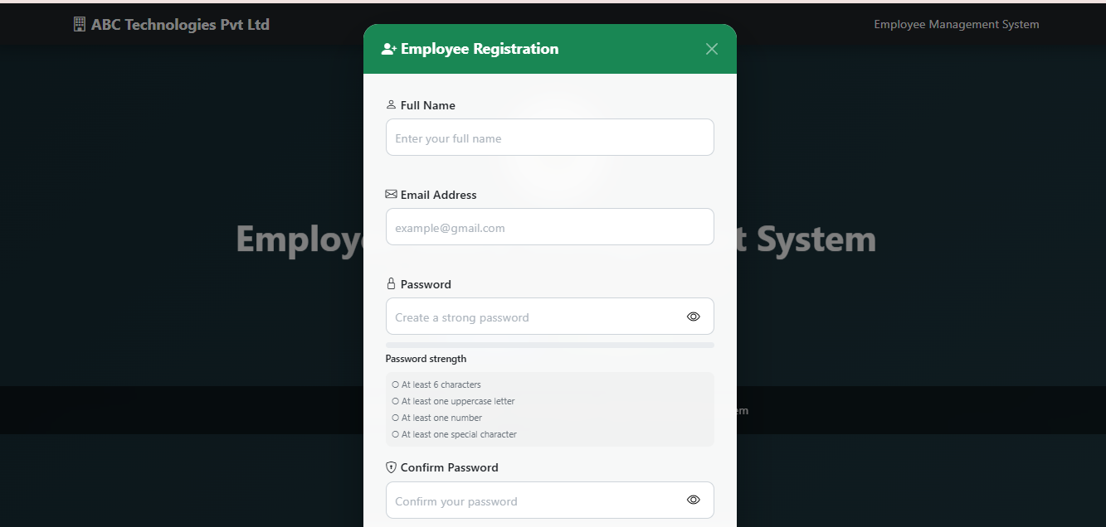



7.LEARNING OUTCOMES:
After completing the Employee Salary Management System, you will be able to:
- Develop a web-based employee management system using HTML, CSS, JavaScript, and Node.js.
- Implement user registration and login authentication with form validation.
- Manage employee and salary information using files such as users.txt and employee.txt.
- Build dynamic dashboards that display employee details, salary information, and calculated data.
- Apply frontend validation and interactive UI features, including password strength checking and email validation.
- Create responsive and animated user interfaces using Bootstrap, CSS animations, and Framer-style motion effects.
- Understand client-server communication and routing using Node.js HTTP server and different application routes.

