


Worksheet No. - 1

Student Name: Anjali kumari UID: 25MCA20023
Branch: MCA general Section:Group:1/A
Semester:3rd Date of Performance:21st july.
Subject Name:MACHINE LEARNING.

Subject Code: CONT_25CAP-702

Experiment 1: Python Libraries and Data Preprocessing on Netflix Dataset. a. Math b. NumPy c. Matplotlib d. Seaborn e. SciPy.
ii) Perform comprehensive data preprocessing on the Netflix dataset by handling missing values, detecting and treating outliers, encoding categorical features, applying feature scaling, and removing noise/duplicate records to improve overall data quality and prepare the dataset for machine learning tasks.
______________________________________________________________________________________________________________________

1.Aim:

To understand the usage of fundamental Python libraries for Machine Learning and perform comprehensive data preprocessing on the Netflix dataset.

2.Objective:
- To load and explore the Netflix dataset using Pandas.
- To identify missing values in the dataset.
- To handle missing values using appropriate techniques.
- To convert categorical data into numerical format using Label Encoding.
- To normalize numerical data using Min-Max Scaling.
- To standardize numerical data using StandardScaler.

3.Task to be done :

• Import the required Python libraries (Pandas and Scikit-learn).
• Load the Netflix dataset from the CSV file.
• Display the first five rows of the dataset.
• Examine the dataset structure and identify missing values.
• Fill missing values in categorical columns with "Unknown".
• Fill missing values in numerical columns using the mean of each column.
• Encode categorical features using LabelEncoder.

• Normalize numerical features using MinMaxScaler.


• Standardize numerical features using StandardScaler.

4.Online Resources:

NumPy Documentation

Pandas Documentation

Scikit-Learn Official Documentation

Matplotlib Official Documentation

Seaborn Documentation

Kaggle Titanic Dataset Resources

Software Requirements

Python 3.x

Jupyter Notebook / Google Colab

Anaconda Distribution

Standard Tools Used

NumPy

Pandas

Matplotlib

Seaborn

SciPy

Scikit-Learn
5.Procedure/ Algorithm:

import pandas as pd
from sklearn.preprocessing import LabelEncoder, StandardScaler

# Load the dataset
df = pd.read_csv(r"C:\Users\ASUS\Downloads\archive\netflix.csv")

# ==============================
# 1. Find Missing Values
# ==============================
print("Missing Values Before Filling:\n")
print(df.isnull().sum())

# ==============================
# 2. Fill Missing Values
# ==============================

# Separate categorical and numerical columns
categorical_cols = df.select_dtypes(include='object').columns
numerical_cols = df.select_dtypes(include=['int64', 'float64']).columns

# Fill categorical columns with "Unknown"
for col in categorical_cols:
df[col] = df[col].fillna("Unknown")

# Fill numerical columns with mean
for col in numerical_cols:
df[col] = df[col].fillna(df[col].mean
print("\nMissing Values After Filling:\n")
print(df.isnull().sum())

# 3. Label Encoding

encoder = LabelEncoder()

for col in categorical_cols:
df[col] = encoder.fit_transform(df[col])

print("\nFirst 5 Rows After Encoding:\n")
print(df.head())

# 5. Standardize Numerical Values

standard_scaler = StandardScaler()

if len(numerical_cols) > 0:
df[numerical_cols] = standard_scaler.fit_transform(df[numerical_cols])

print("\nStandardized Numerical Columns:\n")
print(df[numerical_cols].head())

# Final Dataset

print("\nFinal Dataset Preview:\n")


print(df.head()) ……………………………………………………………………continue,

6.output:

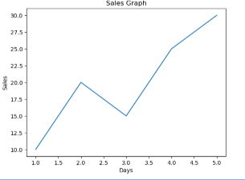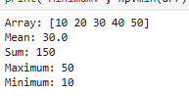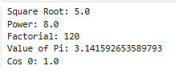




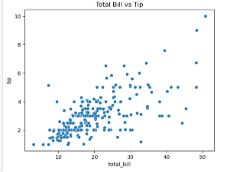

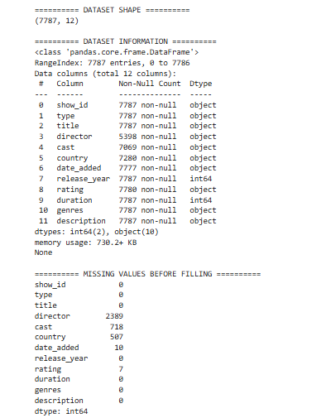



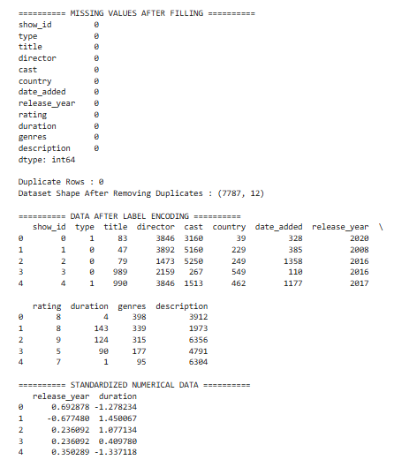

6.Learning outcomes (what I have learnt) :
After completing this experiment, students will be able to:
- Understand the importance of data preprocessing in machine learning.
- Load and explore a dataset using the Pandas library.
- Handle missing values and remove duplicate records.
- Apply Label Encoding to convert categorical data into numerical form.
- Standardize numerical data using StandardScaler.
- Split the dataset into training and testing sets.
- Visualize data using bar and pie charts with Matplotlib.
- Prepare a clean dataset for machine learning and data analysis.

