


Worksheet No. - 3

Student Name: Anjali kumari UID: 25MCA20023
Branch: MCA general Section:Group:1/A
Semester:3rd Date of Performance:5th sept.
Subject Name:MACHINE LEARNING.

Subject Code: CONT_25CAP-702

Experiment 1Implement classification algorithms—Logistic Regression and k-NN—on a suitable dataset and evaluate their performance using confusion matrix, precision, recall, and F1-score._
____________________________________________________________________________________

1.Aim:
To implement and compare Logistic Regression and k-Nearest Neighbors (k-NN) classification algorithms on a suitable dataset and evaluate their performance using accuracy, precision, recall, F1-score, and confusion matrix
On Breast cancer dataset.

2.Objective:
- To understand the concept of classification algorithms in machine learning.
- To implement Logistic Regression for classification.
- To implement k-Nearest Neighbors (k-NN) for classification.
- To evaluate the performance of both algorithms using accuracy, precision, recall, F1-score, and confusion matrix.
- To compare the performance of Logistic Regression and k-NN and identify the better-performing model.

3.Task to be done :

• Load and preprocess the Breast Cancer dataset.
• Separate the dataset into input features (X) and target variable (y).
• Split the data into training and testing sets and apply feature scaling.
• Train and test Logistic Regression and k-NN models and generate predictions.
• Calculate evaluation metrics, display confusion matrices, and compare both models using a performance graph.



.

4.Online Resources:

NumPy Documentation

Pandas Documentation

Scikit-Learn Official Documentation

Matplotlib Official Documentation

Seaborn Documentation

Kaggle Titanic Dataset Resources

Software Requirements

Python 3.x

Jupyter Notebook / Google Colab

Anaconda Distribution

Standard Tools Used

NumPy

Pandas

Matplotlib

Seaborn

SciPy

Scikit-Learn
5.Procedure/ Algorithm:
# ============================================
# LOGISTIC REGRESSION
# ============================================
import pandas as pd
from sklearn.preprocessing import LabelEncoder, StandardScaler
df = pd.read_csv(
r"C:\Users\Dell\Downloads\archive\data.csv"
)

df = df.drop(
columns=["id", "Unnamed: 32"],
errors="ignore"
)

df["diagnosis"] = df["diagnosis"].map({
"B": 0,
"M": 1
})

# Separate X and y
X = df.drop("diagnosis", axis=1)
y = df["diagnosis"]
X_train, X_test, y_train, y_test = train_test_split(
X,
y,
test_size=0.25,
random_state=10,
stratify=y
)




scaler = StandardScaler()

X_train_scaled = scaler.fit_transform(X_train)
X_test_scaled = scaler.transform(X_test)

# Create Logistic Regression model
lr_model = LogisticRegression(max_iter=5000)

# Train model
lr_model.fit(X_train_scaled, y_train)
# Prediction
y_pred_lr = lr_model.predict(X_test_scaled)

# Evaluation
accuracy_lr = accuracy_score(y_test, y_pred_lr)
precision_lr = precision_score(y_test, y_pred_lr)
recall_lr = recall_score(y_test, y_pred_lr)
f1_lr = f1_score(y_test, y_pred_lr)………………continue,

Output:

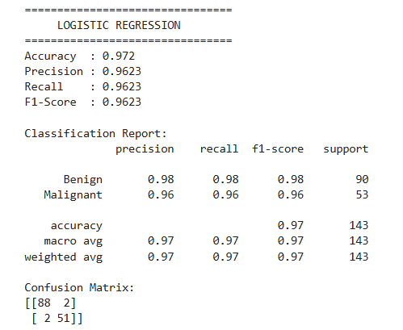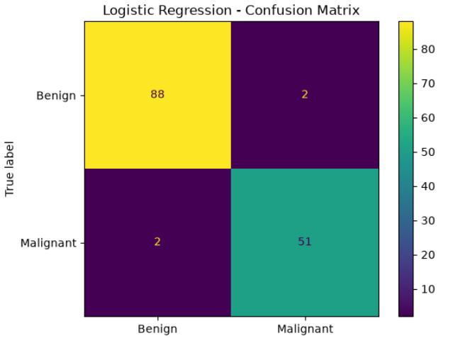

FIG 1(a):Logistic Regression. FIG 1(b): Graph Representation.

# ============================================
# KNN
# ============================================
# Load dataset
df = pd.read_csv(r"C:\Users\Dell\Downloads\archive\data.csv")

# Remove unnecessary columns
df = df.drop(columns=["id", "Unnamed: 32"], errors="ignore")




# Convert diagnosis
df["diagnosis"] = df["diagnosis"].map({"B": 0, "M": 1})

# Input and output
X = df.drop("diagnosis", axis=1)
y = df["diagnosis"]

# Split data
X_train, X_test, y_train, y_test = train_test_split(
X, y,
test_size=0.25,
random_state=10,
stratify=y
)

# Scaling
scaler = StandardScaler()

X_train_scaled = scaler.fit_transform(X_train)
X_test_scaled = scaler.transform(X_test)

# k-NN model
knn_model = KNeighborsClassifier(n_neighbors=5)

knn_model.fit(X_train_scaled, y_train)

# Prediction
y_pred_knn = knn_model.predict(X_test_scaled)……………………………..continue,

OUTPUT:
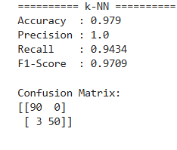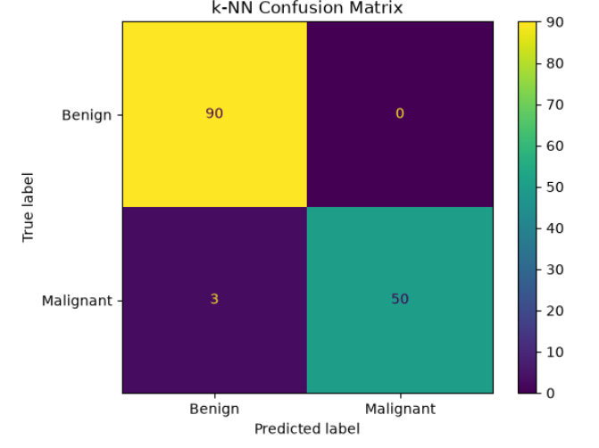

FIG 2(a): KNN FIG 2(b): Graph Repreentation




# ============================================
# COMPARISON
# ============================================

comparison = pd.DataFrame({
"Metric": ["Accuracy", "Precision", "Recall", "F1-Score"],
"Logistic Regression": [
accuracy_lr,
precision_lr,
recall_lr,
f1_lr
],

"k-NN": [
accuracy_knn,
precision_knn,
recall_knn,
f1_knn
]

print(comparison)

# Comparison graph
comparison.set_index("Metric").plot(
kind="bar",
figsize=(9, 5)
)

plt.title("Logistic Regression vs k-NN")
plt.xlabel("Metrics")
plt.ylabel("Score")
plt.ylim(0, 1.1)
plt.xticks(rotation=0)
plt.grid(axis="y")
plt.show()




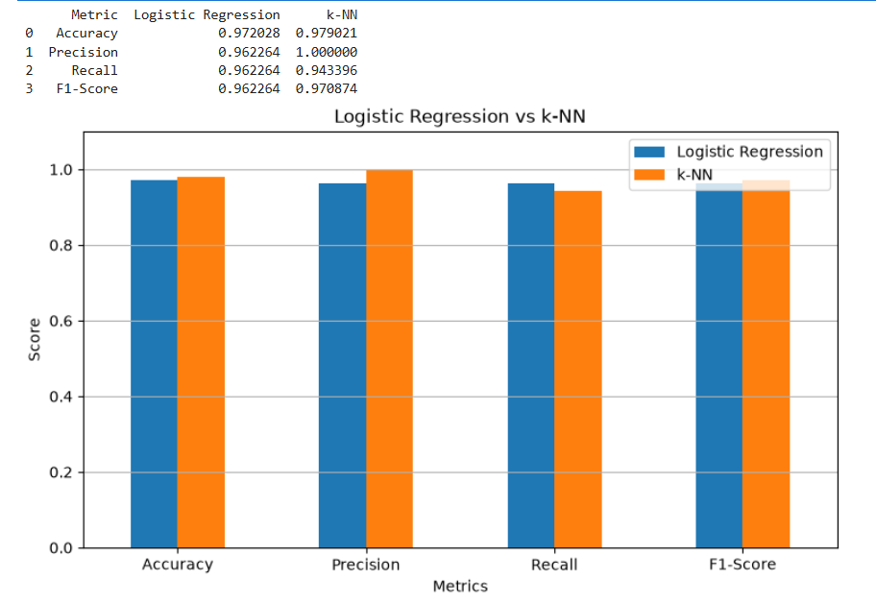

Fig 3: COMPARISON OF LOGISTIC VS KNN .

6. Learning Outcomes
After completing this experiment, students will be able to:
- Understand the fundamental concepts of classification in machine learning.
- Implement Logistic Regression and k-NN algorithms using Python.
- Perform data preprocessing, feature scaling, and train-test splitting.
- Evaluate classification models using accuracy, precision, recall, F1-score, and confusion matrix.
- Compare different classification models and select the better-performing model based on evaluation results.

