

High Level Design (HLD)

NBA Draft Combine

Measurements

# Document Version Control

|  |  |  |  |
| --- | --- | --- | --- |
| **Date Issued** | **Version** | **Description** | **Author** |
| 20/01/2022 | 1 | HLD – V1.0 | Anjali kumari |
|  |  |  |  |
|  |  |  |  |
|  |  |  |  |
|  |  |  |  |

Contents

Document Version Control.........................................................................................................2

Abstract......................................................................................................................................3

1 Introduction .............................................................................................................................5

1.1 Why this High-Level Design Document?.........................................................................5

1.2 Scope ...............................................................................................................................5

2 General Description ................................................................................................................6

2.1 Problem Statement .....................................................................6

2.2 Tools used........................................................................................................................6

3 Design Details.........................................................................................................................7

3.1 Functional Architecture ....................................................................................................7

3.2 Optimization .....................................................................................................................8

4 KPIs.........................................................................................................................................9

4.1 KPIs (Key Performance Indicators) .................................................................................9

5 Deployment.............................................................................................................................9

# Abstract

Each year, thousands of players from all around the world submit their name to the National Basketball Association (NBA), in hopes that their talent warrants an invitation to the upcoming draft. The draft a process that enables teams to select the best talent to add to their roster. One of the major obstacles for teams in this process is trying to weed out the bad players, so to speak, from the good. Traditional selection methods have no real empirical backing and currently possess no fullproof measure of ensuring that the players chosen will perform well in the league. The purpose of this research paper is to develop models that can assist scouts in selecting the optimal players and prevent the selection of players who are more prone to "bust" or exhibit poor performance. In this study, I have developed several predictive models, such as decision trees and neural networks, that aide in forecasting a player’s first-year performance in the NBA. These models illustrate how pre-draft characteristics such as an individual’s height, hand size, weight, wingspan, and other attributes serve as a predictor for their first-year performance.

1 Introduction

1.1 Why this High-Level Design Document?

The purpose of this High-Level Design (HLD) Document is to add the necessary detail to the

current project description to represent a suitable model for coding. This document is also

intended to help detect contradictions prior to coding, and can be used as a reference manual

for how the modules interact at a high level.

The HLD will:

• Present all of the design aspects and define them in detail

• Describe the user interface being implemented

• Describe the hardware and software interfaces

• Describe the performance requirements

• Include design features and the architecture of the project

• List and describe the non-functional attributes like:

o Security

o Reliability

o Maintainability

o Portability

o Reusability

o Application compatibility

o Resource utilization

o Serviceability

1.2 Scope

The HLD documentation presents the structure of the system, such as the database

architecture, application architecture (layers), application flow (Navigation), and technology

architecture. The HLD uses non-technical to mildly-technical terms which should be understandable to the administrators of the system.

2 General Description

2.1 Problem Statement

For many people NBA is a festival. Their souls rejuvenate with the seasons of NBA. To do

justice to these fans you are required to analysis and tell the story of NBA data.

Measurements for NBA draft combine participants from DraftExpress.com

Analyze year-wise comparison

Find key metrics and factors and show the meaningful relationships between attributes

The objective of the project is to perform data visualization techniques to understand the

insight of the data. This project aims apply various Business Intelligence tools such as Tableau

or Power BI to get a visual understanding of the data.

2.2 Tools used

Business Intelligence tools and libraries works such as Numpy, Pandas, Excel,

Power BI are used to build the whole framework.

    

* + - For visualization of the plots, Matplotlib, Seaborn and Plotly are used.
    - Tableau/Power BI is used for dashboard creation.
    - GitHub is used as version control system.

Design Details

3.1 Functional Architecture

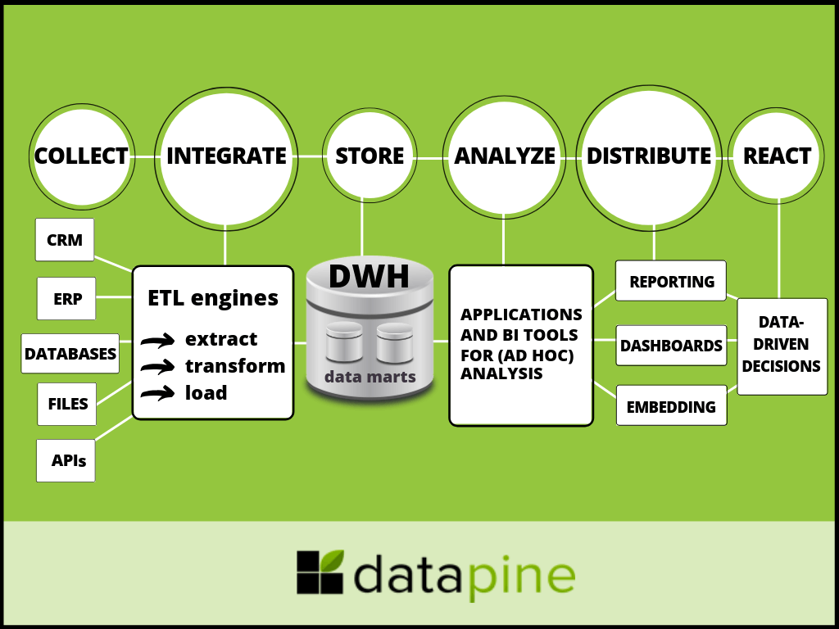

**How bi Really works**

**Organizational memory->information integration->insight creation->presentation**

3.2 Optimization

Your data strategy drives performance

• Minimize the number of fields

• Minimize the number of records

• Optimize extracts to speed up future queries by materializing calculations, removing

columns and the use of accelerated views

Reduce the marks (data points) in your view

• Practice guided analytics. There’s no need to fit everything you plan to show in a single

view. Compile related views and connect them with action filters to travel from overview

to highly-granular views at the speed of thought.

• Remove unneeded dimensions from the detail shelf.

• Explore. Try displaying your data in different types of views.

Limit your filters by number and type

• Reduce the number of filters in use. Excessive filters on a view will create a more

complex query, which takes longer to return results. Double-check your filters and

remove any that aren’t necessary.

• Use an include filter. Exclude filters load the entire domain of a dimension, while

include filters do not. An include filter runs much faster than an exclude filter, especially

for dimensions with many members.

• Use a continuous date filter. Continuous date filters (relative and range-of-date filters)

can take advantage of the indexing properties in your database and are faster than

discrete date filters.

• Use Boolean or numeric filters. Computers process integers and Booleans (t/f) much

faster than strings.

• Use parameters and action filters. These reduce the query load (and work across data

sources).

Optimize and materialize your calculations

• Perform calculations in the database

• Reduce the number of nested calculations.

• Look at the number of unique dimension members in the calculation.

• Where possible, use MIN or MAX instead of AVG. AVG requires more processing

than MIN or MAX. Often rows will be duplicated and display the same result with

MIN, MAX, or AVG.

• Use Booleans or numeric calculations instead of string calculations. Computers can

process integers and Booleans (t/f) much faster than strings.

Boolean>Int>Float>Date>DateTime>String

4 KPIs

Dashboards will be implemented to display and indicate certain KPIs and relevant indicators

As and when, the system starts to capture the periodic data for a user, the

dashboards will be included to display charts over time with progress on various indicators or

factors

4.1 KPIs (Key Performance Indicators)

Key indicators displaying a summary of the Player and its relationship with different attributes

1 Impact of BMI on performance of player

2. Impact of Sprint on performance of player

3. Influence of Agility parameter on performance of player

4. Influence of Draft pick parameter on Player

5. Influence of Wingspan parameter on Player

6. Yearly performance of Player

5 Deployment

Prioritizing data and analytics couldn’t come at a better time. Your company, no matter what

size, is already collecting data and most likely analyzing just a portion of it to solve business

problems, gain competitive advantages, and drive enterprise transformation. With the

explosive growth of enterprise data, database technologies, and the high demand for

analytical skills, today’s most effective IT organizations have shifted their focus to enabling self-service by deploying .

### **The various versions of Power BI**

* Power BI Desktop
* Power BI service
* Mobile Power BI apps for iOS and Android devices

Power BI is a **collection of software services, apps, and connectors** that work together to turn your unrelated sources of data into coherent, visually immersive, and interactive insights. Your data may be an Excel spreadsheet, or a collection of cloud-based and on-premises hybrid data warehouses.

Microsoft Power BI is used **to run reports and surface insights based on a company's data**. Power BI can connect to a wide range of data sets, and “tidies up” the info it's fed so that it can be better digested and understood. The reports and visuals generated from this data can then be shared with other users.

Power BI Service back end uses **Azure Service Bus** to connect on-premise datasources with the cloud. Azure Service Bus receives all the requests to fetch data from the on-premise data source. Then it processes the request and executes the query on the on-premise data source to retrieve data from it to the cloud service.