Q1. What is the distinction between a numpy array and a pandas data frame? Is there a way to convert between the two if there is?

Ans:- Numpy is memory efficient. Pandas has a better performance when number of rows is 500K or more. Numpy has a better performance when number of rows is 50K or less. ... Pandas offers 2d table object called DataFrame.

The Pandas module mainly works with the tabular data, whereas the NumPy module works with the numerical data. The Pandas provides some sets of powerful tools like DataFrame and Series that mainly used for analyzing the data, whereas in NumPy module offers a powerful object called Array.

Pandas dataframe is a two-dimensional data structure to store and retrieve data in rows and columns format. Numpy arrays provide fast and versatile ways to normalize data that can be used to clean and scale the data during the training of the machine learning models.

As Pandas dataframe objects already are 2-dimensional data structures, it is of course quite easy to create a dataframe from a 2-dimensional array. Much like when converting a dictionary, to convert a NumPy array we use the pd.DataFrame() constructor:

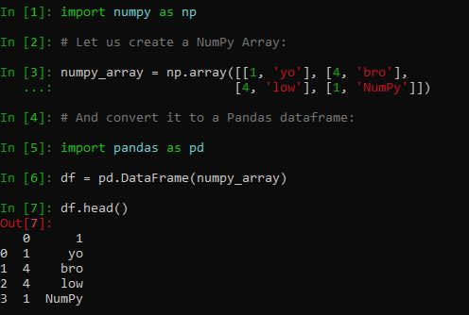

Q2. What can go wrong when an user enters in a stock-ticker symbol, and how do you handle it?

Ans:-

A stock symbol can consist of letters, numbers, or a combination of both, and is **a way to uniquely identify that stock**. The symbols were kept as short as possible to reduce the number of characters that had to be printed on the ticker tape, and to make it easy to recognize by traders and investors.

However, the name change, particularly if accompanied by a change in the stock's ticker symbol, usually implies that **a substantive issue affecting the stock price has already occurred**.

A ticker symbol with a fifth letter identifies **that there are additional circumstances with the stock, beyond a normal stock issue**. For example, the letter "K" at the end of a stock symbol means this is non-voting stock.

Most investors don't reverse the **incorrect** trade until a week or that's how long it takes for the **stock price** to return to normal.

Q3. Identify some of the plotting techniques that are used to produce a stock-market chart.

Ans:- Stock charts, like all other charts, have two axis—the vertical axis and the horizontal axis. The horizontal axis represents the historical time periods for which a technical chart has been constructed. The vertical axis displays the stock price or the trading volume corresponding to each period.

There are many types of charts that are used for technical analysis. However, the four types that are most common are—line chart, bar chart, point and figure chart and candlestick chart.

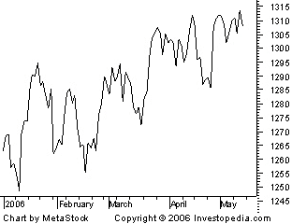

**Line charts:**A line chart is the figure that, perhaps, automatically comes to mind when you think of a chart. The line chart has the stock price or trading volume information on the vertical or y-axis and the corresponding time period on the horizontal or x-axis). Trading volumes refer to the number of stocks of a company that were bought and sold in the market on a particular day. The closing stock price is commonly used for the construction of a line chart.

**Bar charts:**A bar chart is similar to a line chart. However, it is much more informative. Instead of a dot, each marking on a bar chart is in the shape of a vertical line with two horizontal lines protruding out of it, on either side. The top end of each vertical line signifies the highest price the stock traded at during a day while the bottom point signifies the lowest price at which it traded at during a day. The horizontal line to the left signifies the price at which the stock opened the trading day. The one on the right signifies the price at which it closed the trading day. As such, each mark on a bar chart tells you four things.

**Candlestick charts:**Candlestick charts give the same information as bar charts. They only offer it in a better way. Like a bar chart is made up of different vertical lines, a candlestick chart is made up of rectangular blocks with lines coming out of it on both sides. The line at the upper end signifies the day’s highest trading price. The line at the lower end signifies the day’s lowest trading price. The day’s trading can be shown in Intraday charts. As for the block itself (called the body), the upper and the lower ends signify the day’s opening and closing price. The one that is higher of the two, is at the top, while the other one is at the bottom of the body.

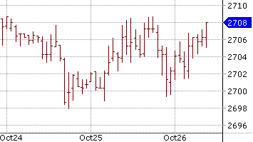

pip install yfinance

df = yf.download("TSLA", start="2018-11-01", end="2020-10-18", interval="1d")df.head()

t = yf.Ticker("T")t.dividends

t.dividends.plot(figsize=(14, 7))

pip install plotly

jupyter labextension install jupyterlab-plotly

import plotly.graph_objects as gofig = go.Figure(  
 data=go.Ohlc(  
 x=df.index,  
 open=df["Open"],  
 high=df["High"],  
 low=df["Low"],  
 close=df["Close"],  
 )  
)  
fig.show()

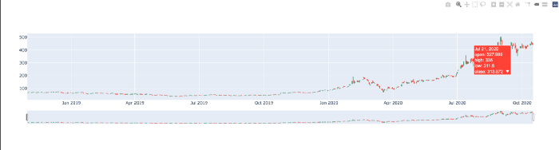

Q4. Why is it essential to print a legend on a stock market chart?

Ans:- The legend of a graph **reflects the data displayed in the graph's Y-axis**, also called the graph series. This is the data that comes from the columns of the corresponding grid report, and usually represents metrics. A graph legend generally appears as a box to the right or left of your graph.

A chart's legend shows what kind of data is represented in the chart

**displaying an example of a symbol found on the map followed by a description of the phenomenon represented by that symbol**.

 3 elements of a legend

Characters and Setting. Characters in a legend are limited to a small cast.

Plot and Theme. A legend's plot will include a lot of action, suspense and conflict.

Point of View and Style. Legends are written from the third person point of view.

Generations.

"Print" can refer to **increasing the money supply or any type of financial information transcribed into a hard copy** that is either printed or formatted for printing. It could also refer to when the price of a securities trade is timestamped by an exchange.

legend is an essential part of the chart. It **explains what the symbols on the chart mean and allows you to make sense of the chart**. chart are very valuable tools that can be used to easily show things that would otherwise be difficult to understand. **legend holds the key and other information**.

large print is a aggressive trade which usually means **a big move is coming**. We don't want to jump into this yet. The first thing that usually happens when we get big prints is a giant splash.

Q5. what is the best way to limit the length of a pandas data frame to less than a year?

Ans:- df.info(memory_usage = "deep")

With the df.info we get the following information:

The number of rows or entries

* The number of columns
* The index and name of each column
* The data type of each column
* Total memory usage of the data frame
* How many columns belong to each data type

Since a lot of these are listed as either int64 or float64, we can probably reduce them down to smaller space datatypes like int16 or float8. Downcasting means we reduce the datatypes of each feature to its lowest possible type.

## downcasting loop  
for column in df:  
 if df[column].dtype == ‘float64’:  
 df[column]=pd.to_numeric(df[column], downcast=’float’)  
 if df[column].dtype == ‘int64’:  
 df[column]=pd.to_numeric(all_data[column], downcast=’integer’)## dropping an unused column  
df = df.drop('item_name',axis =1)

Q6. What is the definition of a 180-day moving average?

Ans:-A moving average is simply an arthematic mean of a certain number of data points. Therefore 180- days moving average is calcuated by summing up the past 180 data points and then dividing the result by 180.

Q7. Did the chapter's final example use "indirect" importing? If so, how exactly do you do it?

Ans:- Indirect tax is a type of tax collected by the government from an intermediary and are not directly transferred to the government. Indirect taxes are **basically taxes that can be passed on to another entity or individual**. They are usually imposed on a manufacturer or supplier who then passes on the tax to the consumer. The most common example of an indirect tax is the excise tax on cigarettes and alcohol. Value Added Taxes (VAT)

Indirect taxes are typically added to the prices of goods or services. **Sales tax, value-added tax, excise tax, and customs duties** are examples of indirect taxes.

While direct taxes are imposed on income and profits, indirect taxes are levied on goods and services. A major difference between direct and indirect tax is the fact that **while direct tax is directly paid to the government**, there is generally an intermediary for collecting indirect taxes from the end-consumer.

GST is known as the Goods and Services Tax. It is an **indirect tax** which has replaced many indirect taxes in India such as the excise duty, VAT, services tax, etc. The Goods and Service Tax Act was passed in the Parliament on 29th March 2017 and came into effect on 1st July 2017.

Excise duty is a form of **indirect tax** that is levied by the Central Government of India for the production, sale, or license of certain goods. Excise duty charges are also collected by state governments for alcohol and narcotics.

Imports of Goods and Services will be **treated as inter-state supplies** and IGST will be levied on import of goods and services into the country. ... No tax will be payable on exports of goods or services, however credit of input tax credit will be available and same will be available as refund to the exporters.

**a situation in which a company buys products from someone in another country using an intermediary (= a person or organization that arranges business agreements)**, or a product that is bought in this way: ... Some of these goods are indirect imports.