**Kafka Integration:  
  
Zookeeper:**

In First Step, Start the Zookepeer server by the following command.

.\bin\windows\zookeeper-server-start.bat .\config\zookeeper.properties

**Server Properties:**

In second Step, Execute the properties

.\bin\windows\kafka-server-start.bat .\config\server.properties

**Created Topic:**In Third Step, Create a new Topic called 'sales'

.\bin\windows\kafka-topics.bat --create --topic quickstart-events --bootstrap-server localhost:9092

**Producer:**

In Fourth Step, Send Topic, key, value from producer

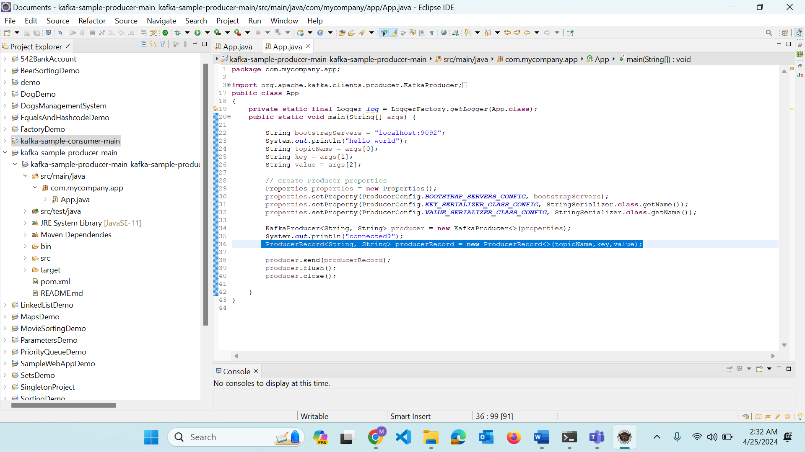

**Producer Record:**

In Fifth Step, Update the ProducerRecord in the Producer Code



**Consumer:**

Update the topic name in consumer that we created in 3rd step

Then execute the consumer and producer.

