**PLOTS OF RAW RAT DATA (ECG & RESPIRATION):**

*(from Dr. Pedro’s Lab)*

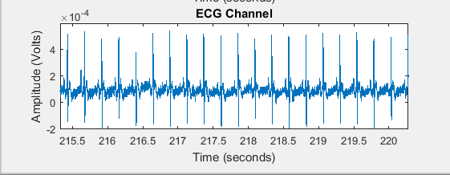

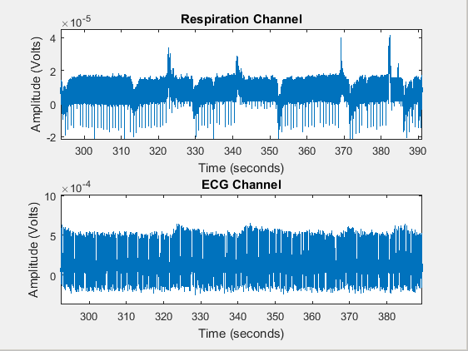

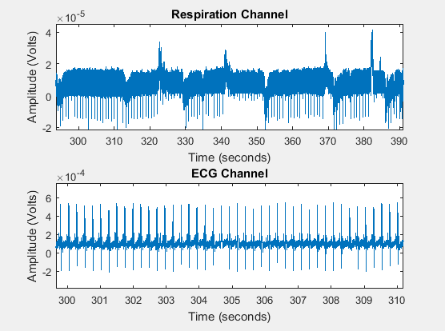

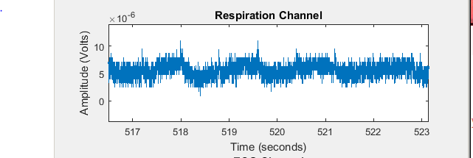

**STATISTICAL VALUES FOR RAT DATA FROM LITERATURE:**

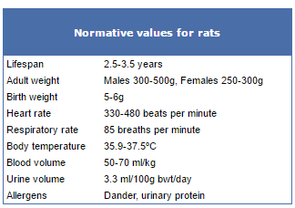

*5.5-8 beats per second*

*1.42 breaths per second*

**Reference:**

<http://web.jhu.edu/animalcare/procedures/rat.html>