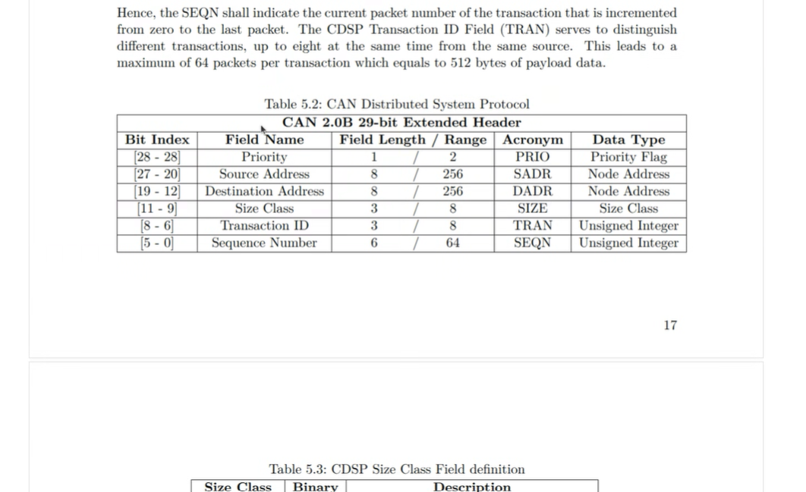

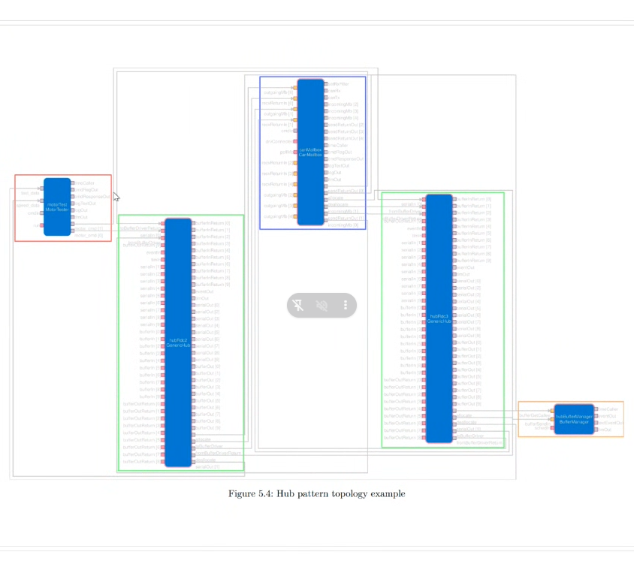

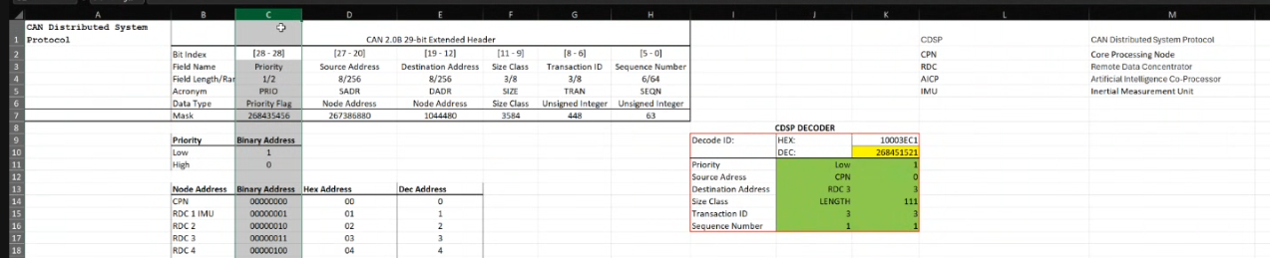

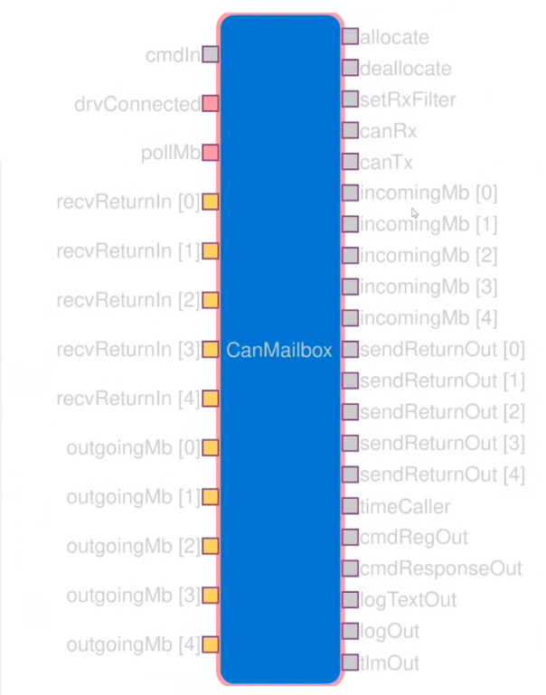

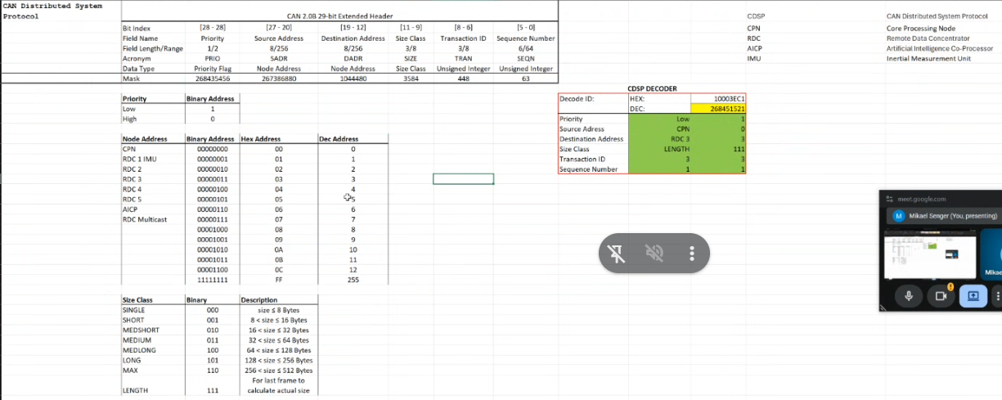

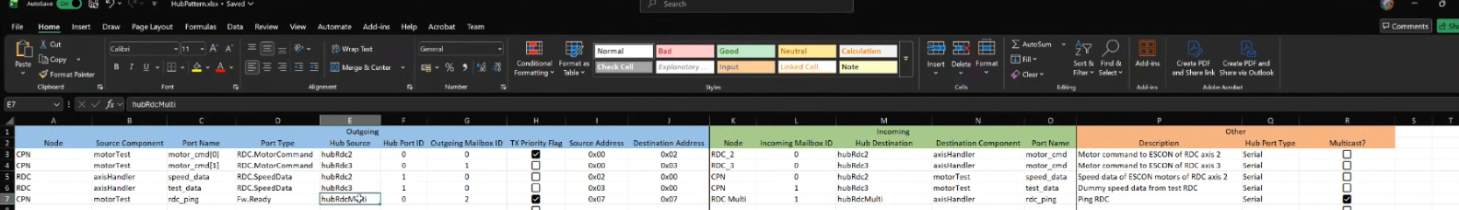

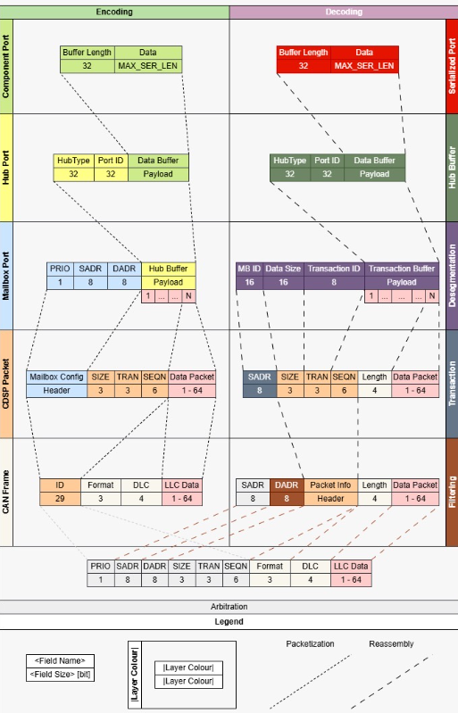

Application/FPP layer:
The application sends typed F´ port data, for example MotorCommand or SpeedData. At this level, the component does not know whether the receiver is local or on another board.
Hub layer:
The Hub serializes the typed F´ port call into a byte buffer. It adds F´ routing information such as the HubType / Port ID, so the receiving side knows which F´ port should receive the deserialized data. This is not CAN-specific.
Mailbox layer:
The Mailbox binds that serialized hub buffer to the CAN protocol. It adds node communication information: priority, source address, destination address, and manages outgoing/incoming mailbox configuration. This is the layer that makes the communication logically peer-to-peer.
Packetization / transaction layer:
Because CAN payload is limited, larger serialized buffers are split into packets. The protocol adds fields such as SIZE, TRAN, SEQN so the receiver can reassemble the original buffer.
CAN frame layer:
The final CAN frame uses the 29-bit extended CAN ID to encode protocol metadata such as priority, source address, destination address, size, transaction ID, and sequence number. The actual CAN data field carries the packet fragment.
So physically it is still one shared CAN bus, but logically it behaves like peer-to-peer because every frame contains addressing information and every node filters messages by destination/source.

