Set 2
- Q1. Write a Python function `is prime(n)` to check if a number is prime. Use an AI coding tool to generate and justify a set of test cases before implementation. Pass all generated test cases.
(Each question carries 5 marks)

Prompt:
Generate justified test cases for a Python function is_prime(n) covering normal, edge, negative, and boundary values. Then write an efficient is_prime(n) function that passes all those test cases.

Code:
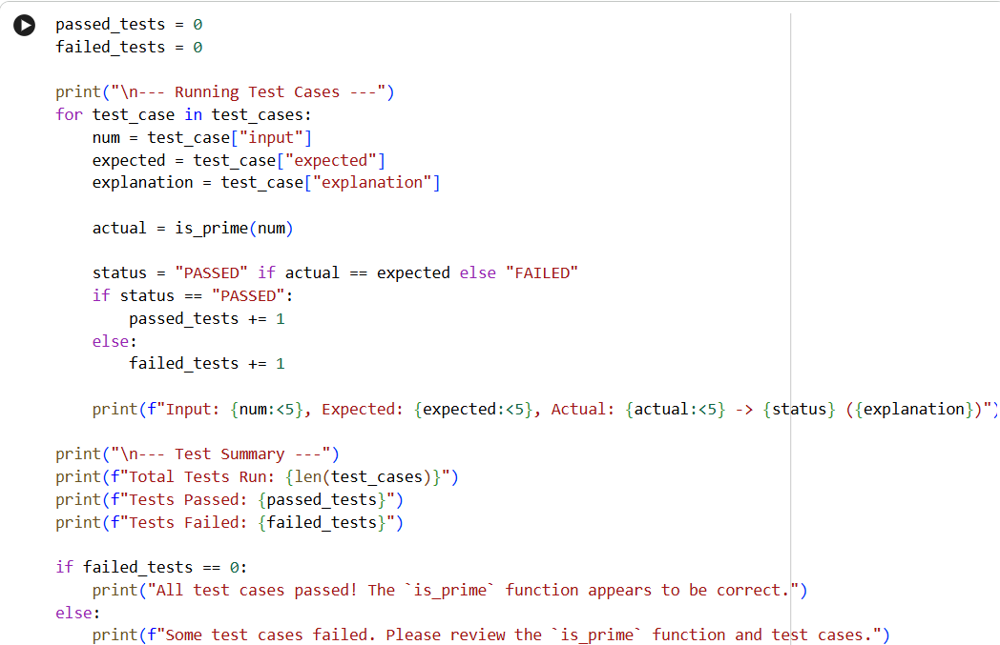

Output:
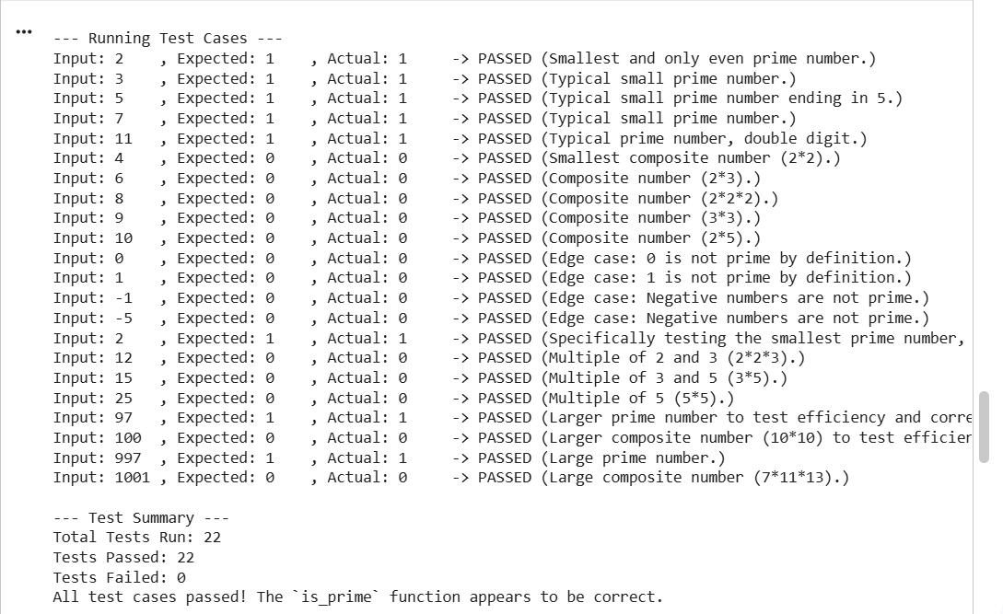

- Q2. Develop a Python class `Rectangle` with methods for area and perimeter. Use an AI assistant for auto-generating docstrings and inline comments. Compare them with your manual documentation.
(Each question carries 5 marks)

Prompt:
Create a Python class Rectangle with methods for area and perimeter. Auto-generate docstrings and inline comments using an AI assistant. Then provide my own manual documentation so I can compare both.

Code:
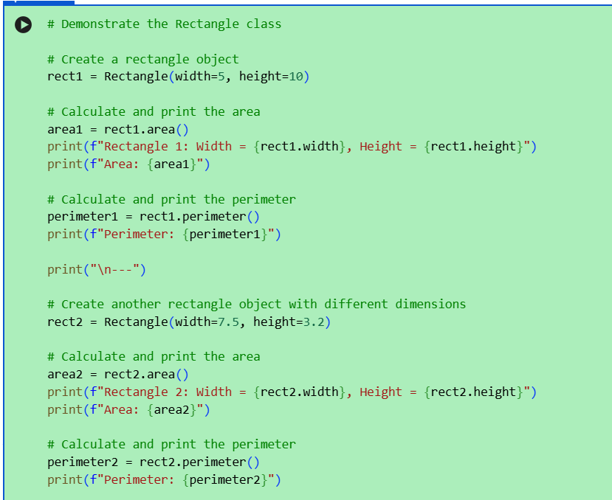

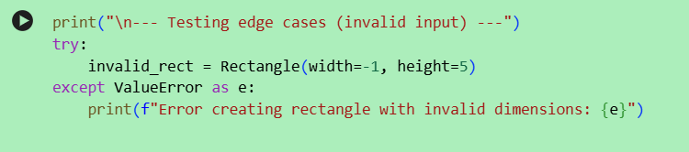

Output:

