import java.io.*;
import java.math.*;
import java.security.*;
import java.text.*;
import java.util.*;
import java.util.concurrent.*;
import java.util.function.*;
import java.util.regex.*;
import java.util.stream.*;
import static java.util.stream.Collectors.joining;
import static java.util.stream.Collectors.toList;

class Result {

/*
* Complete the 'findDay' function below.
*
* The function is expected to return a STRING.
* The function accepts following parameters:
* 1. INTEGER month
* 2. INTEGER day
* 3. INTEGER year
*/
public static String findDay(int month, int day, int year) {

Calendar cal = Calendar.getInstance();
cal.set(year, month - 1, day);

String[] days = {
"SUNDAY",
"MONDAY",
"TUESDAY",
"WEDNESDAY",
"THURSDAY",
"FRIDAY",
"SATURDAY"
};

return days[cal.get(Calendar.DAY_OF_WEEK) - 1];
}
}

public class Solution {
public static void main(String[] args) throws IOException {
BufferedReader bufferedReader = new BufferedReader(new InputStreamReader(System.in));
BufferedWriter bufferedWriter = new BufferedWriter(new FileWriter(System.getenv("OUTPUT_PATH")));

String[] firstMultipleInput = bufferedReader.readLine().replaceAll("\\s+$", "").split(" ");

int month = Integer.parseInt(firstMultipleInput[0]);

int day = Integer.parseInt(firstMultipleInput[1]);

int year = Integer.parseInt(firstMultipleInput[2]);

String res = Result.findDay(month, day, year);

bufferedWriter.write(res);
bufferedWriter.newLine();

bufferedReader.close();
bufferedWriter.close();
}
}
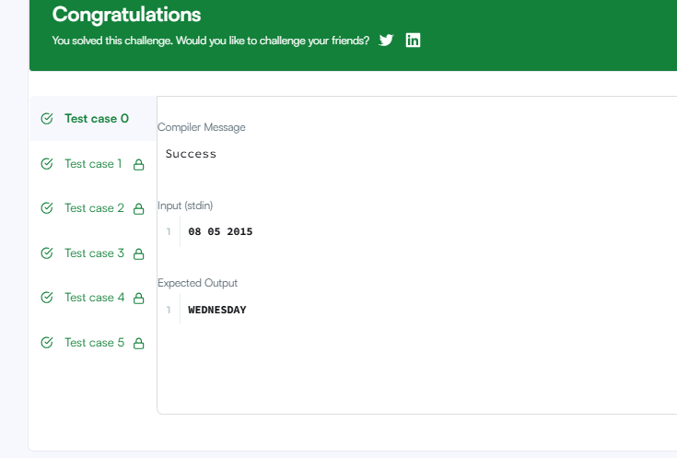

2. import java.time.LocalDate;
import java.time.temporal.ChronoUnit;

class Solution {
public int daysBetweenDates(String date1, String date2) {
LocalDate d1 = LocalDate.parse(date1);
LocalDate d2 = LocalDate.parse(date2);

return Math.abs((int) ChronoUnit.DAYS.between(d1, d2));
}
}

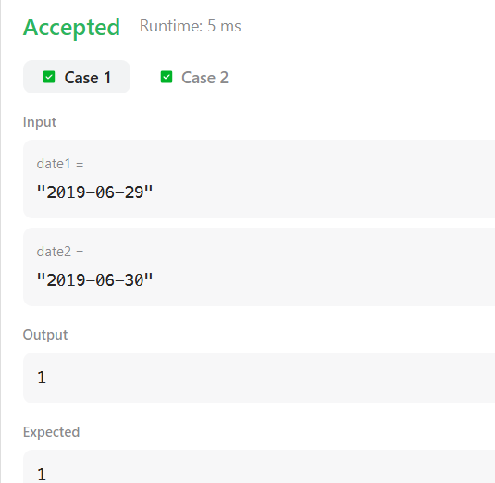
3 . class Solution {
public int dayOfYear(String date) {
String[] parts = date.split("-");
int year = Integer.parseInt(parts[0]);
int month = Integer.parseInt(parts[1]);
int day = Integer.parseInt(parts[2]);

int[] daysInMonth = {31, 28, 31, 30, 31, 30, 31, 31, 30, 31, 30, 31};

// Check if the year is a leap year
if ((year % 4 == 0 && year % 100 != 0) || (year % 400 == 0)) {
daysInMonth[1] = 29;
}

int dayCount = day;
for (int i = 0; i < month - 1; i++) {
dayCount += daysInMonth[i];
}

return dayCount;
}
}
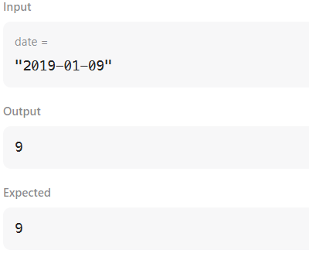
4. import java.time.LocalDate;
import java.time.format.TextStyle;
import java.util.Locale;

class Solution {
public String dayOfTheWeek(int day, int month, int year) {
LocalDate date = LocalDate.of(year, month, day);
return date.getDayOfWeek()
.getDisplayName(TextStyle.FULL, Locale.ENGLISH);
}
}
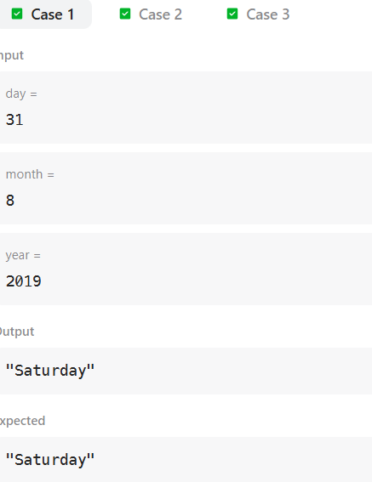
5. import java.util.ArrayList;
import java.util.List;
import java.util.Scanner;
import java.util.PriorityQueue;
import java.util.Comparator;
class Student {
private int id;
private String name;
private double cgpa;

public Student(int id, String name, double cgpa) {
this.id = id;
this.name = name;
this.cgpa = cgpa;
}

public int getID() {
return id;
}

public String getName() {
return name;
}

public double getCGPA() {
return cgpa;
}
}

class Priorities {

public List<Student> getStudents(List<String> events) {

PriorityQueue<Student> pq = new PriorityQueue<>(new Comparator<Student>() {
@Override
public int compare(Student s1, Student s2) {

if (Double.compare(s2.getCGPA(), s1.getCGPA()) != 0) {
return Double.compare(s2.getCGPA(), s1.getCGPA());
}

if (!s1.getName().equals(s2.getName())) {
return s1.getName().compareTo(s2.getName());
}

return Integer.compare(s1.getID(), s2.getID());
}
});

for (String event : events) {
String[] arr = event.split(" ");

if (arr[0].equals("ENTER")) {
pq.add(new Student(
Integer.parseInt(arr[3]),
arr[1],
Double.parseDouble(arr[2])
));
} else if (arr[0].equals("SERVED")) {
if (!pq.isEmpty()) {
pq.poll();
}
}
}

List<Student> result = new ArrayList<>();

while (!pq.isEmpty()) {
result.add(pq.poll());
}

return result;
}
}

public class Solution {
private final static Scanner scan = new Scanner(System.in);
private final static Priorities priorities = new Priorities();

public static void main(String[] args) {
int totalEvents = Integer.parseInt(scan.nextLine());
List<String> events = new ArrayList<>();

while (totalEvents-- != 0) {
String event = scan.nextLine();
events.add(event);
}

List<Student> students = priorities.getStudents(events);

if (students.isEmpty()) {
System.out.println("EMPTY");
} else {
for (Student st: students) {
System.out.println(st.getName());
}
}
}
}

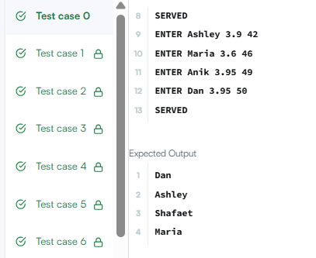
6. import java.util.ArrayList;
import java.util.List;
import java.util.Scanner;

public class Solution {
public static void main(String[] args) {
Scanner scanner = new Scanner(System.in);

int n = scanner.nextInt();
List<List<Integer>> lines = new ArrayList<>();

// Read all n lines of numbers
for (int i = 0; i < n; i++) {
int d = scanner.nextInt(); // Number of elements in this line
List<Integer> line = new ArrayList<>();
for (int j = 0; j < d; j++) {
line.add(scanner.nextInt());
}
lines.add(line);
}

int q = scanner.nextInt(); // Number of queries

// Process each query
for (int i = 0; i < q; i++) {
int x = scanner.nextInt(); // Line index (1-based)
int y = scanner.nextInt(); // Position index (1-based)

// Convert 1-based indexing to 0-based indexing
int lineIndex = x - 1;
int posIndex = y - 1;

// Check if line index and position index are within valid bounds
if (lineIndex >= 0 && lineIndex < lines.size()) {
List<Integer> targetLine = lines.get(lineIndex);
if (posIndex >= 0 && posIndex < targetLine.size()) {
System.out.println(targetLine.get(posIndex));
continue;
}
}

System.out.println("ERROR!");
}

scanner.close();
}
}
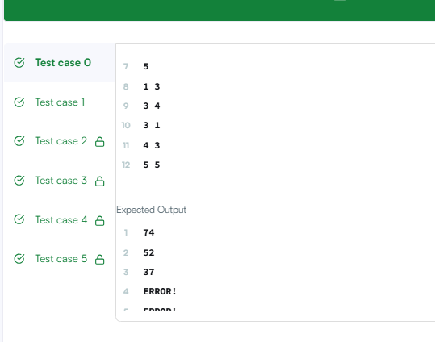
7. import java.util.Arrays;

class Solution {
public String largestNumber(int[] nums) {
// Convert integer array to String array
String[] strNums = new String[nums.length];
for (int i = 0; i < nums.length; i++) {
strNums[i] = String.valueOf(nums[i]);
}

// Custom comparator: compare concatenated strings (b + a vs a + b)
Arrays.sort(strNums, (a, b) -> (b + a).compareTo(a + b));

// Edge case: if the largest number after sorting is "0", the entire result is "0"
if (strNums[0].equals("0")) {
return "0";
}

// Build the final result
StringBuilder result = new StringBuilder();
for (String num : strNums) {
result.append(num);
}

return result.toString();
}
}
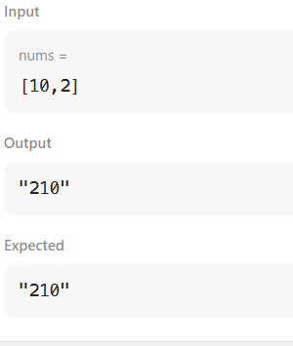
8. import java.util.*;
class Checker implements Comparator<Player> {
@Override
public int compare(Player a, Player b) {
// If scores are equal, sort alphabetically by name
if (a.score == b.score) {
return a.name.compareTo(b.name);
}
// Otherwise, sort in descending order of score
return b.score - a.score;
}
}

class Player{
String name;
int score;

Player(String name, int score){
this.name = name;
this.score = score;
}
}

class Solution {

public static void main(String[] args) {
Scanner scan = new Scanner(System.in);
int n = scan.nextInt();

Player[] player = new Player[n];
Checker checker = new Checker();

for(int i = 0; i < n; i++){
player[i] = new Player(scan.next(), scan.nextInt());
}
scan.close();

Arrays.sort(player, checker);
for(int i = 0; i < player.length; i++){
System.out.printf("%s %s\n", player[i].name, player[i].score);
}
}
}
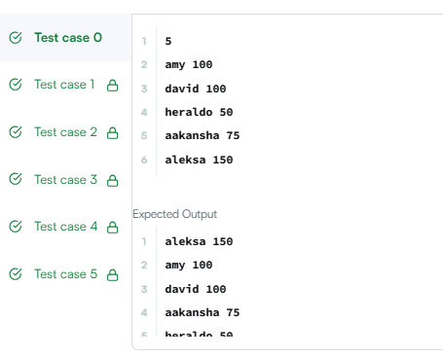
9. import java.util.Arrays;

class Solution {
public String[] sortPeople(String[] names, int[] heights) {
int n = names.length;
Person[] people = new Person[n];

for (int i = 0; i < n; i++) {
people[i] = new Person(names[i], heights[i]);
}

// Sort descending by height
Arrays.sort(people, (a, b) -> Integer.compare(b.height, a.height));

String[] result = new String[n];
for (int i = 0; i < n; i++) {
result[i] = people[i].name;
}

return result;
}

private static class Person {
String name;
int height;

Person(String name, int height) {
this.name = name;
this.height = height;
}
}
}
