SRE CHALLENGE

-By Anjali

[AnjaliReddyk5@gmail.com](mailto:AnjaliReddyk5@gmail.com)

Note : Ansible has been chosen to accomplish this project

Spin up the EC2 Instance with RHEL configuration on AWS to be used as Ansible server:

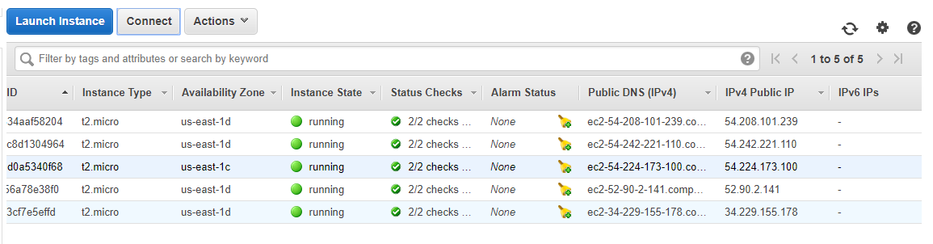

Connect to the server using SSH:

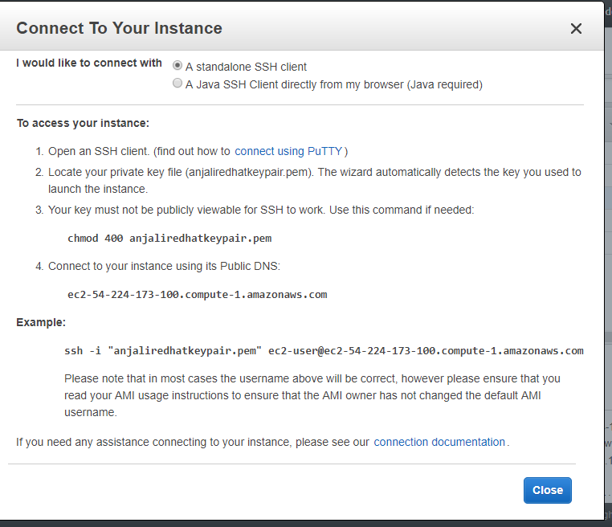

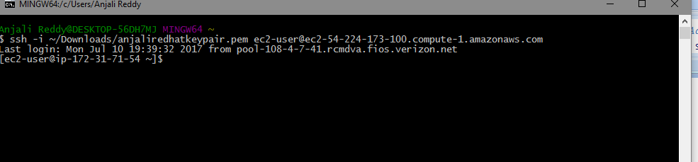

Login as root user to perform installations

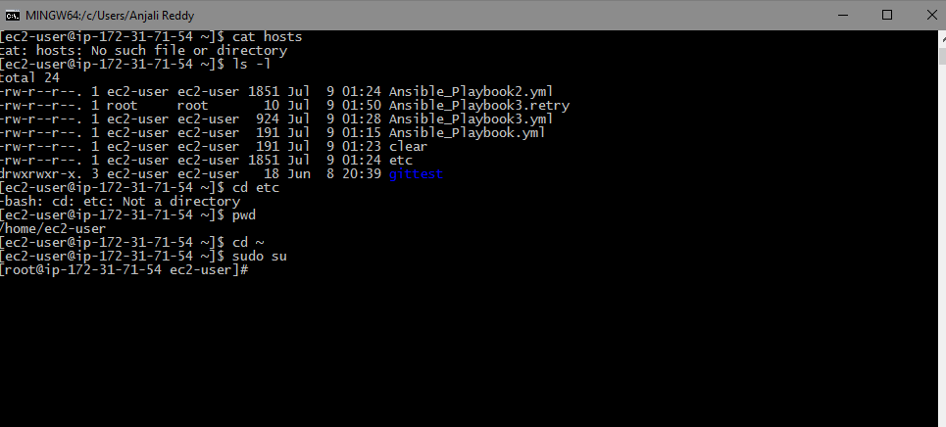

Install Ansible on top of it

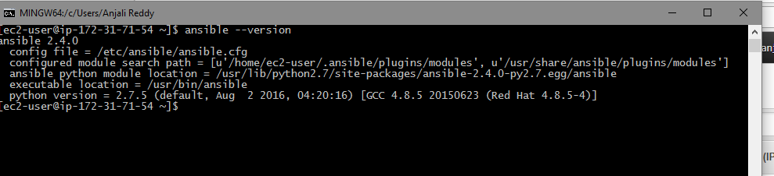

RHEL doesn’t have Ansible package. So, EPEL has been used to download and install Ansible.

Create a ~/Hosts file and do the necessary configuration

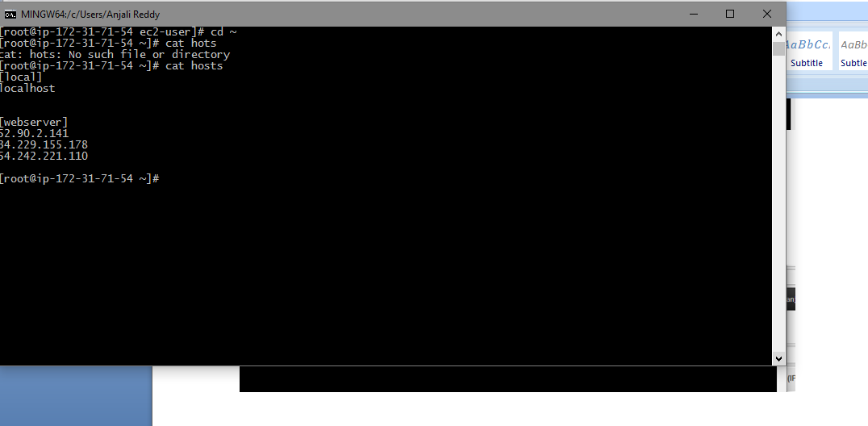

Set the access keys for the instance.

Now, this machine will act as a Ansible server.

We can run playbooks on this and spin up the infrastructure.

For the purpose of configuring HTTPS we need to create the certificate.

Create a Self Signed certificate using IIS or whatever open source that is available. In live projects these are provided by TRM or the Arcitect and are installed by Middleware teams.

