SRE CHALLENGE

-By Anjali

[AnjaliReddyk5@gmail.com](mailto:AnjaliReddyk5@gmail.com)

Do a CHMOD and make the key pair public

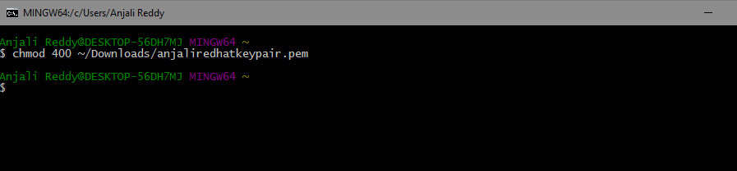

Use SCP and copy the playbook onto the Ansible server

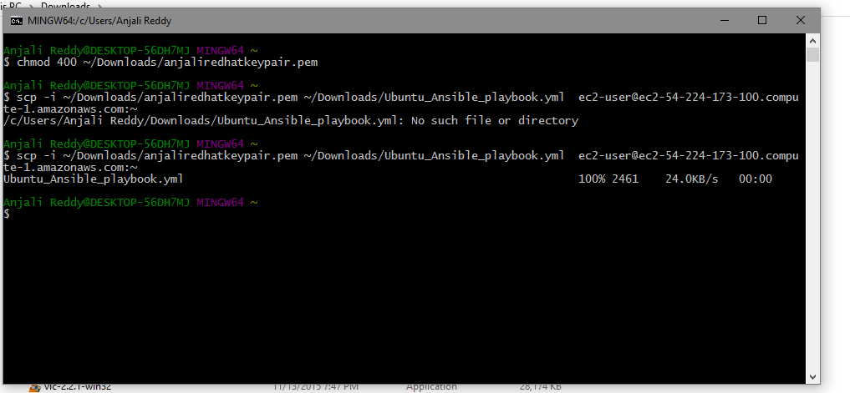

Run the playbook and that spins up the UBUNTU machine and configures the necessary firewalls for ports 22,80,443.

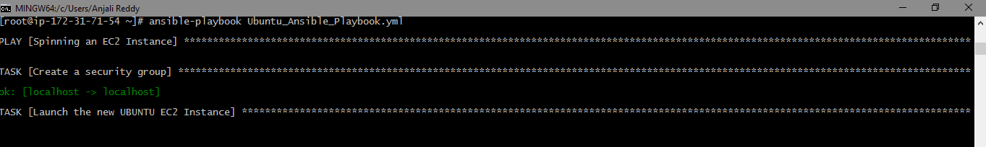

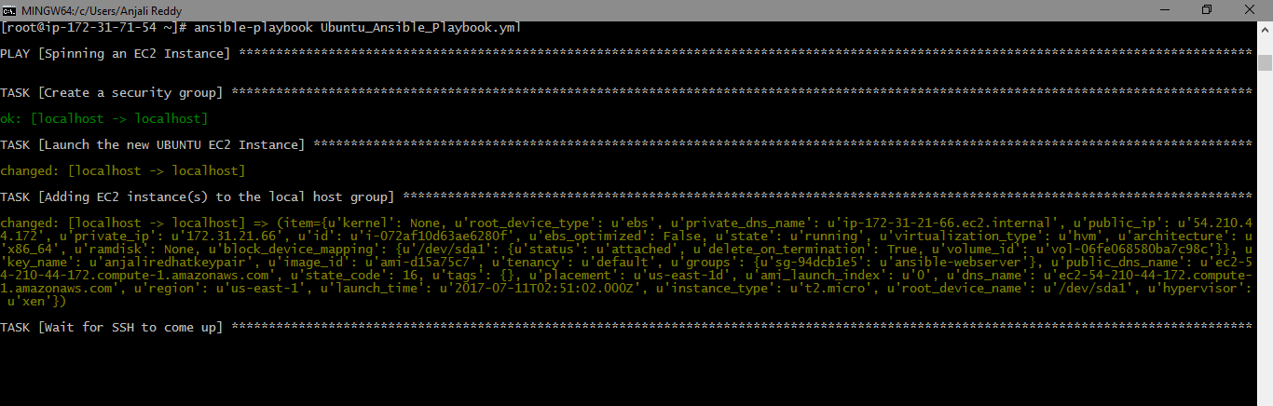

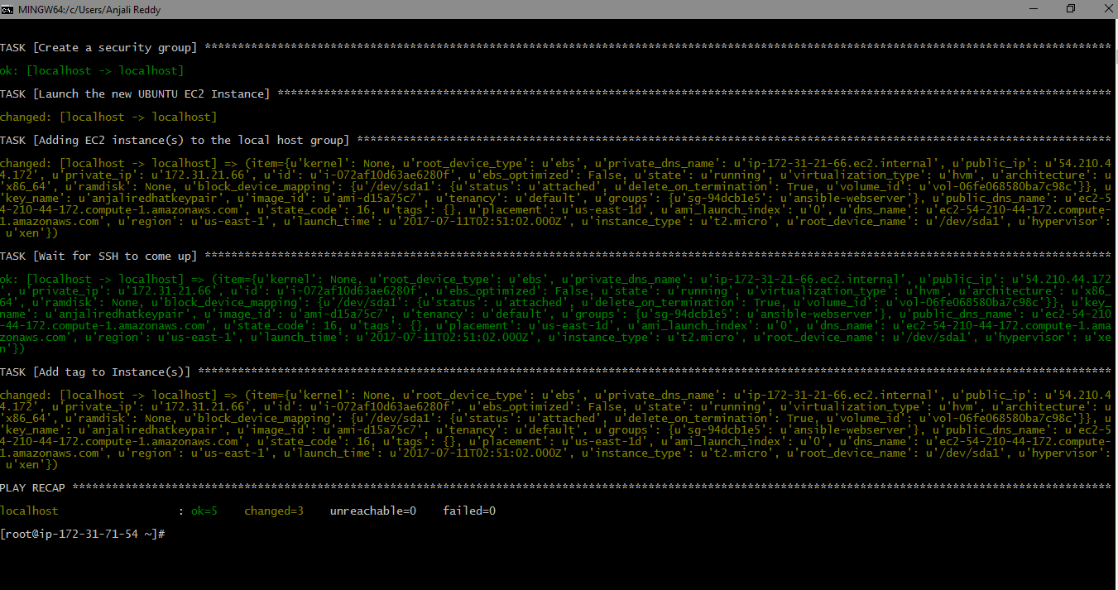

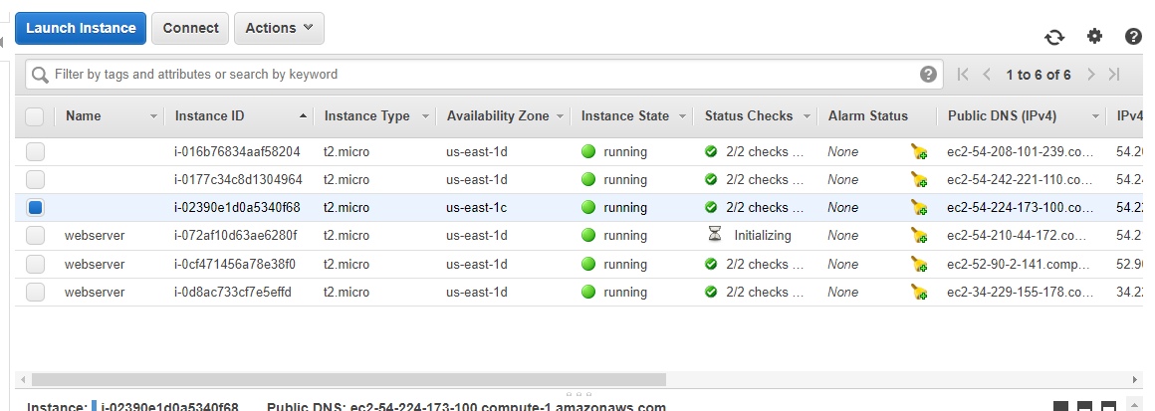

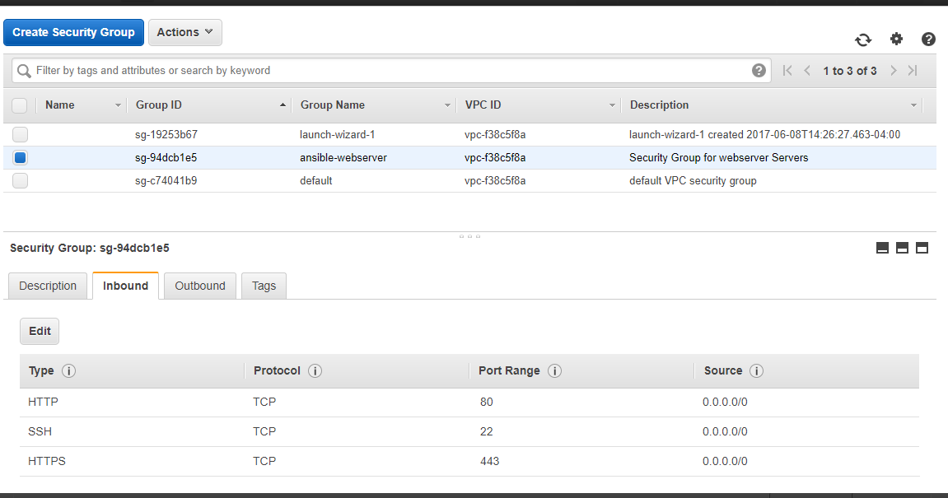

Now set up the Apache using the Ubuntu_Apache_Ansible_playbook.yml.

The Automated tests are also handled in this playbook.