STUDENT PERFORMANCE ANALYTICS SYSTEM
Project Documentation
Details | Information
Student Name | Anjali Shikhare
Course | Python with AI
Project Type | Python Data Analysis Project
Technologies | Python, NumPy, Pandas
Dataset | 20 student records
Submission Year | 2026

This document explains the objective, dataset, implementation, features, results, learning outcomes and final outcome of the Student Performance Analytics System.

1. Objective
The aim of this project is to analyze student marks and attendance using Python, NumPy and Pandas. The system reads student data from a CSV file, processes the marks, calculates performance measures and presents useful results such as total marks, average marks, grades, pass/fail status, ranking, subject-wise performance and top performers.

2. Technologies Used
Technology | Purpose
Python | Used for the main program, functions, conditions and loops.
NumPy | Used for numerical calculations such as sum, mean, median and standard deviation.
Pandas | Used to read the CSV file, create/process the DataFrame and perform data analysis.
CSV | Used to store the student dataset.

3. Dataset Description
The project uses a CSV file named students.csv containing 20 student records. The dataset includes student identification, department, marks in five subjects and attendance.
Field | Description
Student_ID | Unique ID of the student.
Name | Student name.
Department | Student department such as CSE, IT, ECE, Civil and Mechanical.
Python | Marks in Python.
Java | Marks in Java.
DBMS | Marks in DBMS.
Web Development | Marks in Web Development.
Data Analytics | Marks in Data Analytics.
Attendance | Attendance percentage.

4. Implementation

Step 1 – Load the Dataset
The load_data() function uses Pandas read_csv() to read students.csv and return the student data as a DataFrame.

Step 2 – Calculate Total and Average
For each student, the five subject marks are selected. NumPy is used to calculate the total using np.sum() and the average using np.mean().

Step 3 – Grade and Result
Grades are assigned according to the calculated average. The grading rule used in the project is: A+ for 90 and above, A for 80–89, B+ for 70–79, B for 60–69, C for 50–59, D for 40–49 and F below 40. A student is marked Fail if any subject mark is below 40; otherwise the result is Pass.

Step 4 – Attendance Status
Attendance is checked using a minimum attendance value of 75%. Students with attendance of 75% or above are marked Regular; otherwise they are marked Low.

Step 5 – Ranking and Analysis
Students are ranked according to total marks. The project also calculates class average, median, standard deviation, pass percentage and average attendance. Subject-wise analysis finds average, highest, lowest, passed, failed and subject topper values.

5. Project Structure
File | Purpose
main.py | Runs the project and displays the final analysis.
functions.py | Contains reusable functions for calculations and analysis.
students.csv | Stores the 20 student records.
README.md | Provides basic project information and running instructions.

6. Key Features
- Reads and displays student data from a CSV file.
- Calculates total marks for each student.
- Calculates average marks using NumPy.
- Assigns grades based on the average.
- Identifies Pass/Fail based on subject marks.
- Ranks students based on total marks.
- Performs subject-wise analysis.
- Identifies the top five students.
- Checks attendance status using the 75% threshold.
- Calculates class-level performance statistics.

7. Output / Results
The program was executed successfully using the project files. The following results were obtained from the current 20-student dataset.
Metric | Result
Total Students | 20
Class Average | 71.88
Highest Average | Ananya Bhosale – 93.2
Lowest Average | Rahul Sawant – 44.0
Students Passed | 17
Students Failed | 3
Pass Percentage | 85.0%

Subject-wise Analysis
Subject | Average | Highest | Lowest | Topper
Python | 70.70 | 95 | 35 | Priya Deshmukh
Java | 69.20 | 95 | 38 | Ananya Bhosale
DBMS | 70.20 | 92 | 39 | Ananya Bhosale
Web Development | 74.75 | 92 | 50 | Neha Pawar
Data Analytics | 74.55 | 98 | 46 | Priya Deshmukh

8. Top Performers
Rank | Student | Department | Total | Average | Grade
1 | Ananya Bhosale | ECE | 466 | 93.2 | A+
2 | Priya Deshmukh | CSE | 460 | 92.0 | A+
3 | Neha Pawar | IT | 454 | 90.8 | A+
4 | Meera Phadke | Civil | 437 | 87.4 | A
5 | Ishita Kamble | CSE | 424 | 84.8 | A

Sample Output
The console output displays sections for Student Data, Results, Overall Performance, Subject Analysis and Top 5 Students. The program finishes with “PROJECT COMPLETED”.
Example: Total Students: 20 | Class Average: 71.88 | Students Passed: 17 | Students Failed: 3 | Pass Percentage: 85.0%
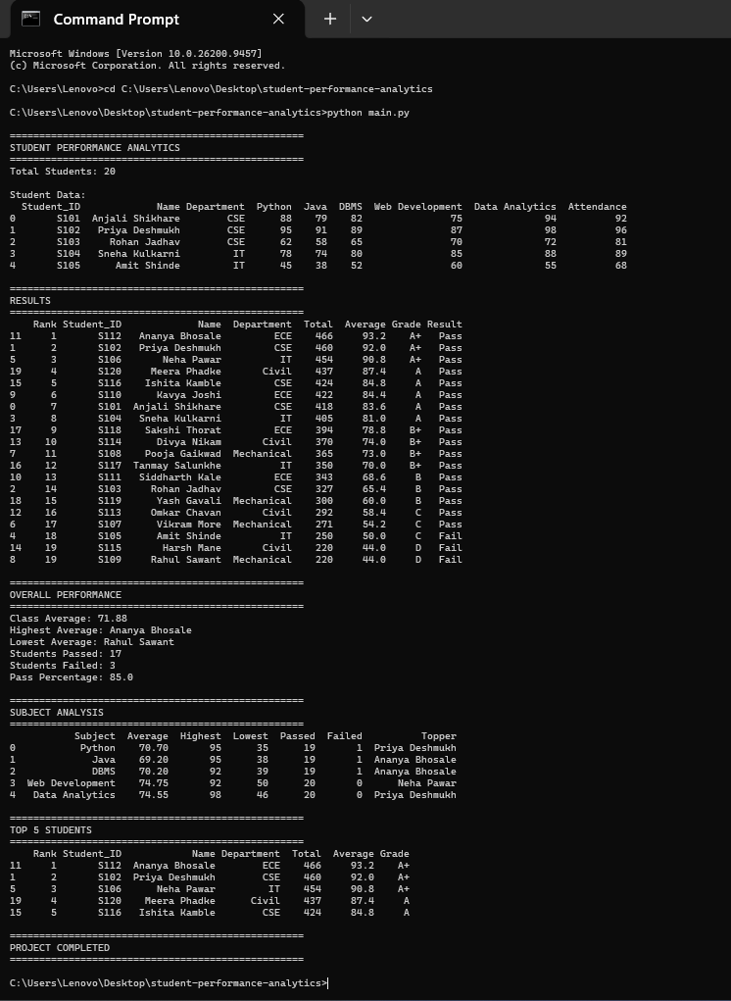

9. Final Outcome
The Student Performance Analytics System successfully reads student data and performs basic academic analysis using Python, NumPy and Pandas. It provides student-wise results, grades, pass/fail status and rankings, along with subject-wise and class-level performance information. The project demonstrates the use of Python fundamentals, NumPy calculations and Pandas DataFrame operations in a practical data-analysis application.

10. Challenges and Learning
While developing the project, attention was required to keep the subject names consistent between the Python code and CSV dataset. The project also helped in understanding how to divide calculations into reusable functions and how to use loops, conditions, NumPy and Pandas together for a complete analysis task.

11. GitHub Repository
GitHub repository: https://github.com/anjalishikhare80/student-performance-analytics

12. Conclusion
This project meets the main requirements of the Student Performance Analytics System assignment. It uses a 20-record student dataset, Pandas for data handling, NumPy for numerical calculations, functions and loops for processing, and produces meaningful academic performance results.

Final Project Files
File | Status
main.py | Completed and tested
functions.py | Completed and tested
students.csv | 20 student records
README.md | Project information and run instructions
Project_Documentation.docx | This documentation

End of Project Documentation

