What is DevOps?
- DevOps is a set of practices, methodologies, and cultural philosophies that aim to improve collaboration and communication between software development (Dev) and information technology operations (Ops) teams.
- The main goal of DevOps is to create a more streamlined and efficient software development and deployment process, leading to faster delivery of high-quality software products.
- Traditionally, software development and operations teams operated in silos, which could lead to communication gaps, inefficiencies, and delays in the software delivery process.
- DevOps seeks to break down these barriers and encourage a more collaborative and integrated approach to software development and deployment.
The Key aspects and principles of DevOps include:
- Automation: DevOps heavily emphasizes automation of repetitive tasks such as building, testing, and deploying software. Automation helps reduce manual errors, increases efficiency, and enables faster iterations.
- Continuous Integration (CI): CI is the practice of frequently integrating code changes into a shared repository. Each integration triggers an automated build and test process to detect issues early.
- Continuous Delivery (CD): CD takes CI further by automating the deployment process to ensure that software changes can be deployed to production or staging environments quickly and reliably.
- Infrastructure as Code (IaC): IaC involves managing and provisioning infrastructure through code, allowing for consistency, versioning, and reproducibility of infrastructure configurations.
- Monitoring and Logging: DevOps teams put a strong emphasis on real-time monitoring and logging of applications and infrastructure to identify issues and gather performance insights.
- Collaboration and Communication: Effective communication and collaboration between development, operations, and other stakeholders are fundamental to DevOps. This often involves breaking down organizational barriers and encouraging shared responsibility.
- Agile Practices: DevOps is closely aligned with Agile software development principles, promoting iterative development, feedback loops, and customer-centricity.
By adopting DevOps practices, organizations can achieve faster software development cycles, reduced time-to-market, improved product quality, increased collaboration, and enhanced customer satisfaction. It's important to note that DevOps is not just a set of tools
but a cultural shift that requires collaboration, flexibility, and a focus on continuous improvement.

What are the phases of DevOps?

DevOps is a continuous and iterative process that involves several key phases throughout the software development and deployment lifecycle.
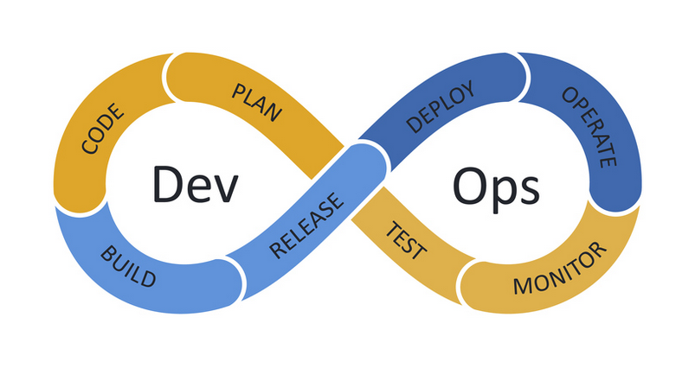
While the implementation of DevOps can vary from one organization to another, here are the common phases of DevOps:
- Planning: The planning phase sets the foundation for the entire DevOps process. It involves defining project goals, outlining requirements, and creating a roadmap for development and deployment. Stakeholders, including developers, operations teams, and business representatives, collaborate to prioritize tasks and set objectives.
- Development: In this phase, developers write code to implement the features and changes outlined in the planning phase. The development process should follow best practices, including version control, code reviews, and continuous integration.
- Continuous Integration (CI): In the CI phase, code changes are integrated into a shared repository frequently and automatically. Each integration triggers an automated build and testing process to detect and address any issues as early as possible.
- Testing: The testing phase involves various types of testing, such as unit testing, integration testing, system testing, and performance testing. Automated testing is often a crucial component of DevOps to ensure quick feedback on code quality and functionality.
- Continuous Delivery (CD): In the CD phase, the application is continuously prepared for release to production or staging environments. Automated deployment pipelines ensure that the application can be released at any time with confidence.
- Deployment: In this phase, the application is deployed to production or staging environments. Automation helps ensure consistency and reduces the risk of errors during deployment.
- Monitoring and Feedback: Monitoring is a crucial aspect of DevOps. Once the application is in production, continuous monitoring and logging provide valuable insights into performance, user behavior, and any potential issues that need to be addressed.
- Feedback and Iteration: DevOps encourages a culture of continuous improvement. Feedback from users and stakeholders, as well as insights from monitoring, inform further iterations and enhancements to the application.
It's important to note that DevOps is not a linear process, and these phases are often interconnected and overlapping. The iterative nature of DevOps allows for continuous refinements and optimizations at each stage of the software development and deployment lifecycle. This leads to faster, more reliable releases and a culture of continuous learning and collaboration within the organization.

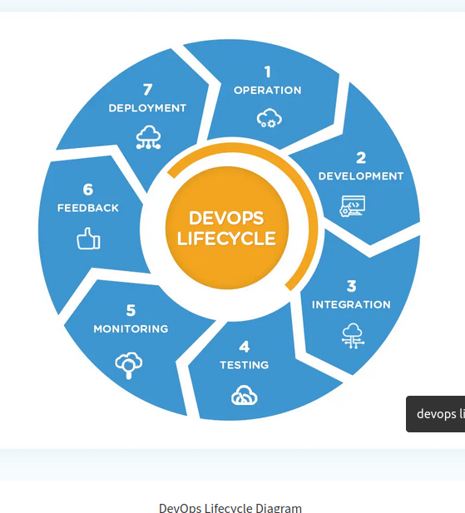

What are the different tools in different phases?
DevOps involves the integration of various tools across different phases of the software development and deployment lifecycle to facilitate automation, collaboration, monitoring, and more. Here's an overview of some common tools used in different DevOps phases:
- Planning Phase:
  - Version Control: Git, Subversion (SVN), Mercurial
  - Project Management: Jira, Trello, Asana
  - Requirements Management: Confluence, Microsoft Azure DevOps
- Development Phase:
  - Integrated Development Environments (IDEs): Visual Studio Code, IntelliJ IDEA, Eclipse
  - Code Review: GitHub, GitLab, Bitbucket
  - Static Code Analysis: SonarQube, ESLint, Checkstyle
  - Continuous Integration: Jenkins, GitLab CI/CD, Travis CI, CircleCI
- Continuous Integration (CI) and Continuous Deployment (CD) Phase:
  - Build Automation: Apache Maven, Gradle
  - Automated Testing: JUnit, TestNG, Selenium, Cypress
  - Artifact Repository: Nexus Repository, JFrog Artifactory
  - Continuous Deployment: Kubernetes, Docker, AWS Elastic Beanstalk
- Testing Phase:
  - Test Automation: Selenium, JUnit, TestNG, Cucumber
  - Load Testing: Apache JMeter, Gatling, Locust
  - Security Testing: OWASP Zap, SonarQube (for security code analysis)
- Monitoring and Feedback Phase:
  - Application Performance Monitoring (APM): New Relic, Dynatrace, AppDynamics
  - Log Management: ELK Stack (Elasticsearch, Logstash, Kibana), Splunk
  - User Feedback and Analytics: Google Analytics, Mixpanel
- Collaboration Phase:
  - Communication and Chat: Slack, Microsoft Teams
  - Collaboration Platforms: Microsoft Azure DevOps, Atlassian Confluence
- Configuration Management Phase:
  - Infrastructure as Code (IaC): Terraform, AWS CloudFormation, Azure Resource Manager
  - Configuration Management Tools: Ansible, Puppet, Chef
- Containerization:
  - Container Orchestration: Kubernetes, Docker Swarm, Amazon ECS
  - Container Registry: Docker Hub, Google Container Registry, Amazon ECR
It's important to note that the choice of tools can vary depending on the organization's specific needs, technology stack, and existing infrastructure. Also, some tools may cover multiple phases or functionalities, and there are numerous other tools available in the DevOps ecosystem beyond the examples provided here. The key is to select tools that best fit the organization's requirements and integrate them effectively to create a cohesive and efficient DevOps pipeline.

Difference between Virtual machine and Container?
Aspect | Virtual Machines (VMs) | Containers
Architecture | Complete virtualized OS on a hypervisor | Share host OS kernel
Isolation | Strong isolation between VMs | Lighter isolation between containers
Resource Overhead | Higher resource overhead (more memory and storage) | Lower resource overhead (share OS components)
Deployment & Startup Time | Longer startup time (boot entire OS) | Faster startup (only launch application process)
Portability | Portable between hypervisors with some compatibility considerations | Highly portable across environments
Use Cases | Suitable for running multiple different OSes and workloads | Ideal for microservices and scalable applications
Management | Requires individual OS management for each VM | Easier management with standardized environments
Ecosystem | Diverse virtualization platforms | Docker is a popular container platform

What is Docker?What are the architecture of the Docker?

Docker is an open-source platform that enables developers to automate the deployment, scaling, and management of applications using containerization technology. It provides a way to package applications, along with their dependencies and configurations, into containers. Docker has become widely popular for its ease of use, portability, and efficiency in creating lightweight, isolated environments for running applications.
Architecture of Docker:
The architecture of Docker revolves around the following key components:
- Docker Daemon: The Docker daemon, also known as dockerd, is a background service responsible for managing Docker objects such as images, containers, networks, and volumes. It listens to the Docker API requests and handles container lifecycle management, image downloads, and other core functionalities.
- Docker Client: The Docker client, known as docker, is a command-line tool that allows users to interact with the Docker daemon via the Docker API. Developers and administrators use the Docker client to build, run, and manage containers. It communicates with the Docker daemon either locally or remotely.
- Docker Images: Docker images are the building blocks of containers. An image is a lightweight, standalone, and executable software package that includes everything needed to run an application, including code, runtime, libraries, environment variables, and configuration files. Images are typically built from a Dockerfile, which specifies the instructions for creating the image.
- Docker Containers: Containers are instances of Docker images. A container is a runnable environment that encapsulates the application and its dependencies, isolated from the underlying system and other containers. Containers can be started, stopped, and deleted easily, making them ideal for fast and consistent application deployment.
- Docker Registry: The Docker registry is a repository that stores Docker images. It can be either public, such as Docker Hub, where developers can share and access pre-built images, or private, where organizations store their proprietary images. Docker clients can pull images from the registry to their local system for use.
- Docker Network: Docker provides networking functionality that allows containers to communicate with each other and with external networks. Docker creates a default bridge network to facilitate communication between containers on the same host.
- Docker Volumes: Docker volumes are used to persist data and share files between containers and the host system. Volumes ensure that data stored in a container is retained even after the container is removed, allowing for data persistence and easy backup.
Docker's architecture and ease of use have made it a go-to tool for many developers and organizations looking to simplify the process of deploying applications and managing infrastructure in a consistent and scalable manner.

