RV COLLEGE OF ENGINEERING
DEPARTMENT OF MCA

USN :- 1RV22MC012 DATE:10/08/23 NAME:- ANJALI SINGH

TUTORIAL-3

BASIC COMMANDS OF DOCKER

1. Create a base Container
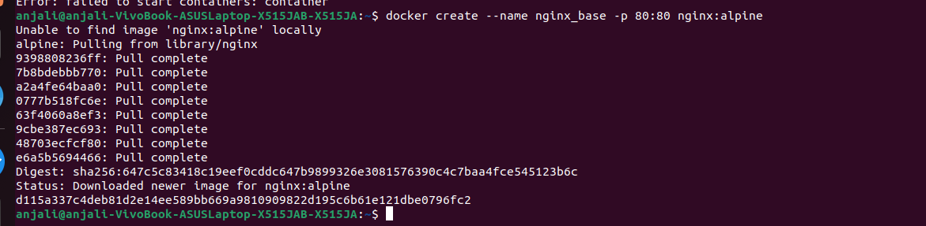

2. List all containers

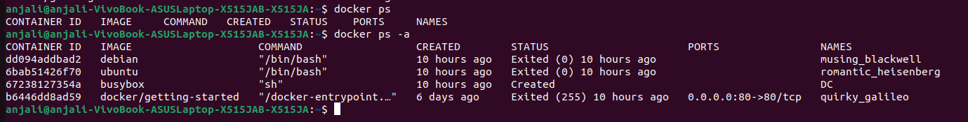
3. List Images

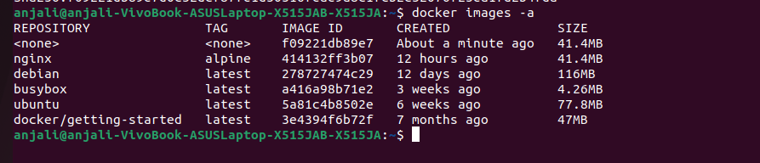

4. Create an Image from Container

5. Tag the Image

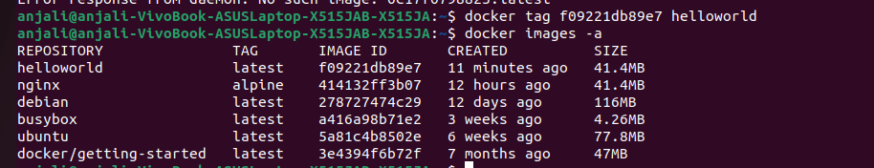

6. Pull the images

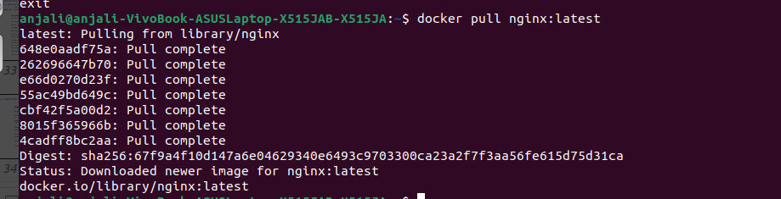

7. Start a New Container

8. Stops a container

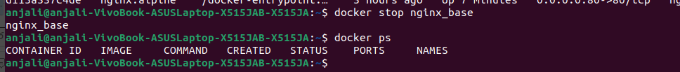

9. Restart a Container

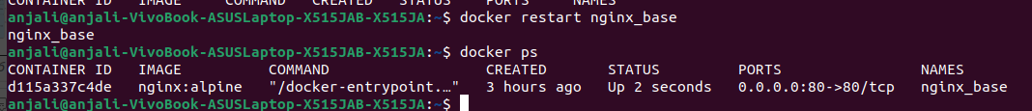

10. Blocks a container

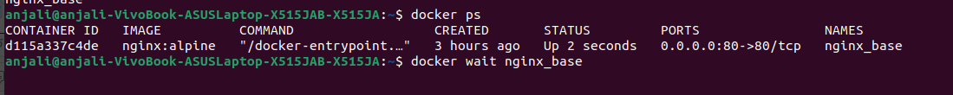

11. Inspects changes to directories and files in the container file system

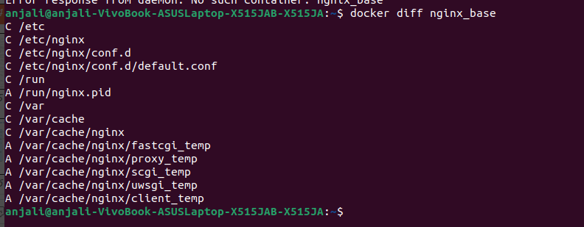

12. Shows all running processes in an existing container

14. Gathers the logs for a container

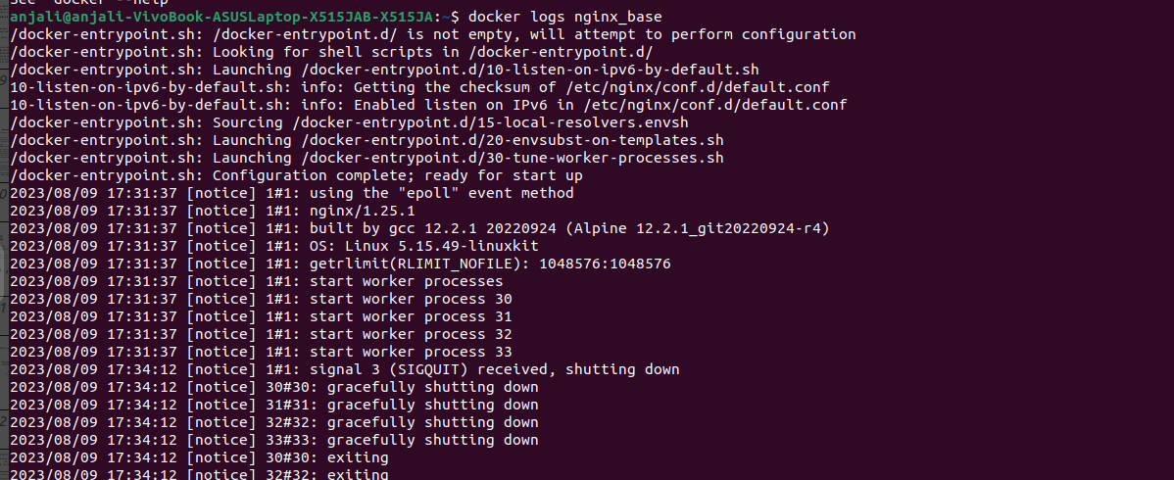

15. Shows container resource usage statistics

