Write a program using functions to read three sides of triangle and display the area of perimeter depending on the user choice.

#include <stdio.h>
#include <math.h>

int calculate_area(int a, int b, int c);
int calculate_perimeter(int a, int b, int c);

int main() {
int a, b, c;
int choice;

printf("Enter the three sides of the triangle: ");
scanf("%d %d %d", &a, &b, &c);

printf("Choose what to calculate:\n");
printf("1. Area\n");
printf("2. Perimeter\n");
printf("Enter your choice (1 or 2): ");
scanf("%d", &choice);

switch (choice) {
case 1:
printf("Area of the triangle is: %d", calculate_area(a, b, c));
break;
case 2:
printf("Perimeter of the triangle is: %d", calculate_perimeter(a, b, c));
break;
default:
printf("Invalid choice!");
break;
}

return 0;
}

int calculate_area(int a, int b, int c) {
int s = (a + b + c) / 2;
int area = sqrt(s * (s - a) * (s - b) * (s - c));
return area;
}

int calculate_perimeter(int a, int b, int c) {
int perimeter = a + b + c;
return perimeter;
}

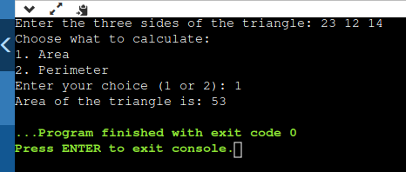

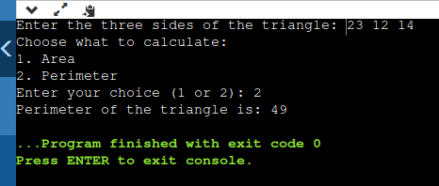

Write a program using function to read a matrix of size m x n. Calculate the sum of rows and columns.

#include <stdio.h>

void read_matrix(int matrix[][100], int m, int n);
void sum_rows(int matrix[][100], int m, int n, int row_sum[]);
void sum_cols(int matrix[][100], int m, int n, int col_sum[]);

int main() {
int m, n;
int matrix[100][100];
int row_sum[100] = {0}, col_sum[100] = {0};

printf("Enter the size of the matrix (m x n): ");
scanf("%d %d", &m, &n);

printf("Enter the elements of the matrix:\n");
read_matrix(matrix, m, n);

sum_rows(matrix, m, n, row_sum);
sum_cols(matrix, m, n, col_sum);

printf("Sum of rows:\n");
for (int i = 0; i < m; i++) {
printf("%d ", row_sum[i]);
}

printf("\nSum of columns:\n");
for (int j = 0; j < n; j++) {
printf("%d ", col_sum[j]);
}

return 0;
}

void read_matrix(int matrix[][100], int m, int n) {
for (int i = 0; i < m; i++) {
for (int j = 0; j < n; j++) {
scanf("%d", &matrix[i][j]);
}
}
}

void sum_rows(int matrix[][100], int m, int n, int row_sum[]) {
for (int i = 0; i < m; i++) {
for (int j = 0; j < n; j++) {
row_sum[i] += matrix[i][j];
}
}
}

void sum_cols(int matrix[][100], int m, int n, int col_sum[]) {
for (int j = 0; j < n; j++) {
for (int i = 0; i < m; i++) {
col_sum[j] += matrix[i][j];
}
}
}

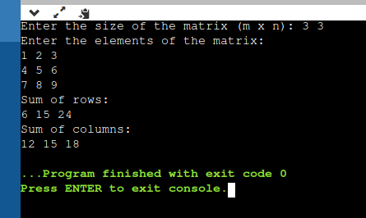

Write a program using pointers to read an array of integer and print the reverse order.

#include <stdio.h>

void print_reverse(int *arr, int n);

int main() {
int n;
int arr[100];

printf("Enter the size of the array: ");
scanf("%d", &n);

printf("Enter the elements of the array:\n");
for (int i = 0; i < n; i++) {
scanf("%d", &arr[i]);
}

printf("The array in reverse order is:\n");
print_reverse(arr, n);

return 0;
}

void print_reverse(int *arr, int n) {
for (int i = n - 1; i >= 0; i--) {
printf("%d ", *(arr + i));
}
}

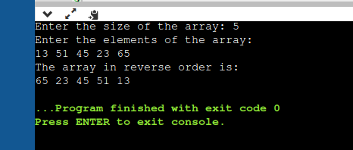

Write a program using recursion to find the series.

#include<stdio.h>
double series_out(float n)
{
if (n>=1)
return n*series_out(n-1);
else
return 1;
}
void main()
{
float x,p=0,q=0,i,sum=0,z,n;
printf("\nEnter x:");
scanf("%f",&x);

printf("\nEnter n:");
scanf("%f",&n);

for(i = 1;i <= n;i += 4)
p=p+(x*i)/series_out(i);

for(i = 3;i < n;i += 4)
q=q+(x*i)/series_out(i);
sum=p - q;
printf("\nSum of series = %.4f",sum);
}

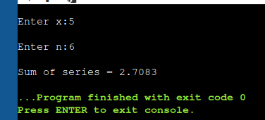

Write a program that uses two pointer one to receive coefficient a,b & c as another to send the roots to the calling function then calculate the roots of quadratic equation and display the output.

#include <math.h>
void roots(float a, float b, float c, float* root1, float* root2)
{
float diff;
diff = b*b - 4*a*c;
if (diff < 0) {
printf("Roots are imaginary.\n");
*root1 = *root2 = 0;
return;
}
*root1 = (-b + sqrt(diff)) / (2*a);
*root2 = (-b - sqrt(diff)) / (2*a);
}
void main()
{
float a, b, c, root1, root2;
printf("Enter coefficients a, b, and c: ");
scanf("%f %f %f", &a, &b, &c);
roots(a, b, c, &root1, &root2);
printf("Root 1: %f\n", root1);
printf("Root 2: %f\n", root2);
}

