WEEK 1 PROJECT REPORT
Data Acquisition, Cleaning and
Exploratory Data Analysis
Customer Churn Analysis Using Python
Internship: Python Apprentice
Dataset: IBM Telco Customer Churn
Tools: Python, Pandas, NumPy and Matplotlib
Student: ______________________________
Submission date: _______________________

1. Executive Summary
This project explores customer churn in a telecommunications dataset containing 7,043 customer records and 21 columns. The data was inspected, cleaned and analysed using Python. The cleaned dataset contains no remaining missing values and no duplicate rows. The analysis found that 1,869 customers (26.54%) churned, while 5,174 (73.46%) did not. Customers who churned had a higher average monthly charge (74.44) than customers who stayed (61.27). The correlation analysis showed a strong positive association between tenure and total charges (0.83). These descriptive findings do not establish that any single factor causes churn.

2. Introduction
Customer churn occurs when a customer stops using a company's products or services. Understanding churn can help a business identify customer groups that may need improved service, support or retention initiatives. This project follows a data science workflow involving data acquisition, inspection, cleaning, exploratory analysis and reporting.

3. Objectives
- Acquire a publicly available customer churn dataset.
- Inspect its structure, variables, data types, missing values and duplicate records.
- Clean data-quality issues and prepare an analysis-ready dataset.
- Use descriptive statistics and visualizations to explore customer churn, tenure and charges.
- Summarize patterns and identify areas for further analysis.

4. Dataset Description and Acquisition
The IBM Telco Customer Churn dataset contains customer-level information including demographics, tenure, phone and internet services, contract type, payment method, monthly charges, total charges and churn status.
Dataset dimensions: 7,043 rows × 21 columns.
Dataset URL used in the notebook:
https://raw.githubusercontent.com/IBM/telco-customer-churn-on-icp4d/master/data/Telco-Customer-Churn.csv
The dataset was loaded into a Pandas DataFrame using read_csv(). An original CSV copy was saved before cleaning, and a separate cleaned dataset was exported as telco_customer_churn_cleaned.csv.

5. Tools and Libraries
- Pandas: loading, inspecting, cleaning and summarizing tabular data.
- NumPy: numerical operations.
- Matplotlib: creating plots.
- Seaborn: used in the Colab exploratory visualizations.

6. Data Inspection and Cleaning
Initial inspection showed 7,043 records and 21 columns. Pandas initially reported zero null values and zero duplicate rows. A separate whitespace check of TotalCharges found 11 entries containing blank spaces. These were not initially counted as null values because they were stored as whitespace strings.
All 11 blank TotalCharges records had tenure equal to zero. The TotalCharges column was stripped of whitespace and converted to a numeric type using pandas.to_numeric(errors='coerce'). This converted the blank strings into missing numeric values. Since the affected customers had zero tenure and no accumulated total charges, the 11 resulting missing values were filled with 0.
After cleaning, TotalCharges had the float64 data type. The cleaned dataset contains 0 missing values, 0 duplicate rows and retains 7,043 rows × 21 columns.

6.1 Key cleaning code
df_clean = df.copy()
df_clean['TotalCharges'] = df_clean['TotalCharges'].astype(str).str.strip()
df_clean['TotalCharges'] = pd.to_numeric(
df_clean['TotalCharges'], errors='coerce'
)
df_clean['TotalCharges'] = df_clean['TotalCharges'].fillna(0)
print(df_clean.isnull().sum().sum())
print(df_clean.duplicated().sum())
print(df_clean['TotalCharges'].dtype)

7. Exploratory Data Analysis and Visualizations
Four visualizations were used to examine churn distribution, customer tenure, monthly charges by churn status and correlations among selected numerical variables.

7.1 Customer Churn Distribution
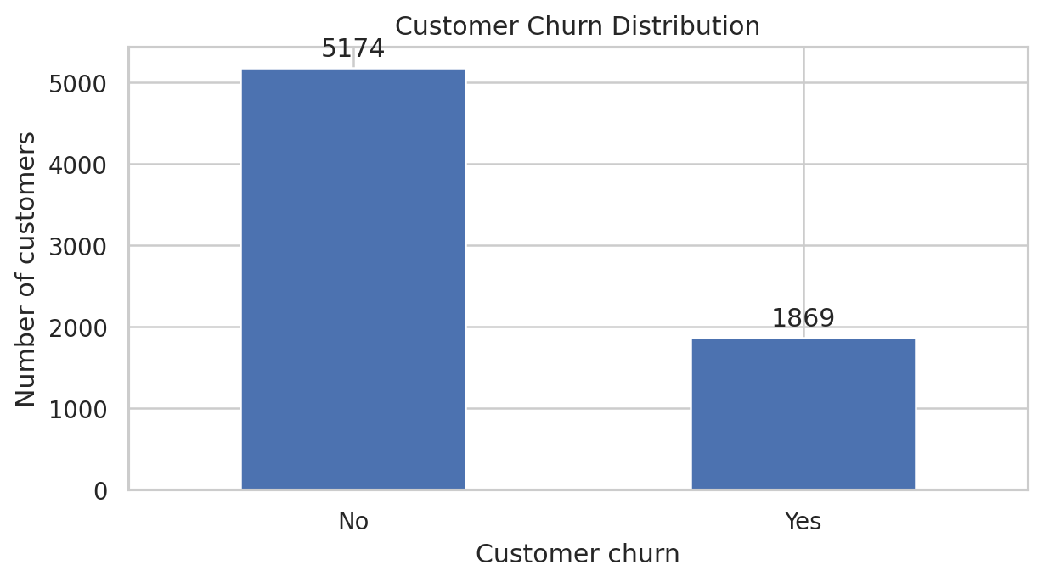
Figure 1. Number of customers who stayed and customers who churned.
The dataset contains 5,174 customers who stayed (73.46%) and 1,869 customers who churned (26.54%). Most customers remained with the company, but the churn share is large enough to merit further investigation.

7.2 Distribution of Customer Tenure
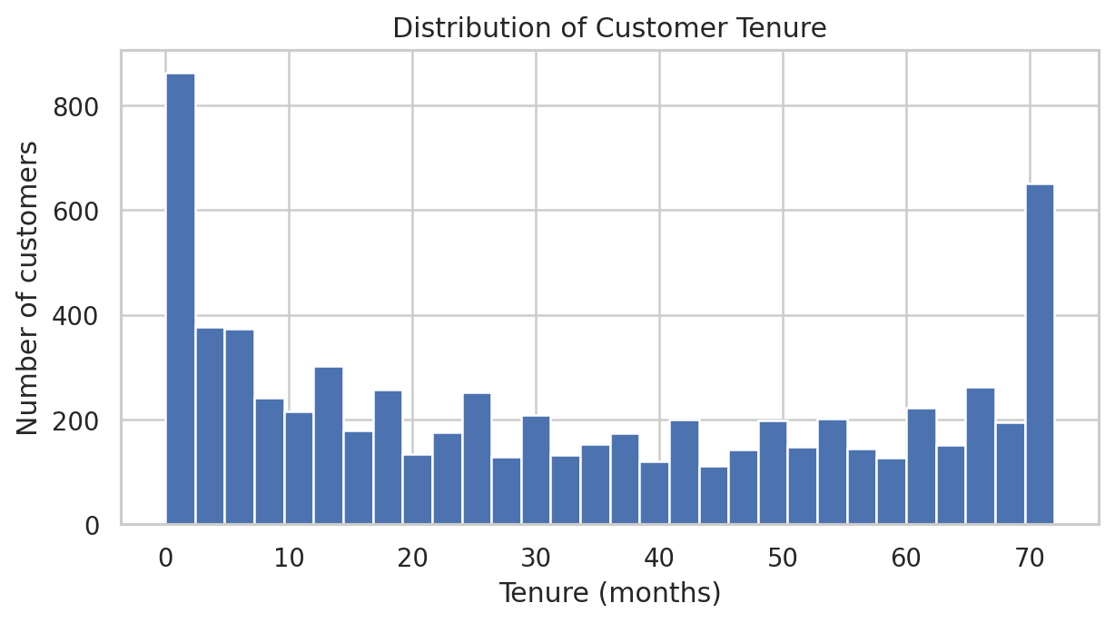
Figure 2. Distribution of customer tenure in months.
Tenure ranges from 0 to 72 months. Mean tenure is 32.37 months and median tenure is 29 months. The distribution shows variation in how long customers remain subscribed.

7.3 Monthly Charges by Churn Status
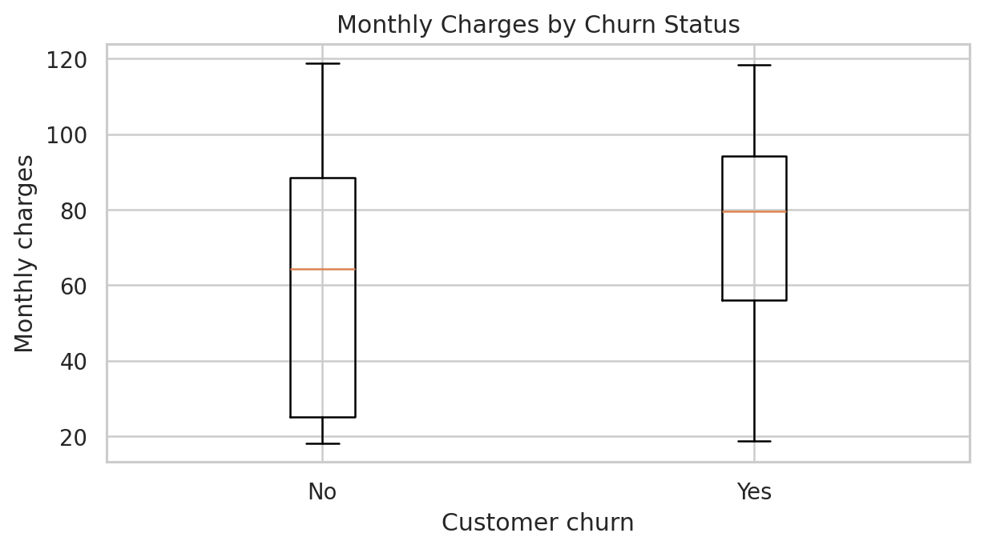
Figure 3. Box plots comparing monthly charges for customers who stayed and churned.
Customers who churned had a mean monthly charge of 74.44 and median of 79.65. Customers who stayed had a mean of 61.27 and median of 64.43. This suggests an association between monthly charges and churn, but the comparison alone cannot show that charges caused customers to leave.

7.4 Correlation Heatmap
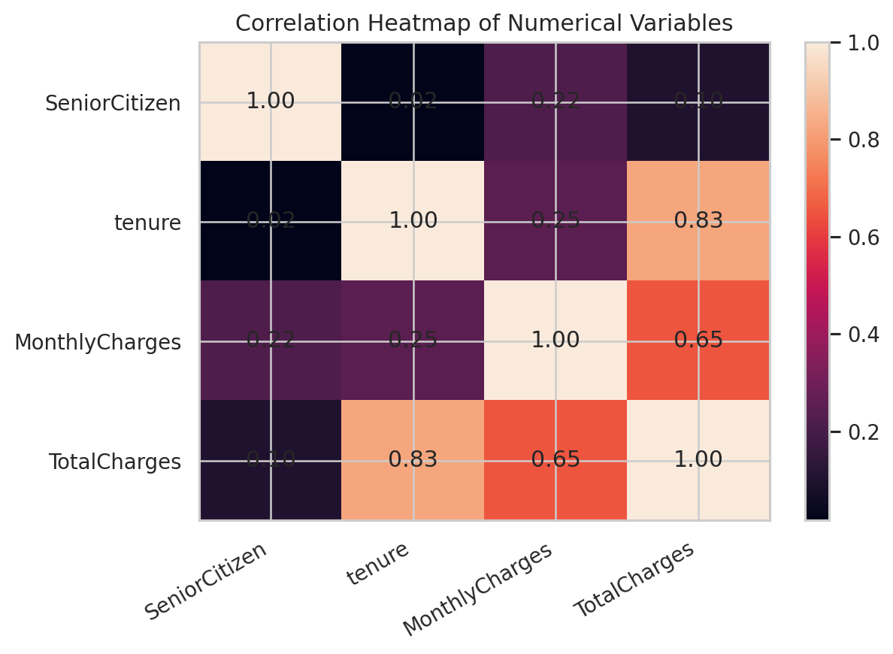
Figure 4. Pearson correlation matrix for selected numerical variables.
The strongest positive correlation is between tenure and TotalCharges (0.83). MonthlyCharges and TotalCharges also have a positive correlation (0.65). Tenure and MonthlyCharges have a weaker positive correlation (0.25). Correlation measures linear association, not causation.

8. Statistical Summary and Key Findings
Churn: 5,174 customers stayed (73.46%) and 1,869 churned (26.54%).
Tenure: mean = 32.37 months; standard deviation = 24.56; median = 29; minimum = 0; maximum = 72.
Average monthly charges: 61.27 for customers who stayed and 74.44 for customers who churned.
- Approximately 26.54% of customers in the dataset churned.
- Mean customer tenure was approximately 32.37 months.
- Customers who churned had higher average and median monthly charges than customers who stayed.
- Tenure and total charges had a strong positive correlation (0.83).
- Monthly charges and total charges had a positive correlation (0.65).

9. Potential Business Implications and Further Analysis
The results suggest areas for further investigation. The company could examine whether customers with higher monthly bills need clearer plan comparisons or more suitable service bundles. It could also study the early customer experience because tenure varies considerably. Retention initiatives should be based on additional analysis rather than assuming that price or tenure alone explains churn.
Further work could compare churn rates across contract types, payment methods, internet-service categories and technical-support status. Statistical testing and predictive modelling can be explored in later internship tasks.

10. Limitations
- This is an exploratory analysis and does not establish causal relationships.
- The correlation heatmap includes selected numerical variables only.
- The analysis does not yet test statistical significance or build a predictive model.
- The interpretation of blank TotalCharges as zero is based on the observed zero-tenure records.

11. Conclusion
The Week 1 task demonstrated data acquisition, inspection, cleaning and exploratory analysis using Python. The 11 whitespace-only TotalCharges entries were identified, converted to missing numeric values and replaced with zero after confirming that the affected customers had zero tenure. The cleaned dataset contains 7,043 rows and 21 columns, with no remaining missing values or duplicate rows. Exploratory analysis showed a churn rate of 26.54%, higher average monthly charges among churned customers and a strong positive correlation between tenure and total charges. These findings provide a foundation for deeper statistical analysis and machine-learning work.

Appendix A. Reproducibility Notes
The analysis was performed in Google Colab using Python. The uploaded cleaned CSV was independently checked and confirmed to contain 7,043 rows, 21 columns, zero null values, zero duplicate rows and a numeric TotalCharges column. Figures in this report were regenerated from the uploaded cleaned dataset.

