**MODERN COLLEGE OF ARTS, SCIENCE AND**

**COMMERCE, GANESHKHIND, PUNE-16**

## Description: logo2

**ACADEMIC YEAR 2023-2024**

**A**

**PROJECT REPORT**

**ON**

**“DRAWING APPLICATION”**

**SUBMITTED TO**

**SAVITRIBAI PHULE PUNE UNIVERSITY**

**BY**

Rutuja Shailendra Kondra (233351025)

Anjali Nitin Mukund (233351030)

Project Index

|  |  |  |
| --- | --- | --- |
| Sr. no | Chapter name | Page no |
| 1 | **Introduction** | 1-3 |
|  |  |  |
|  | 1.1 Introduction of project |  |
|  | 1.2Scope of work |  |
|  | 1.3Operating environment (Software and Hardware) |  |
|  | 1.4 Module description |  |
|  | 1.5 Detailed description of technology used |  |
| 2 | **Proposed system** | 4-5 |
|  | 2.1 Proposed system |  |
|  | 2.2 Objectives of system |  |
|  | 2.3 User requirements |  |
| 3 | **Analysis and design** | 6-9 |
|  | 3.1 Class diagram |  |
|  | 3.2 Deployment diagram |  |
|  | 3.3 Activity diagram |  |
| **4** | **Drawbacks and limitations** | 14 |
| **5** | **Proposed enhancements** | 15 |
| **6** | **User interface screen** | 16 |
| **7** | **Conclusion** | 18 |
| **8** | **Bibliography** | 19 |

1. **INTRODUCTION**

**1.1 Introduction of The Project**

Drawing Application is an application which is build by using the java language. This application includes a drawing interface which includes button like operator buttons, numeric buttons, scientific buttons , and a text field.

In this application, user can do all type of calculations very easily.

This application requires less efforts than solving the calculations physically. The application has a pleasant user interface.

This application is also user-friendly as it can be used in day to day life and can be easily used. This application provides user an accurate results.

**Scope of Project**

The scope of a drawing application project encompasses the range of features, functionalities, and goals that the development team aims to achieve. It defines what the application will include, how it will function, and the overall objectives it seeks to fulfill.

1. **User Interface (UI) Design:**
   * Outline the design principles for the user interface, ensuring it is intuitive, user-friendly, and adaptable to various devices.
2. **Platform Compatibility:**
   * Specify the target platforms (desktop, tablet, mobile) and ensure compatibility with different operating systems (Windows, macOS, iOS, Android).

## Operating Environment (Software and Hardware)

**Operating environment:**

Operating system: Windows 10

Technology: Java



**Hardware interfaces:**

* Operating System - Windows 10
* Processor - Intel core i3
* RAM – 1 GB
* Hard Disk – Minimum 40 GB
* Keyboard, monitor and mouse

**Software interfaces:**

* Software Development Tool: Eclipse
* JAVA
* Browser: Google chrome

**communication interfaces:**

This application supports all type of devices like android iOS.

This application also supports any operating systems like Windows, Linux.

**1.3 Technology Used:**

**Language Used** - Java

**Interface Design** -Java

**Web Browser** - Google Chrome

**Software Tool** - Eclipse

1. **PROPOSED SYSTEM**

**2.1 Proposed System :**

The use of this Drawing Application is to draw shape easily and make it attractive.

This java project is easy for small kids to draw shape and enhance their interest in painting.

* User friendly.
* Easy to use.
* Effortless.

**2.2 Objectives of System :**

The objective of a drawing application is to provide users, ranging from casual doodlers to professional artists, with a versatile and user-friendly platform for creating digital art. The primary goals and objectives of a drawing application typically include:

1. **Creative Expression:**
   * Enable users to express their creativity and artistic vision through a digital medium.
   * Provide a wide range of tools and features to accommodate various art styles and techniques.
2. **User-Friendly Interface:**
   * Design an intuitive and accessible interface that allows users to navigate the application easily.
   * Ensure a seamless and enjoyable drawing experience for users of all skill levels.

**2.3 User Requirements:**

User requirements for a drawing application can vary based on the individual needs and preferences of artists, designers, and hobbyists.

**Intuitive Interface:**

* Users prefer an intuitive and user-friendly interface that allows for easy navigation and quick access to drawing tools.

**Undo Functionality:**

* A robust undo feature is essential for users to quickly correct mistakes or experiment with different ideas without fear of losing work.

**Customizable Shortcuts:**

Many users prefer the ability to customize keyboard shortcuts and gestures to enhance their workflow and accommodate personal preferences.

**Offline Mode :**

* The option to work offline and have the application automatically sync work when an internet connection is reestablished can be crucial for users who switch between devices.

**3. ANALYSIS AND DESIGN**

**CLASS DIAGRAM:**

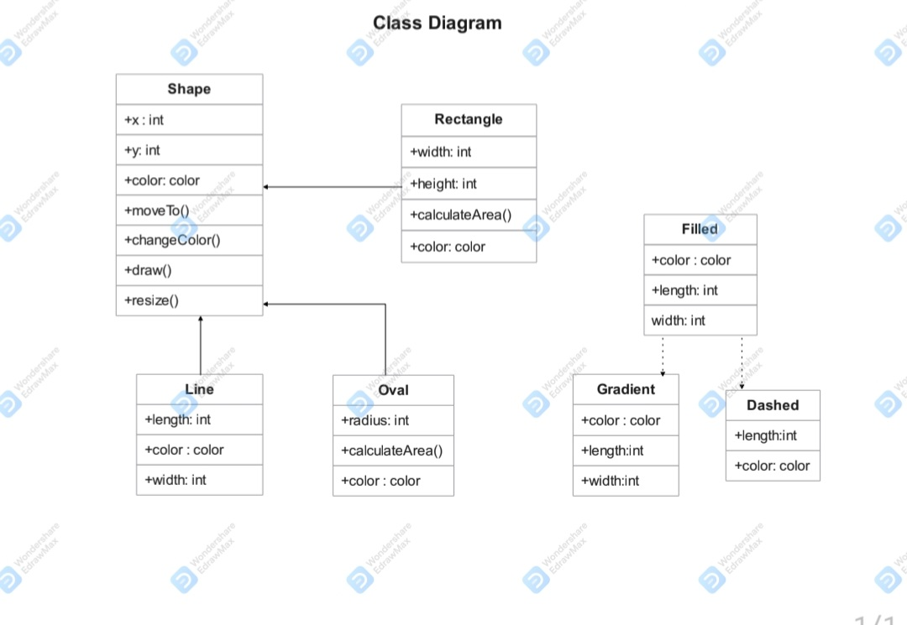

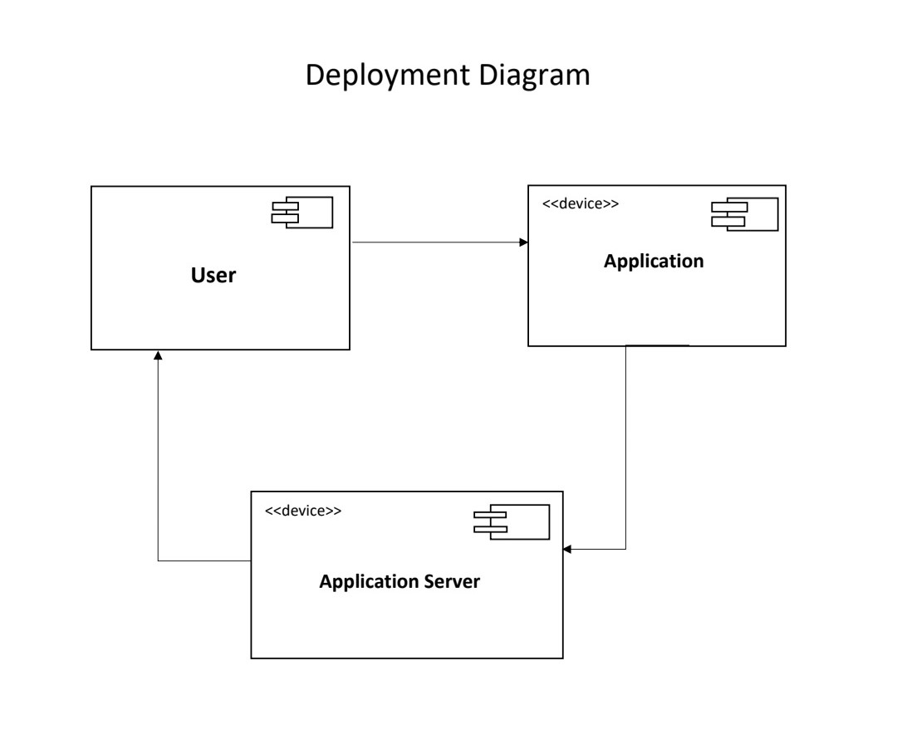

Activity Diagram

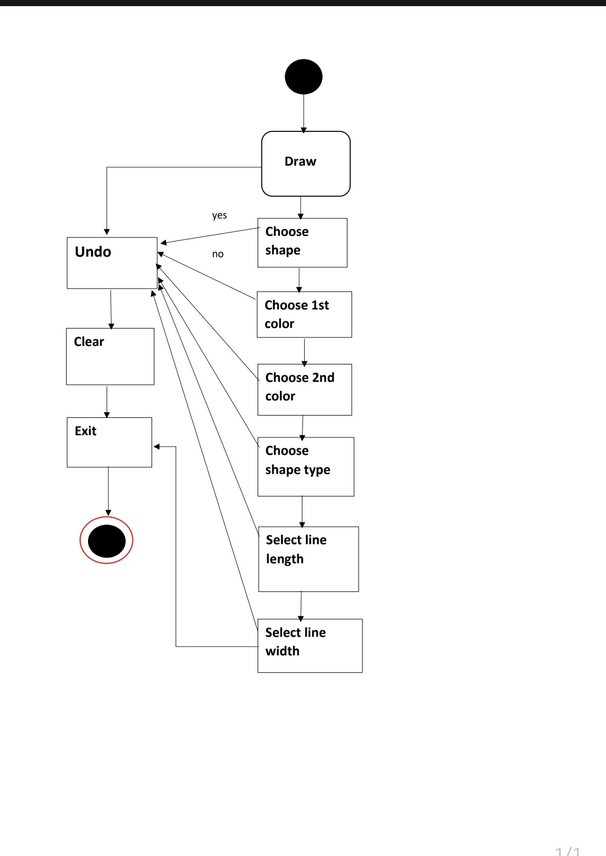

**4. DRAWBACKS AND LIMITATIONS**

* Owing to the fact that these are all digital apps, they also fall prey to their fair share of glitches, crashes, freezes, etc.
* Lack of Choices in Shape.

**Learning Curve:** Mastering a drawing application can be challenging, especially for beginners. The diverse array of tools and features may overwhelm users who are new to digital art, requiring a significant investment of time and effort to become proficient.

**Hardware Requirements:** Some advanced drawing applications may demand high-performance hardware to run smoothly. Users with older devices or limited resources may experience lag, reduced functionality, or even compatibility issues.

**5. PROPOSED ENHANCEMENTS**

1. **Customizable Interface:**
   * Provide users with the ability to customize the interface, including tool placement, color schemes, and shortcut keys.
   * Allow for the creation and sharing of custom workspace presets.
2. **Cross-Platform Compatibility:**
   * Ensure seamless integration with various operating systems and devices, promoting accessibility for users across different platforms.
   * Implement cloud syncing to enable users to seamlessly switch between devices while working on the same project.
3. **Advanced Layer Management:**
   * Introduce advanced layer blending modes, grouping, and non-destructive editing features.

**6 . USER INTERFACE SCREEN**

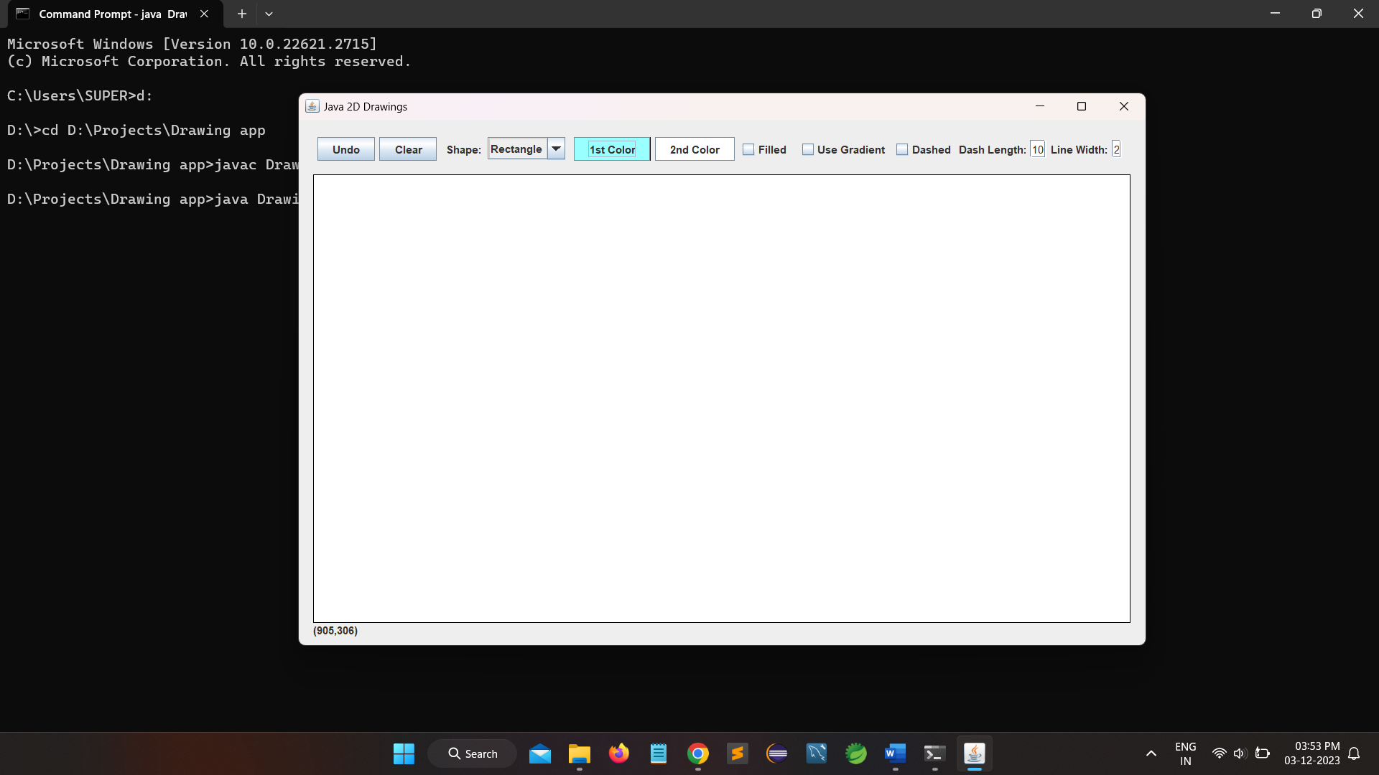

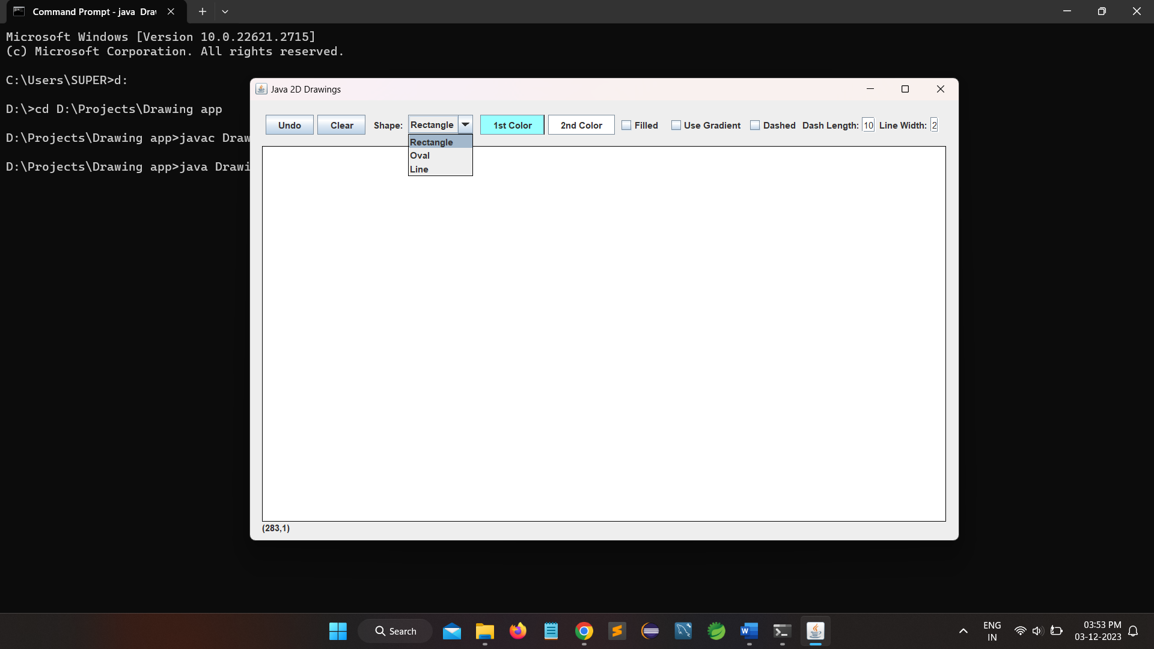

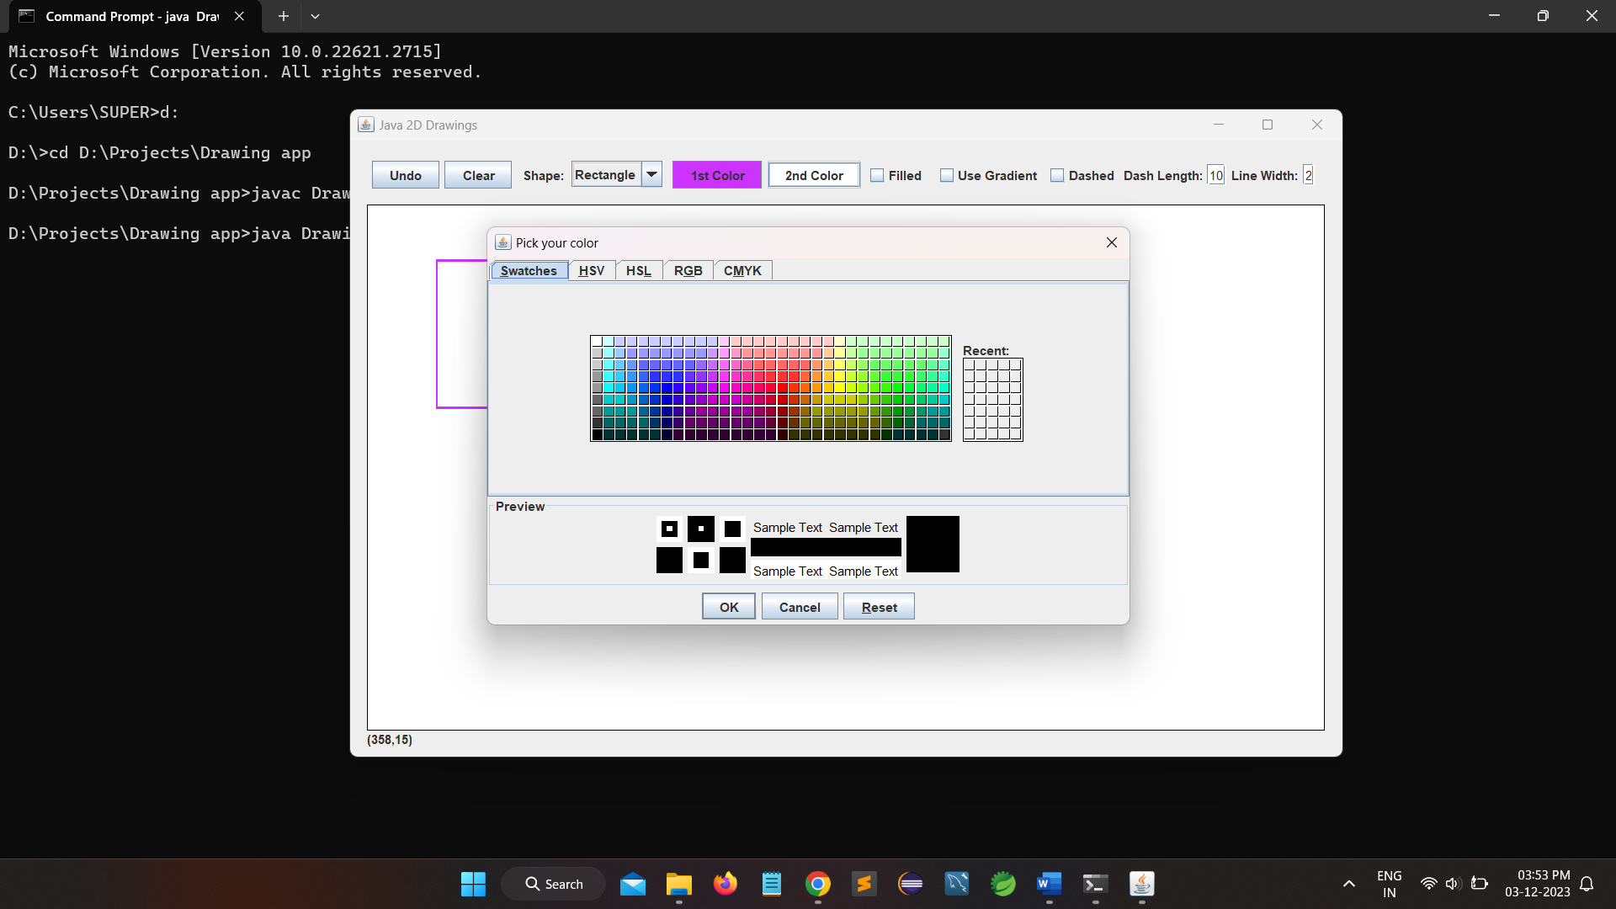

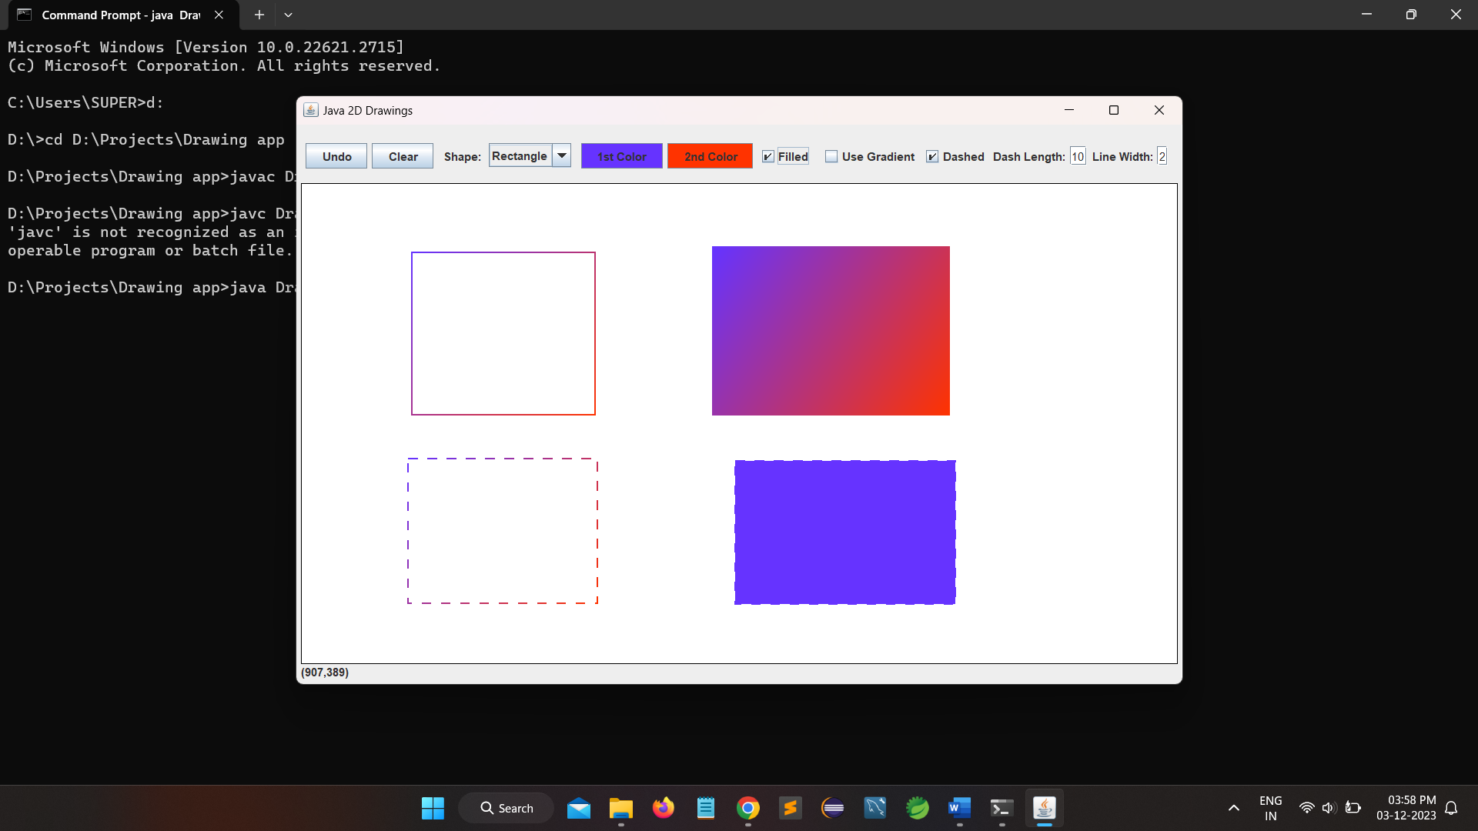

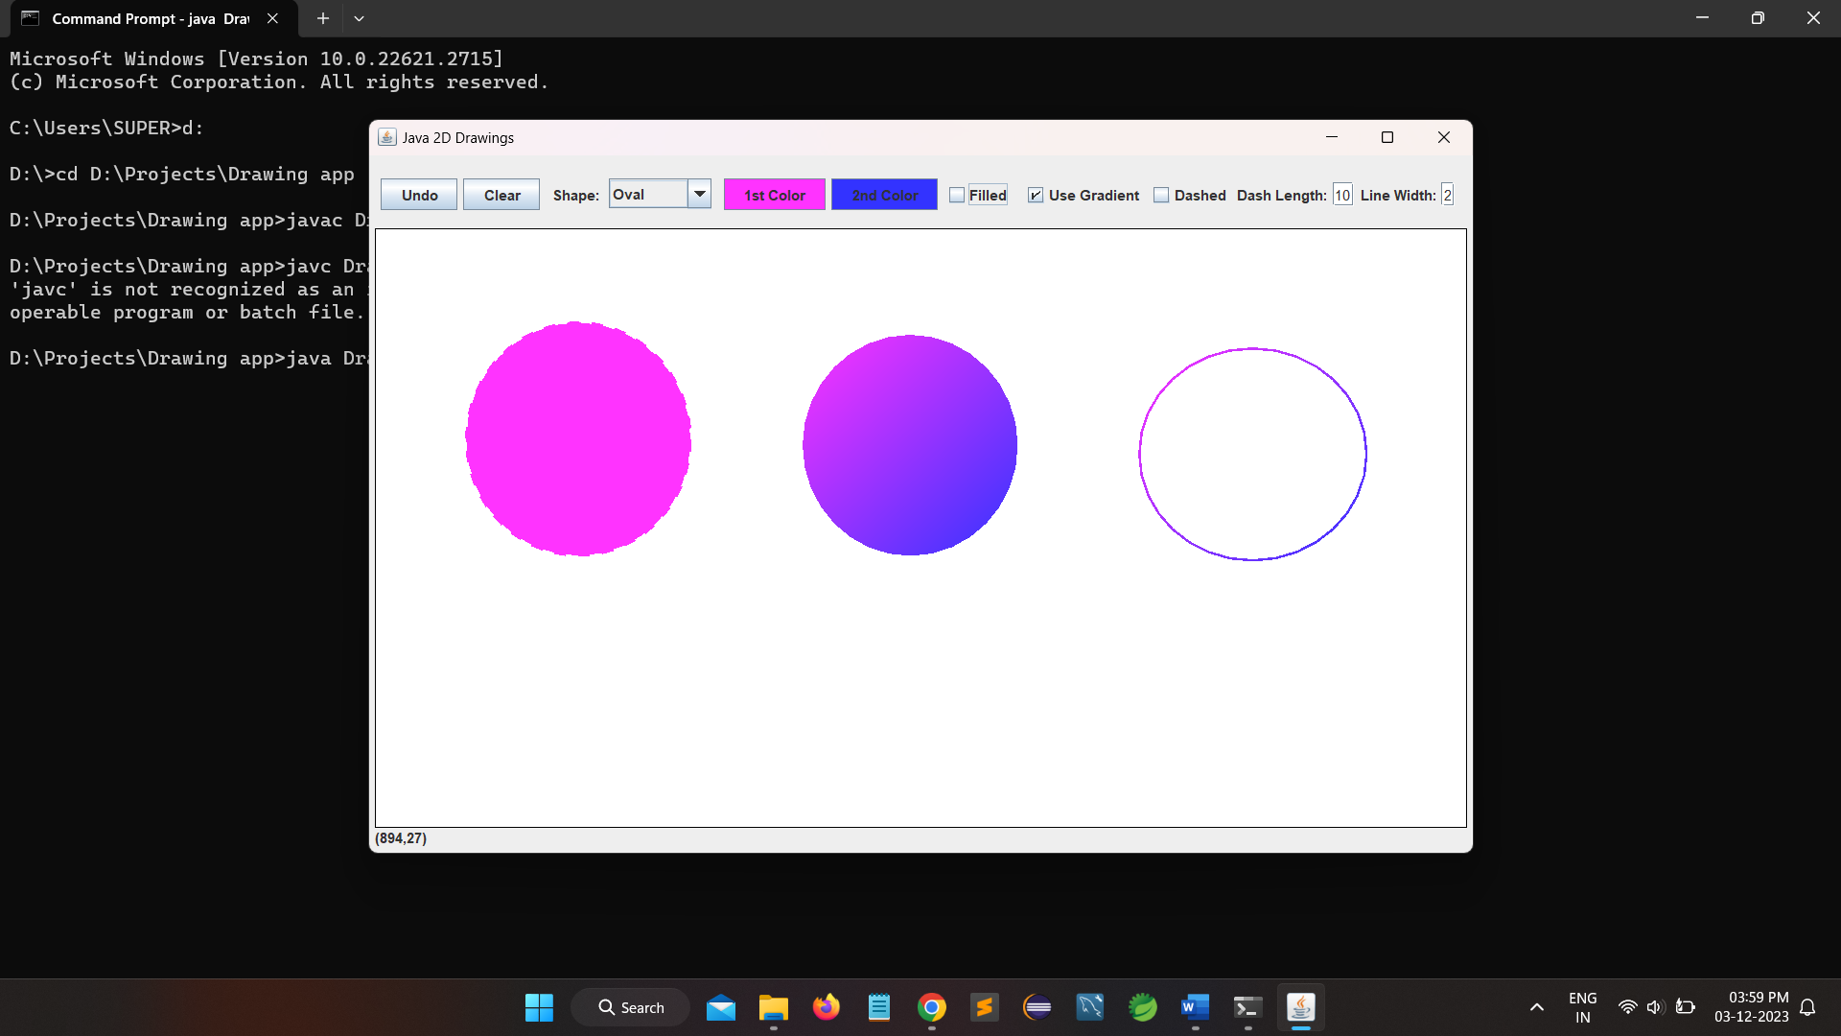

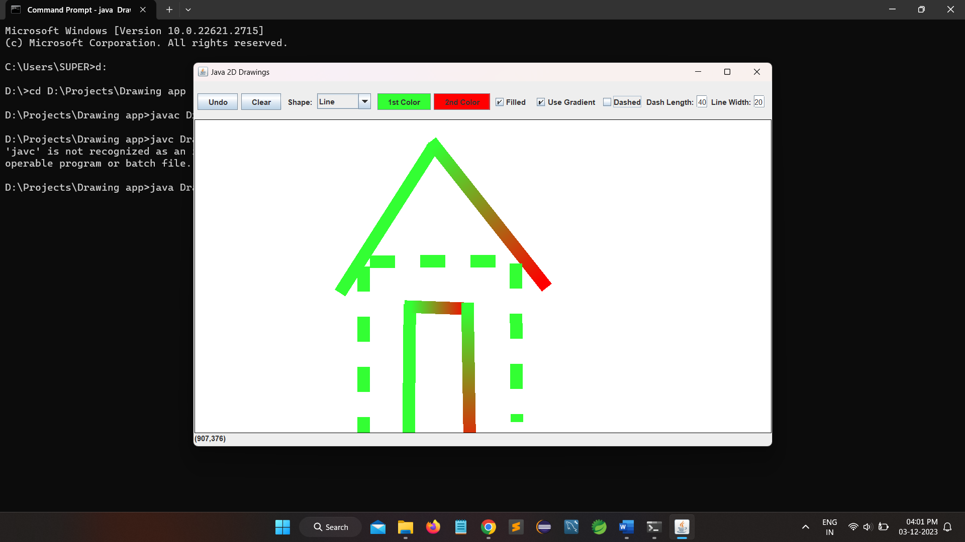

**7 . CONCLUSION**

In this work we have developed a drawing application for 2D Shapes.

The following conclusions can be deduced from the development of the

project:

Through careful design and implementation, the application successfully addresses the diverse needs of users, providing a wide range of features and functionalities.

Providing a thorough and user-friendly guide, the drawing application

and inspire creativity, foster artistic expression, and contribute

positively to the digital art community.

This documentation aims to empower users, from beginners to advanced by ensuring they can harness the full capabilities of the application.

.

**8 . BIBLIOGRAPHY**

**Publication date:** 1/12/2023

**Title:** Drawing Application

**Pages:** 17

**References:**

* <https://www.javatpoint.com/java-tutorial>
* <https://www.w3schools.com/java/>