

Foundations of Programming
Assignment No. : 12

PROBLEM STATEMENT:
Write a program in C to accept two numbers from the user and compute:
- The smallest common divisor of the two numbers (other than 1, if any)
- The Greatest Common Divisor (GCD) of the two numbers

OBJECTIVE:
• To understand the use of mathematical operations in C.
• To implement loops and conditional statements
. • To perform number-based computations.
• To enhance logical thinking using menu-driven programs.

THEORY:
Divisors and the Greatest Common Divisor (GCD) are fundamental concepts in number theory. The smallest common divisor of two numbers is the smallest positive integer greater than 1 that divides both numbers. The GCD of two numbers is the largest positive integer that divides both numbers without leaving a remainder. In C programming, these operations can be efficiently implemented using loops and the Euclidean algorithm, which repeatedly applies the modulo operation until the remainder becomes zero.

PLATFORM:
Linux

ALGORITHM:
1. Start
2. Input: Read two positive integers from the user and store them in variables num1 and num2.
3. Find the Smallest Common Divisor (SCD):
- Initialize a variable scd = -1 (to act as a flag if no divisor is found).
- Find the smaller of the two numbers (num1 and num2) and store it in a variable called min.
- Start a loop with a counter i starting from 2 up to min.
- Inside the loop, check if both numbers are perfectly divisible by i (i.e., num1 % i == 0 AND num2 % i == 0).
- If the condition is true, set scd = i and break/exit the loop immediately. (Since we started counting from 2 upwards, the first common divisor found is guaranteed to be the smallest).
4. Find the Greatest Common Divisor (GCD) using the Euclidean method:
- Initialize two temporary variables, a = num1 and b = num2.
- Start a while loop that continues as long as b != 0.
- Inside the loop, do the following:
  - Store the current value of b in a temporary variable temp.
  - Update b to be the remainder of a divided by b (b = a % b).
  - Update a to the value of temp.
- When the loop ends (because b becomes 0), the variable a will hold the Greatest Common Divisor. Store it in a variable gcd = a.
5. Display Results:
- If scd != -1, print: "The smallest common divisor is scd".
- If scd == -1, print: "There is no common divisor other than 1".
- Print: "The Greatest Common Divisor (GCD) is gcd".
6. Stop

C PROGRAM:
#include <stdio.h>

// Function to find the smallest common divisor (other than 1)
int findSmallestCommonDivisor(int a, int b) {
int min = (a < b) ? a : b; // Find the smaller of the two numbers

// Start checking from 2 up to the smaller number
for (int i = 2; i <= min; i++) {
if (a % i == 0 && b % i == 0) {
return i; // First common divisor found will be the smallest
}
}
return -1; // Returns -1 if no common divisor (other than 1) exists
}

// Function to find the Greatest Common Divisor (GCD) using Euclidean Algorithm
int findGCD(int a, int b) {
while (b != 0) {
int temp = b;
b = a % b;
a = temp;
}
return a;
}

int main() {
int num1, num2;

// Accept two numbers from the user
printf("Enter the first number: ");
scanf("%d", &num1);
printf("Enter the second number: ");
scanf("%d", &num2);

// Ensure we are working with positive integers for simplicity
if (num1 <= 0 || num2 <= 0) {
printf("Please enter positive integers greater than 0.\n");
return 1;
}

printf("\n--- Results ---\n");

// a) Compute and print the smallest common divisor
int scd = findSmallestCommonDivisor(num1, num2);
if (scd != -1) {
printf("a) The smallest common divisor (other than 1) is: %d\n", scd);
} else {
printf("a) There is no common divisor other than 1 (they are co-prime).\n");
}

// b) Compute and print the Greatest Common Divisor (GCD)
int gcd = findGCD(num1, num2);
printf("b) The Greatest Common Divisor (GCD) is: %d\n", gcd);

return 0;
}

INPUT AND OUTPUT:
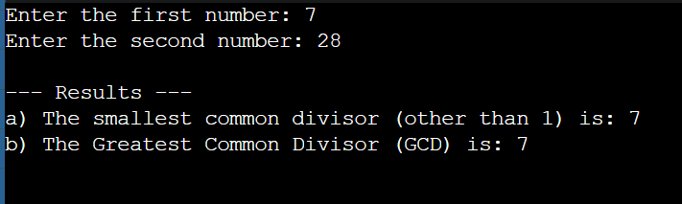

CONCLUSION:
Thus, the program to find the smallest common divisor and the Greatest Common Divisor of two numbers was successfully implemented using C programming. This program demonstrates the use of loops, conditional statements, and the Euclidean algorithm.

