

Foundations of Programming
Assignment No. : 13

PROBLEM STATEMENT:
Write a program in C to accept a number from the user and print the digits of the number in reverse order.

OBJECTIVE:
• To understand number manipulation using loops
. • To learn the use of modulo (%) and division (/) operators.
• To implement logic for reversing digits of a number.
• To improve problem-solving skills using iterative structures.

THEORY:
• To understand number manipulation using loops. • To learn the use of modulo (%) and division (/) operators. • To implement logic for reversing digits of a number. • To improve problem-solving skills using iterative structures.

PLATFORM:
Linux

ALGORITHM:
1. Start
2. Input: * Declare integer variables num and remainder.
- Prompt the user to enter a number and read the value into num.
3. Handle Edge Cases (Optional but recommended):
- If num is equal to 0, print 0.
- If num is less than 0 (a negative number), print a negative sign (-) and convert num to a positive number (num = -num) so the extraction loop works properly.
4. Extract and Print Digits:
- Start a while loop that continues to run as long as num > 0.
- Inside the loop, perform the following steps:
  - Extract: Calculate remainder = num % 10 to get the last digit of the number.
  - Print: Display the remainder immediately.
  - Reduce: Update the number by removing its last digit using integer division: num = num / 10.
5. End Loop: The loop terminates when num becomes 0 (meaning all digits have been extracted and printed).
6. Stop

C PROGRAM:
#include <stdio.h>

int main() {
int num, remainder;

// Accept a number from the user
printf("Enter an integer: ");
scanf("%d", &num);

printf("The digits in reverse order are: ");

// Handle the special case where the user enters 0
if (num == 0) {
printf("0");
}

// If the number is negative, print the negative sign and make the number positive
if (num < 0) {
printf("-");
num = -num;
}

// Loop to extract and print each digit from right to left
while (num > 0) {
remainder = num % 10; // Get the last digit
printf("%d", remainder); // Print the digit
num = num / 10; // Remove the last digit from the number
}

printf("\n");

return 0;
}

INPUT AND OUTPUT:
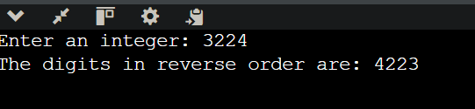

CONCLUSION:
Thus, the program to print the digits of a number in reverse order was successfully implemented using C programming. The program demonstrates the effective use of loops, modulo operator, and division operator.

