1. When to use (Rapid Application Development) RAD model
When not to use (Rapid Application Development) RAD model ?

RAD can be used :
a) At developing a software in a short span of time.
b) Requires minimal planning in favor of rapid prototyping
c) RAD should be used only if there is high availability of resources be it be human or tools requirements.
d) RAD requires high experts .
e) RAD SDLC model should be chosen only if domain experts are available with relevant business knowledge.
f) RAD is usable where concern is needed on develop the application rather than deliver it.
g) It should be used only if the budget permits use of automated code generating tools.
h) RAD is used when the functionality is there and is lower quality .

RAD cannot be used :
a) If the system cannot be modularised.
b) Inapplicable to cheaper projects as cost of modelling and automated code generation is very high.
c) RAD cannot be used if the customer is not ready to get involved and makes a statement that he just needs the end product and not any prototype.
Rad cannot be used if there is no high end developers,architecters,automation tools etc.
d) Requires highly skilled developers/designers. Ifit is not then RAD is not usable.
e) High dependency on modeling skills is in RAD .
f) Inapplicable to cheaper projects as cost of modeling and automated code generation is very high.

2. Define an ER diagram of a software Organization with all the relationship model that was discussed in the classroom?

S/W CMPNY
Project
Mngmnt
team
PROJECT
client
id
name
address
p_id
p_topic
tools
c_name
project
Id
topic
d_id
dv_tools
Dev team
has
has
specialization
manages
Works
for
Request
project
pct_id
pct_Tools
Title

3. Describe the Entity Relationships for the following diagram
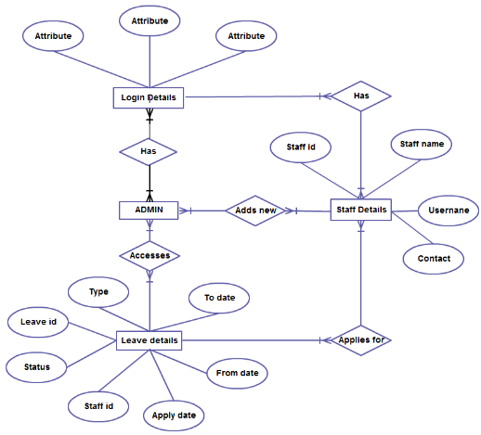

In this ER Diagram Login Details, Staff Details Admin and Leave details are entities. Each of them has some attributes which are values related to the corresponding entities . An attribute characterize an entity. Login Details can be login Id, login Password . Staff Details can be his Id, name, username and contact details etc. Leave Details can be type, todate, fromdate, ld, status, staffid, apply date etc Here we can see that an entity ‘Admin’ which has a many to many relationship with Login Details and also with Leave details. Entity Admin has an adds new relation with staff details. Its a many to many relationship. Entity staff details has applies new relationship with Leave Details.

