1. **COLLABORATION DIAGRAM**

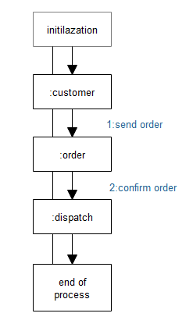

**2. ACTIVITY DIAGRAM**

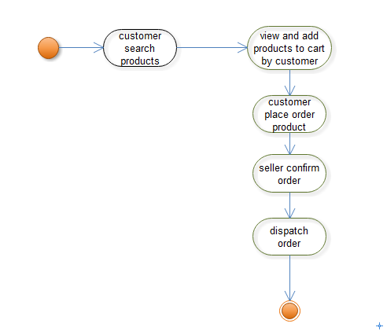

**3.STATE CHART**

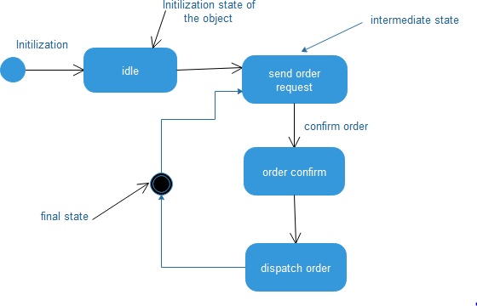

4.CLASS DIAGRAM

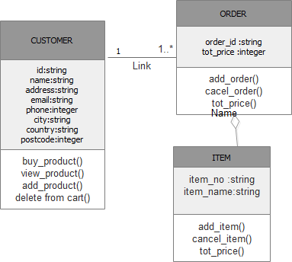

5.OBJECT DIAGRAM

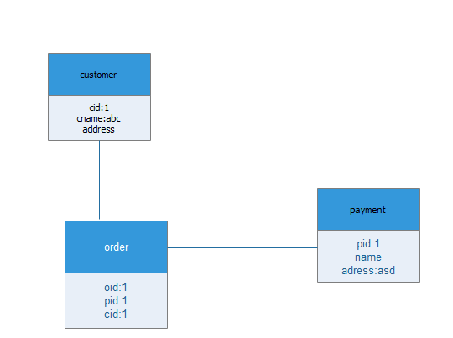

6.SEQUENCE DIAGRAM

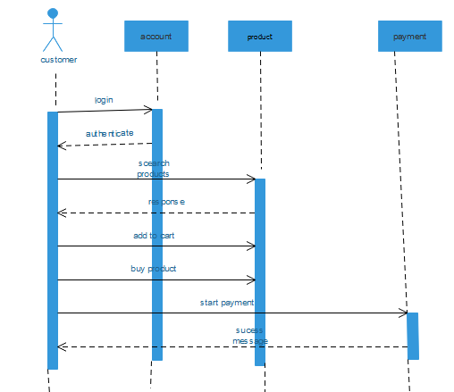

7.USECASE DIAGRAM

