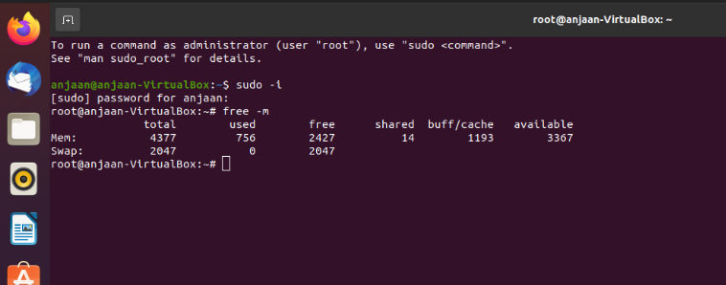**TO CHECK RAM SIZE**

**TO CHECK UBUNTU SYSTEM CONF**

**TO CHECK WHETHER YOU HAVE INTERNET IN SYSTEM**

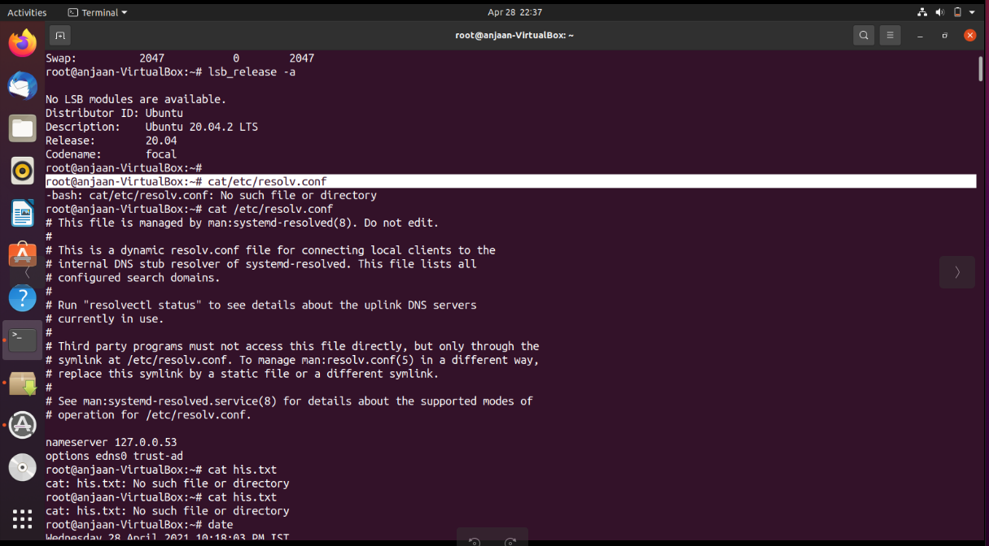

**INSTALL PREQUSITE PACKAGES FOR DOCKER**

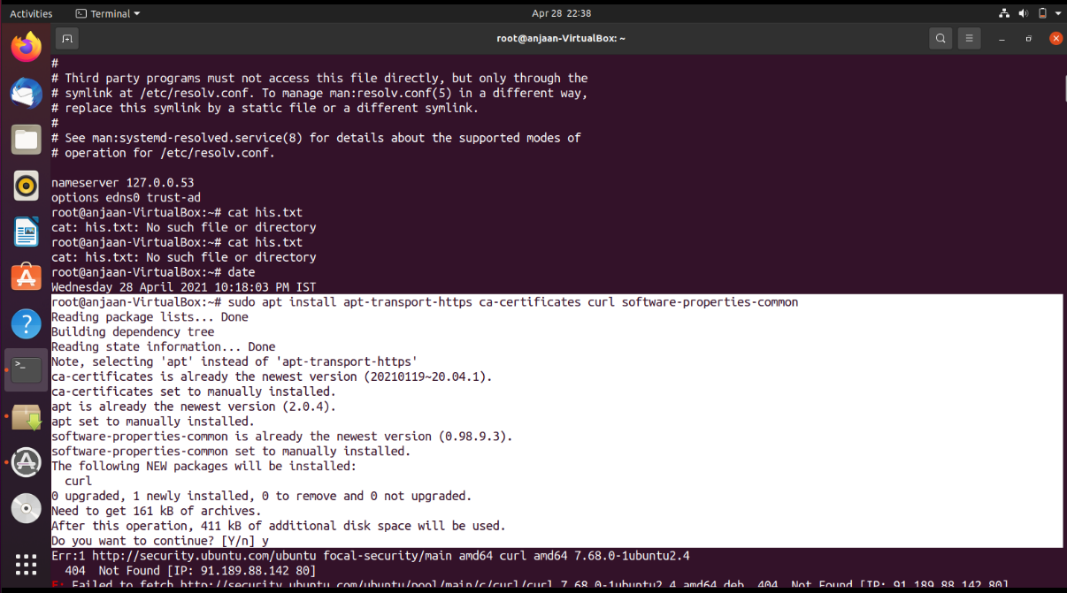

**DOWNLOADING REPOSITORY**

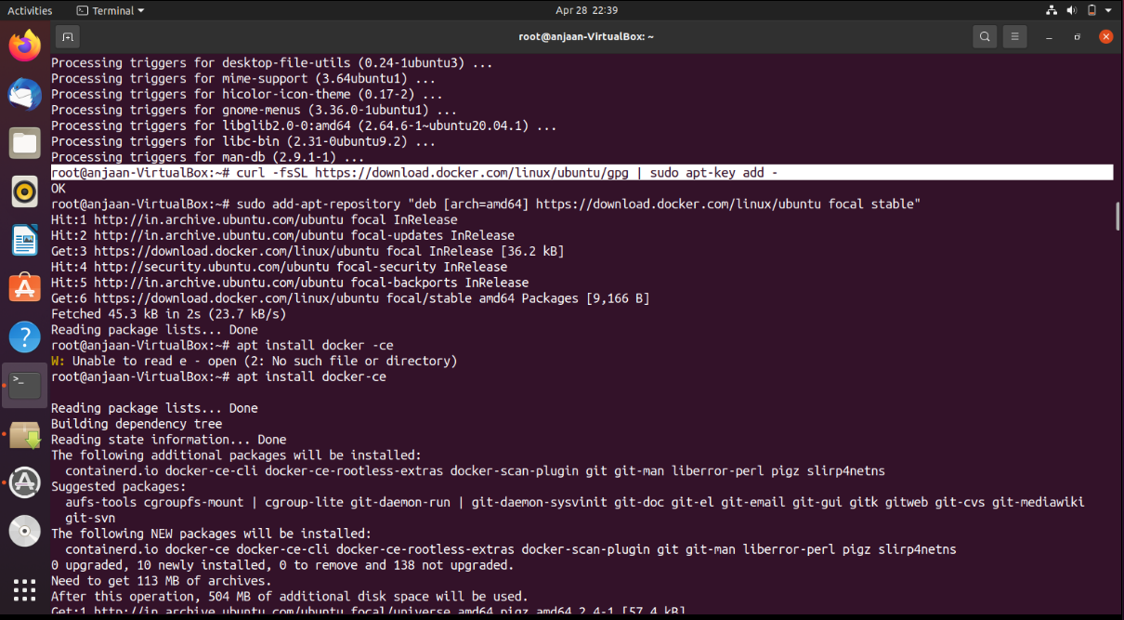

**UPDATE DOCKER REPOSITORY IN OUR SYSTEM**

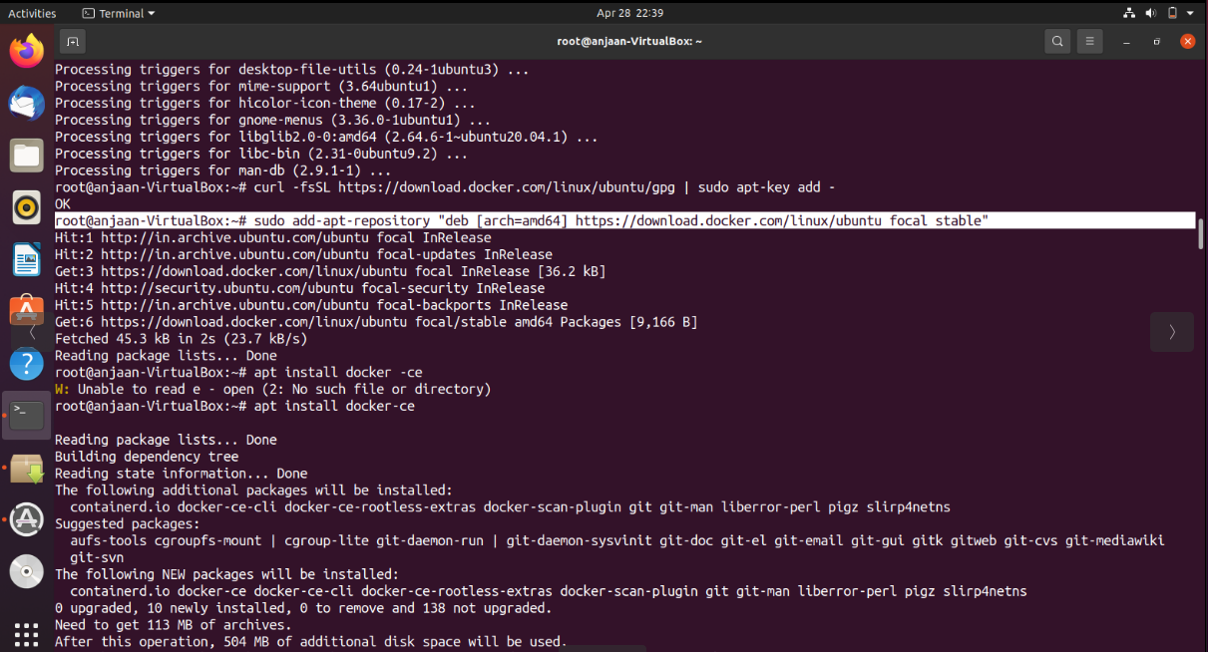

**UPDATING APT**

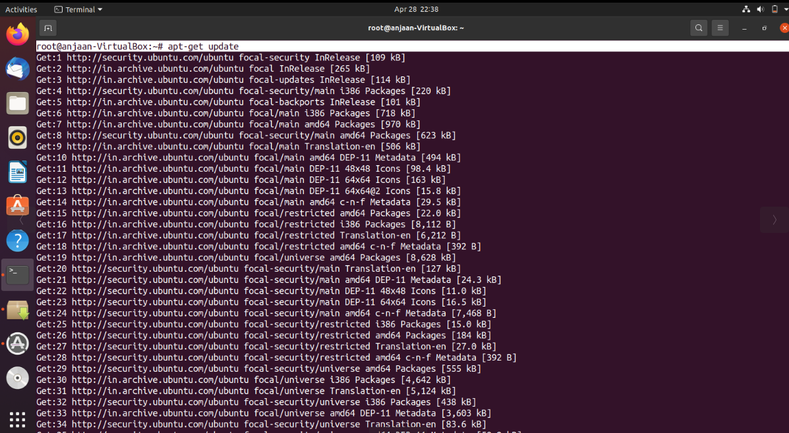

**DOWNLOADING DOCKER:**

WE HAVE IN TWO FORM ce AND ee

WE WILL INSTALL ce EDITION(community edition)

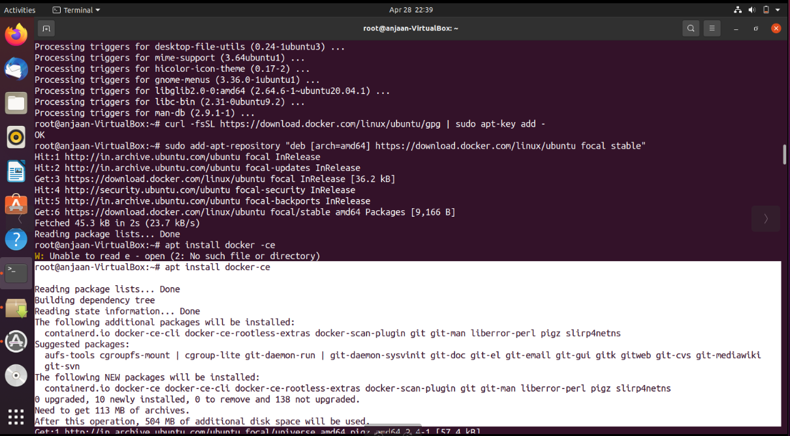

After downloading it will automatically configured in single node

We can again check it is installed with newer version with same command

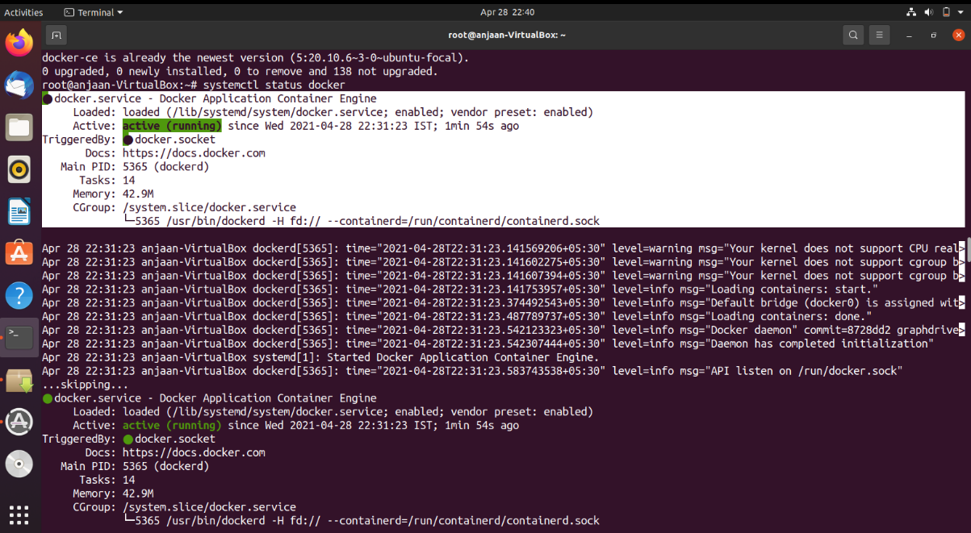**CHECKING STATUS FOR DOCKER THAT SERVICE IS RUNNING OR NOT :**

**CHECKING VERSION OF MY DOCKER**

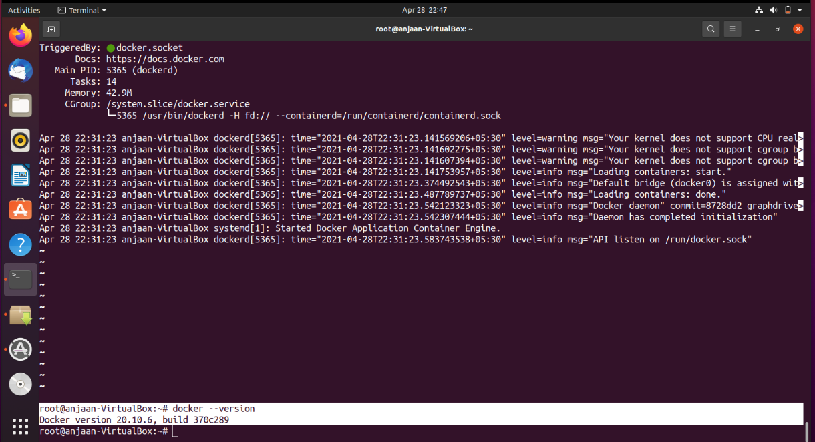

**GETTING A UBUNTU IMAGE FROM INTERNET**

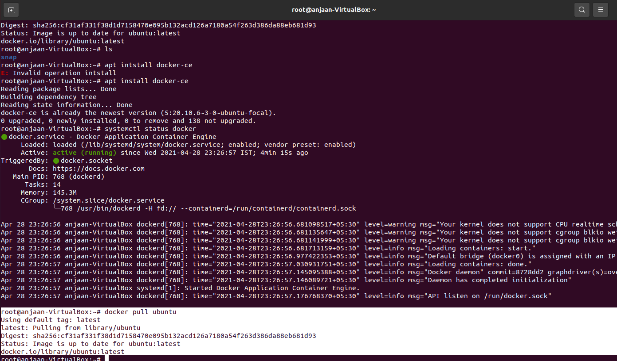

**DOCKER IMAGE:**

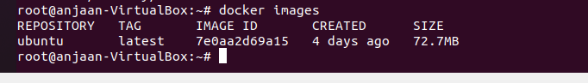

**LAUNCHING IMAGE:**

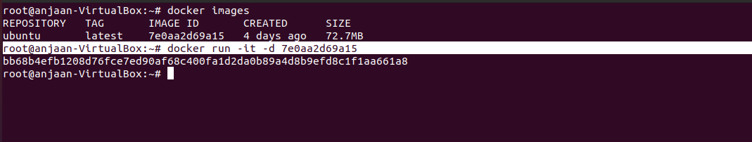

**LOGIN TO THIS IMAGE WITH CONTAINER ID:**

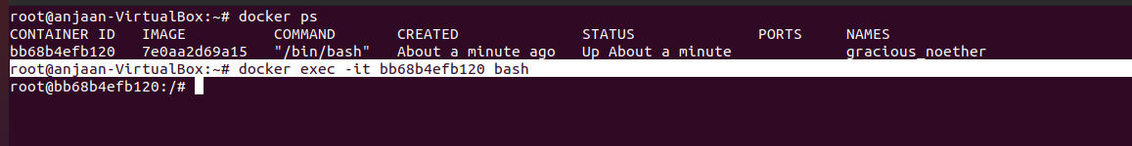

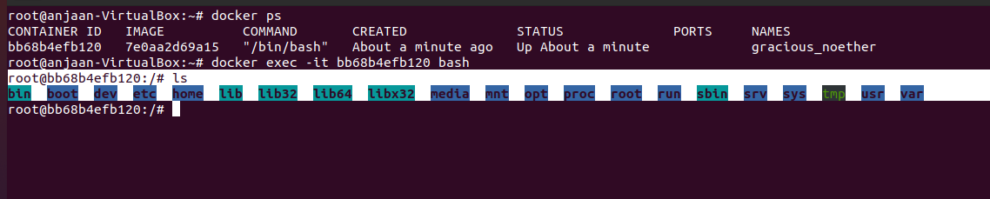

WE CAN PUT OUR APPLICATION HERE AND WORK HERE

TO EXIT WE CAN GIVE **exit** COMMAND TO COME OUT OF THIS IMAGE.