-Int val = 3.14;
Int ceiling_val = ceil(val); //return the ceiling value
-to_string(val) //convert the value in string (‘3.10)/
-isdigig(str[0]) // return true if str[0] is a digit
-int* arr = new size[10]//dynamic array declaration
Normal vs Dynamic array in c++:
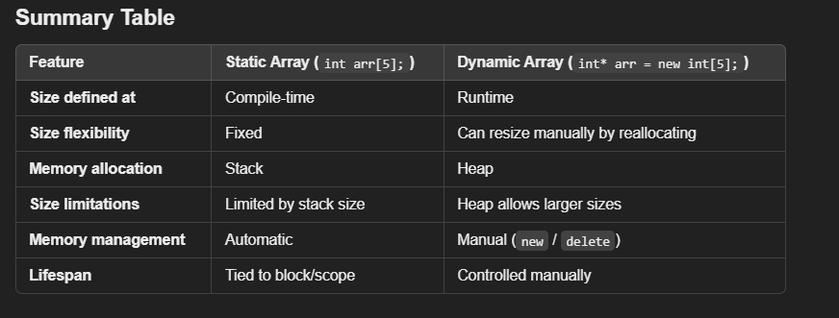
-stringstream:
This class allows you to treat a string as a stream, making it easy to extract words using the extraction operator (>>).
while (ss >> word):
This loop extracts each word from the stringstream ss until there are no more words left.
string sentence = "This is a sample sentence.";
stringstream ss(sentence); // ss not in syntax part it can be ss1, s1,str
string word;
while (ss >> word) {
cout << word << endl;
}

