Part 1: creating a VM intance

Part 1-B:

**To set default compute zone**

Need to run the command gcloud config set compute/zone us-south1-a

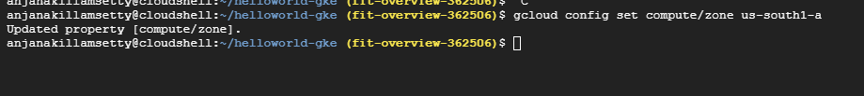

To get the value compute/zone

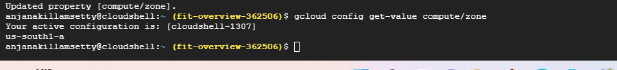

**Create a kuberneties cluster in google cloud platform from kuberneties engine**

Command for getting the cluster credentials

gcloud container clusters get-credentials cluster-1 –region us-south1

Deployment server:

The below command is used to create new server and deploy the app hello-app:1.0:

Kubectl create deployment new-server –image=us-docker.pkg.dev/google-samples/containers/gke/hello-app;1.0

To get info of pods:

We use the command: kubectl get pods

We are expose the new-server to port and getting info of new service by using the below command

**Kubectl get service new-server**

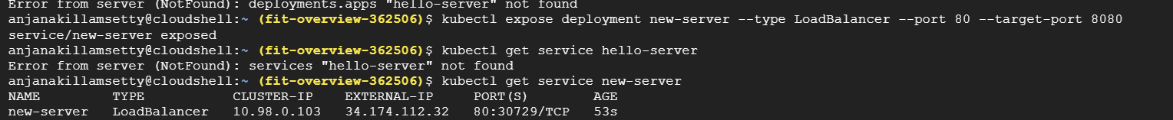

Deleting the cluster

1.To delete the applications service by using the following command

**Kubectl delete service new-server**

To delete the server

**Gcloud container clusters delete cluster-1 region us-south1**

