LAB(DOCKER)

Installation of docker by using the command prompt

We can run the new repository by using the command prompt.

Docker Container which is created

Part 2

Creating a new Docker file.

Building the new repository using the build command

New container is created.

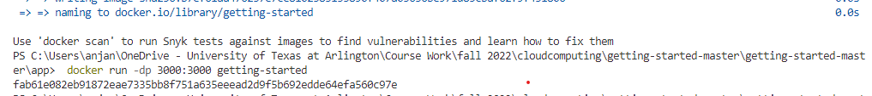

Part3: Update the Application

Build new version of getting-started container

Starting new container using the updated code

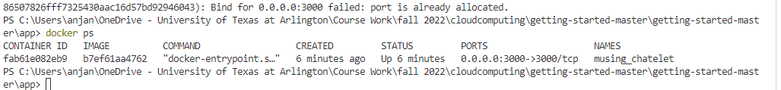

Removing the old container:







Start the updated container:

Part4:Share the Application

Creating the repo

Push the code



Run the image on anew instance

Part 5

Persistent DB:

Starting a ubuntu

Persist the todo data



Dive into the volume

Step 6:Use bind mounts

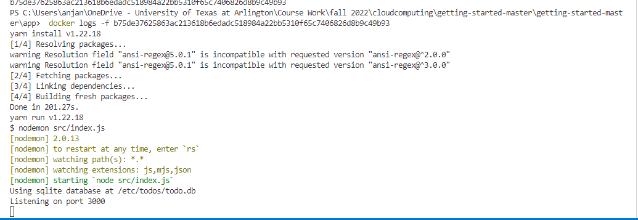

Start a dev-mode container

Part 7:start Mysql

Connect to Mysql:

Run your app with mysql

Part 8: Use Docker Compose



Define the app Service

MYSQL SERVICE

Run the application stack

Tear it all down



Part 9:security scanning

Scanning the container

