THANAL.com

Submitted to Submitted by

Ms.Meera Rose Mathew Anjana Alex

Asst.Professor RollN.04

Dept.of Computer Applications MCA Reg S5

**ABSTRACT**

THANAL.com is a online website for those living with paralysis.This site provide informations(health issues,help & assistance living with paralysis) for quadriplegic or paralytic patients.

It comprises of the following 4 modules,

1.Admin

2.Patient/caregiver

3.Home Nurse

4.Hospital

5.Doctor

Admin

Admin manages the entire system,where admin can login into their account and perform the operatios of,

* Approve or reject the request of the home nurse.
* Can provide the information about health issues(autonomic dysreflexia ,bladder management, skin management and urinary tract informations).
* Can provide scientific informations(spinal cord details,different levels and anatomy).
* Can provide information about living with paralysis(inssurances,wheel chairs and home & travel).

Patient /Caregiver

This is the module where patient/caregiver can login into their account and it includes

* View the information about health issues.
* View the scientific information.
* View living with paralysis.
* Can take appointment of doctors.
* View the registered nurse

Home Nurse

This is the module where home nurse can login into their account and it includes

➢ Register for the job.

➢ View requested patients.

➢ Edit their profile.

Hospital

This is the module where home nurse can login into their account and it includes

➢ Update the doctor’s details.

➢ Add doctor’s to the site.

➢ Approve the doctor appointment and arrange their time.

➢ Provide information about hospital fecilities.

Doctor

This is the module where home doctor can login into their account and it includes

➢ Patient details.

➢ Give medicines.

USECASE DIAGRAMS

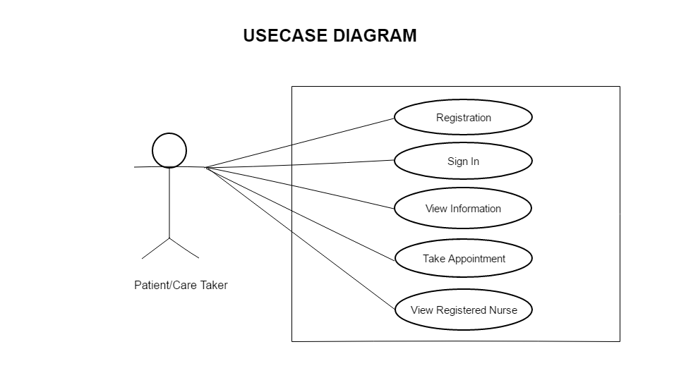

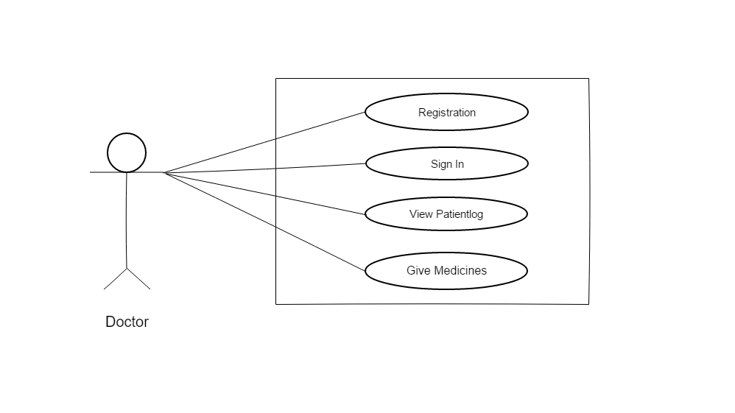

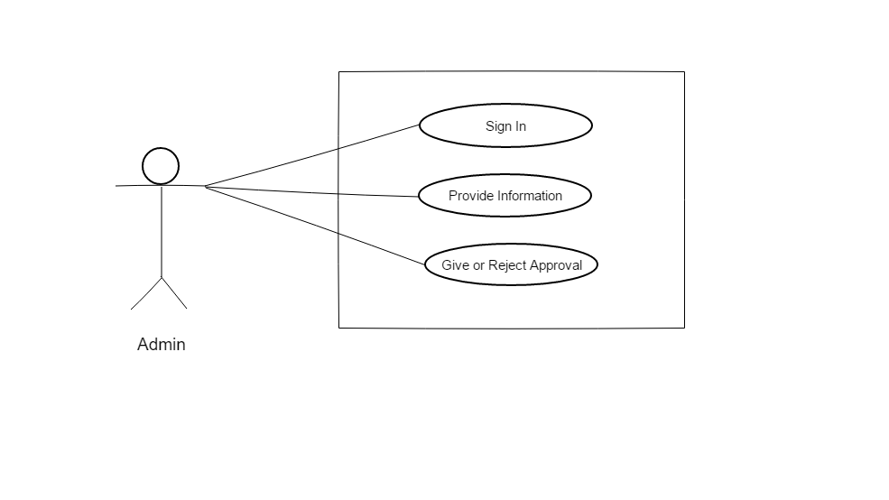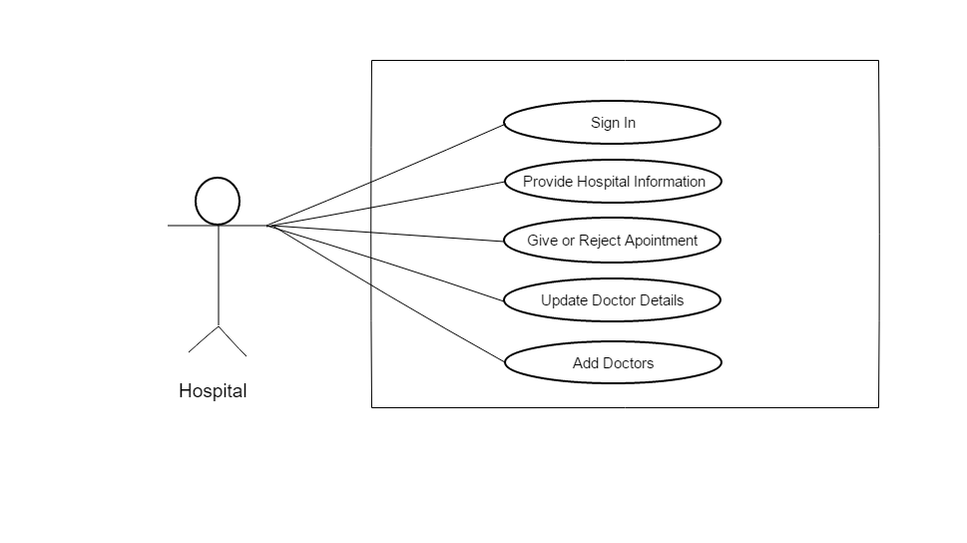

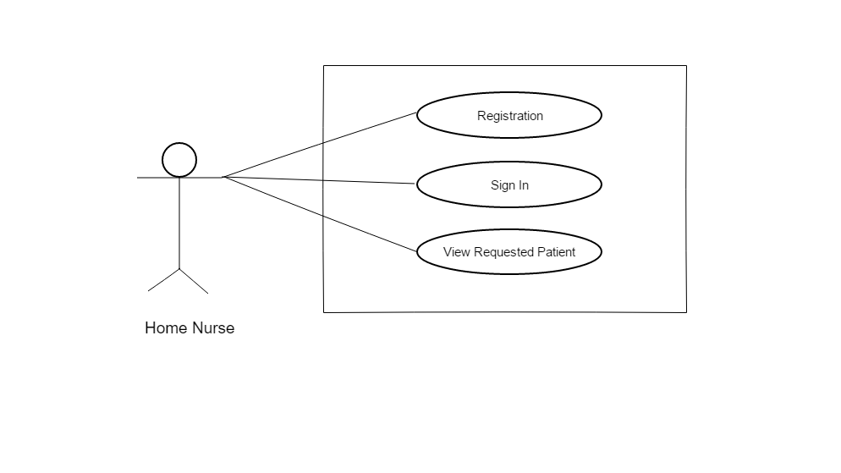

FORM DESIGN

1.Login

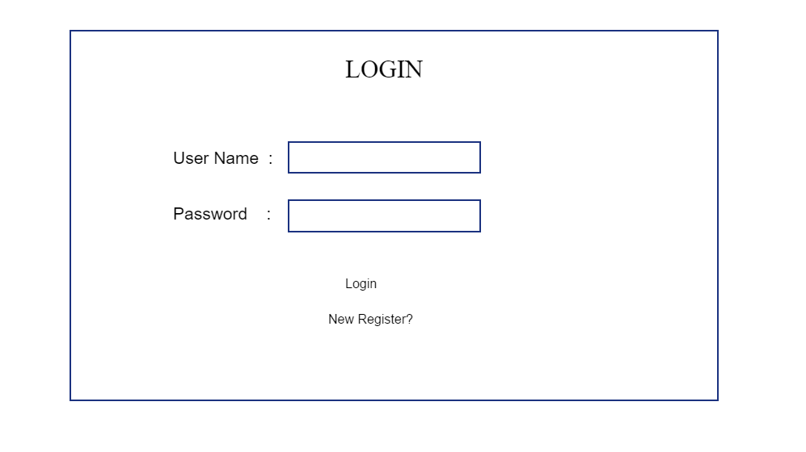

2.Admin home

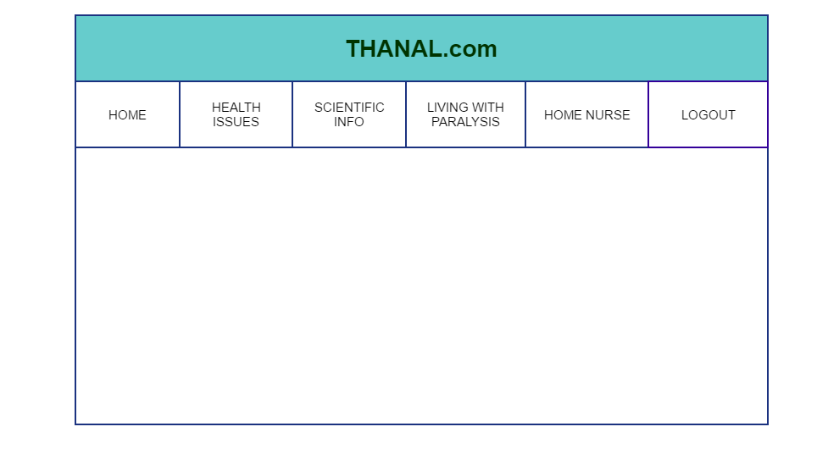

3.Patient/Caregiver home

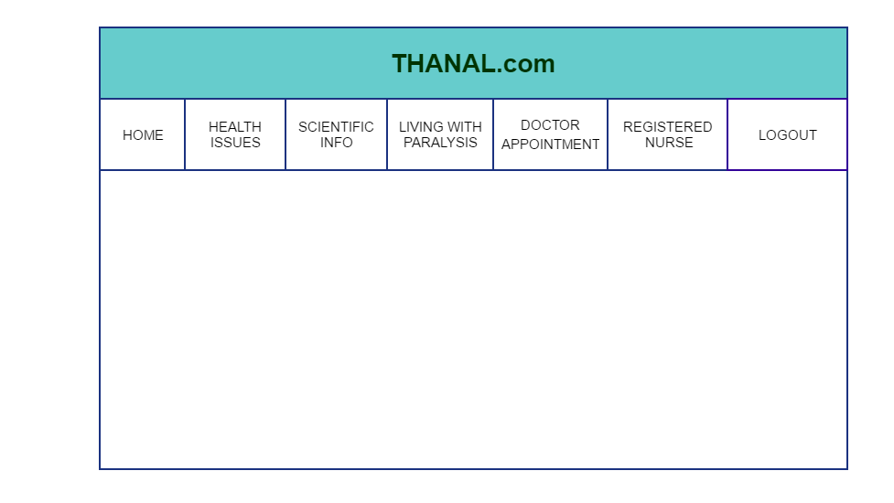

4.Hospital home

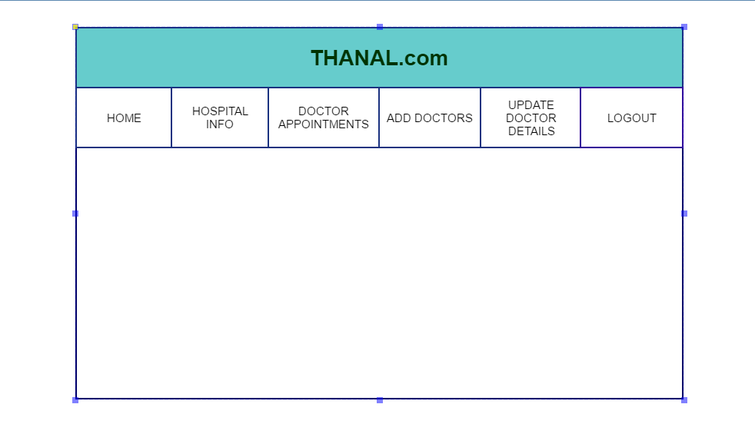

5.Home Nurse Home

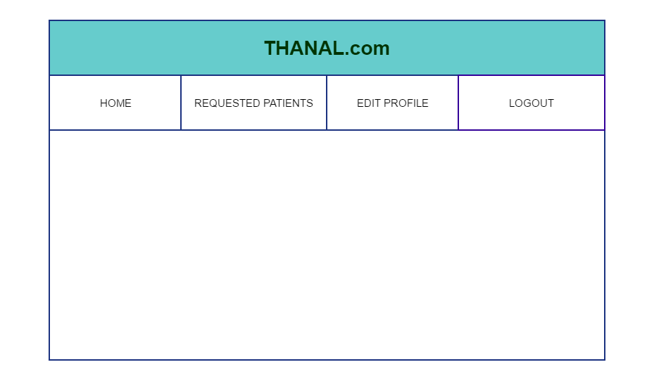6.Doctor Appointment Form

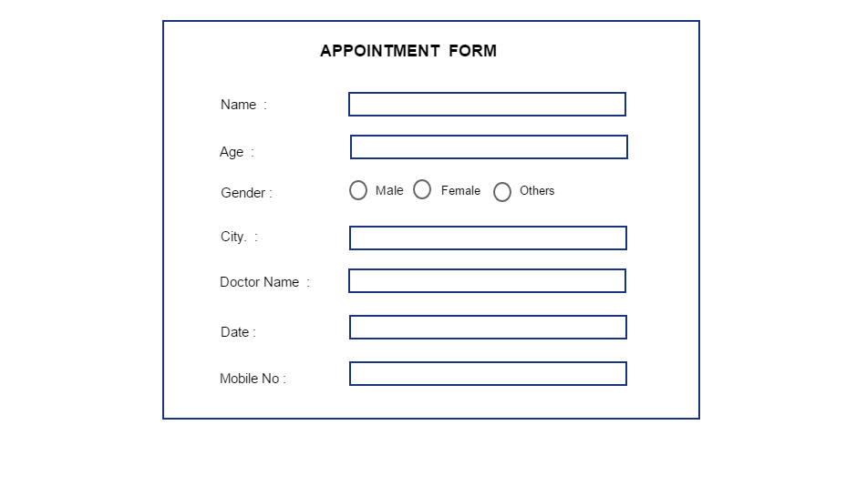

7.Doctor Registration

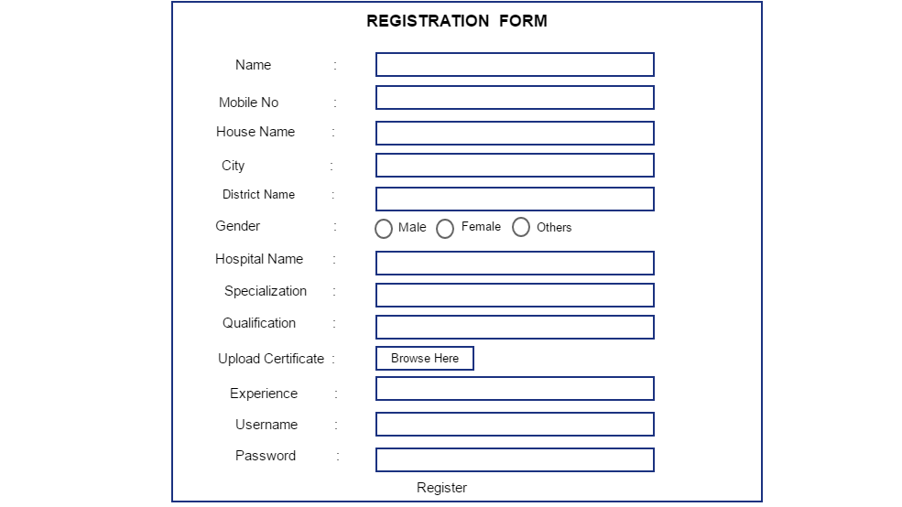

8.Nurse Registration

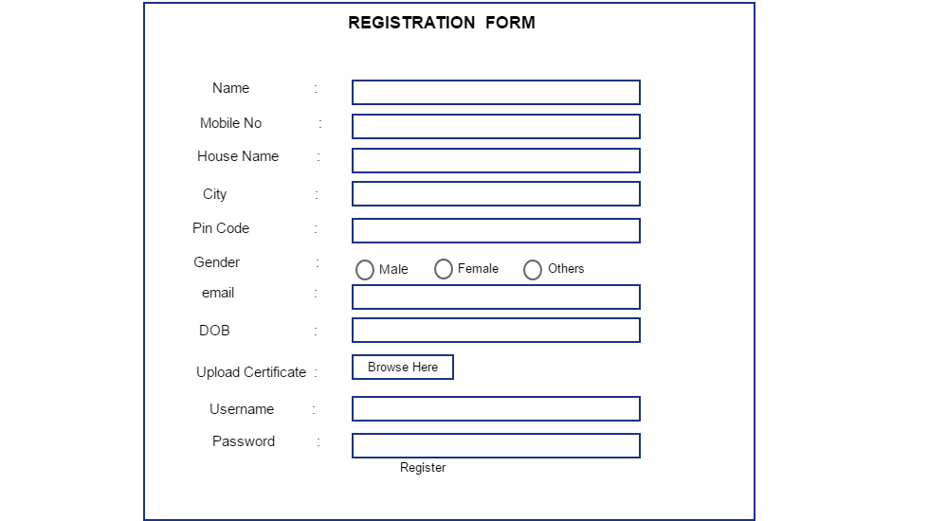

9.Patient Registration

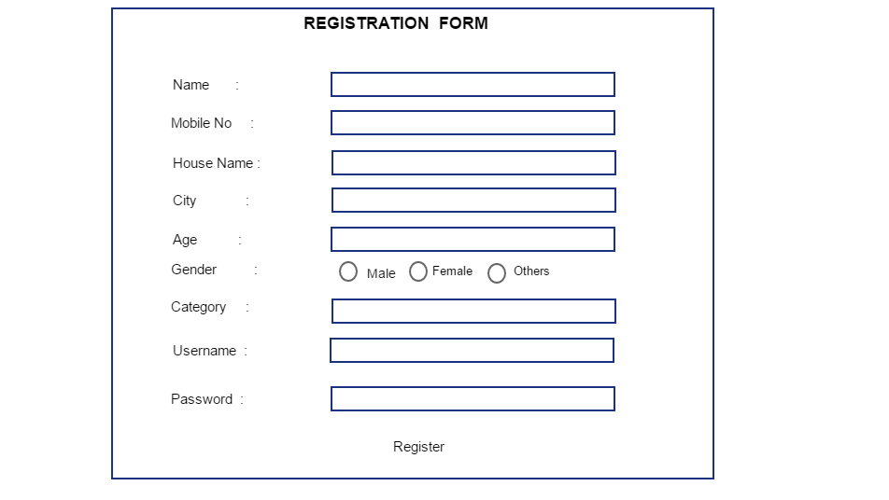

10.Patientlog

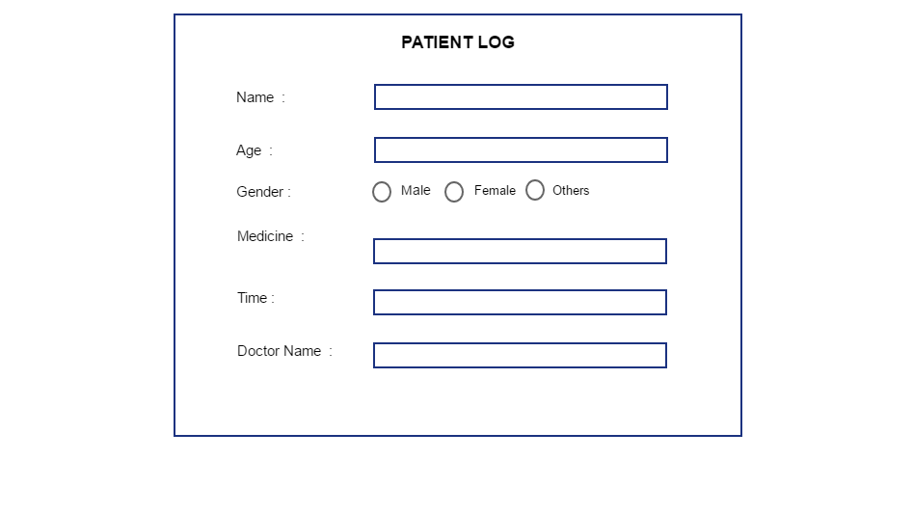

TABLE DESIGN

Table 1: tbl_login

|  |  |  |  |
| --- | --- | --- | --- |
| Field | Datatype | Constraint | Description |
| username | varchar | Primary key | It stores the username for login |
| password | varchar | Not null | It stores the password for login |

Table 2: tbl_nursereg

|  |  |  |  |
| --- | --- | --- | --- |
| Field | Datatype | Constraint | Description |
| nurseid | int | Primary key | It stores the nurse id |
| name | varchar | Not null | It stores the nurse name |
| mobile | int | Not null | It stores the mobile number |
| housename | varchar | Not null | It stores the house name |
| city | varchar | Not null | It stores the nurse city |
| pincode | int | Not null | It stores the pin code |
| email | varchar | Not null | It stores the email |
| gender | varchar | Not null | It stores the gender |
| dob | date | Not null | It stores the date of birth |
| ucertificate | blob | Not null | It browse the certificate |
| username | varchar | Foreign key | It stores the nurse username |
| password | varchar | Foreign key | It stores the nurse password |

Table 3: tbl_district

|  |  |  |  |
| --- | --- | --- | --- |
| Field | Datatype | Constraint | Description |
| disid | int | Primary key | It stores the district id |
| disname | varchar | Not null | It stores the district name |

Table 4: tbl_docreg

|  |  |  |  |
| --- | --- | --- | --- |
| Field | Data Type | Constraint | Description |
| did | int | Primary key | It stores the doctor id |
| dname | varchar | Primary key | It stores the doctor name |
| dmob | int | Not null | It stores the doctor mobile number |
| dhname | varchar | Not null | It stores the house name |
| dcity | varchar | Not null | It stores the city |
| dgender | varchar | Not null | It stores the gender |
| dhospname | varchar | Not null | It stores the hospital name |
| dqualification | varchar | Not null | Stores the qualification |
| dspecialization | varchar | Not null | Stores the specialization |
| dexperience | varchar | Not null | Stores the experience |
| dcertificate | blob | Not null | Browse the certificate |
| disname | varchar | Foreign key | Retrieves the district name |
| dusername | varchar | Foreign key | Retrieves the doctor user name |
| dpassword | varchar | Foreign key | Retrieves the doctor password |

Table 5: tbl_appointment

|  |  |  |  |
| --- | --- | --- | --- |
| Field | Data type | Constraint | Description |
| aid | int | Primary key | Stores the id |
| pname | varchar | Foreign key | Retrieves the patient name |
| page | int | Foreign key | Retrieves the patient age |
| mobno | int | Not null | Stores the mobile no |
| pgender | varchar | Not null | Retrieves the gender |
| dname | varchar | Foreign key | Retrieves the doctor name |
| date | date | Not null | Stores the date |
| pacity | varchar | Foreign key | Stores the city name |

Table 6: tbl_patientreg

|  |  |  |  |
| --- | --- | --- | --- |
| Field | Data type | Constraint | Description |
| pid | int | Primary key | Stores the patient id |
| pname | varchar | Primary key | Stores the patient name |
| page | int | Primary key | Stores the patient age |
| pgender | varchar | Not null | It stores the gender |
| pcity | varchar | Primary key | It stores the city |
| phouse | varchar | Not null | It stores the housename |
| pcategory | varchar | Not null | It stores the category |
| username | varchar | Foreign key | Retrieves the username |
| password | varchar | Foreign key | Retrieves the password |

Table 7: tbl_patientlog

|  |  |  |  |
| --- | --- | --- | --- |
| Field | Data type | Constraint | Description |
| logid | int | Primary key | It stores the id |
| pname | varchar | Foreign key | Retrieves the patient name |
| page | int | Foreign key | Retrieves the age |
| pgender | varchar | Foreign key | Retrieves the gender |
| dname | varchar | Foreign key | Retrieves the doctor name |
| pmedicine | varchar | Not null | It stores medicine names |
| ptime | int | Not null | It stores time |

SEQUENCE DIAGRAM

1.Admin

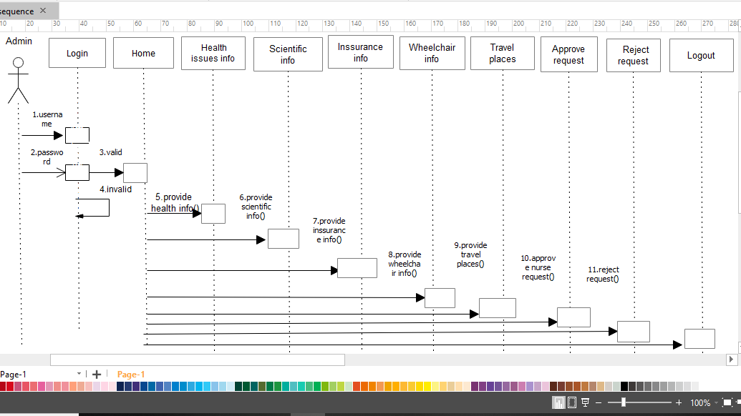

2.Doctor

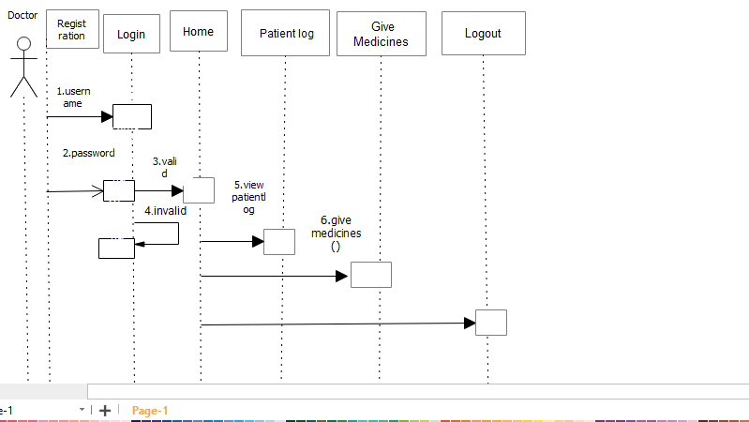

3.Home Nurse

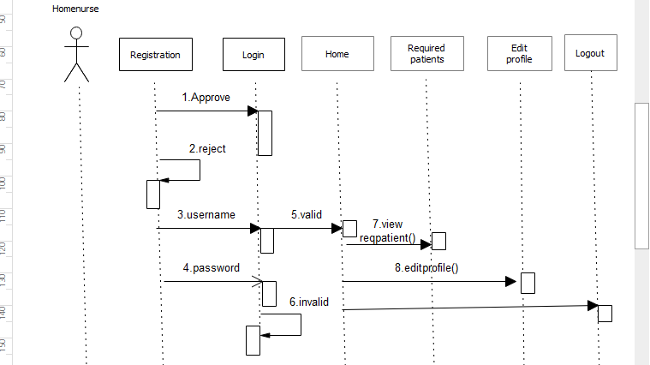

4.Hospital

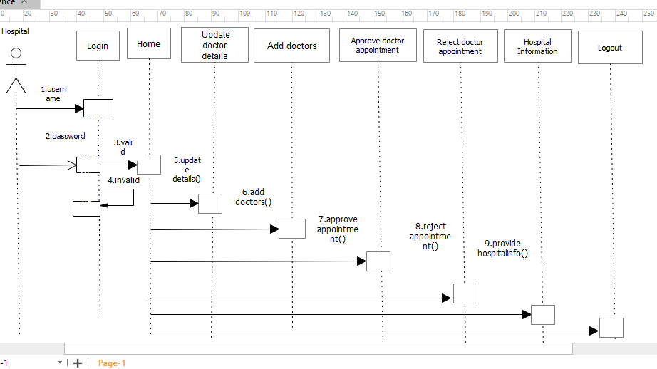

5.Patient

