--Submitting the code in an .ipynb (Jupyter Notebook format)
--To run the notebook, type Jupyter Notebook in the command prompt/terminal.
--Once the Jupyter Notebook is launched, select the required file and open a new Python 3 notebook.

Libraries required:
Latest version of pandas
Latest version of Numpy

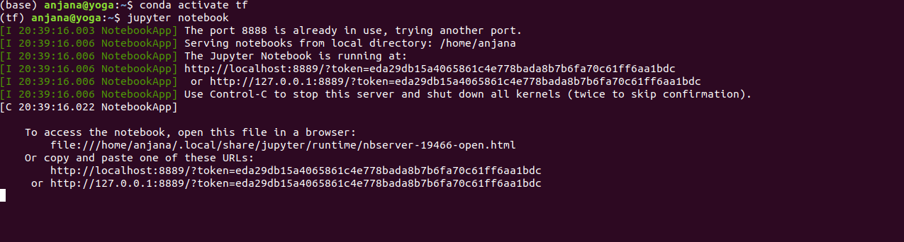
--Will also be submitting a .py file of the notebook, PDF version of the report and HTML version of the report.

