Client Credit Dashboard Mockups
Mockups: 1) Client list dashboard with an Evaluate button per client (factors hidden). 2) Gauge view showing the result (Low/Medium/High) after clicking Evaluate.

Dashboard (Clients with Evaluate button)
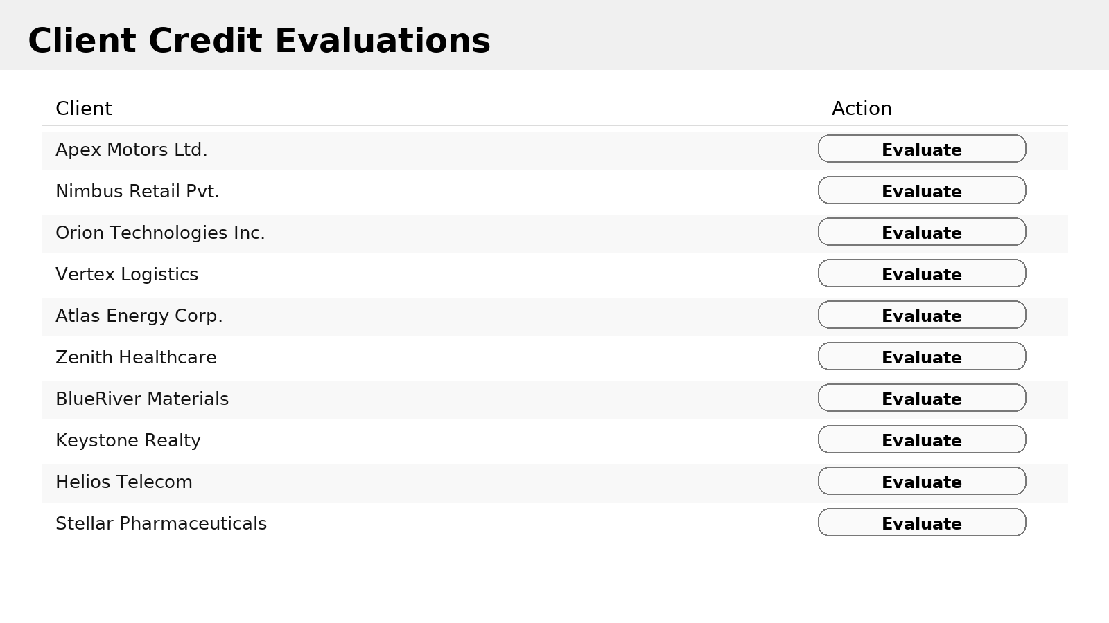

Gauge Result (after clicking Evaluate)
