 |  | PSG College of Technology  Fifth National level  “Research Conclave 2026”  May14-15, 2026  Schedule
May 14, 2026 |  | Venue : Hall –D Block Ground Floor Seminar Hall
Time slot |  | Sessions
08.15 am- 08.50 am |  | Registration
09:00 am - 09.30am |  | Inaugural Function
Keynote I  9.30 am- 10.15 am |  | 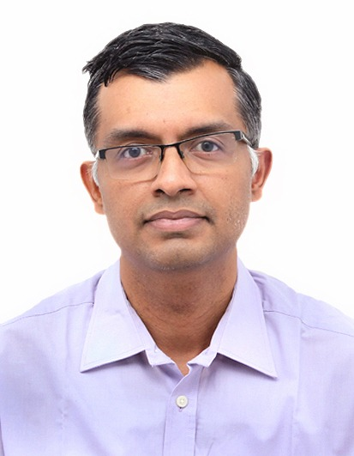 |  |  | Dr.Vaidyanathan Subramanian  Deputy Director  Compact modelling  Global Foundries  Bengaluru |  |  | Research, Innovation and Beyond
10:15 am – 10:30 am |  | Refreshments
Keynote II  10:30 am – 11:15 am |  | 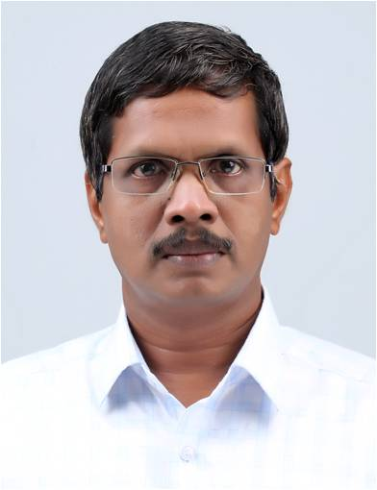 |  |  | Dr.Surendran Cherukodan  Assistant Librarian (Senior grade)  University Library  Cochin University of Science and Technology  Cochin |  |  | Academic Publishing : Platforms, Metrics and Visibility
11:30 pm – 01:00 pm |  | Technical Sessions in respective departments
12:15 pm – 01:00 pm |  | Lunch
02:00 pm – 03:00 pm |  | Technical Sessions in respective departments
03:00 pm – 03:30 pm |  | Refreshments
03:15 pm – 04:15 pm |  | Technical Sessions in respective departments
04:15 pm – 05:15 pm |  | Technical Sessions in respective departments
May 15, 2026 | Hall –D Block Ground Floor Seminar Hall
Time slot | Sessions
09:00 am – 10:45 pm | Technical Sessions in respective departments
10:45 am – 11:00 am | Refreshments
Keynote III  11:00 am – 11:45 am | 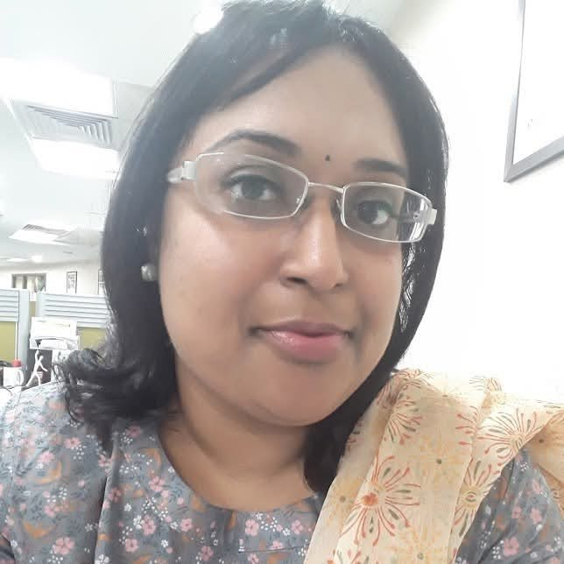 |  |  | Dr. Subhasree Nag  Strategic Customer Success Consultant  Clarivate Analytics  Mumbai |  | Building Global Reputation and Research Impact through Web of Science
12.00 pm - 01.00 pm. | Technical Sessions in respective departments.
10:30 am – 11:00 am | Refreshments
11.00 am - 12.30 pm. | Technical Sessions in respective departments.
12:30 pm – 01:30 pm | Lunch
Keynote IV  02:15 pm – 03:00 pm | 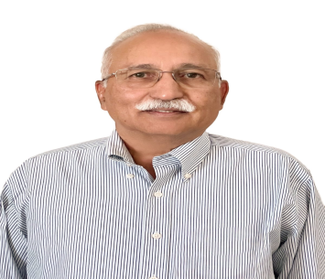 |  | Dr. Ankineedu Velaga  Senior Vice-President & Country Head - Operations  Yield Engineering Systems Inc |  |  |  | Idea factories that can generate great products
03:00 pm – 3:30 pm | Refreshments
03:30 pm-04:30 pm | Valedictory Function  Hall –D Block Ground Floor Seminar Hall

