Title of the manuscript

A.B. Student ª, C.D. Supervisor ^{b,*}

ª Affiliation (Department of XXXX, XXXXCollege/University, City, Pincode, Country
^{b} Affiliation (Department of XXXX, XXXX College/University, City, Pincode, Country
*Corresponding Author Ph: Fax: E-mail :

Abstract
- The abstract must be a precise and reflection of what is in your article.
- Do not use abbreviations, references, formulas, figures (Graphs), tables and footnotes in abstract.
- The abstract must be between 150-250 words.

Keywords: Provide 4-6 keywords suitable for your article.

1. Introduction
Introduction should represent past, present and future vision of the proposed research. Describe abbreviation and acronyms for the first time they included in the text [1, 2]. Authors are requested to include recent references emphasizing the background of the work [3-5]. Additional sub headings such as separate aim, objective, literature review etc, not permitted [6].

2. Experimental or Materials and Methods
2.1, Participants, Measures, Procedures, Analysis, Instruments and Software (Use numbering for each sub headings)

3. Results and Discussion
- Include Figures, Tables, and equations and numbers in the text wherever necessary and provide proper explanations.
- Subheadings are not compulsory.
- Figures must have a resolution of 300 dpi
- Equations must be editable (Use Microsoft or math type)
- Units (SI unites are highly encouraged)
- Use Zero before any decimal point (Eg. 0.12)

4. Conclusion

Conclusion should summarize the key results, suggestions and applications of the paper and it should not resemble the abstract.
- Do not include References
- The abstract must be between 150-250 words.

Acknowledgement
Funding Information:
Conflict of Interest
Author’s contribution
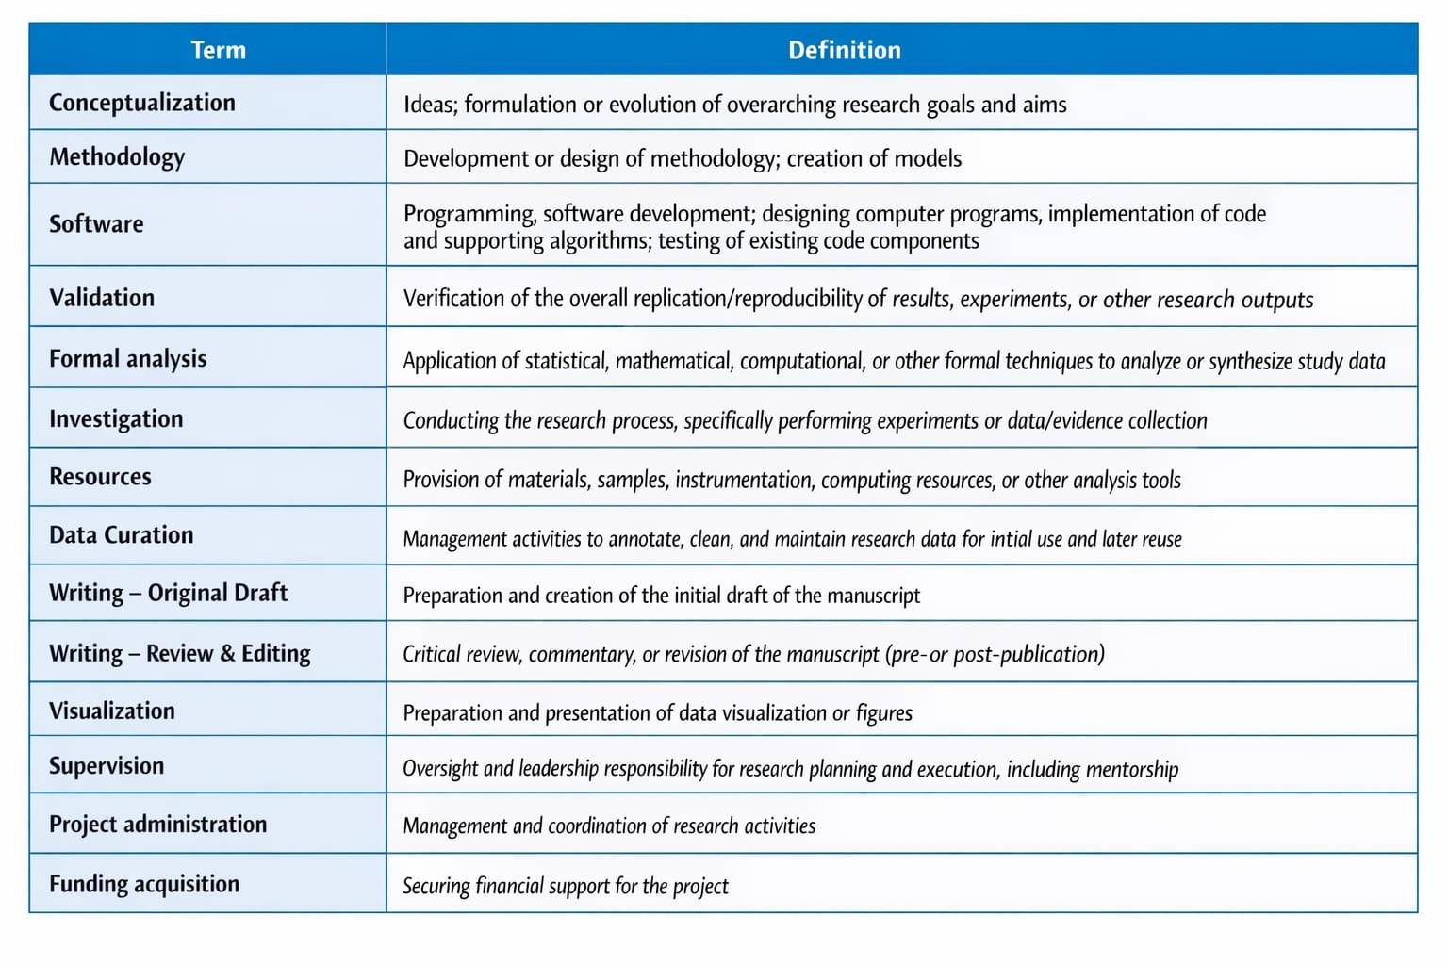
Example
Author Statement
Author A: Conceptualization, Methodology, Formal analysis, Writing – Original Draft
Author B: Investigation, Data Curation, Visualization
Author C: Software, Validation, Writing – Review & Editing
Author D: Supervision, Project administration, Funding acquisition

References
References must be numbered in a numerical manner [1,2], [3-5], [6], [7-9], etc.,
Journals
M. Vandoni, V.C. Pellino, S. Dell'Anna, E. Ricagno, G. Liberali, C. Bonfanti, L. Correale, International Journal of Physical Educations, Fitness and Sports, 8(4) (2019) 45-54. https://doi.org/10.26524/ijpefs1945

Books
A.J. Blazevich, (2017) Sports Biomechanics : The Basics: Optimising Human Performance, Bloomsbury Publishing PLC, London, United Kingdom.

Book Chapter
V. Baltzopoulos, (2007) Isokinetic dynamometry, in C.J. Payton and R.M. Bartlett (eds), Biomechanical Evaluation of Movement in Sport and Exercise, Abingdon: Routledge.

Proceedings or Abstracts
J.L. Vera-Rivera1, A.J. Ortega-Parra and Y.A. Ramírez-Ortiz, Impact of technology on the evolution of sports training, Journal of Physics: Conference Series, Volume 1386, 5th International Meeting for Researchers in Materials and Plasma Technology (5th IMRMPT) (2019), San José de Cúcuta, Colombia. https://doi.org/10.1088/1742-6596/1386/1/012144

Patents
S. Akila, Indian Patent XXXXXXXX (2020).

Thesis (Make sure it is available online)
Katharina Wirnitzer, Athletic performance capacity in mountainbike sports with extremely strenuous more days lasting endurance impact, Ph.D. Thesis, Faculty of Psychology and Sport Science, University of Innsbruck, Innrain 52, 6020 Innsbruck (2009).
Link : https://www.nurmi-study.com/wp-content/uploads/2017/01/thesis.pdf

Websites
We do not encourage the authors to include website or webpage as a reference

