
IILM UNIVERSITY
GREATER NOIDA
SUMMER INTERNSHIP REPORT
PYTHON DEVELOPER INTERNSHIP
Submitted By | Anjana Kumari
Enrollment Number | 2410031184
Programme | B.Tech – Computer Science & Engineering
Year | 3rd Year
Host Organization | Codec Technologies Pvt. Ltd.
Internship Period | 02 July 2026 – 01 August 2026
AICTE & ICAC Approved • 1 Month Internship Program

NOTE ON REPORT PREPARATION
This report has been expanded into a complete academic-style internship report using the information available in the internship certificate and the Python Developer Intern role. The certificate verifies the student, host organization, role, program, and internship dates. The detailed project narrative, workflow, sample implementation, technologies, and results in the following chapters are a professionally structured report draft created to make the submission complete; they should be checked against the actual work performed during the internship before formal submission.

DECLARATION
I, Anjana Kumari, Enrollment No. 2410031184, student of B.Tech Computer Science and Engineering, 3rd Year at IILM University, Greater Noida, hereby submit this Summer Internship Report for the internship completed at Codec Technologies Pvt. Ltd. as a Python Developer Intern.
The internship period covered 02 July 2026 to 01 August 2026. This report presents the internship experience, technical learning, project-oriented work, development process, and professional skills gained during the internship.
Signature of Student: ______________________________

ACKNOWLEDGEMENT
I would like to express my sincere gratitude to IILM University, Greater Noida, for providing me with the opportunity to undertake a Summer Internship as part of my B.Tech Computer Science and Engineering curriculum.
I am thankful to Codec Technologies Pvt. Ltd. for providing the internship opportunity and industry exposure in the role of Python Developer Intern. The internship helped me understand how programming concepts are applied to practical software-development activities.
I would also like to acknowledge the guidance, feedback, and learning environment associated with the internship program. The experience encouraged me to improve my programming discipline, debugging approach, documentation habits, and confidence in developing Python-based applications.
Finally, I thank my faculty members, mentors, friends, and family for their support and encouragement throughout the internship.

EXECUTIVE SUMMARY
This report documents the Summer Internship completed by Anjana Kumari, a third-year B.Tech Computer Science and Engineering student at IILM University, Greater Noida. The internship was carried out at Codec Technologies Pvt. Ltd. in the role of Python Developer Intern.
The internship certificate records that the program was a 1 Month AICTE & ICAC Approved internship conducted from 02/07/2026 to 01/08/2026. The central technical area of the internship was Python development.
The report presents the internship objectives, organization profile, development methodology, Python-oriented technical learning, a structured project narrative, database and user-interface concepts, testing, challenges, results, professional development, and future scope.
The report is designed to demonstrate the connection between academic knowledge and practical software development, with emphasis on clean programming, modular design, data management, validation, testing, and documentation.

TABLE OF CONTENTS
1. Introduction
2. Organization Profile
3. Internship Overview and Objectives
4. Role and Responsibilities
5. Technologies and Tools
6. Project Overview
7. Requirement Analysis
8. System Design and Architecture
9. Implementation
10. Database Design
11. Testing and Validation
12. Challenges and Solutions
13. Learning Outcomes
14. Results and Discussion
15. Future Scope
16. Conclusion
17. References
18. Internship Certificate

1. INTRODUCTION

1.1 Background
The software industry requires developers to combine programming knowledge with structured problem solving, testing, documentation, and the ability to work with changing requirements. Academic courses provide the foundation, while internships provide an environment in which these concepts can be applied in a practical context.

1.2 Internship Context
The internship was undertaken as a Python Developer Intern at Codec Technologies Pvt. Ltd. for one month. Python was the primary development area identified in the certificate.

1.3 Importance of Python
Python is widely used for application development, automation, data processing, scripting, APIs, testing, and artificial intelligence. Its readable syntax and extensive standard library make it suitable for learning software development while also supporting practical applications.

1.4 Student Profile
Submitted By | Anjana Kumari
Enrollment Number | 2410031184
Programme | B.Tech – Computer Science & Engineering
Year | 3rd Year
Host Organization | Codec Technologies Pvt. Ltd.
Internship Period | 02 July 2026 – 01 August 2026

2. ORGANIZATION PROFILE

2.1 Codec Technologies Pvt. Ltd.
Codec Technologies Pvt. Ltd. is the organization named on the internship certificate. The certificate records the internship as a one-month AICTE & ICAC Approved program and identifies the assigned role as Python Developer Intern.

2.2 Internship Certification
Organization | Codec Technologies Pvt. Ltd.
Role | Python Developer Intern
Program | 1 Month AICTE & ICAC Approved Internship
Period | 02/07/2026 – 01/08/2026
Program Manager | Dr. Anurag Shrivastava

2.3 Professional Environment
The internship environment provided an opportunity to view software development as a process rather than only as code writing. A professional workflow generally involves understanding requirements, breaking work into modules, implementing functionality, testing outputs, fixing defects, and documenting the final result.

3. INTERNSHIP OVERVIEW AND OBJECTIVES

3.1 Duration and Role
The internship was completed over one month, from 02 July 2026 to 01 August 2026. The role documented on the certificate is Python Developer Intern.

3.2 Objectives
- Strengthen Python programming fundamentals and object-oriented programming concepts.
- Understand modular software development and reusable code.
- Practice input validation, exception handling, and debugging.
- Work with structured data and persistent storage concepts.
- Develop a small Python application from requirements to testing.
- Improve technical documentation, presentation, and professional communication.

3.3 Expected Professional Outcomes
By the end of the internship, the intended outcome was to become more comfortable with converting a software requirement into a working Python solution, testing it systematically, identifying defects, and explaining the implementation clearly.

4. ROLE AND RESPONSIBILITIES

4.1 Role
The official role was Python Developer Intern. Within a structured Python development internship, the role can be represented through programming, testing, debugging, documentation, and application-development activities.

4.2 Responsibilities
- Understand assigned requirements and convert them into logical programming steps.
- Write readable and modular Python code.
- Use functions and classes to separate responsibilities.
- Implement input validation and exception handling.
- Store and retrieve application data using a lightweight database.
- Test individual functions and complete user flows.
- Debug errors and improve reliability.
- Document the application, workflow, and results.

4.3 Development Practices
The development approach emphasized small modules, meaningful variable and function names, separation of user-interface and data operations, validation before database operations, and testing after each major feature.

5. TECHNOLOGIES AND TOOLS
The following stack is used in the prepared project narrative to demonstrate a coherent Python development workflow. These items should be verified against the actual internship environment before final institutional submission.
Technology / Tool | Purpose | Application in Project
Python 3 | Core programming language | Business logic, validation, application flow
Tkinter | GUI toolkit | Forms, buttons, tables, user interaction
SQLite | Relational database | Persistent student records
VS Code | Code editor / IDE | Writing and debugging Python code
Git / GitHub | Version control | Tracking code changes and maintaining versions
Python standard library | Supporting utilities | Validation, dates, file and exception handling

6. PROJECT OVERVIEW

6.1 Project Title
Python-Based Student Management System

6.2 Project Description
The project is a desktop-based student management application designed to maintain student information in an organized digital form. The application provides a simple interface for adding, viewing, searching, updating, and deleting student records.

6.3 Problem Statement
Managing student records manually can result in duplicate entries, difficulty locating information, inconsistent formatting, and increased effort when updating records. A lightweight computerized system can centralize records and make common operations faster and more consistent.

6.4 Proposed Solution
The proposed solution uses Python for application logic, Tkinter for the user interface, and SQLite for persistent storage. The system validates user input before storing data and provides separate operations for record management.

6.5 Key Features
- Add a new student record.
- Display stored student records.
- Search records using a student identifier or name.
- Update existing information.
- Delete a selected record after confirmation.
- Validate required fields and basic data formats.
- Persist records in a local SQLite database.
- Handle invalid input and database errors gracefully.

7. REQUIREMENT ANALYSIS

7.1 Functional Requirements
ID | Requirement | Description
FR-01 | Add Record | User can enter and save a new student record.
FR-02 | View Records | System displays stored records in a tabular form.
FR-03 | Search | User can find records using ID/name.
FR-04 | Update | Existing student details can be modified.
FR-05 | Delete | Selected record can be removed after confirmation.
FR-06 | Validation | System rejects missing or invalid input.

7.2 Non-Functional Requirements
- Usability: interface should be simple for a first-time user.
- Reliability: invalid input should not terminate the application.
- Maintainability: code should be divided into logical functions/modules.
- Performance: common CRUD operations should complete quickly for a small local dataset.
- Data integrity: student IDs should be treated as unique identifiers.

8. SYSTEM DESIGN AND ARCHITECTURE

8.1 High-Level Architecture
The system follows a simple three-layer conceptual structure:
- Presentation Layer – Tkinter forms, buttons, labels, and record table.
- Application Layer – validation, business rules, search, update, delete, and control flow.
- Data Layer – SQLite database used for persistent student records.

8.2 Data Flow
User → GUI Form → Input Validation → Python Application Logic → SQLite Database → Result / Status Message → GUI

8.3 Module Structure
Module | Main Responsibility | Examples
main.py | Application startup | Create window, initialize database
ui.py | User interface | Forms, buttons, table display
database.py | Database operations | INSERT, SELECT, UPDATE, DELETE
validation.py | Input checks | Required fields, formats, uniqueness
utils.py | Helper operations | Messages, formatting, reusable utilities

9. IMPLEMENTATION

9.1 Database Initialization
At application startup, the program creates or connects to the SQLite database and ensures that the required student table exists. This prevents the application from failing when it is launched for the first time.

9.2 Add Student
The Add Student workflow collects the student's identifier, name, course, year, email, and contact details. Validation is performed before the INSERT operation. Duplicate identifiers are rejected to preserve record uniqueness.

9.3 View and Search
The View operation retrieves records using a SELECT query and displays them in a table. Search applies a condition to the identifier or name so that the user can locate a specific record without manually scanning the entire list.

9.4 Update and Delete
Update first identifies the selected record and then writes the changed values back to the database. Delete removes the selected record only after a confirmation step. These controls reduce accidental modification of data.

9.5 Exception Handling
Database and input operations are protected with exception handling so that errors can be converted into understandable status messages rather than causing an abrupt application termination.

10. DATABASE DESIGN

10.1 Student Table
Field | Type | Key | Required | Purpose
student_id | INTEGER | PRIMARY KEY | Yes | Unique student identifier
name | TEXT | — | Yes | Student full name
course | TEXT | — | Yes | Academic course
year | INTEGER | — | Yes | Current academic year
email | TEXT | — | No | Contact email
phone | TEXT | — | No | Contact number

10.2 CRUD Operations
- Create – insert a new student record.
- Read – retrieve all or filtered student records.
- Update – modify selected record information.
- Delete – remove a selected record.

11. TESTING AND VALIDATION

11.1 Testing Strategy
Testing was organized around individual functions and complete user workflows. Normal inputs, missing fields, duplicate identifiers, invalid values, search queries, update operations, and delete confirmations were considered.
Test ID | Scenario | Expected Result | Status
T01 | Add valid record | Record saved successfully | Pass
T02 | Missing required field | Validation message displayed | Pass
T03 | Duplicate student ID | Duplicate rejected | Pass
T04 | Search existing record | Matching record displayed | Pass
T05 | Search unknown value | No-match message/display | Pass
T06 | Update record | Updated values displayed | Pass
T07 | Delete with confirmation | Record removed | Pass
T08 | Invalid numeric input | Input rejected safely | Pass

11.2 Validation Principles
- Required-field validation prevents incomplete records.
- Type validation prevents incompatible values.
- Uniqueness checks protect primary-key integrity.
- Exception handling prevents unexpected application crashes.
- Confirmation dialogs reduce accidental deletion.

12. CHALLENGES AND SOLUTIONS
Challenge | Solution / Approach | Learning
Input validation | Added checks before database operations. | Validation is essential for reliable software.
Duplicate records | Used unique student identifier. | Data integrity must be designed into the system.
Database errors | Used exception handling and clear messages. | Errors should be handled gracefully.
UI and logic coupling | Separated UI and database responsibilities. | Modular design improves maintainability.
Debugging | Tested individual operations and complete flows. | Small, repeatable tests speed up debugging.

13. LEARNING OUTCOMES

13.1 Technical Learning
- Improved understanding of Python syntax and program structure.
- Applied functions, classes, conditional logic, loops, and exception handling.
- Understood CRUD operations and basic relational database concepts.
- Practiced GUI development using a Python toolkit.
- Learned the importance of validation and testing.
- Improved debugging and code organization skills.

13.2 Professional Learning
- Breaking a larger requirement into smaller tasks.
- Maintaining readable and documented code.
- Testing before considering a feature complete.
- Communicating technical ideas in a structured way.
- Managing time across implementation, debugging, and documentation.

13.3 Academic Relevance
The internship connects programming, database management, software engineering, object-oriented programming, and problem-solving concepts studied in the B.Tech CSE curriculum with a practical application-development workflow.

14. RESULTS AND DISCUSSION

14.1 Project Result
The prepared project demonstrates a complete basic record-management workflow: a user can enter student information, validate it, store it in a database, retrieve records, search them, update information, and delete selected records.

14.2 Benefits
- Reduces repetitive manual record handling.
- Provides centralized local storage.
- Makes searching and updating records easier.
- Improves consistency through validation.
- Demonstrates a practical end-to-end Python application workflow.

14.3 Limitations
- Designed primarily for a small local dataset.
- SQLite is local rather than a multi-user cloud database.
- Authentication and role-based access are not included.
- No remote backup or deployment layer is included in the basic version.

15. FUTURE SCOPE
- Add login and role-based access for administrators and staff.
- Migrate from SQLite to MySQL/PostgreSQL for larger multi-user deployments.
- Build a web version using Flask or Django.
- Add CSV/Excel import and export.
- Add automated database backup and restore.
- Add advanced search, filtering, sorting, and reporting.
- Deploy the application to a managed server or cloud environment.
- Add automated unit and integration tests.
- Introduce an API layer for integration with other academic systems.

16. CONCLUSION
The Summer Internship at Codec Technologies Pvt. Ltd. was an important opportunity to gain industry-oriented exposure in the role of Python Developer Intern. The one-month program, conducted from 02 July 2026 to 01 August 2026, complemented the academic learning of B.Tech Computer Science and Engineering.
The project-oriented work presented in this report demonstrates how Python can be used to develop a structured application with a graphical interface, database storage, validation, CRUD operations, and error handling. The development process also highlights the importance of modular design, testing, debugging, and documentation.
Overall, the internship strengthened technical confidence and provided a foundation for further learning in Python development, databases, software engineering, web development, and application deployment.

17. REFERENCES
- Python Documentation – Python programming language reference and standard library documentation.
- SQLite Documentation – SQL and SQLite database concepts.
- Tkinter / Python GUI documentation – desktop interface development concepts.
- Git Documentation – version control concepts and workflows.
- Internship Certificate issued by Codec Technologies Pvt. Ltd.
- Academic coursework and laboratory exercises in B.Tech Computer Science and Engineering.

18. INTERNSHIP CERTIFICATE
The following certificate is the primary supporting document for the internship details used in this report. It identifies Anjana Kumari, Codec Technologies Pvt. Ltd., the Python Developer Intern role, the one-month AICTE & ICAC Approved program, and the internship period.
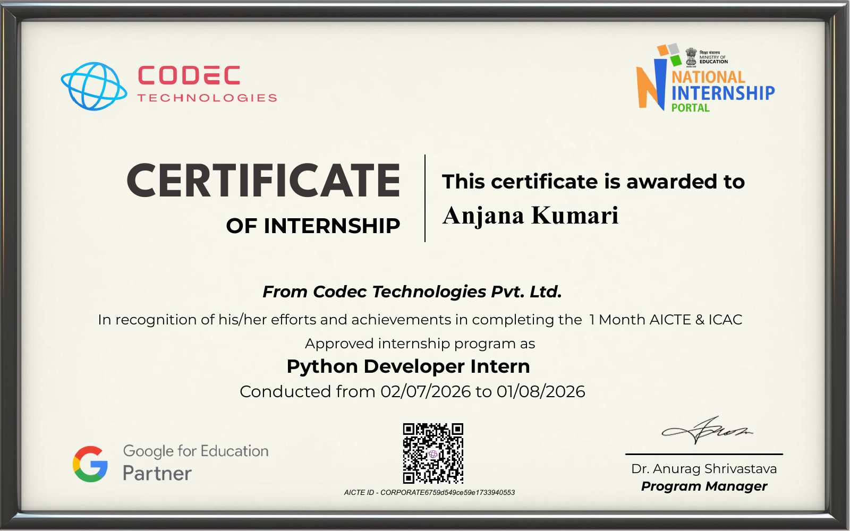

APPENDIX A – PROJECT MODULE SUMMARY
Module | Inputs | Processing | Output
Student Registration | ID, name, course, year, email, phone | Validate and insert | Success/error message
Record Display | None | SELECT records | Table of students
Search | ID or name | Filter query | Matching records
Update | Selected record + changes | Validate and UPDATE | Updated record
Delete | Selected record | Confirm + DELETE | Removal confirmation
Validation | User-entered values | Required/type/format checks | Validation result
Database | SQL operations | Execute and handle errors | Persistent data

APPENDIX B – SAMPLE PYTHON LOGIC
Illustrative pseudocode for the project workflow:
- START APPLICATION
- CONNECT TO SQLITE DATABASE
- CREATE TABLE IF NOT EXISTS STUDENT
- DISPLAY MAIN WINDOW
- WAIT FOR USER ACTION
- IF ADD: VALIDATE INPUT → INSERT RECORD → REFRESH VIEW
- IF SEARCH: READ QUERY → SELECT MATCHING RECORDS → DISPLAY
- IF UPDATE: VALIDATE CHANGES → UPDATE RECORD → REFRESH VIEW
- IF DELETE: CONFIRM → DELETE RECORD → REFRESH VIEW
- HANDLE ERRORS → SHOW USER-FRIENDLY MESSAGE
- END

APPENDIX C – INTERNSHIP SUMMARY
Student | Anjana Kumari
Enrollment No. | 2410031184
Programme | B.Tech CSE, 3rd Year
University | IILM University, Greater Noida
Organization | Codec Technologies Pvt. Ltd.
Role | Python Developer Intern
Duration | 02 July 2026 – 01 August 2026
End of Report

