PLC Implementation of Heat Exchanger
Temperature Control with Smith Predictor (CODESYS)
Project Design Report
Anjana Mahendran · M.Tech Instrumentation & Control Engineering, CUSAT

1. Objective
This project implements, in a PLC, the heat exchanger temperature control system that was designed and analysed in an earlier MATLAB project. In that study, a PI controller and a PI controller with a Smith predictor were designed for a heat exchanger with a long transport delay, and compared on setpoint tracking, disturbance rejection, robustness and noise. This project turns that design into a working PLC program in CODESYS, with the features an operator and a plant would need.
The project has these specific objectives:
- Implement the heat exchanger plant, the valve, the sensor lag and the transport delay as a simulation in the PLC.
- Implement a PI controller and a PI controller with a Smith predictor in Structured Text, using the tuning values from the MATLAB project.
- Provide a selector so the operator can switch between PI and Smith predictor control.
- Provide automatic and manual modes with bumpless transfer, and anti-windup on the controller output.
- Add a measurement filter on the temperature signal, because the MATLAB study showed that the higher controller gain of the Smith predictor amplifies sensor noise at the valve.
- Build an alarm system and a safety interlock, and an operator screen with live trends.
- Validate the PLC implementation by repeating the MATLAB test cases and comparing the PLC responses with the MATLAB results.
The aim is to show the full path from control design to a working, tested PLC implementation. The process is simulated inside the PLC program, so no hardware is needed.

2. Scope

2.1 What the project includes
Area | What will be done
Process simulation | The heat exchanger as a first-order lag with transport delay (implemented as a sample buffer), a sensor lag and optional measurement noise. The operator can change the plant gain and delay while running, to repeat the robustness cases.
Controllers | A PI controller and a PI controller with a Smith predictor, written as function blocks in Structured Text. The predictor uses a model with and without delay.
Controller selection | A selector for PI or Smith predictor control. Both predictor models keep running in the background, so switching does not disturb the process.
Operator modes | Automatic and manual modes. In manual the operator sets the valve position. Switching modes does not cause a sudden valve movement (bumpless transfer).
Anti-windup | Output limits of 0–100 % and a limit on the integral term while the valve is saturated.
Measurement filter | A first-order filter on the temperature signal, which can be switched on or off, so its effect can be tested.
Alarm management | High and high-high temperature alarms and a sensor fault alarm, with deadband, on-delay, acknowledgement and a time-stamped history.
Safety interlock | A high-high temperature interlock that forces the heating valve closed, released after the temperature is back in range and the operator resets it.
Operator screen | A CODESYS visualization with setpoint entry, mode and controller selection, a disturbance entry, live values, trends, and the alarm list.
Validation | The MATLAB test cases are repeated in the PLC and compared with the MATLAB results.
Table 1. Scope of the project.

2.2 What the project does not include
- No real hardware, sensors, valves or field wiring. All signals are simulated in software.
- No new controller design. The tuning values come from the MATLAB project.
- No connection to a real DCS, SCADA system or plant network.

2.3 Link to the MATLAB project
The MATLAB project answers the question of how to design the controller and how well it works. This project answers the question of how to build it as a PLC program and check that it behaves as designed. The plant, the controllers and the test cases are the same, so the two projects form one continuous piece of work: design and analysis, then implementation and validation.

3. Process and Plant Model
The process is the outlet temperature of a heat exchanger, controlled by a heating valve. The plant model is the one identified in the MATLAB project: a first-order lag with transport delay, followed by a temperature sensor with its own lag.
Parameter | Value | Source
Process gain K | 1.5 °C per % valve | MATLAB project
Time constant τ | 50 s | MATLAB project
Transport delay θ | 15 s | MATLAB project
Sensor lag | 5 s | MATLAB project
Measurement noise | 0.05 °C (optional) | MATLAB project
Setpoint step | 10 °C rise | MATLAB project
Input disturbance | 5 % valve step | MATLAB project
Scan time | 100 ms (initial value) | PLC design
Table 2. Plant parameters. The temperature is the outlet temperature rise above the inlet temperature.
The delay is realised as a buffer of past controller outputs. With a scan time of 100 ms, a delay of 15 s needs 150 samples. The plant and sensor lags are discretised with the same scan time. The operator can change the delay and gain by ±30 % to repeat the robustness cases of the MATLAB study.

4. Control Strategy
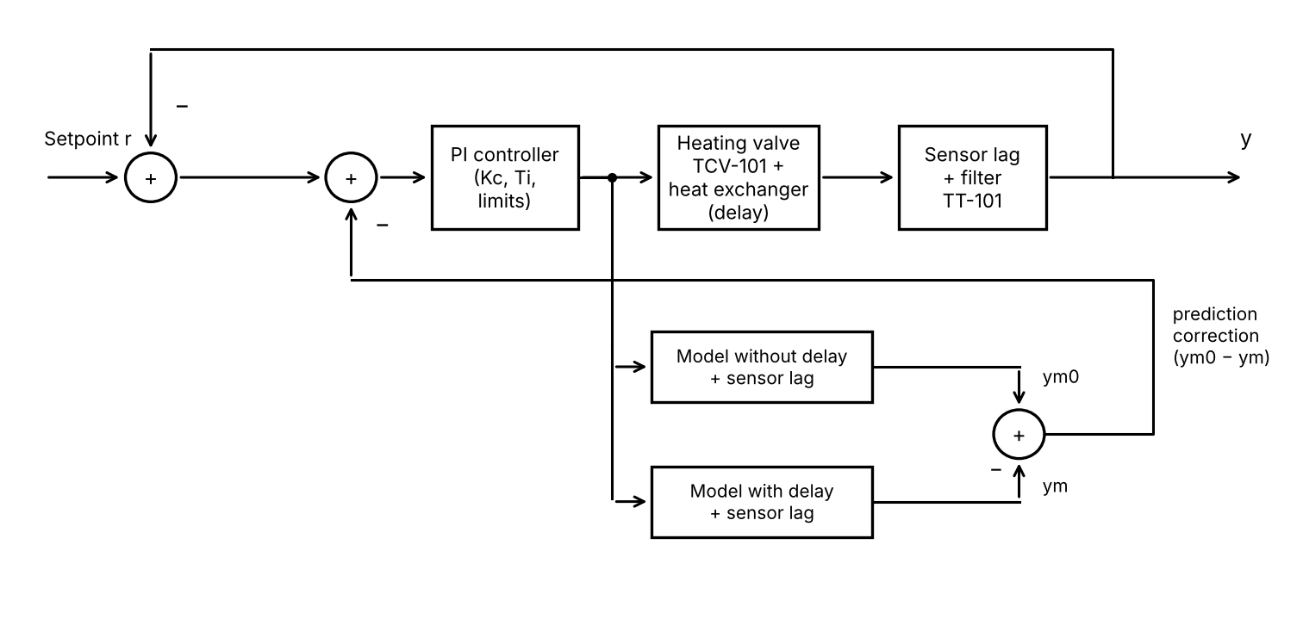
Figure 1. PI controller with Smith predictor, as implemented in the PLC.

4.1 PI controller
A PI controller acts on the error between the setpoint and the measured temperature. The initial tuning is the final design from the MATLAB project: Kc = 0.834 and Ti = 50 s.

4.2 PI with Smith predictor
The controller output also drives two internal models of the plant: one without the delay and one with it, both including the sensor lag. The difference between their outputs is subtracted from the error, so the controller reacts as if the delay were not there, while any mismatch with the real plant still shows up. The initial tuning is Kc = 3.336 and Ti = 50 s, as in the MATLAB project.

4.3 Operator modes and selection
Selection | Behaviour
Auto, PI | PI controller drives the valve.
Auto, Smith predictor | PI with Smith predictor drives the valve.
Manual | Operator sets the valve position. Controller states follow the valve, so returning to Auto causes no jump.
Table 3. Controller selection and modes.

4.4 Anti-windup and measurement filter
The valve output is limited to 0–100 %. While it is at a limit, the integral term is stopped from growing, so the controller recovers quickly. A first-order filter on the temperature signal reduces the noise that reaches the valve. Because the filter adds lag inside the loop, its effect on the response will be tested with the filter on and off.

5. Instrumentation and I/O List
Tag | Description | Type | Range
TT-101 | Outlet temperature transmitter | Analog input | 0–50 °C rise
TCV-101 | Heating valve | Analog output | 0–100 %
TIC-101 | Temperature controller (PI or Smith) | Function block | Output: valve position
TAH-101 | Temperature high alarm | Alarm | 15 °C rise
TAHH-101 | Temperature high-high alarm | Alarm, interlock | 20 °C rise
TSF-101 | Temperature sensor fault | Alarm | Out of range or frozen signal
Table 4. Tag list (initial values). Signals are simulated in software.

6. Alarm Management
Alarm | Setpoint | Priority | Action
Temperature high | 15 °C rise | Medium | Alarm to operator
Temperature high-high | 20 °C rise | High | Alarm and interlock: valve forced closed
Sensor fault | Out of range or frozen | Medium | Alarm to operator
Table 5. Alarm list (initial values).
Each alarm has a deadband and a short on-delay to avoid chattering. An alarm moves through four states: normal, active and unacknowledged, active and acknowledged, and returned to normal but unacknowledged. The operator acknowledges alarms from the screen, and each alarm is time-stamped in an alarm history list. The interlock overrides the controller and is released only after the temperature is below the high-high limit and the operator resets it.

7. Software Structure
Block | Language | Purpose
PLC_PRG | Structured Text | Main program: calls all blocks each scan
FB_PlantSim | Structured Text | Plant lag, delay buffer, sensor lag and optional noise
FB_PI | Structured Text | PI with output limits, anti-windup and mode tracking
FB_SmithPredictor | Structured Text | Models with and without delay, and the correction
FB_TempControl | Structured Text | Selector, modes and bumpless transfer
FB_Filter | Structured Text | Measurement filter
FB_Alarm | Structured Text | Alarm detection, deadband, delay, acknowledgement and history
GVL | Variable list | Tags shared between blocks and the screen
Visualization | CODESYS visualization | Operator screen: values, trends, selection and alarm list
Table 6. Program organisation.

8. Validation Plan
The MATLAB test cases will be repeated in the PLC with the same settings, and the PLC responses compared with the MATLAB results below. The filter is switched off for the comparison, and noise is switched on only for the noise test. Agreement is expected to be close but not exact, because the PLC works with a fixed scan time. Any difference will be investigated and recorded.
Case (MATLAB final design) | Controller | Overshoot (%) | Settling (s) | Disturbance peak (°C)
Nominal | PI | 4.39 | 63 | 3.45
Nominal | PI + Smith | 6.78 | 45.5 | 2.70
Delay +30 % | PI | 12.68 | 124 | 3.73
Delay +30 % | PI + Smith | 27.83 | 102.5 | 3.07
Gain +30 % | PI | 15.73 | 99.5 | 4.22
Gain +30 % | PI + Smith | 36.21 | 74.5 | 3.36
Table 7. MATLAB reference values for the comparison (from the MATLAB project report).
Valve movement caused by sensor noise will also be compared with the MATLAB values (standard deviation 0.040 for PI and 0.156 for PI with Smith predictor).

9. Test Plan
Test | Purpose
Setpoint step with PI and with Smith predictor | Compare with the MATLAB reference values
Input disturbance step | Compare disturbance peak with MATLAB
Delay and gain changed by ±30 % | Repeat the MATLAB robustness cases
Switching between PI and Smith, and between Auto and Manual | Check bumpless transfer
Valve forced to its limit | Check anti-windup behaviour
Noise on, filter on and off | Check valve movement and the filter's effect on the response
High and high-high temperature, sensor fault | Check alarms, acknowledgement and the interlock
Table 8. Planned tests.

10. Tools
- CODESYS V3.5 SP22 Patch 4 with the CODESYS Control Win V3 x64 soft PLC.
- CODESYS visualization for the operator screen and trends.
- IEC 61131-3 Structured Text for all function blocks.
- MATLAB project (results and scripts) as the reference for validation.

11. Deliverables
- CODESYS project with commented function blocks.
- Operator screen with trends and alarm list.
- README with I/O list, control narrative, alarm list, and the validation table comparing the PLC with MATLAB.
- Screenshots of the screen and trends for each test.
- Link to the MATLAB project repository.

