**UNIVERSITY OF MICHIGAN-Dearborn**

**Fall 2022**

**ASSIGNMENT5**

**Instructor: Dr. Khalid Kattan**

**CIS-525/002(online)**

**Submitted By**

**Anjana Mohan**

**UMID:64477031**

**WEBSITE SUMMARY**

This is a blog on my trip to Mackinac Island with my family and friends. I chose this website to relive the memories of a beautiful trip I enjoyed, I went for this trip in the summer of the 2021 and had a lot of fun. This website consists of 4 pages such as a home page which describes about the Mackinac Island and its history. Also, the key attractions and more places to be explored are mentioned in this page. More pages are included in this blog which shows the photos of our trip on Day1,Day2 and Day 3 consecutively.

**WEBSITE NAVIGATION**

HOME

DAY1

DAY2

DAY3

TRAVERSE CITY

MORE PLACES TO VISIT

CONTACT US

COMMENTS

My Mackinac Trip

**CHECK LIST:**

1. **Include table – showing the different semantics (table header, caption, colspan and rowspan) include styling css with zebra pattern**

**More Places To visit Page:**

**2. Include a separate page that uses a form – this could be a sign up form and contact us. etc.**

**Comments Page:**

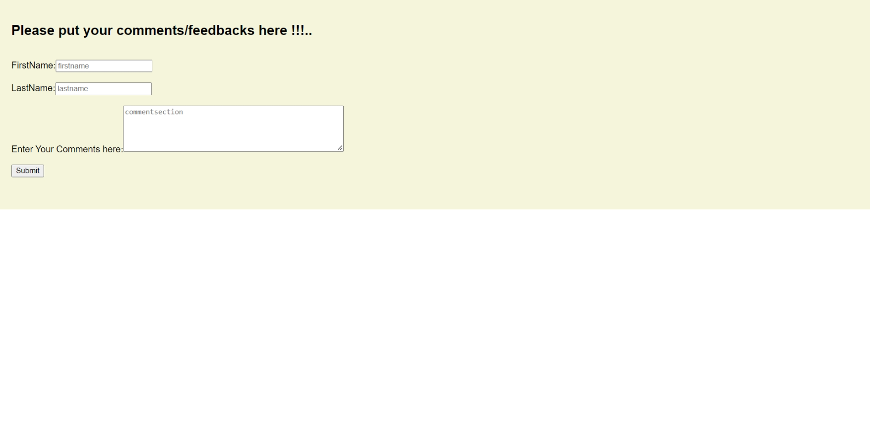

**3. Use form validation (chapter 5.7)**

**4. You can use a third page to consume the form (use javascript to read the data passed in the URL**

Consuming the form using JavaScript App.js

// show a message with a type of the input

function showMessage(input, message, type) {

// get the small element and set the message

const msg = input.parentNode.querySelector("small");

msg.innerText = message;

// update the class for the input

input.className = type ? "success" : "error";

return type;

}

function showError(input, message) {

return showMessage(input, message, false);

}

function showSuccess(input) {

return showMessage(input, "", true);

}

function hasValue(input, message) {

if (input.value.trim() === "") {

return showError(input, message);

}

return showSuccess(input);

}

function validateEmail(input, requiredMsg, invalidMsg) {

// check if the value is not empty

if (!hasValue(input, requiredMsg)) {

return false;

}

// validate email format

const emailRegex =

/^(([^<>()\[\]\\.,;:\s@"]+(\.[^<>()\[\]\\.,;:\s@"]+)*)|(".+"))@((\[[0-9]{1,3}\.[0-9]{1,3}\.[0-9]{1,3}\.[0-9]{1,3}\])|(([a-zA-Z\-0-9]+\.)+[a-zA-Z]{2,}))$/;

const email = input.value.trim();

if (!emailRegex.test(email)) {

return showError(input, invalidMsg);

}

return true;

}

const form = document.querySelector("#signup");

const NAME_REQUIRED = "Please enter your name";

const EMAIL_REQUIRED = "Please enter your email";

const EMAIL_INVALID = "Please enter a correct email address format";

form.addEventListener("submit", function (event) {

// stop form submission

event.preventDefault();

const queryString = window.location.search;

//alert(queryString);

const urlParams = new URLSearchParams(queryString);

const nameCont = urlParams.get('name');

const emailCont = urlParams.get('email');

const messageCont = urlParams.get('message');

//alert("your name is" + nameCont);

// validate the form

let nameValid = hasValue(form.elements["name"], NAME_REQUIRED);

//contactussecerr = document.getElementById('contactussec');

//contactussecerr.innerHTML = "your name is" + nameCont;

let emailValid = validateEmail(form.elements["email"], EMAIL_REQUIRED, EMAIL_INVALID);

// if valid, submit the form.

if (nameValid && emailValid) {

//alert("Demo only. No form was posted.");

}

//queryString = "";

});

**5. Include different form elements (buttons, labels, textbox) and use ID field for all elements (in addition to name and value, and   
placeholder)**

**Contactus.html**

<!DOCTYPE html>

<html lang="en">

<head>

<title>JavaScript Form Demo</title>

<meta name="viewport" content="width=device-width, initial-scale=1.0" />

<link rel="stylesheet" href="css/contactstyle.css" />

</head>

<body>

<div class="main">

<form action="Contactus.html" method="get" id="signup">

<h1>Contact Us</h1>

<div class="field">

<label for="name">Name:</label>

<input type="text" id="name" name="name" placeholder="Enter your fullname" />

<small></small>

</div>

<div class="field">

<label for="email">Email:</label>

<input type="text" id="email" name="email" placeholder="Enter your email address" />

<small></small>

</div>

<div class="field">

<label for="textarea">Your Message:</label>

<input type="text" id="message" name="message" cols="50" rows="5" placeholder="Enter your message" />

<small></small>

</div>

<div class="field">

<button type="submit" class="full">SEND</button>

</div>

</form>

</div>

<script src="js/app.js"></script>

</body>

</html>

**6. Check using the validator. Paste the report. Fix the Errors but you can ignore the warnings.** [**https://validator.w3.org/**](https://validator.w3.org/)

**DONE**

**7. Check Accessibility or Create account on GitHub (free) and upload your website there. (Include screen shots and URL to share with me)**

**GIT URL:**[**https://github.com/anjanamohan88/Assignment5/**](https://github.com/anjanamohan88/Assignment5/)

**8. SPELLCHECK! You want your site to be as professional as possible so be sure to check your spelling and grammar. Focus is on the Tables   
and Forms**

**DONE**

**WEBSITE ISSUES**

1. Validation Issues- validating the code was an issue in the notepad editor.it was resolved by using the code validators online.
2. Image Issues- Finding the images and resizing the resolution accordingly.

**FUTURE PLANS TO IMPLEMENT**

Planning to stretch this into a full-scale travel blog by including all my travel

Stories and pictures. Make it more beautiful by upscaling the design by including more details.

**SUMMARY**

I have successfully designed and created my blog regarding one of my passions . This blog is very easy to access and is very user friendly and is helpful for people who like to travel. It is a platform for people who loves to explore different places. I take this opportunity to thank my professor for giving me this opportunity to make one of my longtime plans successful. I was able to implement my html knowledge and practice it.

**HOMEWORK SUMMARY**

I was able to implement Microsoft visual studio and learn about the IDE and to develop code in the ide.

**VIDEO SUMMARY(video A)**

I found this video very useful as it shows everything we need as a beginner about how to use Visual Studio Code. This video demonstrates all the important functionality of VSCode that you need to know to be as efficient as possible. This tutorial is designed for someone who's never used VSCode before but is still informational for novice users. was struggling with getting Git to work in VSCode and this got me there! It is hard to find a beginner’s tutorial that is recent and that is important given how fast VSCode moves. I will recommend this video to my fellow peers compared to video B .You can find plenty of gold in video B but for a novice video A might give a good start by being precise and sticking to the main points.

**REFERENCES**

1.w3 SCHOOLS

2. <https://developer.mozilla.org/en-US/docs/Learn/Tools_and_testing/Cross_browser_testing/HTML_and_CSS>

3. <https://www.w3schools.com/html/html_favicon.asp>

4. <https://www.tutorialspoint.com/html/index.htm>

5.Wikipedia

6.<https://www.youtube.com/watch?v=WPqXP_kLzpo>

7.<https://www.youtube.com/watch?v=WPqXP_kLzpo>